# Interim – Software Prototype Components

The following are some of the screenshots of the student’s main components of code for the software prototype. A few other classes were created for this prototype but the main classes the student used for this prototype are **AddJournalEntry.java** and **ViewJournalEntries.java**.

The .java and layout resource files can be found under **app\src\main\\***.

***AddJournalEntry():*** All code highlighted within the *onCreate()*, *onActivityResult()* method as well as the functions and code within *openChooseFile()* and *uploadTextImg()* are all part of the student’s own work.

|  |  |
| --- | --- |
| Methods / Functions | Created by Student? |
| onCreate() | Yes |
| openChooseFile() | Yes |
| onActivityResult | Yes |
| uploadTextImg() | Yes |

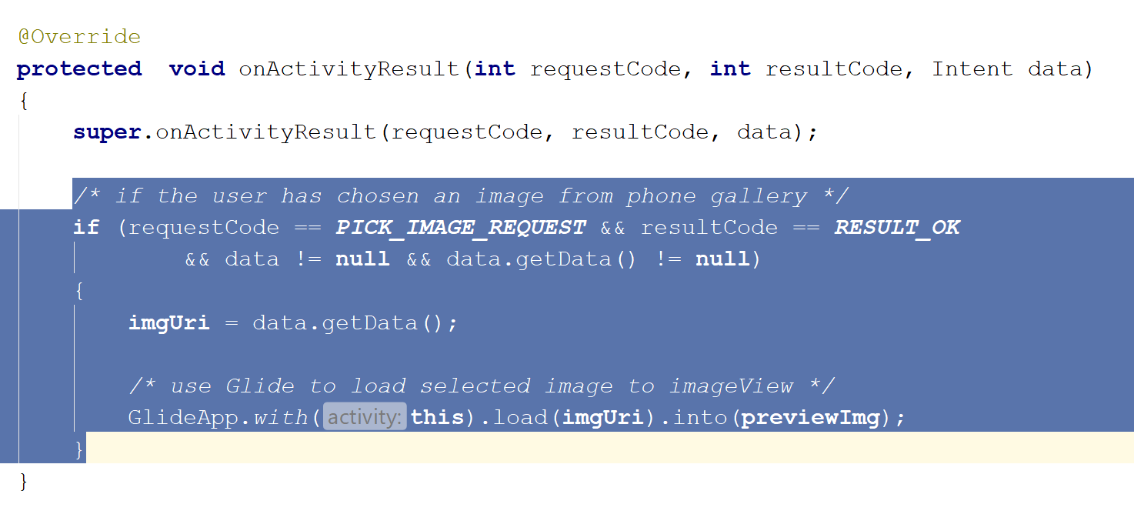

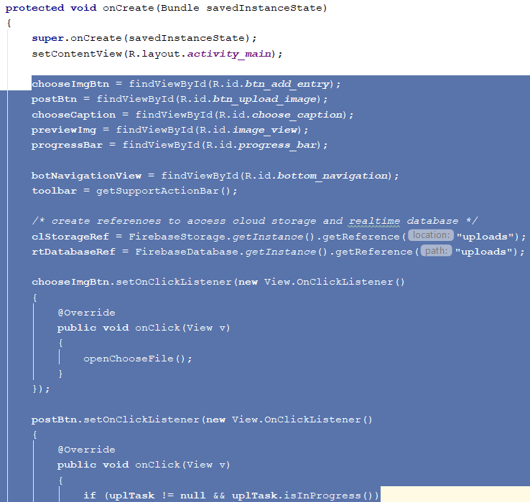

***ViewJournalEntries():*** The code provided within *onCreate()* method as well as the *addJournalEntry()* method are all part of the student’s own work.

The following screenshots all include the components the student has created.

|  |  |
| --- | --- |
| Methods / Functions | Created by Student? |
| onCreate() | Yes |
| addJournalEntry() | Yes |

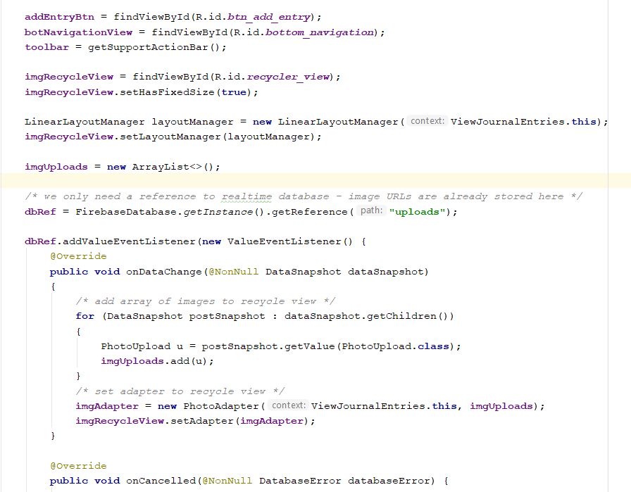

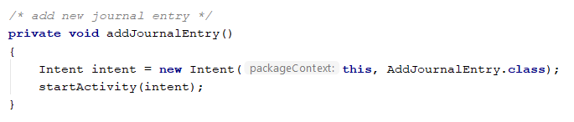

The following table shows other classes and files that are included in the prototype.

|  |  |
| --- | --- |
| Other Classes and Files | Created by Student? |
| PhotoAdapter.java | Yes |
| PhotoUpload.java | Yes |
| ViewScheduledTrips.java | Yes (but no functionality included) |
| MyGlideAppModule.java | No |
| Layout resource files under res\layout | Yes |
| App and build gradle files (dependencies) | No |
| AndroidManifest.xml | No |