SCREENSHOTS:
LOGIN / LOGOUT
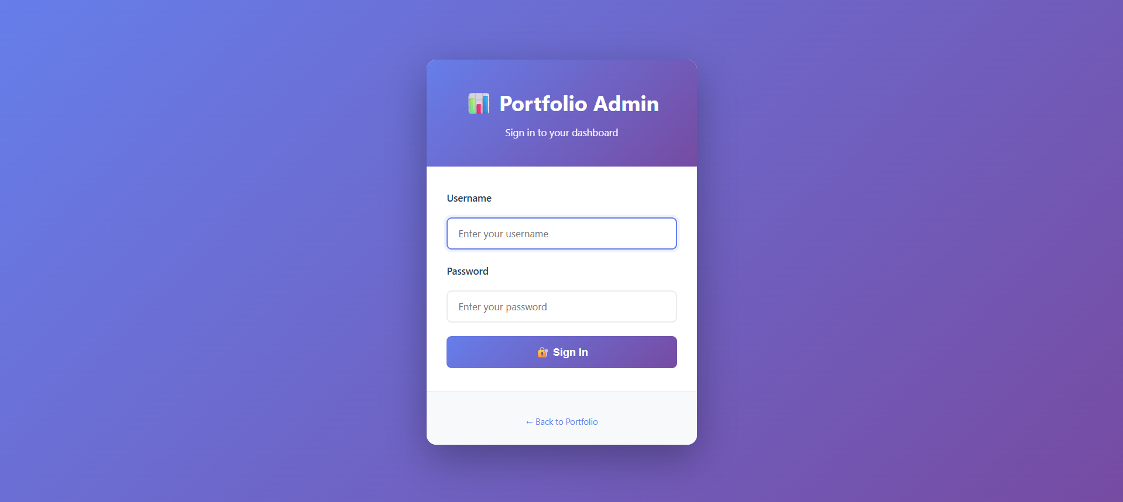

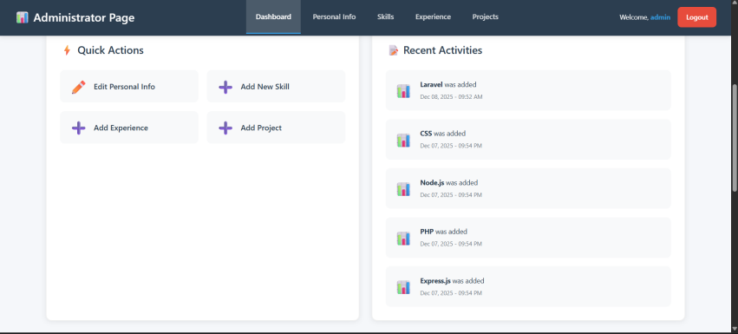
DASHBOARD - ADMIN
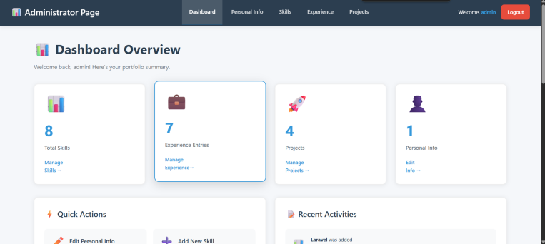

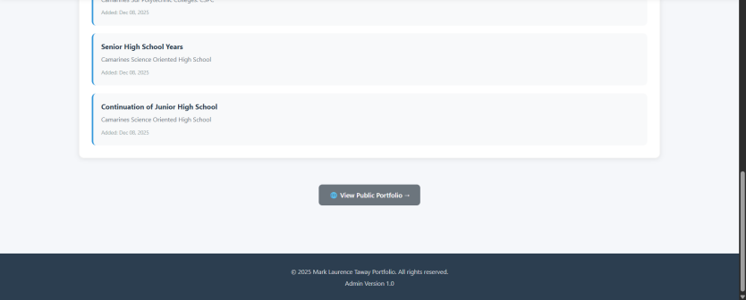

MANAGE PERSONAL INFO - ADMIN
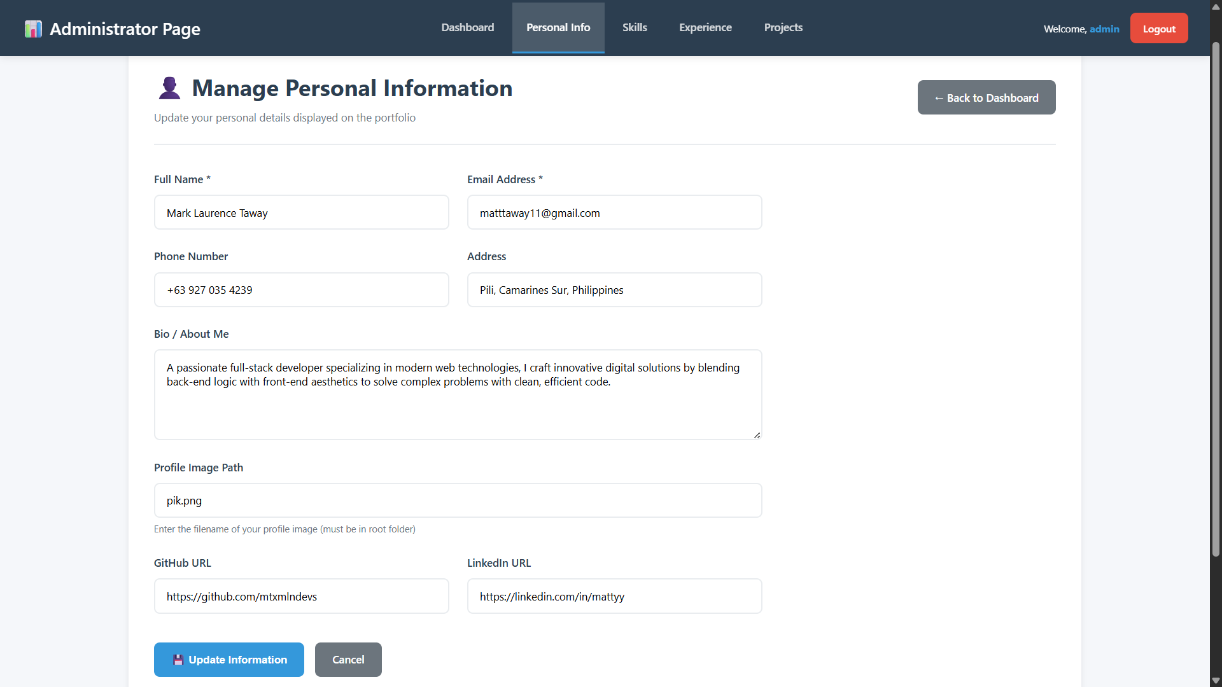

MANAGE SKILLS - ADMIN
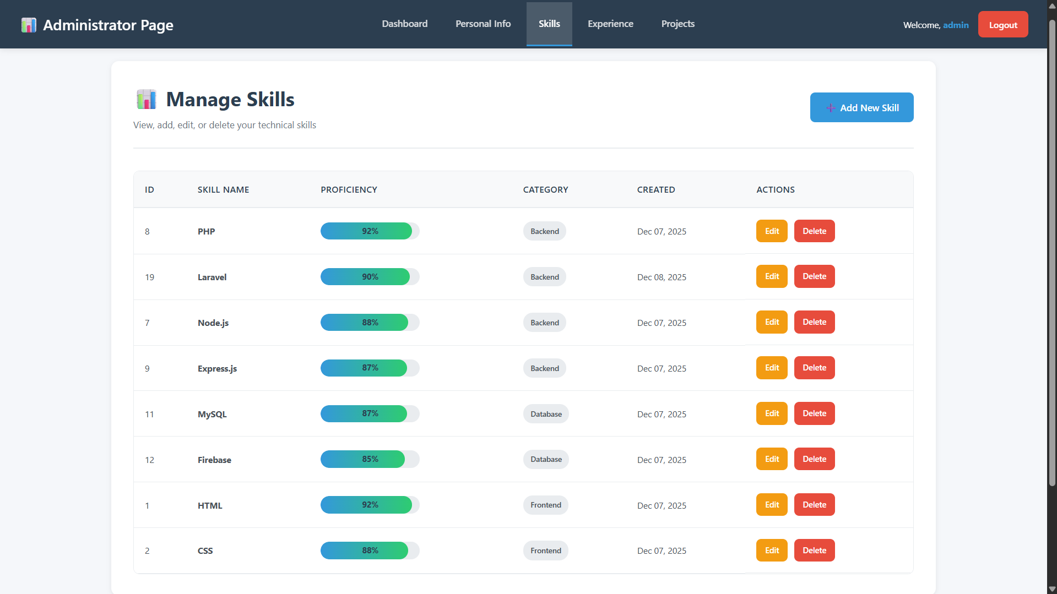

EDIT SKILL - ADMIN
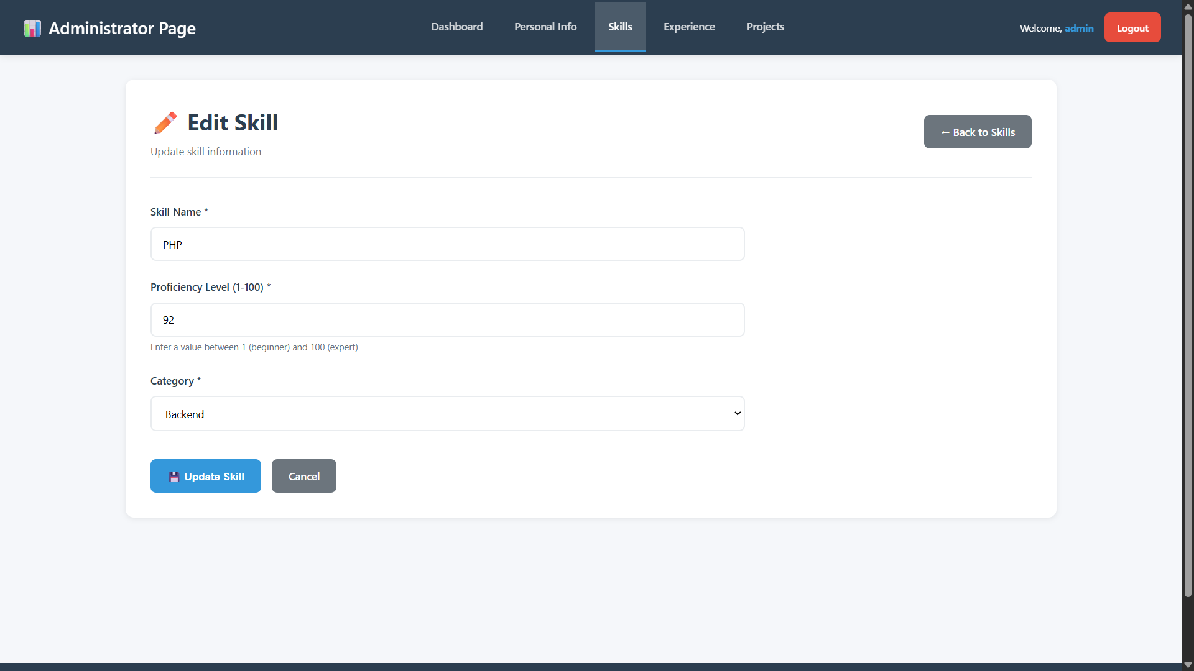

MANAGE EXPERIENCE / EDUCATION - ADMIN
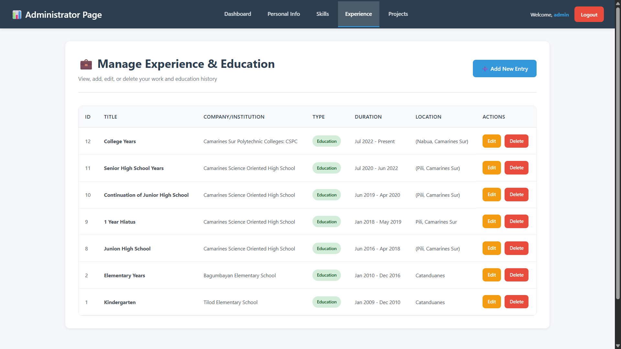

EDIT EXPERIENCE / EDUCATION - ADMIN
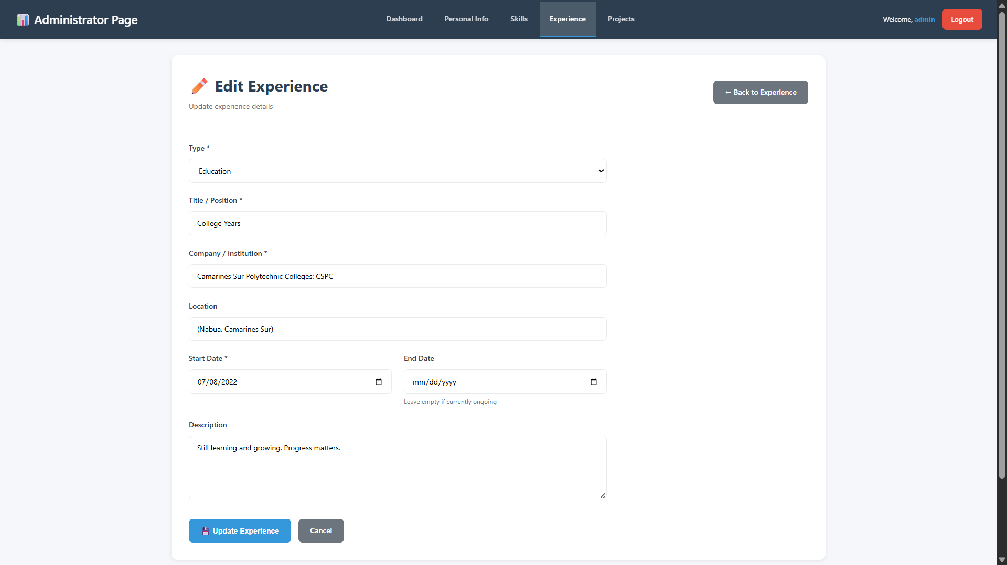

MANAGE PROJECTS -ADMIN
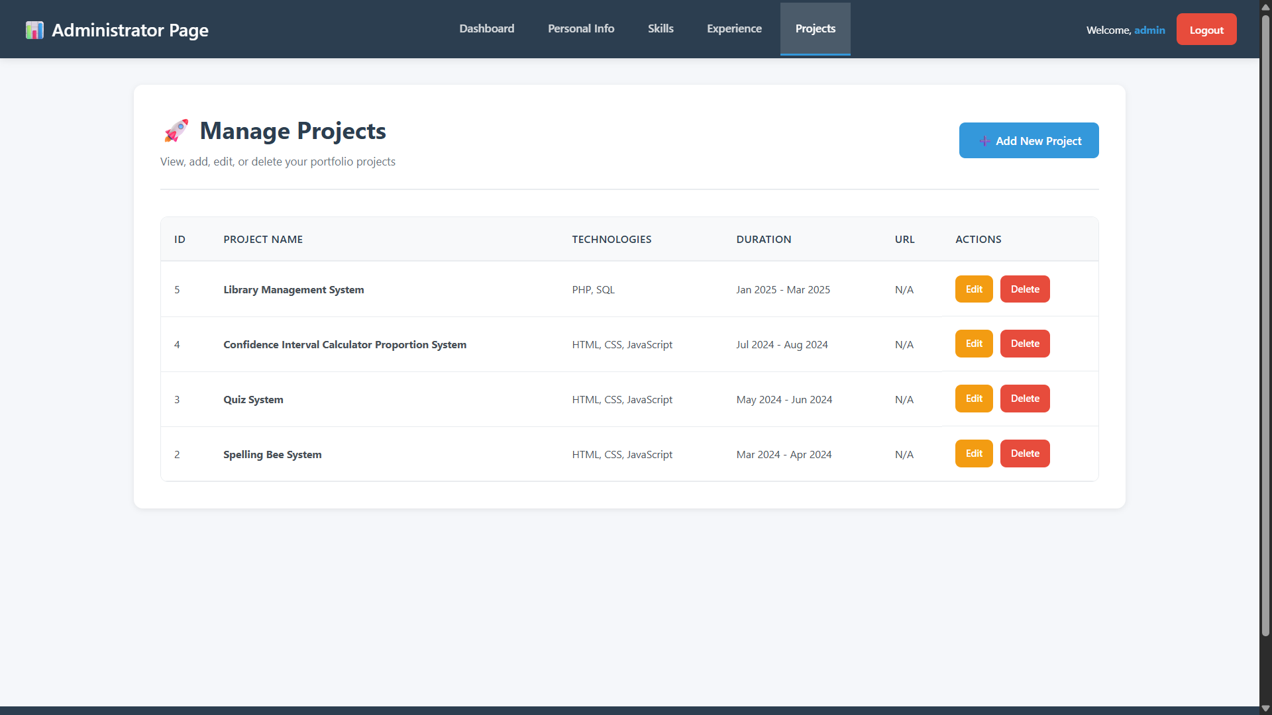

ABOUT - PORTFOLIO
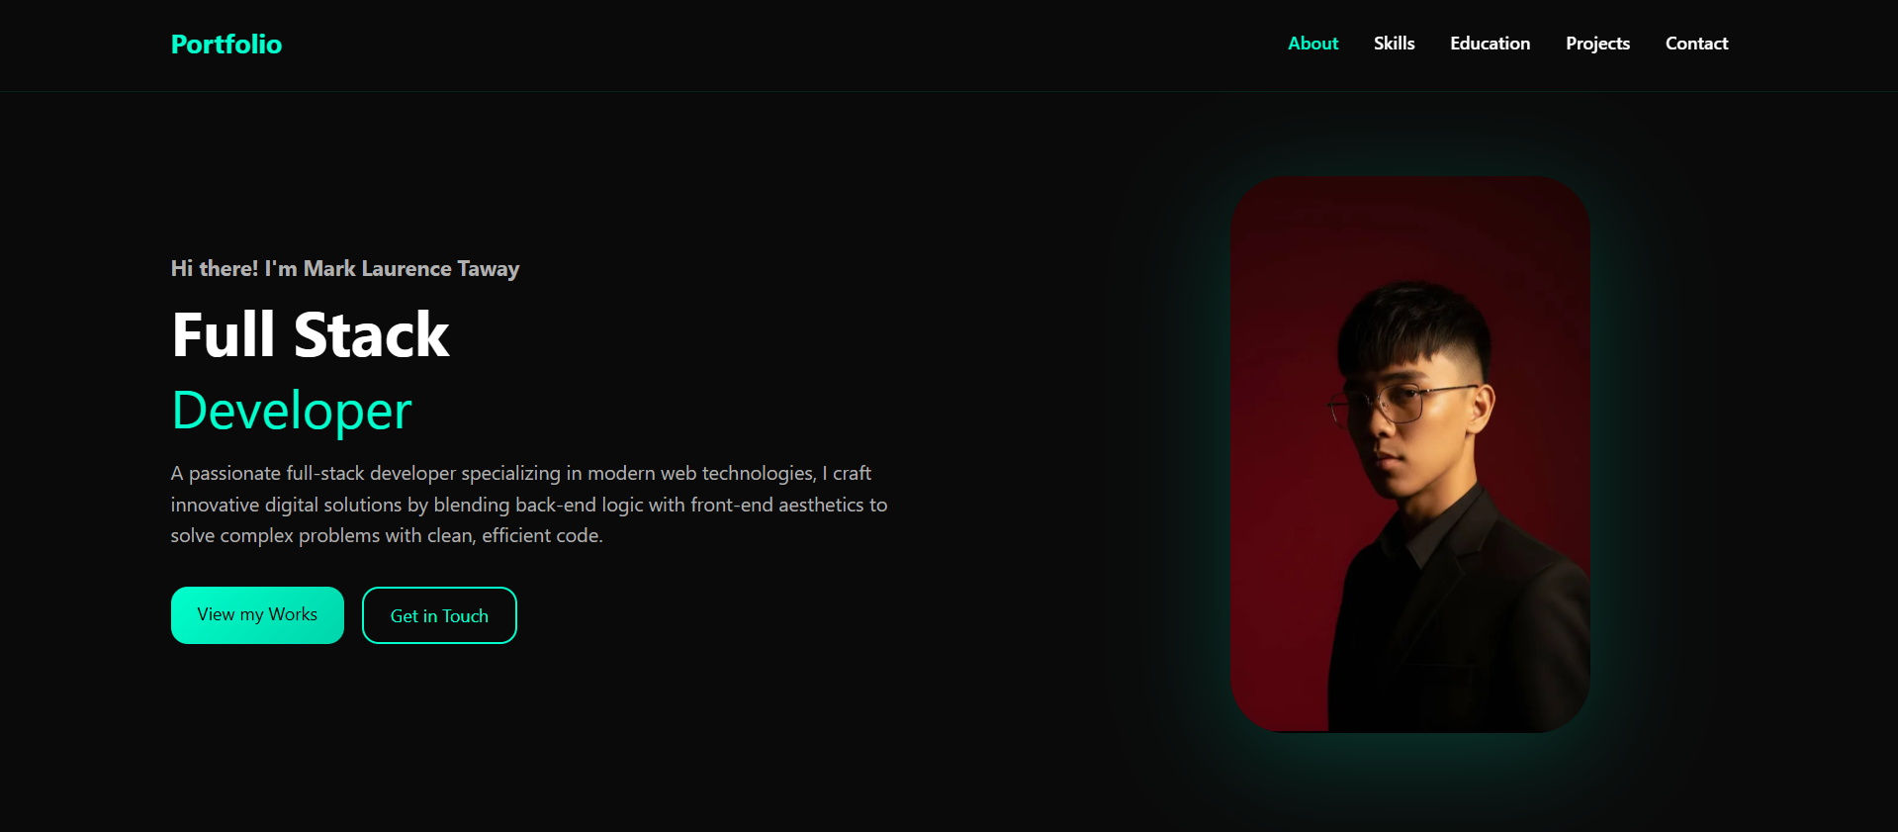

SKILLS - PORTFOLIO
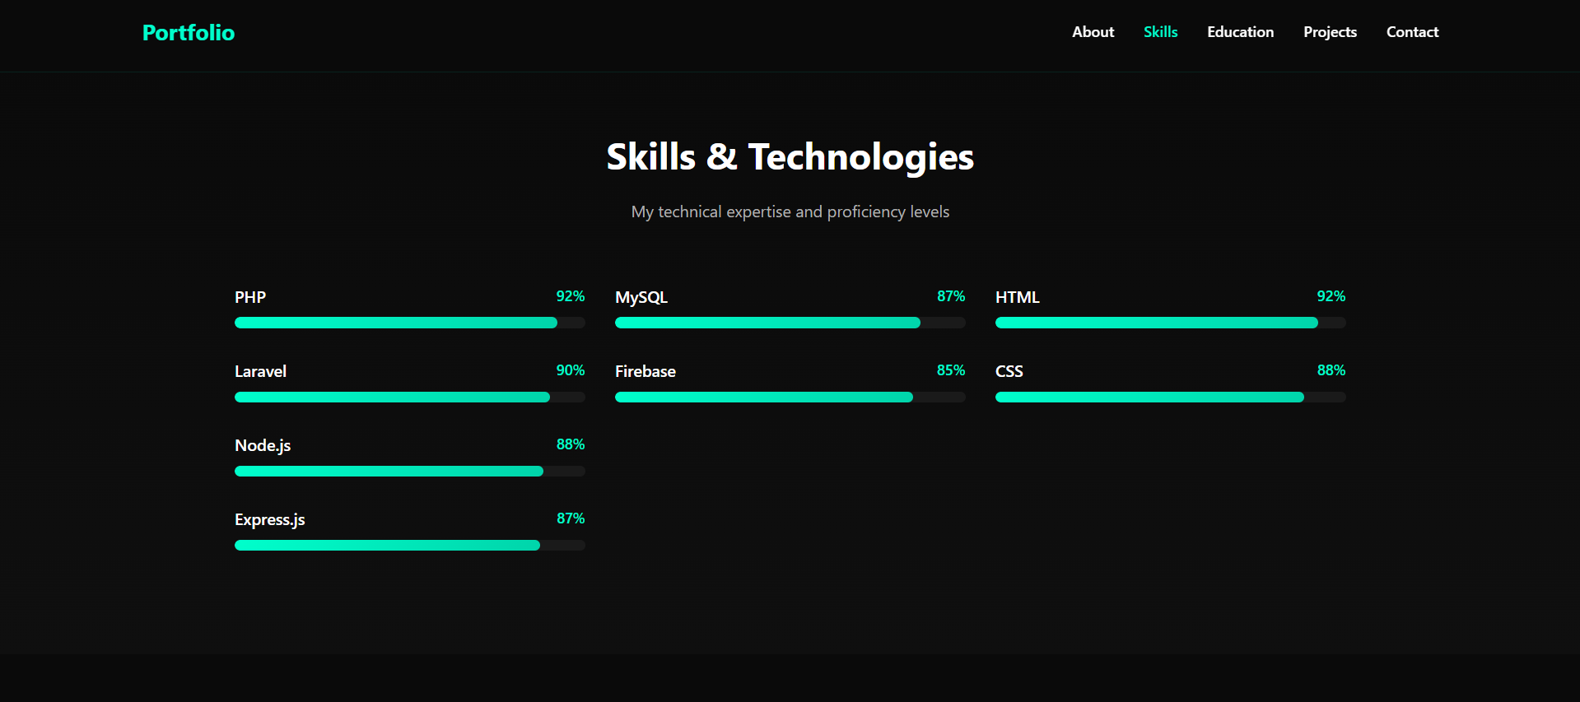
EDUCATION - PORTFOLIO
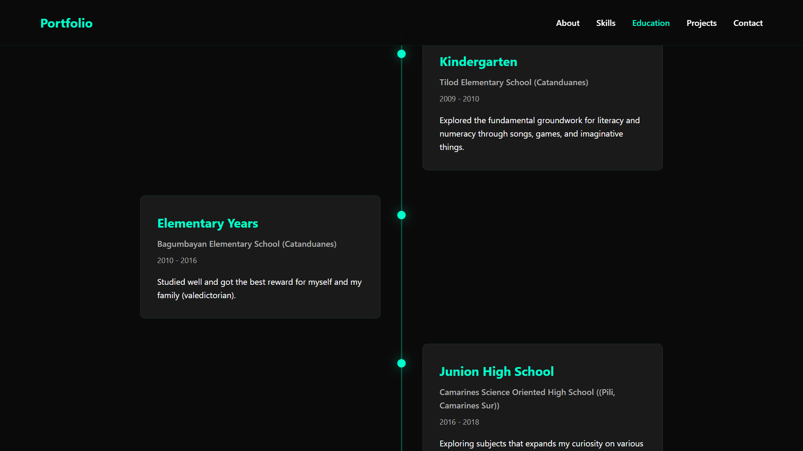

PROJECTS - PORTFOLIO
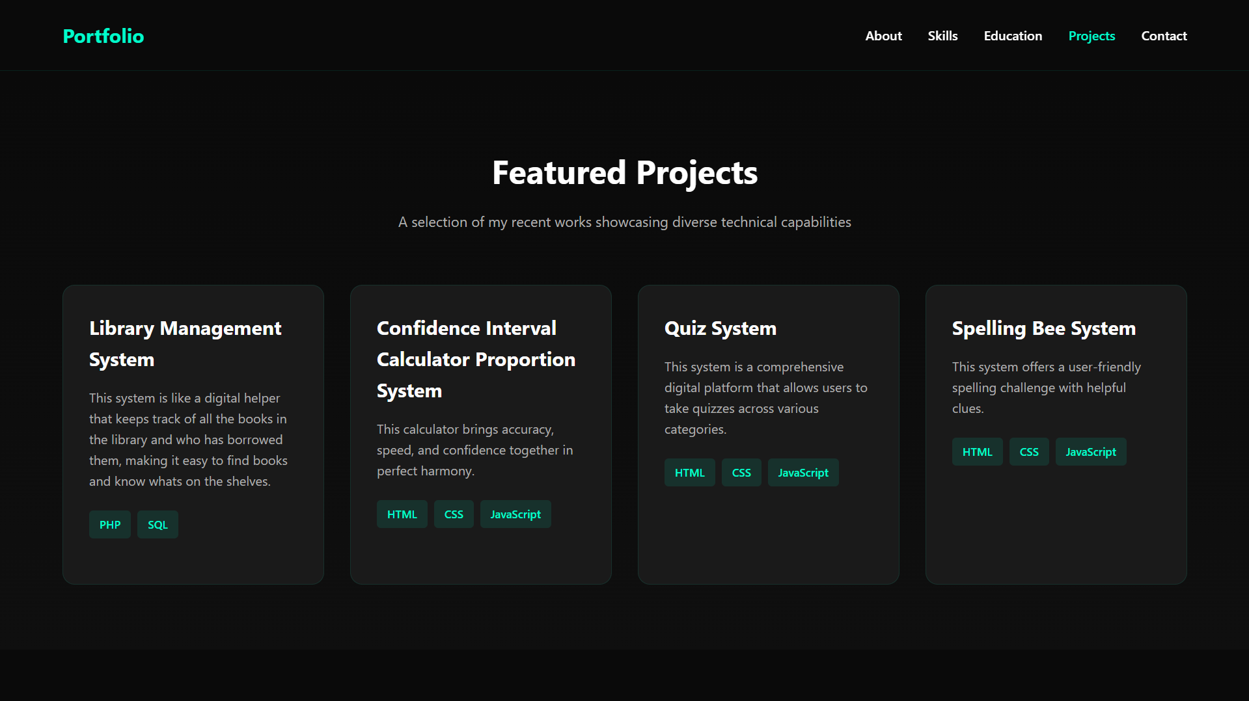

CONTACT - PORTFOLIO
