**airplane** http://www.cs.toronto.edu/~kriz/cifar-10-sample/airplane1.pnghttp://www.cs.toronto.edu/~kriz/cifar-10-sample/airplane2.pnghttp://www.cs.toronto.edu/~kriz/cifar-10-sample/airplane3.pnghttp://www.cs.toronto.edu/~kriz/cifar-10-sample/airplane4.pnghttp://www.cs.toronto.edu/~kriz/cifar-10-sample/airplane5.pnghttp://www.cs.toronto.edu/~kriz/cifar-10-sample/airplane6.pnghttp://www.cs.toronto.edu/~kriz/cifar-10-sample/airplane7.pnghttp://www.cs.toronto.edu/~kriz/cifar-10-sample/airplane8.pnghttp://www.cs.toronto.edu/~kriz/cifar-10-sample/airplane9.pnghttp://www.cs.toronto.edu/~kriz/cifar-10-sample/airplane10.png

**automobile** http://www.cs.toronto.edu/~kriz/cifar-10-sample/automobile1.pnghttp://www.cs.toronto.edu/~kriz/cifar-10-sample/automobile2.pnghttp://www.cs.toronto.edu/~kriz/cifar-10-sample/automobile3.pnghttp://www.cs.toronto.edu/~kriz/cifar-10-sample/automobile4.pnghttp://www.cs.toronto.edu/~kriz/cifar-10-sample/automobile5.pnghttp://www.cs.toronto.edu/~kriz/cifar-10-sample/automobile6.pnghttp://www.cs.toronto.edu/~kriz/cifar-10-sample/automobile7.pnghttp://www.cs.toronto.edu/~kriz/cifar-10-sample/automobile8.pnghttp://www.cs.toronto.edu/~kriz/cifar-10-sample/automobile9.pnghttp://www.cs.toronto.edu/~kriz/cifar-10-sample/automobile10.png

**bird**  http://www.cs.toronto.edu/~kriz/cifar-10-sample/bird1.pnghttp://www.cs.toronto.edu/~kriz/cifar-10-sample/bird2.pnghttp://www.cs.toronto.edu/~kriz/cifar-10-sample/bird3.pnghttp://www.cs.toronto.edu/~kriz/cifar-10-sample/bird4.pnghttp://www.cs.toronto.edu/~kriz/cifar-10-sample/bird5.pnghttp://www.cs.toronto.edu/~kriz/cifar-10-sample/bird6.pnghttp://www.cs.toronto.edu/~kriz/cifar-10-sample/bird7.pnghttp://www.cs.toronto.edu/~kriz/cifar-10-sample/bird8.pnghttp://www.cs.toronto.edu/~kriz/cifar-10-sample/bird9.pnghttp://www.cs.toronto.edu/~kriz/cifar-10-sample/bird10.png

**cat** http://www.cs.toronto.edu/~kriz/cifar-10-sample/cat1.pnghttp://www.cs.toronto.edu/~kriz/cifar-10-sample/cat2.pnghttp://www.cs.toronto.edu/~kriz/cifar-10-sample/cat3.pnghttp://www.cs.toronto.edu/~kriz/cifar-10-sample/cat4.pnghttp://www.cs.toronto.edu/~kriz/cifar-10-sample/cat5.pnghttp://www.cs.toronto.edu/~kriz/cifar-10-sample/cat6.pnghttp://www.cs.toronto.edu/~kriz/cifar-10-sample/cat7.pnghttp://www.cs.toronto.edu/~kriz/cifar-10-sample/cat8.pnghttp://www.cs.toronto.edu/~kriz/cifar-10-sample/cat9.pnghttp://www.cs.toronto.edu/~kriz/cifar-10-sample/cat10.png

**deer**  http://www.cs.toronto.edu/~kriz/cifar-10-sample/deer1.pnghttp://www.cs.toronto.edu/~kriz/cifar-10-sample/deer2.pnghttp://www.cs.toronto.edu/~kriz/cifar-10-sample/deer3.pnghttp://www.cs.toronto.edu/~kriz/cifar-10-sample/deer4.pnghttp://www.cs.toronto.edu/~kriz/cifar-10-sample/deer5.pnghttp://www.cs.toronto.edu/~kriz/cifar-10-sample/deer6.pnghttp://www.cs.toronto.edu/~kriz/cifar-10-sample/deer7.pnghttp://www.cs.toronto.edu/~kriz/cifar-10-sample/deer8.pnghttp://www.cs.toronto.edu/~kriz/cifar-10-sample/deer9.pnghttp://www.cs.toronto.edu/~kriz/cifar-10-sample/deer10.png

**dog** http://www.cs.toronto.edu/~kriz/cifar-10-sample/dog1.pnghttp://www.cs.toronto.edu/~kriz/cifar-10-sample/dog2.pnghttp://www.cs.toronto.edu/~kriz/cifar-10-sample/dog3.pnghttp://www.cs.toronto.edu/~kriz/cifar-10-sample/dog4.pnghttp://www.cs.toronto.edu/~kriz/cifar-10-sample/dog5.pnghttp://www.cs.toronto.edu/~kriz/cifar-10-sample/dog6.pnghttp://www.cs.toronto.edu/~kriz/cifar-10-sample/dog7.pnghttp://www.cs.toronto.edu/~kriz/cifar-10-sample/dog8.pnghttp://www.cs.toronto.edu/~kriz/cifar-10-sample/dog9.pnghttp://www.cs.toronto.edu/~kriz/cifar-10-sample/dog10.png

**frog**  http://www.cs.toronto.edu/~kriz/cifar-10-sample/frog1.pnghttp://www.cs.toronto.edu/~kriz/cifar-10-sample/frog2.pnghttp://www.cs.toronto.edu/~kriz/cifar-10-sample/frog3.pnghttp://www.cs.toronto.edu/~kriz/cifar-10-sample/frog4.pnghttp://www.cs.toronto.edu/~kriz/cifar-10-sample/frog5.pnghttp://www.cs.toronto.edu/~kriz/cifar-10-sample/frog6.pnghttp://www.cs.toronto.edu/~kriz/cifar-10-sample/frog7.pnghttp://www.cs.toronto.edu/~kriz/cifar-10-sample/frog8.pnghttp://www.cs.toronto.edu/~kriz/cifar-10-sample/frog9.pnghttp://www.cs.toronto.edu/~kriz/cifar-10-sample/frog10.png

**horse** http://www.cs.toronto.edu/~kriz/cifar-10-sample/horse1.pnghttp://www.cs.toronto.edu/~kriz/cifar-10-sample/horse2.pnghttp://www.cs.toronto.edu/~kriz/cifar-10-sample/horse3.pnghttp://www.cs.toronto.edu/~kriz/cifar-10-sample/horse4.pnghttp://www.cs.toronto.edu/~kriz/cifar-10-sample/horse5.pnghttp://www.cs.toronto.edu/~kriz/cifar-10-sample/horse6.pnghttp://www.cs.toronto.edu/~kriz/cifar-10-sample/horse7.pnghttp://www.cs.toronto.edu/~kriz/cifar-10-sample/horse8.pnghttp://www.cs.toronto.edu/~kriz/cifar-10-sample/horse9.pnghttp://www.cs.toronto.edu/~kriz/cifar-10-sample/horse10.png

**ship**  http://www.cs.toronto.edu/~kriz/cifar-10-sample/ship1.pnghttp://www.cs.toronto.edu/~kriz/cifar-10-sample/ship2.pnghttp://www.cs.toronto.edu/~kriz/cifar-10-sample/ship3.pnghttp://www.cs.toronto.edu/~kriz/cifar-10-sample/ship4.pnghttp://www.cs.toronto.edu/~kriz/cifar-10-sample/ship5.pnghttp://www.cs.toronto.edu/~kriz/cifar-10-sample/ship6.pnghttp://www.cs.toronto.edu/~kriz/cifar-10-sample/ship7.pnghttp://www.cs.toronto.edu/~kriz/cifar-10-sample/ship8.pnghttp://www.cs.toronto.edu/~kriz/cifar-10-sample/ship9.pnghttp://www.cs.toronto.edu/~kriz/cifar-10-sample/ship10.png

**truck** http://www.cs.toronto.edu/~kriz/cifar-10-sample/truck1.pnghttp://www.cs.toronto.edu/~kriz/cifar-10-sample/truck2.pnghttp://www.cs.toronto.edu/~kriz/cifar-10-sample/truck3.pnghttp://www.cs.toronto.edu/~kriz/cifar-10-sample/truck4.pnghttp://www.cs.toronto.edu/~kriz/cifar-10-sample/truck5.pnghttp://www.cs.toronto.edu/~kriz/cifar-10-sample/truck6.pnghttp://www.cs.toronto.edu/~kriz/cifar-10-sample/truck7.pnghttp://www.cs.toronto.edu/~kriz/cifar-10-sample/truck8.pnghttp://www.cs.toronto.edu/~kriz/cifar-10-sample/truck9.pnghttp://www.cs.toronto.edu/~kriz/cifar-10-sample/truck10.png

只训练最后一层

训练cifar10   
  
```  
python train_image_classifier.py --train_dir=G:\data\resnet50\cifar10/train_dir \  
 --dataset_name=cifar10 --dataset_split_name=train \  
 --dataset_dir=G:\data\resnet50\cifar10/data \  
 --model_name=resnet_v2_50 \  
 --heckpoint_path=G:\data\resnet50\cifar10/pretrained/resnet_v2_50.ckpt \  
 --checkpoint_exclude_scopes=resnet_v2_50/logits \  
 --trainable_scopes=resnet_v2_50/logits \  
 --max_number_of_steps=30000 \  
 --batch_size=32 \  
 --learning_rate=0.01 \  
 --save_interval_secs=60 \  
 --save_summaries_secs=60 \  
 --log_every_n_steps=100 \  
 --optimizer=rmsprop \  
 --weight_decay=0.00004  
```  
  
验证测试集 Run evaluation

python eval_image_classifier.py \  
 --checkpoint_path=G:\data\resnet50\cifar10\train_dir \  
 --eval_dir=G:\data\resnet50\cifar10\eval_dir \  
 --dataset_name=cifar10 \  
 --dataset_split_name=test \  
 --dataset_dir=G:\data\resnet50\cifar10\data \  
 --model_name=resnet_v2_50

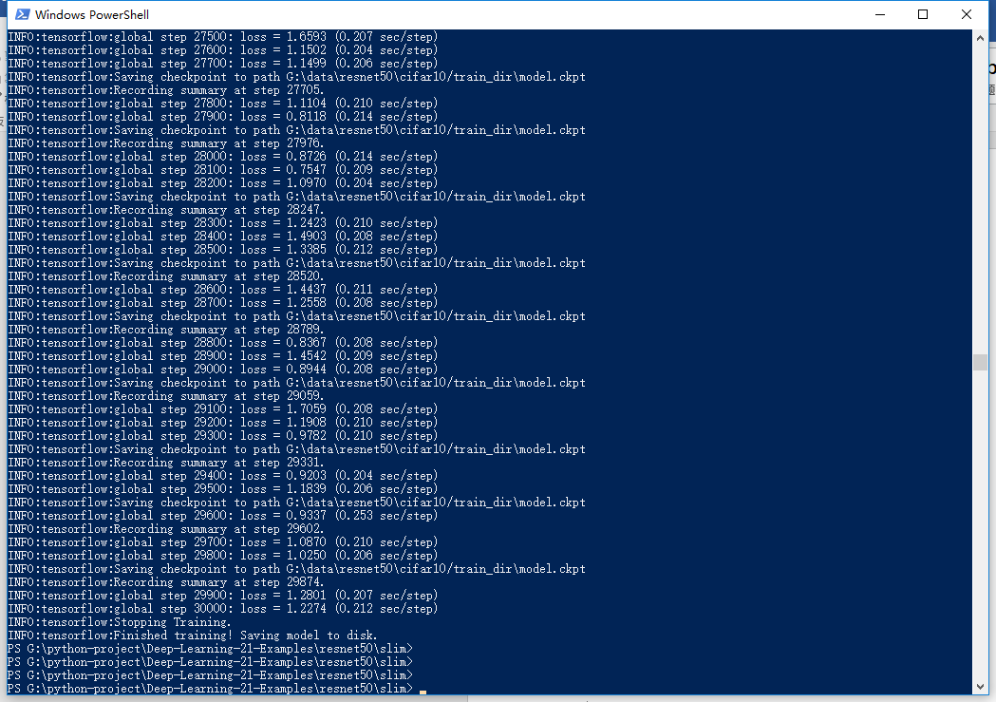

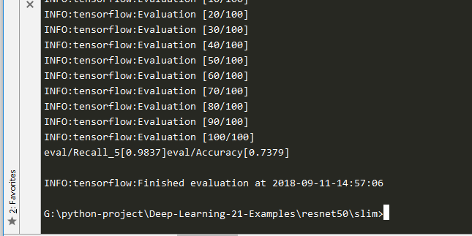

训练全部层

python train_image_classifier.py --train_dir=G:\data\resnet50\cifar10/train_dir --dataset_name=cifar10 --dataset_split_name=train --dataset_dir=G:\data\resnet50\cifar10/data --model_name=resnet_v2_50 --checkpoint_path=G:\data\resnet50\cifar10/pretrained/resnet_v2_50.ckpt --max_number_of_steps=5000 --batch_size=16 --learning_rate=0.001 --save_interval_secs=60 --save_summaries_secs=60 --log_every_n_steps=100 --optimizer=rmsprop --weight_decay=0.00004 --checkpoint_exclude_scopes=resnet_v2_50/logits

python eval_image_classifier.py --checkpoint_path=G:\data\resnet50\cifar10/train_dir --eval_dir=G:\data\resnet50\cifar10/eval_dir --dataset_name=cifar10 --dataset_split_name=test --dataset_dir=G:\data\resnet50\cifar10/data --model_name=resnet_v2_50

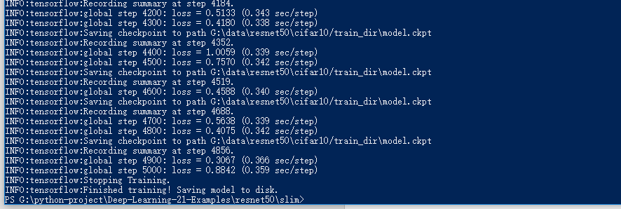

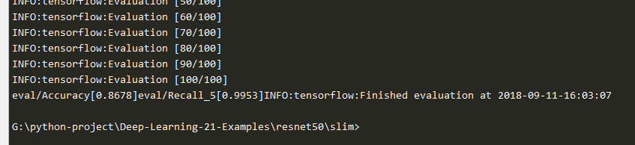

使用adma优化，训练全部层

python train_image_classifier.py --train_dir=G:\data\resnet50\cifar10/train_dir --dataset_name=cifar10 --dataset_split_name=train --dataset_dir=G:\data\resnet50\cifar10/data --model_name=resnet_v2_50 --checkpoint_path=G:\data\resnet50\cifar10/pretrained/resnet_v2_50.ckpt --max_number_of_steps=5000 --batch_size=16 --learning_rate=0.001 --save_interval_secs=60 --save_summaries_secs=60 --log_every_n_steps=100 --optimizer=adam --weight_decay=0.00004 --checkpoint_exclude_scopes=resnet_v2_50/logits

python eval_image_classifier.py --checkpoint_path=G:\data\resnet50\cifar10/train_dir --eval_dir=G:\data\resnet50\cifar10/eval_dir --dataset_name=cifar10 --dataset_split_n

ame=test --dataset_dir=G:\data\resnet50\cifar10/data --model_name=resnet_v2_50

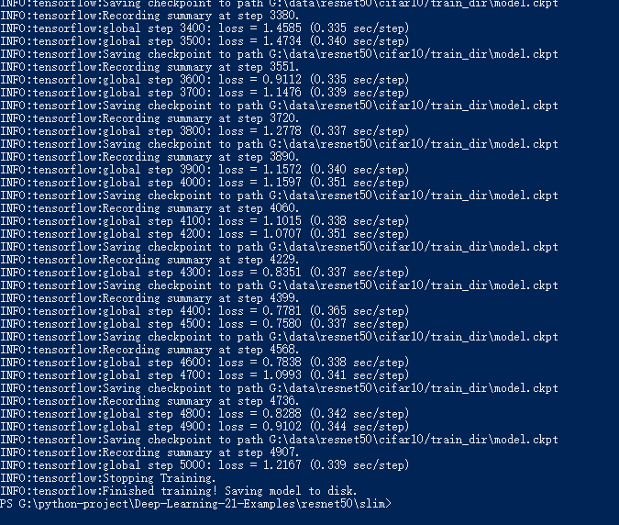

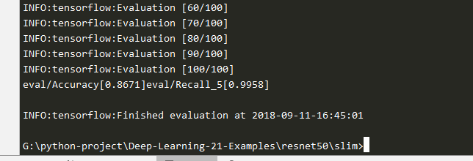

60000步，adma

python train_image_classifier.py --train_dir=G:\data\resnet50\cifar10/train_dir --dataset_name=cifar10 --dataset_split_name=train --dataset_dir=G:\data\resnet50\cifar10/data --model_name=resnet_v2_50 --checkpoint_path=G:\data\resnet50\cifar10/pretrained/resnet_v2_50.ckpt --max_number_of_steps=100000 --batch_size=16 --learning_rate=0.001 --save_interval_secs=60 --save_summaries_secs=60 --log_every_n_steps=100 --optimizer=adam --weight_decay=0.00004 --checkpoint_exclude_scopes=resnet_v2_50/logits

>python eval_image_classifier.py --checkpoint_path=G:\data\resnet50\cifar10/train_dir --eval_dir=G:\data\resnet50\cifar10/eval_dir --dataset_name=cifar10 --dataset_split_name=test --dataset_dir=G:\data\resnet50\cifar10/data --model_name=resnet_v2_50

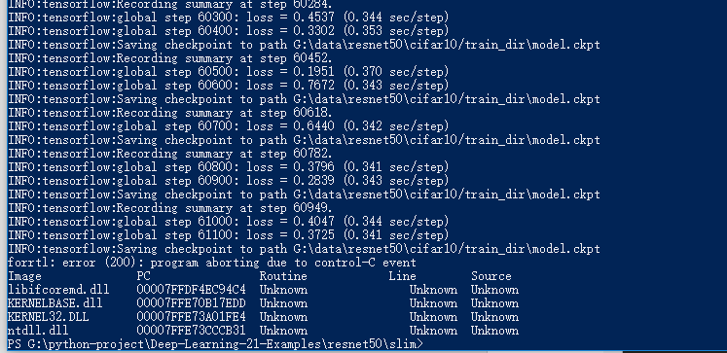

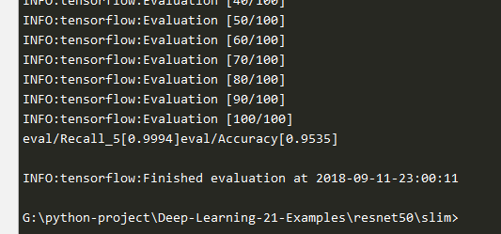

只训练最后一层

python train_image_classifier.py --train_dir=G:\data\resnet50\cifar10/train_dir --dataset_name=cifar10 --dataset_split_name=train --dataset_dir=G:\data\resnet50\cifar10/data --model_name=resnet_v2_50 --checkpoint_path=G:\data\resnet50\cifar10/pretrained/resnet_v2_50.ckpt --max_number_of_steps=50000 --batch_size=16 --learning_rate=0.001 --save_interval_secs=60 --save_summaries_secs=60 --log_every_n_steps=100 --optimizer=adam --weight_decay=0.00004 --checkpoint_exclude_scopes=resnet_v2_50/logits --trainable_scopes=resnet_v2_50/logits

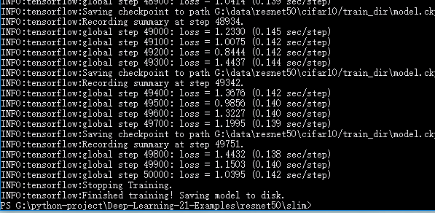

>python eval_image_classifier.py --checkpoint_path=G:\data\resnet50\cifar10/train_dir --eval_dir=G:\data\resnet50\cifar10/eval_dir --dataset_name=cifar10 --dataset_split_name=test --dataset_dir=G:\data\resnet50\cifar10/data --model_name=resnet_v2_50

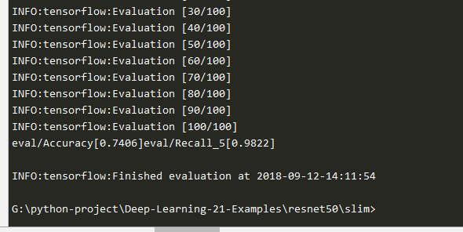

50000步，adma，优化全部层

python train_image_classifier.py --train_dir=G:\data\resnet50\cifar10/train_dir --dataset_name=cifar10 --dataset_split_name=train --dataset_dir=G:\data\resnet50\cifar10/data --model_name=resnet_v2_50 --checkpoint_path=G:\data\resnet50\cifar10/pretrained/resnet_v2_50.ckpt --max_number_of_steps=100000 --batch_size=16 --learning_rate=0.1 --log_every_n_steps=100 --optimizer=adam --weight_decay=0.0001 --momentum=0.9 --checkpoint_exclude_scopes=resnet_v2_50/logits

>python eval_image_classifier.py --checkpoint_path=G:\data\resnet50\cifar10/train_dir --eval_dir=G:\data\resnet50\cifar10/eval_dir --dataset_name=cifar10 --dataset_split_name=test --dataset_dir=G:\data\resnet50\cifar10/data --model_name=resnet_v2_50

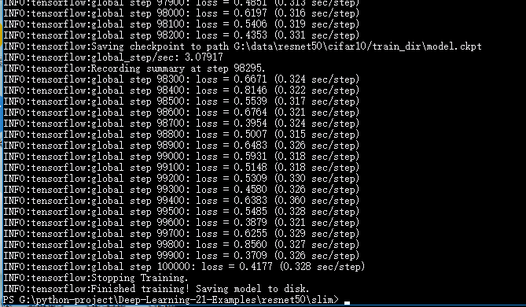

#######################################################

60000步，adma

python train_image_classifier.py --train_dir=G:\data\resnet50\cifar10/train_dir --dataset_name=cifar10 --dataset_split_name=train --dataset_dir=G:\data\resnet50\cifar10/data --model_name=resnet_v2_50 --checkpoint_path=G:\data\resnet50\cifar10/pretrained/resnet_v2_50.ckpt --max_number_of_steps=50000 --batch_size=16 --learning_rate=0.001 --log_every_n_steps=100 --optimizer=adam --checkpoint_exclude_scopes=resnet_v2_50/logits

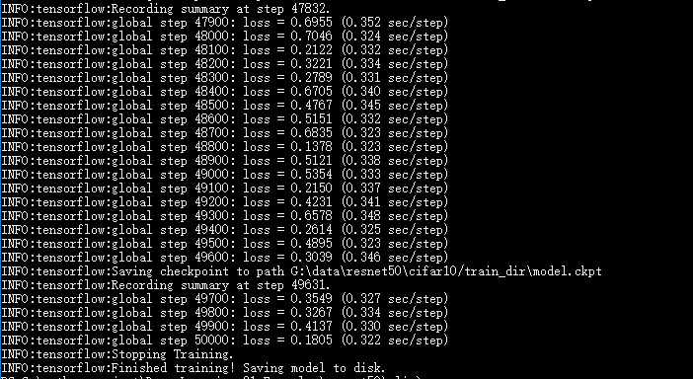

>python eval_image_classifier.py --checkpoint_path=G:\data\resnet50\cifar10/train_dir --eval_dir=G:\data\resnet50\cifar10/eval_dir --dataset_name=cifar10 --dataset_split_name=test --dataset_dir=G:\data\resnet50\cifar10/data --model_name=resnet_v2_50

