Generalization Gap and Adaptive Retraining in Machine Learning-Based
Network Intrusion Detection: A Live-Traffic Case Study with XGBoost

Abstract
Machine-learning intrusion detection systems (ML-IDS) routinely report 95–99% accuracy on benchmark datasets, yet this accuracy is known to collapse once a model is evaluated on a different dataset – a cross-dataset generalization gap. This work extends that problem to a harder, unstudied axis: from a static benchmark to traffic physically captured live on the network being protected. Using an XGBoost-based IDS trained to 99.69% accuracy (99.99% ROC-AUC) on CIC-IDS-2017, we show live lab traffic first collapsed in ranking to near-chance (ROC-AUC 0.61) despite acceptable raw accuracy, was restored to 99.95% via a ground-truth-informed adaptive retrain, then partially failed again on a larger, more diverse capture (95.16% accuracy, all unseen-port traffic misclassified) before a second targeted retrain closed the gap (99.74%), after fixing three dormant retraining-pipeline defects. Benchmark accuracy is not a reliable proxy for live deployment readiness, and one retrain does not permanently close the gap as traffic diversity grows.
live traffic evaluation, domain generalization, adaptive retraining, intrusion detection, XGBoost

Introduction
Machine-learning-based intrusion detection systems are almost universally evaluated the same way: train and test on splits of the same static, pre-captured benchmark dataset, most commonly CIC-IDS-2017 or its 2018 successor. This produces impressive numbers – accuracies above 99% are routine – but says little about how such a system behaves once deployed against traffic it was never shown during training.
Cantone et al. (Cantone et al. 2024) put a number on part of this problem: when several flow-based classifiers trained on CIC-IDS-2017 are scored against CSE-CIC-IDS-2018 instead of their own held-out split, recall falls sharply even though the model architecture itself never changes – evidence that what gets learned is tied to artifacts of a particular data collection rather than to attack behavior that transfers. This paper pushes past an axis that kind of comparison cannot reach: two static datasets are still, in the end, two curated corpora. We instead take a trained model and point it at traffic physically captured, in real time, from the network it is supposed to be protecting, and find the same collapse there too – worse than the dataset-to-dataset case – and that it comes back on a second, more varied capture even after an initial fix appeared to work. We study these findings on SENTINEL, our own 13-phase, 32-module machine-learning-based intrusion prevention framework (Section 3); we refer to it as SENTINEL throughout the rest of this paper.
Our contributions are:
- We reproduce the cross-dataset generalization collapse on our own XGBoost + ANOVA-feature-selection pipeline, consistent with (Cantone et al. 2024), and confirm that combined-dataset training resolves it, matching prior findings.
- We provide, to our knowledge, the first empirical characterization of the dataset-to-live-traffic generalization gap, using a physical lab with ground-truth-labelled packet captures rather than a simulated or synthetic distribution shift.
- We diagnose three previously dormant implementation defects in the adaptive-retraining pipeline used to close the gap – a systems finding alongside the machine-learning one, since the correction mechanism itself first had to be debugged before it could be trusted.
- We show the gap is not closed permanently by a single retrain: a larger, more diverse live capture re-exposes it along a dimension (destination port) the first correction never generalized across, motivating diversity-aware validation over one-shot correction.
This paper deliberately scopes to SENTINEL’s core ML detection pipeline and the generalization-gap findings above rather than its full feature set (Section 3). The remainder of this paper is organized as follows. Section 2 reviews related work on cross-dataset and temporal generalization in ML-IDS. Section 3 briefly describes the system architecture. Section 4 details the datasets, pipeline, and experimental design. Section 5 presents the three escalating findings. Section 6 discusses their implications and limitations, and Section 7 concludes.

Related Work
The CIC-IDS-2017 dataset (Sharafaldin et al. 2018) and its CSE-CIC-IDS-2018 successor remain the dominant benchmarks for ML-IDS research, collected via the same methodology (real background traffic plus scripted attacks in a controlled testbed, flow features extracted via CICFlowMeter). Most published work reports accuracy on held-out splits of a single such dataset – a concern raised as early as Viegas et al. (Viegas et al. 2017), who argued that anomaly-based detectors rarely reach real-world deployment precisely because evaluation methodology does not account for production-network properties; that concern predates CIC-IDS-2017 as the field’s standard benchmark and, as this paper shows, remains only partly addressed by it. Even recent work stays within this static-evaluation pattern: Thanh (Thanh 2026) proposes a deployment-oriented evaluation framework (in-dataset, cross-dataset, mixed-domain, and limited-label fine-tuning scenarios) that nonetheless conducts every experiment on historical records from two existing benchmark corpora rather than on traffic a network actually produced, and Layeghy and Portmann (Layeghy and Portmann 2023) likewise confine their explainability-driven cross-domain analysis to dataset pairs (UNSW-NB15, CIC-IDS, KDD99) rather than live capture.
The clearest existing evidence for the gap this paper reproduces comes from Cantone et al. (Cantone et al. 2024): across several flow-based classifier architectures, moving the evaluation set from one CIC-family corpus to another causes recall to fall far faster than overall accuracy does, even though each model still looks nearly perfect when scored against the data it was trained on. Section 5 reproduces that exact pattern on our own pipeline before pushing the comparison further. A separate line of work by Zouhri et al. (Zouhri et al. 2024) compares several univariate and multivariate feature-selection filters – among them the ANOVA F-value criterion this pipeline also relies on – across CIC-IDS-2017, CSE-CIC-IDS-2018, and CIC-ToN-IoT, giving independent support for ANOVA selection as a deliberate rather than arbitrary choice within this pipeline family (Section 4). Elangovan et al. (Elangovan et al. 2026) approach a related question from a different angle – time rather than deployment context – and find that classifiers trained on 2017 enterprise traffic lose $Δ$F1$≈$0.20–0.27 when applied years later to IoT traffic collected in 2023–2024; that temporal axis of the gap is complementary to, and outside the scope of, the live-deployment axis this paper studies. A third strand of related work targets adaptation directly rather than measuring the gap itself: Gupta et al. (Gupta et al. 2025) combine selective sample annotation with synthetic data generation to correct for concept drift and class imbalance in streaming intrusion detection; Section 6 contrasts that more elaborate correction strategy against the considerably simpler one used here.
What none of these three studies do – comparing datasets to each other, comparing datasets across time, or correcting for drift within a single dataset – is compare a benchmark-trained model against traffic a real network actually produced. That is the gap this paper fills: the same collapse these studies document reappears, more severely, the moment a model leaves curated data behind entirely, and, novel here, a single corrective retrain does not close it for good – it resurfaces as the live traffic observed grows more varied.

System Architecture
SENTINEL (Fig. 1) ingests packets, flows, and logs, enriches them with threat-intelligence signals (IP/domain reputation, Tor exit nodes, honeypot alerts), and passes both into a three-layer Detection Engine: an XGBoost-based flow classifier (the subject of this paper), a signature-based layer matching known payload patterns (SQL injection, XSS, command injection, web shells, CSRF), and an Isolation-Forest-based anomaly detector for zero-day traffic. Detections fan out to attribution (MITRE ATT&CK (MITRE Corporation, n.d.) mapping, geolocation, threat-actor profiling), response (IP blacklisting, connection termination, rate limiting), adaptive retraining, forensics (PCAP logging, timeline reconstruction), and SHAP-based explainability, all surfaced on a live dashboard. This paper evaluates only the ML classification layer of the Detection Engine; the remaining layers are named here for context but are outside its scope, except where the adaptive-retraining loop is directly implicated in Section 6, and where SHAP explainability is applied directly to this layer’s classifier in Section 5.D.
SENTINEL system architecture (compact). This paper evaluates only the highlighted Detection Engine; the other layers of the deployed 32-module system are shown for context, except where the Adaptive layer’s retraining pipeline is directly implicated in the defects discussed in Section 6.

Methodology

Datasets
We use four datasets, two static benchmarks and two live packet captures of our own. CIC-IDS-2017 (Sharafaldin et al. 2018) (2,636,647 flows, 82 features, five days of labelled traffic covering DoS, DDoS, brute force, web attacks, infiltration, port scanning, and botnet activity) is the training set throughout. Its successor CSE-CIC-IDS-2018 (15,007,575 flows, 80 features, extended attack scenarios on a larger AWS-hosted topology) is used only as the cross-dataset evaluation target in Section 5.A. Live Capture 1 (2,092 flows: 2,038 attacker, 54 benign) and Live Capture 2 (17,612 flows: 15,247 attacker, 2,365 benign) are ground-truth-labelled packet captures we generated ourselves from the VirtualBox lab described in Section 4.C, using known source IPs and controlled attacker tooling (nmap, hydra) rather than any existing public corpus; these are the evaluation targets for Sections 5.B and 5.C respectively.

Feature Pipeline
All experiments use the same pipeline: median imputation, standard scaling, ANOVA F-value feature selection (SelectKBest, $k=30$) following the validated use of this selection family on the same dataset pair (Zouhri et al. 2024), and an XGBoost (Chen and Guestrin 2016) classifier ($n_{\text{estimators}}=500$, $\text{max_depth}=8$, $\text{learning_rate}=0.05$, $\text{subsample}=0.8$, $\text{colsample_bytree}=0.8$, $\text{random_state}=42$).

Experimental Design
Three experiments correspond to the three findings of Section 5: (i) train on CIC-IDS-2017, evaluate on CSE-CIC-IDS-2018, versus combined-dataset training; (ii) evaluate the CIC-IDS-2017-trained model against traffic physically captured in a VirtualBox-based lab (an attacker host at 192.168.56.10 running nmap/hydra, a benign-traffic host at 192.168.56.20, and the protected host running live packet capture via Scapy/Npcap and a custom flow collector re-implementing CICFlowMeter’s feature set); (iii) re-evaluate the corrected model from (ii) against a second, independently generated, larger and more diverse live capture.

Adaptive Retraining Strategy
Both live-traffic corrections mix the entire ground-truth-labelled capture into retraining, rather than only the model’s misclassified rows, weighted alongside a baseline sample of the original CIC-IDS-2017 training distribution. Retraining only on mistakes risks silently regressing flow shapes the model already classified correctly, since they would otherwise have zero representation in the retrain; mixing in the full capture at baseline weight preserves them.

Evaluation Metrics
We report accuracy, precision, recall, F1-score, ROC-AUC, and the full confusion matrix for every experiment. This is a deliberate methodological choice, not a formality: Section 5 shows a case where accuracy alone (98.66%) looks acceptable while ROC-AUC (0.61) reveals the model’s ranking is barely better than chance – accuracy alone is misleading precisely when the two classes are imbalanced, which live traffic captures typically are.

Results

Cross-Dataset Domain Shift
In-distribution benchmark (CIC-IDS-2017 $→$ CIC-IDS-2017)
Metric | Value
Accuracy | 99.69%
Precision | 98.53%
Recall | 99.68%
F1-score | 99.10%
ROC-AUC | 99.99%
TP / TN / FP / FN | 90,018 / 435,681 / 1,344 / 287
Flows tested | 527,330
Table 1 establishes the in-distribution ceiling our model achieves under standard held-out evaluation – the number every subsequent comparison in this paper is measured against. We independently reproduced this result via a fresh full-dataset retrain, obtaining 99.79% accuracy, 99.20% precision, 99.57% recall, 99.39% F1, and 99.99% ROC-AUC, within noise of the values above.
Cross-dataset shift vs. combined training
Metric | 2017$→$2018 | 2017+2018$→$2018
Accuracy | 85.64% | —
Precision | 74.18% | 100.00%
Recall | 20.12% | 80.83%
F1-score | 31.66% | 89.40%
ROC-AUC | 92.35% | —
Flows tested | 15,188,468 | —
Table 2 and Fig. 2 show the cross-dataset collapse: a model trained on CIC-IDS-2017 and evaluated on CSE-CIC-IDS-2018 retains 85.64% accuracy – an artifact of class imbalance – while recall collapses to 20.12%. This mirrors the collapse Cantone et al. (Cantone et al. 2024) report for the same dataset pair, replicated here on our own pipeline. Training on the combined 2017+2018 corpus resolves it: recall rises to 80.83% and precision to 100.00%, consistent with (Cantone et al. 2024)’s finding that the gap is a dataset-artifact problem rather than an inherent limit of flow-based classification.
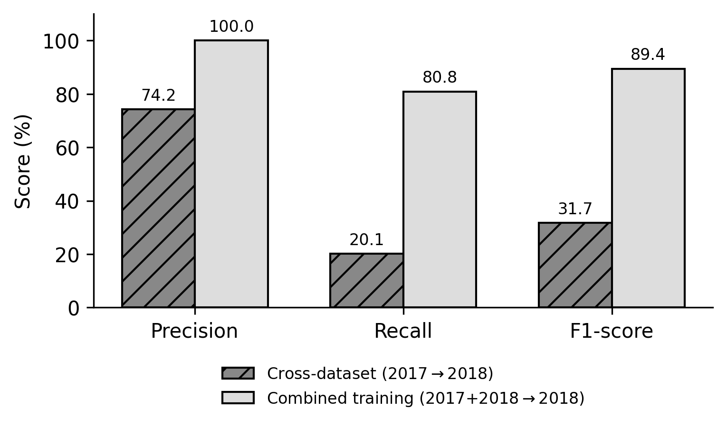
Cross-dataset shift (2017$→$2018) vs. combined training, precision/recall/F1.

Dataset-to-Live Collapse
The same 99.69%-accuracy model was evaluated against traffic physically captured live in our lab (2,092 flows: 2,038 attacker, 54 benign, ground truth from known source IPs). Table 3 reports a same-session reproducibility check against this capture, which we treat as the anchor result since it carries a full confusion matrix and ROC curve; an earlier session reported an even lower pre-fix accuracy of 1.29% on this same capture, which we report here for completeness but did not independently re-verify in this pass.
Dataset-to-live collapse and adaptive-retrain correction
Metric | Before retrain | After retrain
Accuracy | 98.66% | 99.95%
Precision | 98.69% | 100.00%
Recall | 99.95% | 99.95%
F1-score | 99.32% | 99.98%
ROC-AUC | 0.6086 | 0.9999
TP / TN / FP / FN | 2037/27/27/1 | 2037/54/0/1
The headline result here is not the accuracy figure but the ROC-AUC gap (Fig. 4): 98.66% accuracy looks deceptively acceptable, but a ROC-AUC of 0.61 shows the underlying ranking was barely better than random – exactly half of real benign traffic (27 of 54 flows) was misclassified as an attack. Both misclassified flows (Fig. 5) were far more minimal than anything in CIC-IDS-2017’s training distribution: a benign HTTP request (7 forward / 5 backward packets, 6–15 ms) and a single SYN probe (1/1 packets, 9–36 μs) – both too sparse to resemble the model’s learned notions of "typical benign" or "typical PortScan." An adaptive retrain mixing the full ground-truth-labelled capture into training (Section 4) restored ROC-AUC to 0.9999 and eliminated all 27 false positives.

Gap Persists Within Live Traffic
The corrected model from Section 5.B was re-evaluated against a second, independently generated, larger live capture (17,612 flows: 15,247 attacker, 2,365 benign; a new benign host, an nmap -sS -p 1-10000 scan, and 2,000 varied HTTP requests including 732 deliberate probes to a destination port – 8081 – absent from the first capture).
Gap re-opening on a larger, more diverse capture
Metric | Before 2nd retrain | After 2nd retrain
Accuracy | 95.16% | 99.74%
Precision | 95.38% | 100.00%
Recall | 99.22% | 99.70%
F1-score | 97.26% | 99.85%
ROC-AUC | 0.8987 | 0.9998
TP / TN / FP / FN | 15128/1632/733/119 | 15201/2365/0/46
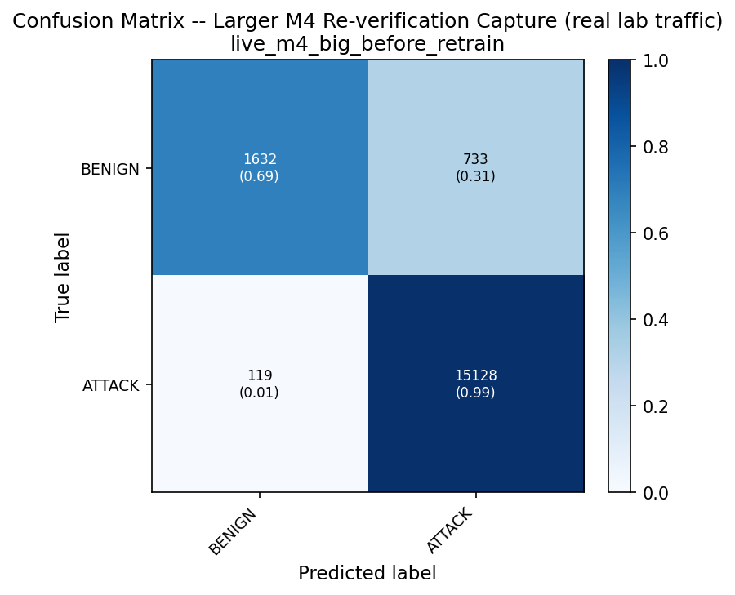  Confusion matrix, before | 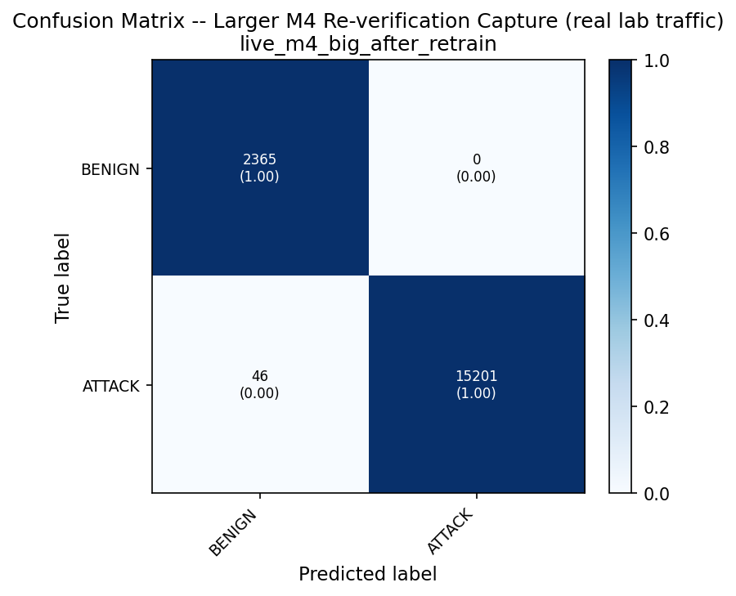  Confusion matrix, after | 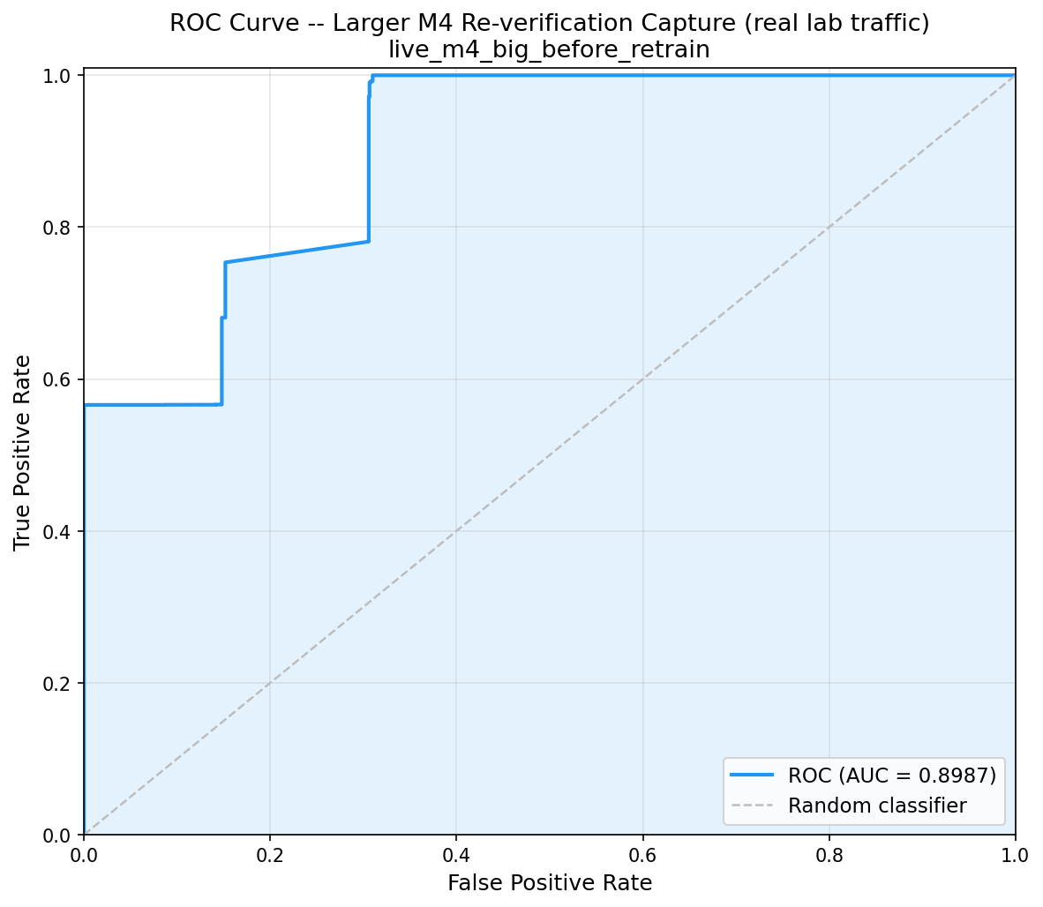  ROC curve, before | 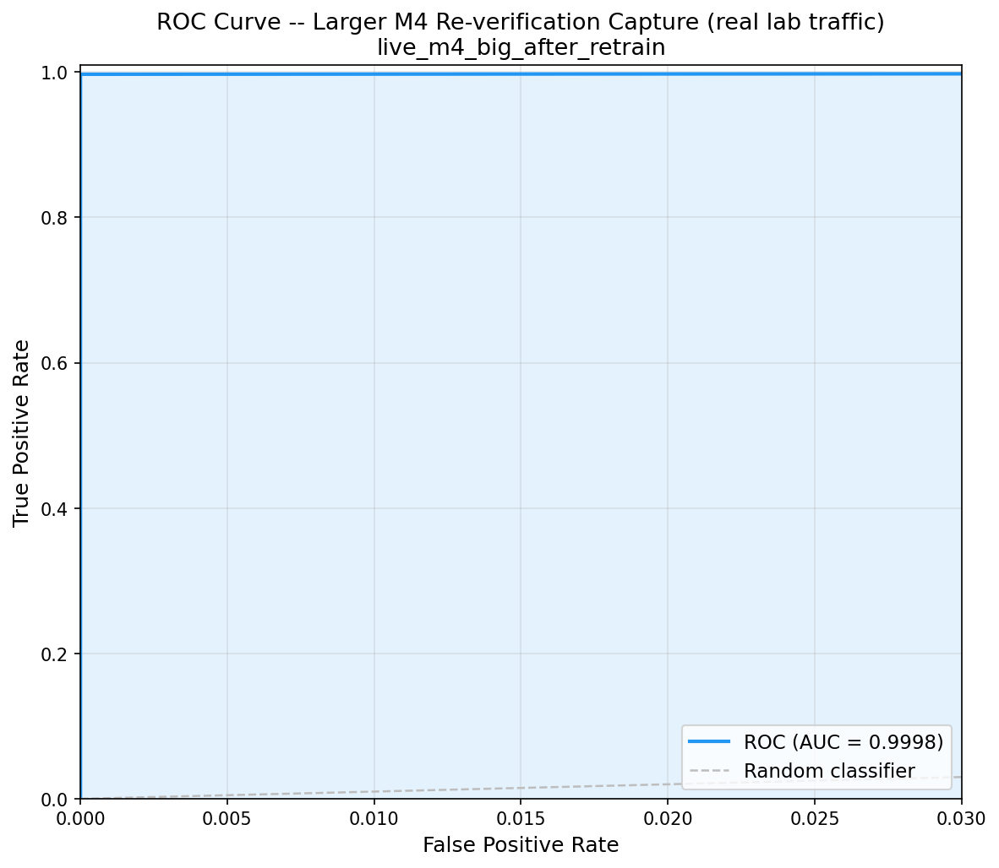  ROC curve, after
Finding 3 (Table 4): confusion matrices and ROC curves before/after the second adaptive retrain, on the larger 17,612-flow capture. Panel (c)’s before-retrain false positives are concentrated on the previously-unseen port-8081 traffic.
Table 4 and Fig. 3 show the already-corrected model scored only 95.16% on this larger capture – 100% correct on the previously-seen port 80 traffic, confirming the first fix genuinely generalized along that axis, but 100% wrong on all 732 port-8081 probes, all flagged as attacks. The first correction had learned "a single SYN with no response is benign" as a rule specific to port 80, not a port-independent rule. A second, targeted retrain – manually promoted after an automated recall-gate check rejected it on a small, noisy proxy validation sample, a documented judgment call discussed further in Section 6 – corrected this, restoring accuracy to 99.74% with zero benign false positives across all 2,365 benign flows, including all 732 previously-failing port-8081 probes. We independently reproduced this table by replaying the original capture through the same before/after model pair in isolation, obtaining accuracy 95.49%/99.72% and ROC-AUC 0.8984/0.9998, within noise of the values above.
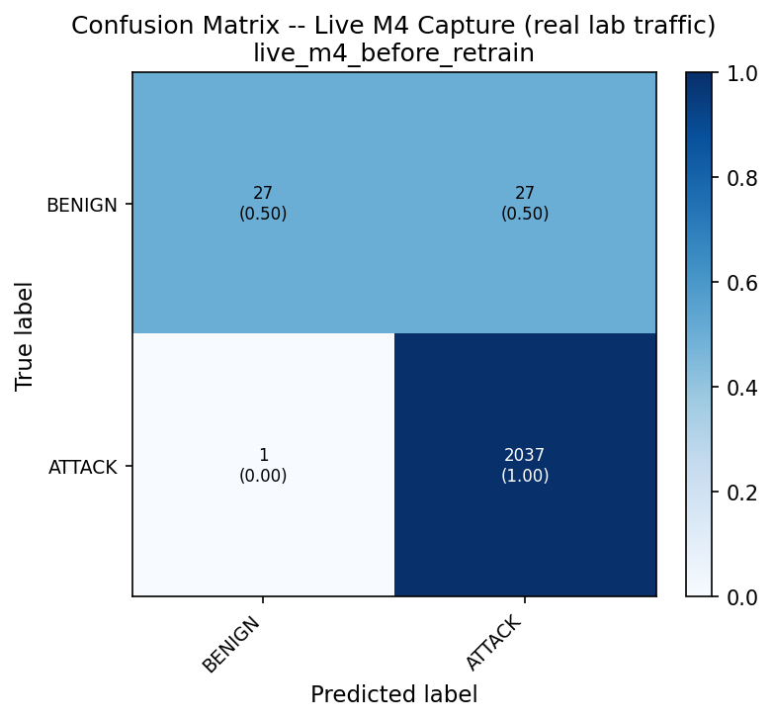  Confusion matrix, before | 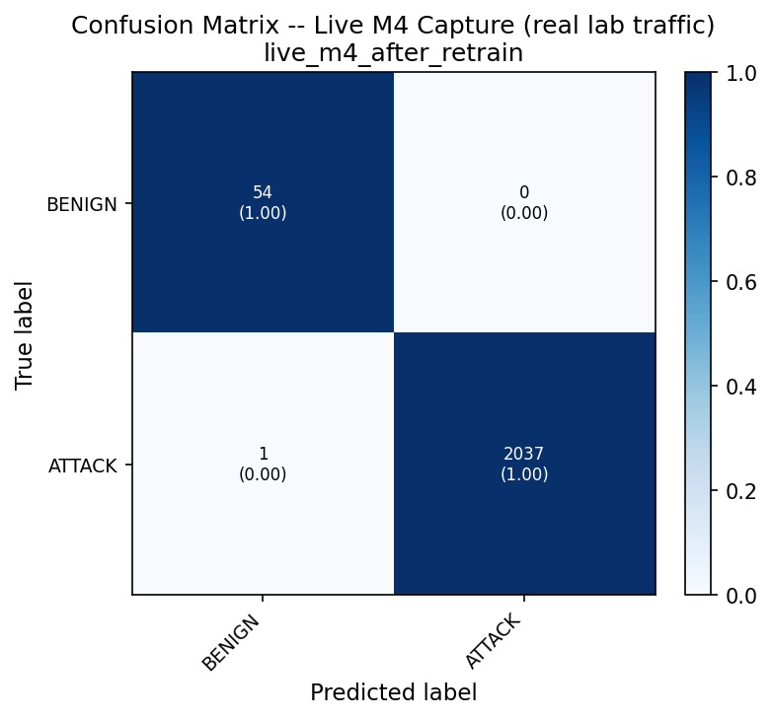  Confusion matrix, after | 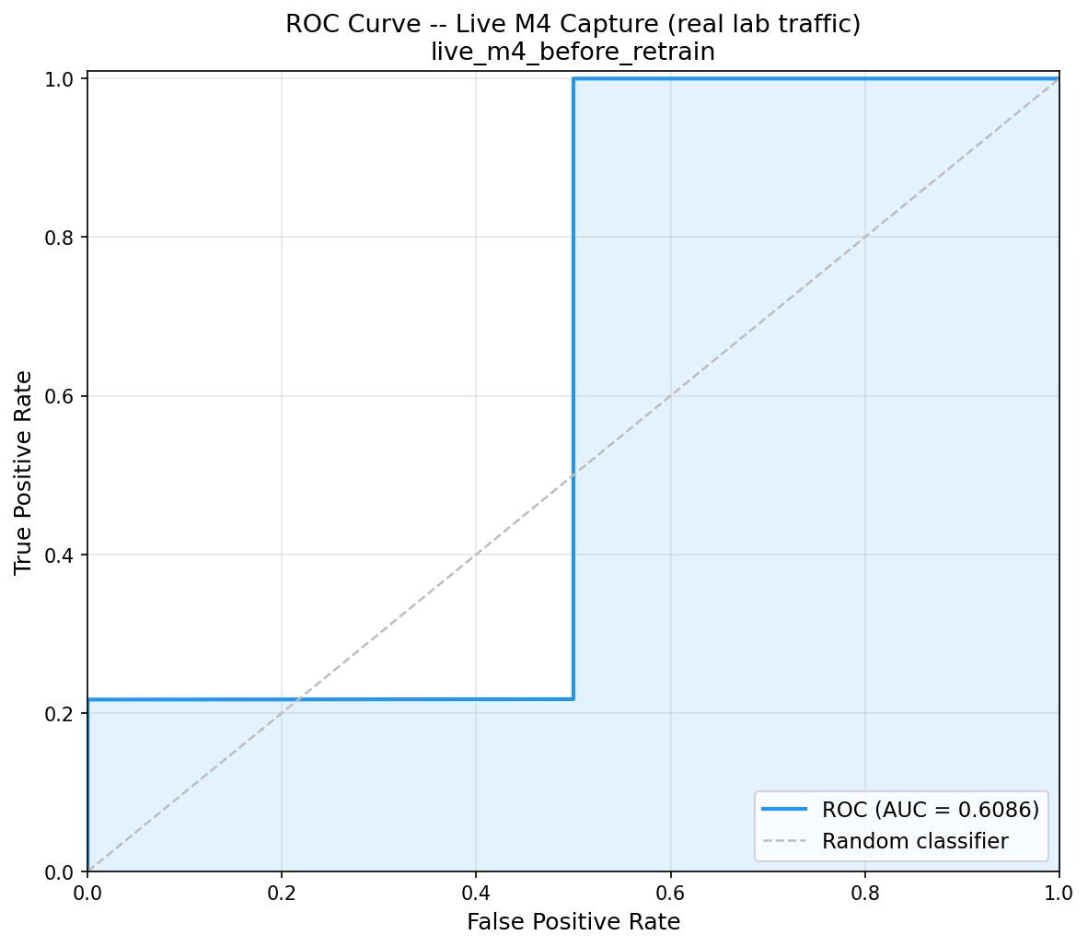  ROC curve, before | 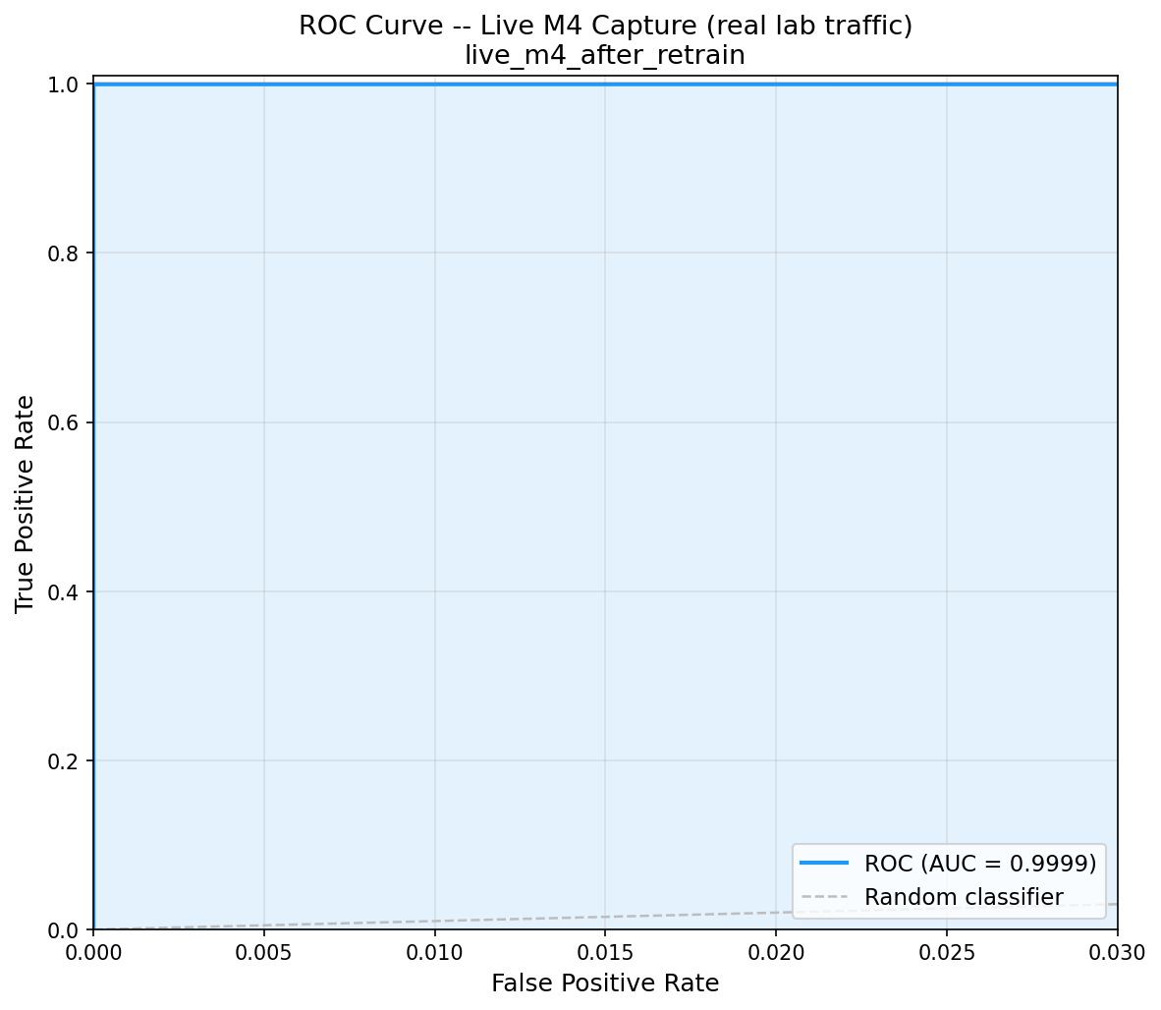  ROC curve, after
Finding 2 (Table 3): confusion matrices and ROC curves before/after the first adaptive retrain. The near-diagonal before-retrain ROC curve (c) is the visual counterpart of the ROC-AUC=0.61 in Table 3 – the ranking was barely better than chance despite 98.66% accuracy.
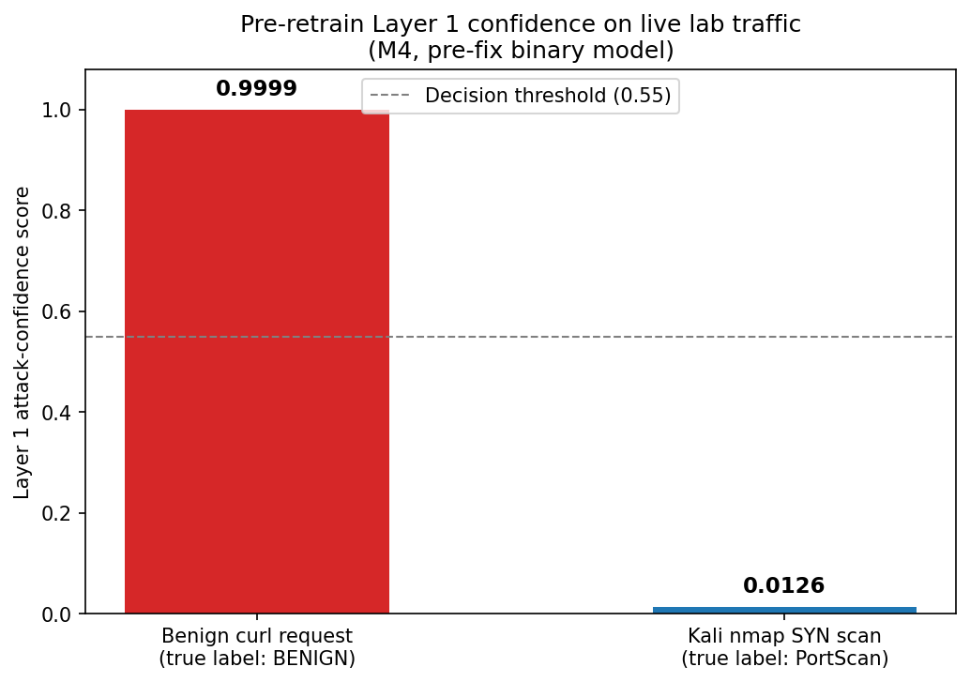
Pre-fix model confidence: a benign request scored 0.9999 (confidently misclassified as attack); a real port scan scored 0.0126 (confidently misclassified as benign).

Feature Importance (SHAP)
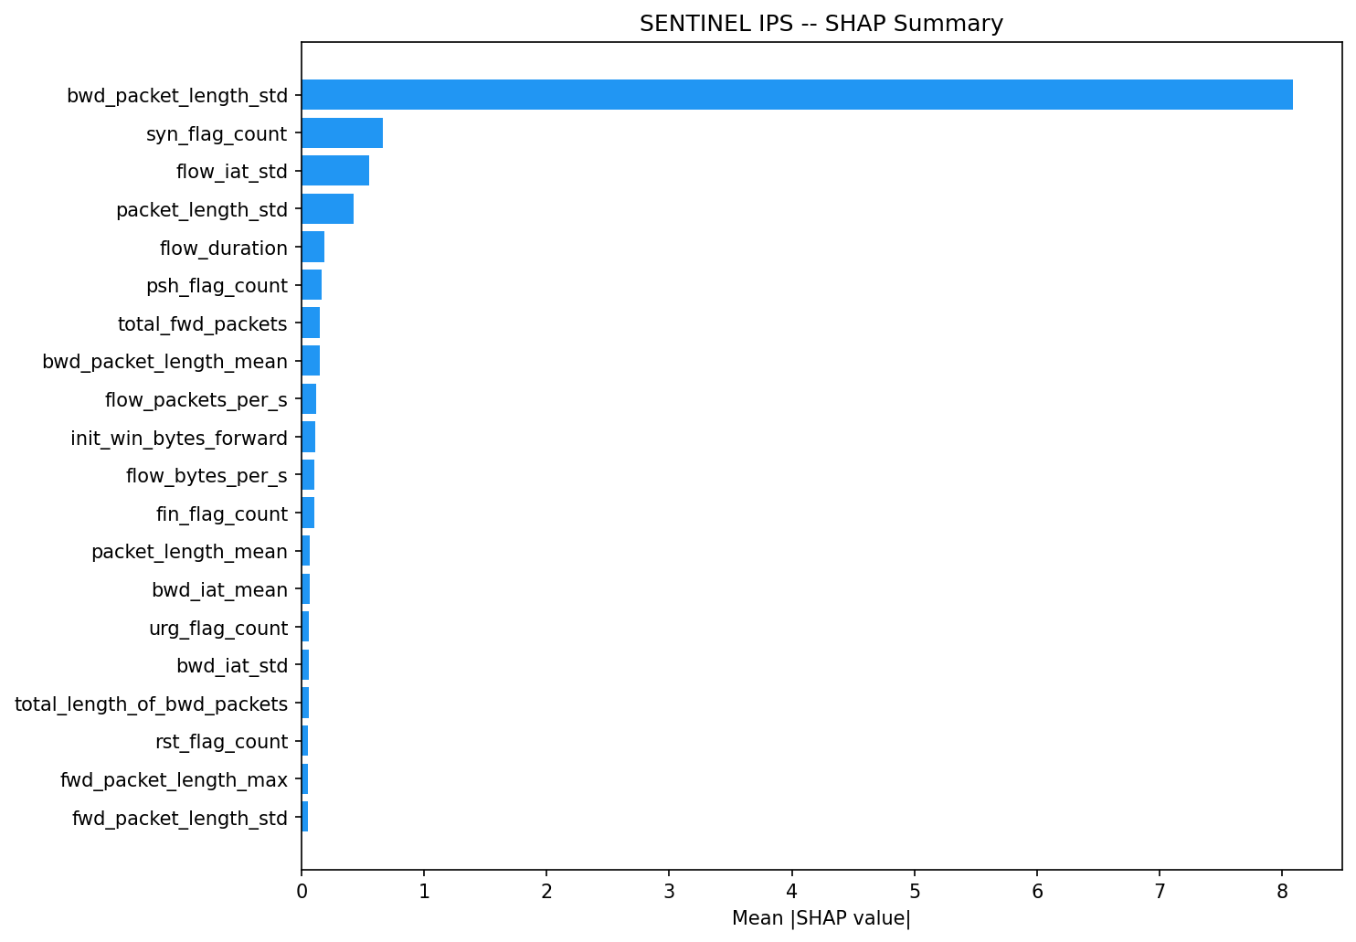
Mean absolute SHAP value per feature for the CIC-IDS-2017-trained classifier (Table 1). bwd_packet_length_std dominates every other feature by close to an order of magnitude.
To interpret why the classifier evaluated throughout Section 5 makes the decisions it does, we compute SHAP values (Lundberg and Lee 2017) for the CIC-IDS-2017-trained model underlying Table 1. Fig. 6 shows bwd_packet_length_std – the variability of backward-direction packet sizes within a flow – as by far the single strongest predictor, with every other feature contributing an order of magnitude less. This is consistent with the flows misclassified in Section 5.B (Fig. 5): both were minimal, near-empty exchanges with almost no backward traffic to compute this statistic over, which is exactly the regime this dominant feature cannot discriminate well – a plausible mechanistic link between the classifier’s most-relied-upon feature and where it fails on live traffic.

Discussion
Read together, Sections 5.A–C form a single escalating arc. Cantone et al. (Cantone et al. 2024) establish that the gap exists between two curated, static datasets. We show it also exists – more severely – between a curated dataset and traffic physically captured from a live network, and, novel to this work, that it is not closed permanently by one corrective retrain: a larger, more diverse capture re-opens it along a dimension (destination port) the first fix never made port-independent.
A secondary contribution is systems-level rather than purely statistical: three previously dormant defects in the adaptive-retraining pipeline had to be found and fixed before Table 3’s correction could be trusted at all. The evaluation routine originally compared retrain candidates against misaligned feature columns, silently rejecting every candidate regardless of quality; the retrained model’s column order was built from an unordered Python set intersection, silently drifting from the order the production inference path expected; and a documented "weight mistakes higher" retraining feature had never been wired to the underlying classifier’s sample-weighting parameter. None of these are machine-learning failures – they are ordinary software defects that happened to sit directly in the path of a machine-learning correction, and would have silently produced an apparently-successful but actually inert retrain if left unfound.
The manually-overridden recall gate in Section 5.C is worth stating plainly rather than hiding: an automated gate rejected the improved candidate because its held-out CIC-IDS-2017 recall dipped slightly on a small, noisy validation sample, even though the real-capture result was unambiguously better. We promoted the candidate anyway, since the live-capture evidence was the metric that mattered for the deployment in question. This reinforces the paper’s central claim from another angle: validation gates built on benchmark-shaped assumptions about what "improvement" looks like can themselves be miscalibrated once the target is live traffic rather than another static split.
Gupta et al. (Gupta et al. 2025) address a related adaptation problem with considerably more sophistication – selective sample annotation combined with generative synthesis of rare-class examples, rather than this work’s approach of mixing the entire ground-truth capture into retraining at baseline weight. Our simpler approach is easier for a small team to implement and audit end-to-end, but is not sample-efficient and offers no mechanism for drift the way generative augmentation could; Section 5.C’s re-opened gap is exactly the kind of failure a more adaptive method might have avoided by generalizing across ports without needing to observe one directly.
Limitations. These findings come from a single small lab with a specific network topology, specific attacker tooling (nmap, hydra), and one previously-unseen dimension tested (destination port). This demonstrates that the gap persists and can re-open along at least one untested axis; it is not proof the gap is now fully closed along every other untested axis (protocol, traffic shape, attacker tooling).

Conclusion
We show that a network intrusion detection model achieving 99.69% accuracy on CIC-IDS-2017 collapsed to near-chance ranking (ROC-AUC 0.61) against live-captured traffic from its own deployment network, was restored via a ground-truth-informed adaptive retrain, and then partially failed again on a larger, more diverse capture before a second correction closed the gap. Three previously dormant defects in the correction pipeline itself had to be fixed before this process could be trusted. The implication for ML-IDS deployment practice is direct: benchmark accuracy is not a reliable proxy for live performance, and validation should be continuous and diversity-aware rather than a one-time retrain treated as a permanent fix. Future work includes extending this analysis to the system’s multiclass attack-type classifier: in follow-on testing on this same deployment, it showed an analogous symptom – live detections collapsed to a generic attack label rather than a specific one, blocking downstream severity escalation, until a comparable corrective retrain was applied – suggesting the generalization gap characterized here is not specific to binary classification, though a full characterization of that case, to the same standard as Sections 5.A–C, is left to future work.

Acknowledgment
The authors thank the Department of Computer Science and Engineering, Global Academy Of Technology, Bangalore, for their support.
Cantone, Marco, Claudio Marrocco, and Alessandro Bria. 2024. “Machine Learning in Network Intrusion Detection: A Cross-Dataset Generalization Study.” IEEE Access 12: 144489–508. https://doi.org/10.1109/ACCESS.2024.3472907.
Chen, Tianqi, and Carlos Guestrin. 2016. “XGBoost: A Scalable Tree Boosting System.” Proceedings of the 22nd ACM SIGKDD International Conference on Knowledge Discovery and Data Mining (KDD), 785–94.
Elangovan, Rajesh, Durga Devi Parthasarathy, M. Jawahar, et al. 2026. “Cross-Dataset Temporal and Semantic Generalization of Intrusion Detection Models for the Future Internet.” Future Internet 18 (4): 194. https://doi.org/10.3390/fi18040194.
Gupta, Ragini, Shinan Liu, Ruixiao Zhang, et al. 2025. “Generative Active Adaptation for Drifting and Imbalanced Network Intrusion Detection.” Proceedings of the 31st ACM SIGKDD Conference on Knowledge Discovery and Data Mining (KDD).
Layeghy, Siamak, and Marius Portmann. 2023. “Explainable Cross-Domain Evaluation of ML-Based Network Intrusion Detection Systems.” Computers and Electrical Engineering 108: 108692. https://doi.org/10.1016/j.compeleceng.2023.108692.
Lundberg, Scott M., and Su-In Lee. 2017. “A Unified Approach to Interpreting Model Predictions.” Advances in Neural Information Processing Systems (NeurIPS) 30: 4765–74.
MITRE Corporation. n.d. MITRE ATT&CK. Https://attack.mitre.org.
Sharafaldin, Iman, Arash Habibi Lashkari, and Ali A. Ghorbani. 2018. “Toward Generating a New Intrusion Detection Dataset and Intrusion Traffic Characterization.” Proceedings of the 4th International Conference on Information Systems Security and Privacy (ICISSP), 108–16.
Thanh, Dung Ha. 2026. “A Transfer-Aware, Deployment-Oriented Evaluation Framework for NetFlow-Based Intrusion Detection Systems (TAN-IDS).” PLoS ONE 21 (4): e0346801.
Viegas, Eduardo K., Altair O. Santin, and Luiz S. Oliveira. 2017. “Toward a Reliable Anomaly-Based Intrusion Detection in Real-World Environments.” Computer Networks 127: 200–216. https://doi.org/10.1016/j.comnet.2017.08.013.
Zouhri, Hafsa, Ali Idri, and Ahmed Ratnani. 2024. “Evaluating the Impact of Filter-Based Feature Selection in Intrusion Detection Systems.” International Journal of Information Security 23: 759–85. https://doi.org/10.1007/s10207-023-00767-y.

