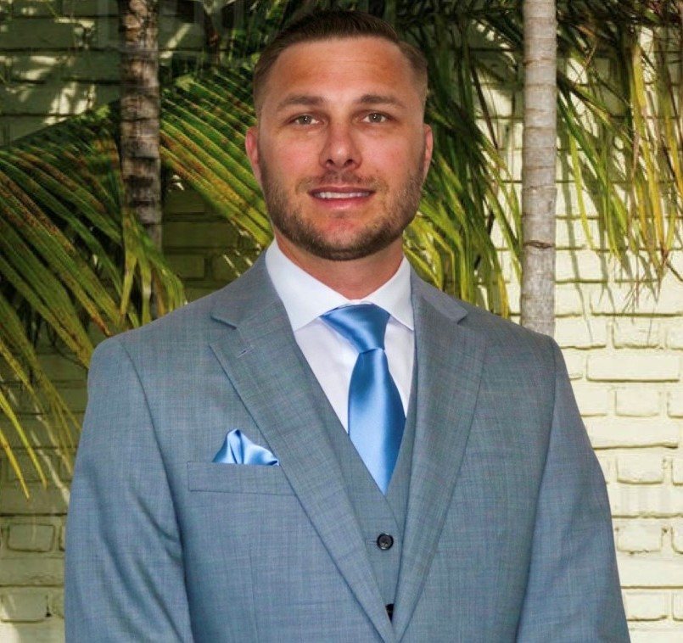  CONTACT  Cape Coral, FL (Open to Remote)  239-233-3349  Tyndall5818@gmail.com  mtyndall88.github.io  linkedin.com/in/mark-tyndall  github.com/mtyndall88  TECHNICAL SKILLS  Languages  Java, JavaScript, SQL, Python, PHP, HTML/CSS  Backend & APIs  Node.js, Express, REST APIs, JWT auth, MVC  Databases  MySQL, JDBC, phpMyAdmin  Data & Pipelines  ETL, NOAA/Census/USCG ingestion, pandas  Cloud & DevOps  Docker, DigitalOcean, GitHub Actions CI/CD, Git  AI & LLM  Claude Code, Anthropic Claude API, LLM evaluation, prompt engineering  EDUCATION  Rasmussen University  B.S., Computer Science (Expected Sept 2026)  Golden Gate University  B.A., Business Management (2020)  American Military University  A.A., General Studies (2018)  CERTIFICATIONS  Active DoD TS/SCI clearance  CompTIA Security+ CE (2020)  Florida Real Estate License (2022)  DoD/USAF analytic training (Geospatial, DCGS, SAR) | MARK TYNDALL  Software Developer | USMC Veteran | Founder, TrueHull LLC  PROFESSIONAL SUMMARY  Software developer and U.S. Marine Corps veteran with an active DoD TS/SCI clearance, applying a decade of mission-critical leadership to full-stack and data engineering. Founder of TrueHull LLC — a Node.js/Express + MySQL web app with Stripe payments and NOAA/Census/USCG data pipelines, deployed on Docker/DigitalOcean with CI/CD. Previously integrated and tested an AI/ML intelligence platform for the DoD. Completing a B.S. in Computer Science (Sept 2026) and seeking a full-time remote software developer role.  EXPERIENCE  Founder & Software Developer May 2026 – Present  TrueHull LLC — Remote  - Designed and built the entire application end to end — REST API, data model, frontend, security, and deployment — as the sole developer.  - Built a Node.js/Express REST API on a normalized MySQL schema (reports, users, sessions, credit ledger, payments) with parameterized queries and purpose-built indexes.  - Implemented secure auth and account management — JWT sessions, scrypt password hashing, email verification, and password reset — plus Stripe Checkout with webhook signature verification and an idempotent, append-only credit/voucher ledger.  - Containerized with Docker/Compose and deployed to DigitalOcean App Platform with managed MySQL (TLS), GitHub Actions CI/CD, health checks, and automated nightly backups.  Field Service Representative (Site Lead, Mission Integration) Dec 2018 – Apr 2021  ECS Federal LLC — Beale AFB, CA  - Served as on-site technical lead integrating the Palantir Maven Smart System — an AI/ML intelligence platform — into 24/7 classified intelligence operations.  - Acted as primary technical liaison between operational analysts, government stakeholders, and the software engineering teams building the platform: tested software, reproduced and documented defects, and fed bug reports and feature requests into the engineering backlog.  - Evaluated emerging AI/ML and computer-vision technologies and briefed findings to senior defense leadership, including the OUSD(I) Algorithmic Warfare Cross-Functional Team (Project Maven).  Senior Consultant — Geospatial / FMV Analyst Jun 2017 – Dec 2018  Booz Allen Hamilton — Beale AFB, CA  - Exploited and analyzed UAS full-motion video and wide-area surveillance data (MQ-9 Reaper, MQ-1 Predator) supporting U.S. Central Command operations, producing daily intelligence products for multiple mission customers.  - Collaborated with mission-support technicians to troubleshoot hardware, software, and database issues; performed pattern-of-life analysis and threat identification.  Imagery Analysis Specialist / Sergeant (E-5) 2008 – 2017  United States Marine Corps — Various Locations  - Progressed from infantry Marine to Imagery / Full-Motion-Video Intelligence Analyst over nine years of service; led and mentored analyst teams.  - As Senior Watch Chief (Afghanistan), supervised a 10-person watch team, logged 7,000+ operational events, and maintained accountability of $104M in classified equipment.  PROJECTS  Gulf Coast HVAC Inventory Management System (Java, MySQL)  Java/MySQL app with role-based access control, DAO and Singleton patterns, and atomic transactional stock adjustments with audit logging (parameterized JDBC).  Gulf Coast HVAC Store (PHP, MySQL, Docker)  Full-stack PHP/MySQL e-commerce app with session auth, catalog, cart, and checkout; Dockerized (PHP/MySQL/phpMyAdmin), Bootstrap UI.  Air Quality Data Analysis (Python, pandas, Jupyter)  Cleaned, transformed, and analyzed the UCI Air Quality dataset with pandas in Jupyter — missing-value handling, type conversion, and exploratory analysis.  Personal Portfolio Website (HTML, CSS, JavaScript)  Responsive single-page portfolio with scroll-spy navigation, project modals, and a photo carousel.

