MAS-PROJECT

TASK1

On the first task, the users’ and items’ D-dimensional distributions were used in order to find a preference list for each user. First the Kullback-Leibler Divergence Criterion was used in order to compute the similarity of the D-Dimensional Gaussians. Using the Kullback-Leibler score of a user for an item, we computed each user’s rating on every item using the following formula:

Based on these ratings the 10 best items for the first 50 users were found and printed.
The corresponding code for the first tasks can be found in the files MA_Task1.m and findPrefTable.m
The executional file is MA_Task1.m.

TASK2

We designed a mechanism that fairly allocates the total cost of an item among the agents in a group, based solely on their budget and their rating in this item. The sum of the share, each player pays, is equal to the item_cost.

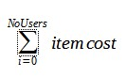
The r(rating) each user has for an item is a real number ϵ [0,10].

The sum of the players’ budget is bigger or equal to the item_cost.

The first step of this procedure is to open the xls files and find the items that can be bought, based on the group budget, and insert them in the list feasible_items.

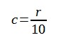
The second step is to compute the case where each user pays the maximum amount of money he has(user_budget).
User pays x(i)=budget(i)*c(i), where

Each user doesn’t actually pay this cost but we want to compute the weight.

The maximum amount of money all players can(!) give is
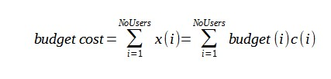
If the budget_cost is less than the item_cost of the selected feasible item then another item is selected.
If the budget_cost is bigger or equal than the item_cost then the third step is to compute the weight based on this analogy:

for budget_cost the weight =1
for item_cost the weight=?
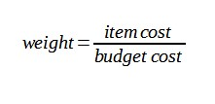
Each user should pay
