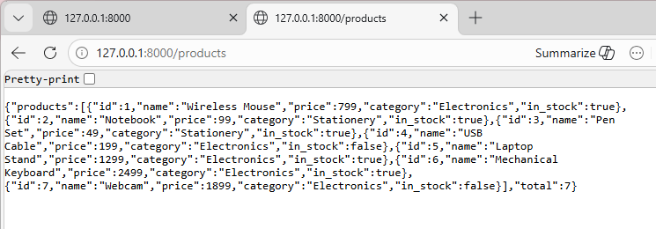
Output 1
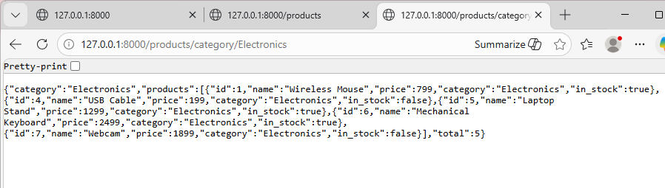
Output 2
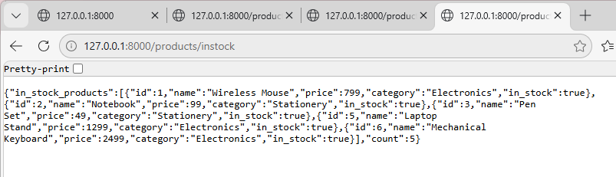
Output 3
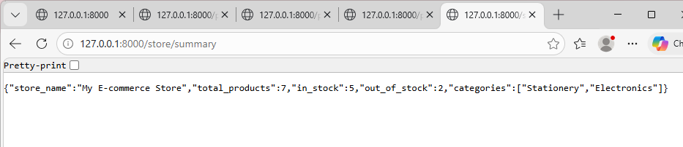
Output 4
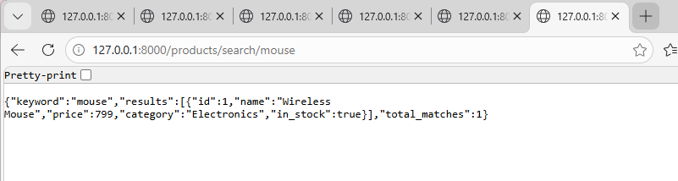
Output 5
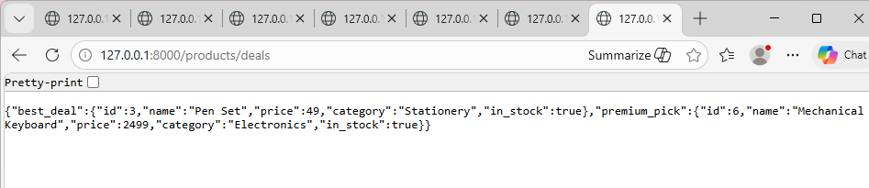
BONUS

