Melih Sahtiyan 190706023
1) Scenario
In an emergency (it depends on situation police,ambulance,fire station etc…) as we know there is a call center ‘112’ but i know that if there is a mobile application, things will be easier for us. Citizen (Customer on database) logs in to the system (e-devlet or mernis verification is necessary). When citizen reports a situation with text, they may attach a file (if they wants thay can upload voice, video or image but text is necessary). Call center (System staff) will process sit. and send to the services (police, doctor or fire fighter…). Fake reports will be announced to police department.
Emergency application which will operate as emergency call center.
2) Functional Requirements:
Client
- FR-1: Upload location
- FR-2: Send a message according to type of emergency (it may be voice, photograph, video or text)
- FR-3: Customer:
  - FR-3.1: Report the situation and send location automatically.
- FR-4: Call Center:
  - FR-4.1: Retrieve location and display it.
  - FR-4.2: Depending on the situation call center will answer civilians back.
Server
- FR-1: Users will be sign up with their e-devlet account
- FR-2: Fake reports will be announced to police department automatically
Actors
- System Staff
- Customer
- Emergency Departments

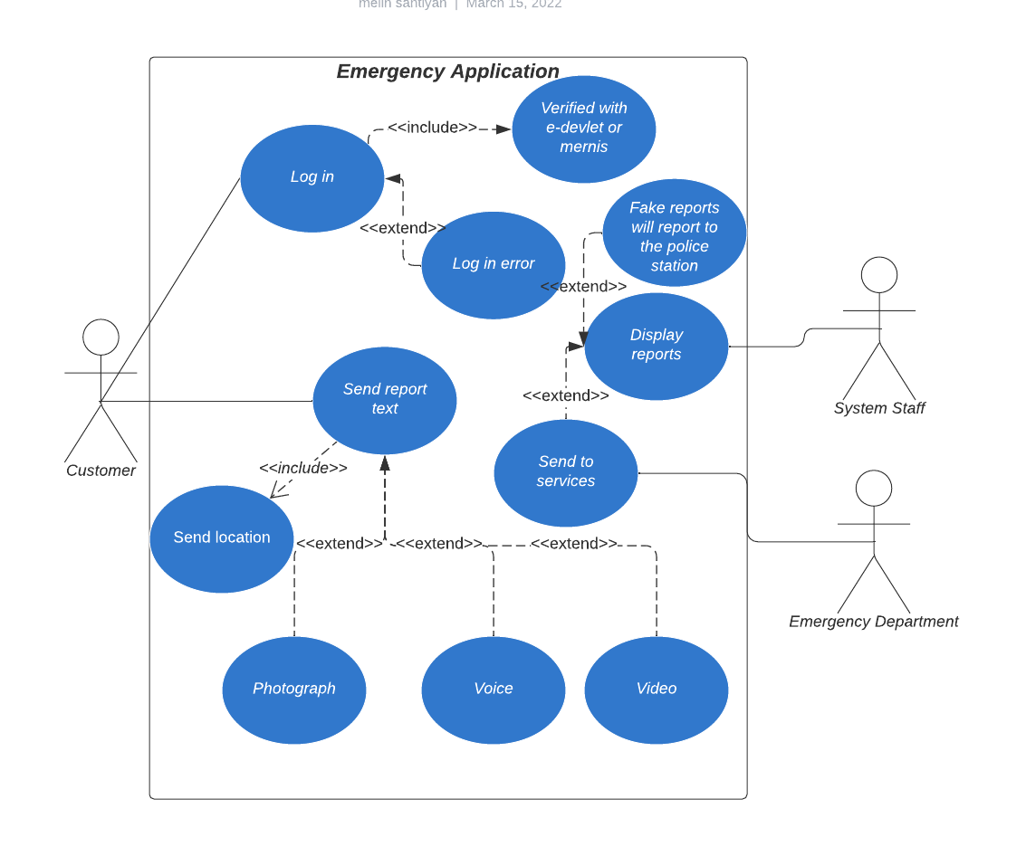
3) Use Case Diagram

Actors | Customer
Description | Customer logs in to the system (it includes verification via e-devlet/mernis and it may fail to log)
Data | Users identity number first name,last name that comes from e-devlet
Stimulus | Customer
Response | Successful or failed to log
Comments | - It will be verified via e-devlet  - It may fail due to verification
Emergency System: Log in

Actors | Customer
Description | Customer sends report to the system via text (it may be voice, video or image)
Data | Users will send report due to situation
Stimulus | Customer
Response | System staff will display the report and direct to services
Comments | - It will be sent the location automatically  - It may include one of these: photograph, video or voice
Emergency System: Send text report

Actors | System staff
Description | System staves will process the report and depending on situation they will send it to Emergency sesrvices
Data | The report that comes from customer
Stimulus | Emergency services
Response | Needed services will be provided
Comments | - It will be sent to the services (Police, Hospital or Fire Station etc…).  - When fake report comes, it will be sent to Police Department.
Emergency System: Display report

