Erman Yalçın

My app’s details

* Server:
  + Save events, announcements, messages, apartment services
  + Save Manager, Residents, and Securities information
* Client:
  + Select your position (Manager, resident, guard)
  + Take information from the Server and send new information to Server.
  + Manager:
    - Can create events, announcements
    - Can write messages
    - Can arrange appointments for apartment services
  + Resident:
    - Can see events, announcements, messages
    - Can join events, write messages
    - Can make appointments for apartment services like pool, gym, etc.
  + Guard:
    - Can see events, announcements, messages
    - Can write messages
    - Can arrange appointments for apartment services

Activities:

Main Page: Choosing the user type

Registration Page: Create new user information from data and then redirects to login page

Login Page: Checks for user information from data and if there is a match it directs to the correct activation

Security Page: It is a page where security can use its privileges.

Manager Page: It is a page where the manager can use its privileges.

Resident Page: It is a page where residents can use its privileges.

Messages Page: It is a page that shows the messaging between people.

Events Page: It is a page showing events.

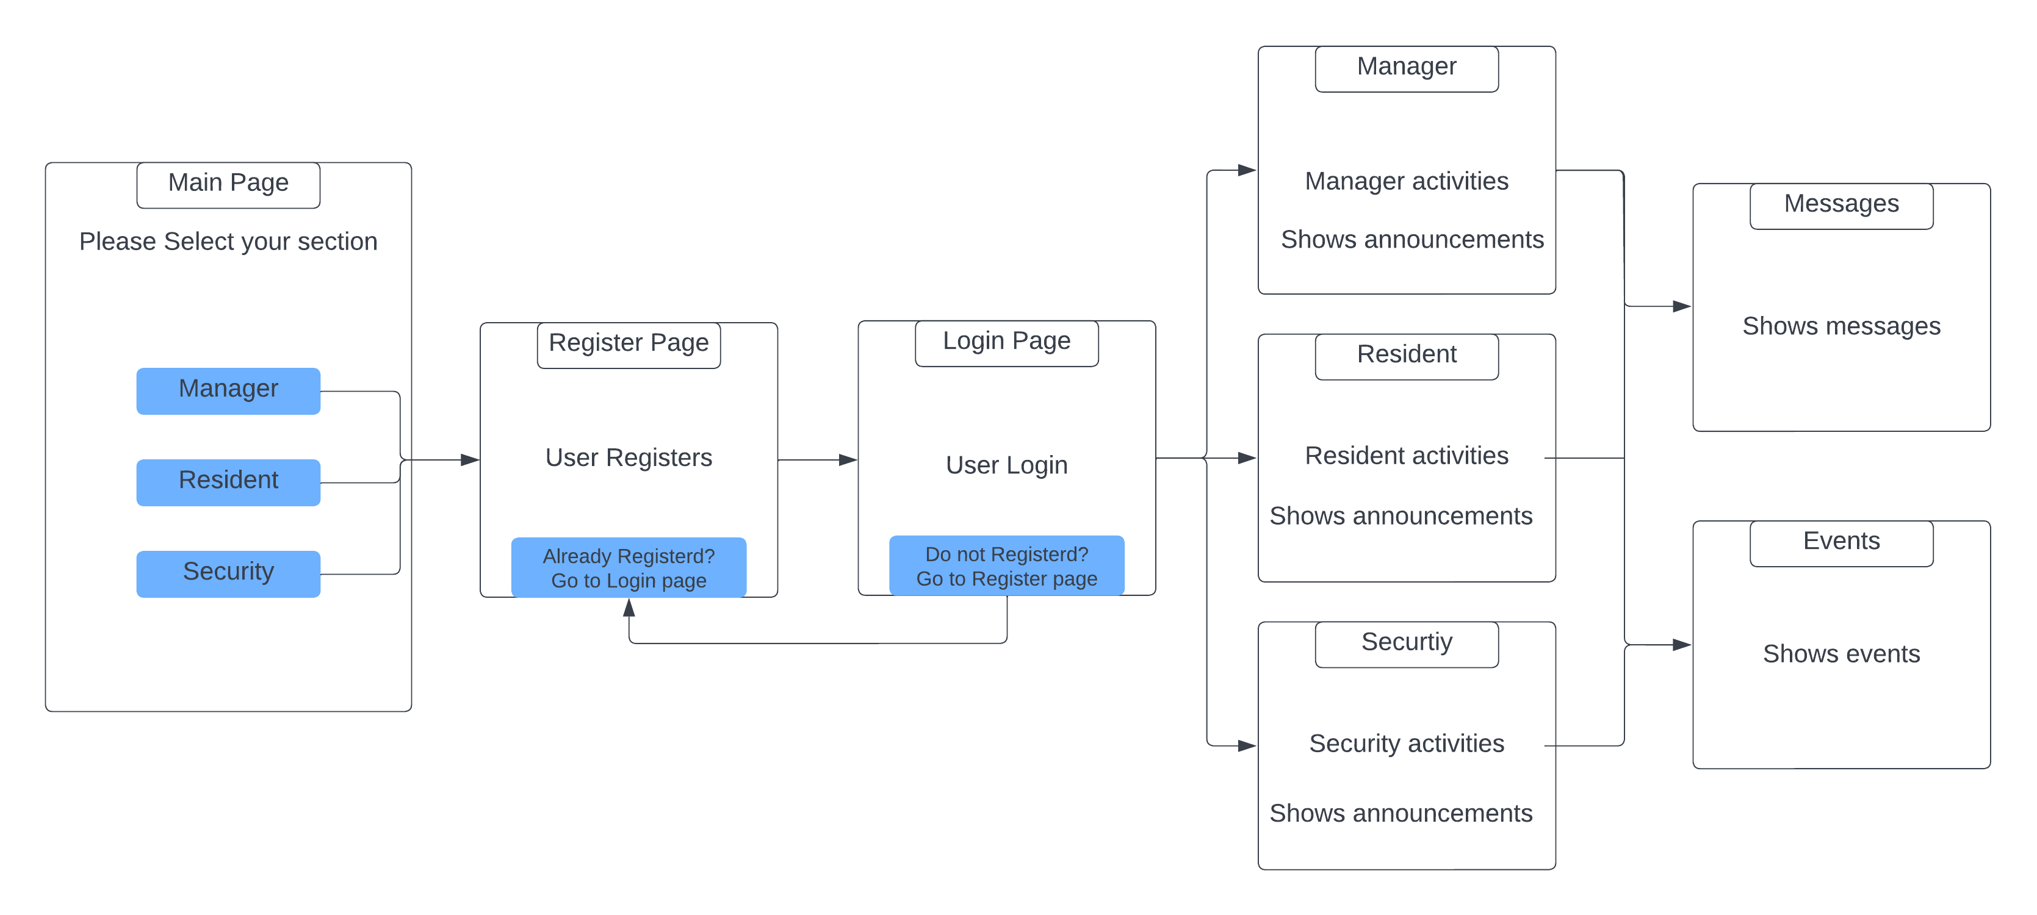

Login or Registers

Select one of them

on-demand processing

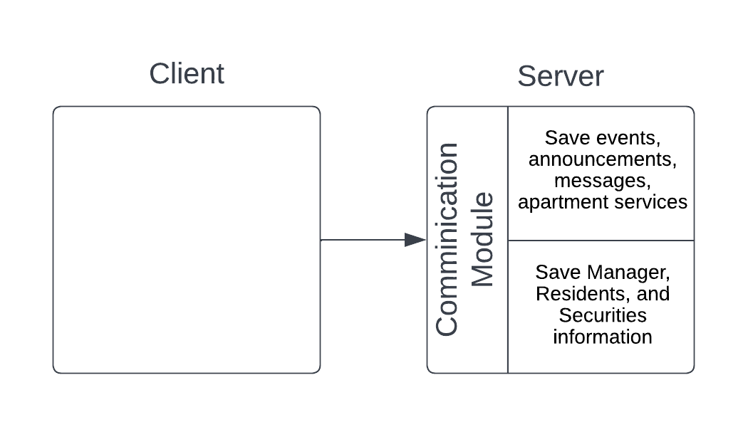

Some UML Diagrams:

* **Class Diagram**
* **Use Case Diagram**
* **Activity Diagram**

**Class Diagram**

**Use Case Diagram**

**Activity Diagram**

