In this page we select empty activitiy and press next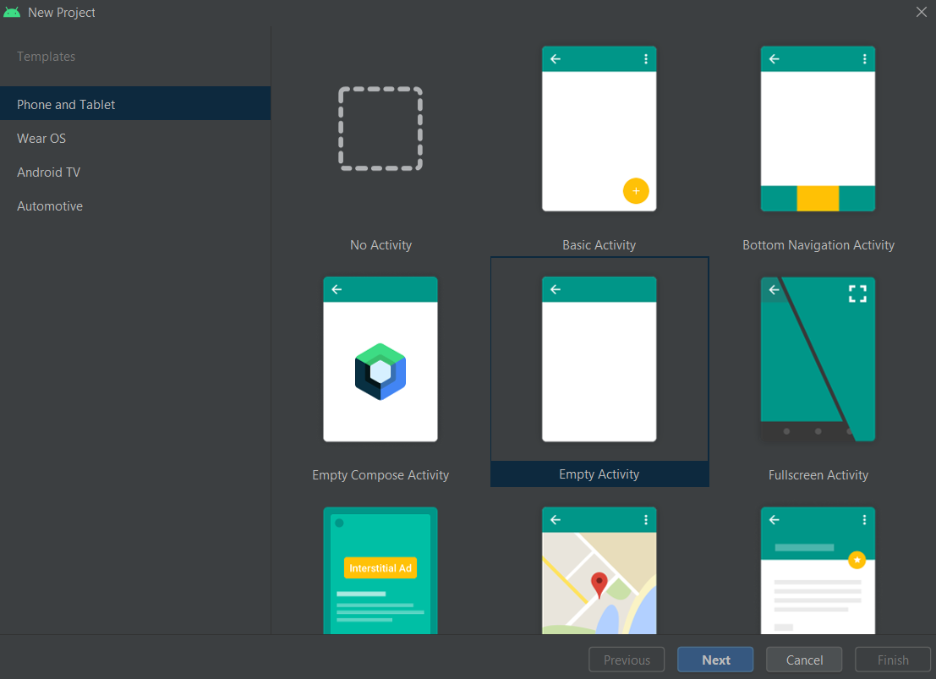

After we type the project name,minimum sdk and save location then press finish

And your hello world project is finished

