**Baston105 Project**

**Mehmet Seven**

**210704303**

**Client(Doctor/Nurse)**

* User login and registration page. User can login on this page. If you don't have a membership, you can sign up.
* User(Doctor/Nurse) can create/delete profile for patient.
* Profile Content:

-Past illnesses of the patient and current illnesses of the patient.

-The content of the patient's routine treatment (the drugs he is currently using).

-The patient's medication hours.

-Extra treatments to be applied to the patient (temporary treatment given upon the doctor's request).

-User can Edit patient's information.

-Calendar pages with treatment changes and important events will be created. Thanks to these calendar pages, doctors and nurses will be able to review all treatment changes and important events in the past.

**Database:**

-Database for each patient.

-Database for each Events.

-Database for each Treatments.

- I used SQLite Database for this Project. So, the Project is serverless.

**Pages:**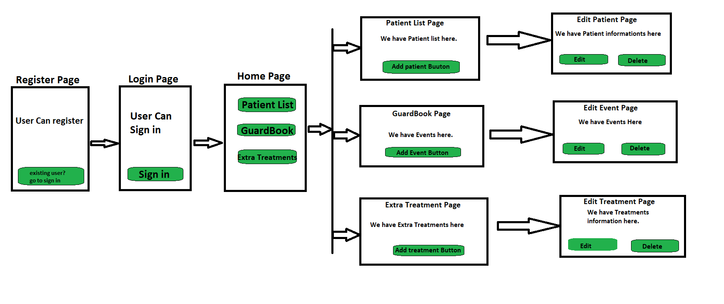

**Class Diagram:**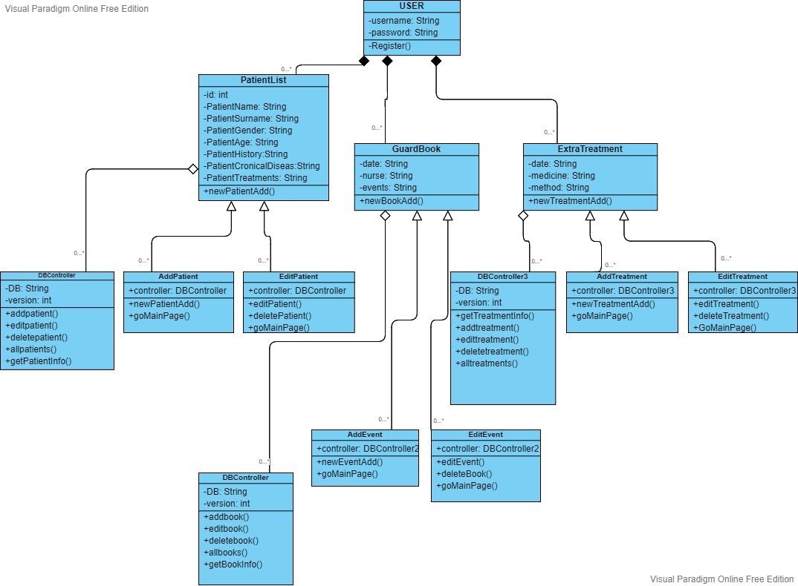

**Use Case Diagram:**

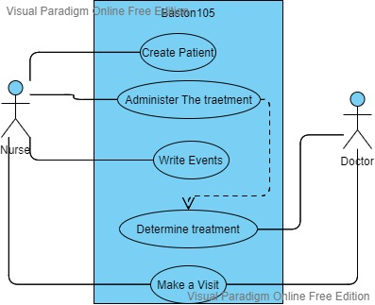

**Activity Diagram:**

