1-Open app
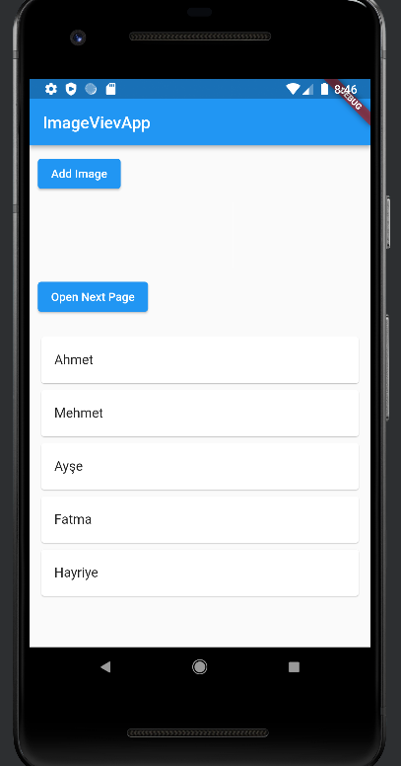

2-Click add image
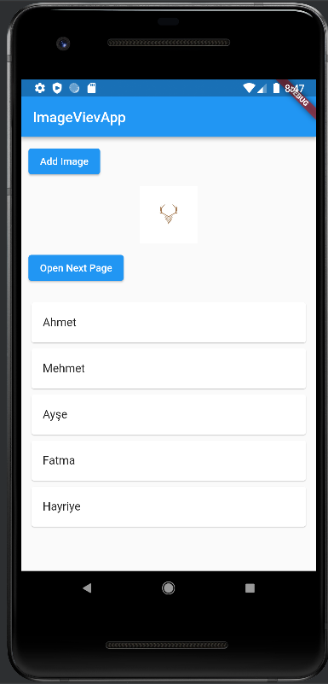
I will add after I go home I got new page but ı could not navigate it.

