 | National University  of Computer and Emerging Sciences  Chiniot-Faisalabad Campus | 

CS4059 – Computer Vision
Assignment Number 1
“Enhancement Image”
Spring 2026

Maximum Marks: 100 | Due Date: 20 February 2026

Submitted By
Name | Muhammad Uzair
Student ID: | 22F-3494
Section: | 8A

Submitted To
Rana Mubeen Tariq
Lecture – CE Department

Submission Date
20 February 2026

Details of Obtained Marks
Question Number | 1 | 2 | 3 | Total
CLO Number | 4 | 4 | 4
Total Marks | 40 | 30 | 30 | 100
Obtained Marks

Image Enhancement Pipeline

Part (a): Histogram Equalization from Scratch

Objective
The goal of this implementation is to enhance the contrast of grayscale images by performing histogram equalization manually, without using library functions for the actual equalization process. Two types of images are used:
- A low-contrast image
- A dark/underexposed image
The implementation also plots before and after images, their histograms, and prints the transformation mapping used for pixel intensity adjustment.

Methodology
- Image Loading
  - Images are loaded using imageio.imread ().
  - If the image is RGB, it is converted to grayscale using the standard luminance formula: Gray = 0.2989 * R + 0.5870 * G + 0.1140 * B
- Histogram Calculation
  - For a grayscale image, the histogram is computed manually:
    - Initialize a 256-element array hist for pixel intensities 0–255.
    - Count the occurrences of each pixel value.
- Normalization
  - The histogram is normalized to represent probability distribution by dividing by the total number of pixels:
hist_norm(i) = ∑i​, j=0 hist(i) / total pixels
- Cumulative Distribution Function (CDF)
  - The cumulative sum of the normalized histogram is computed:
cdf (i) = hist_norm(j)
- Transformation Mapping
  - Each original intensity value is mapped to a new intensity using the CDF:
new pixel = floor (255. Cdf(i))
  - This mapping array (transform map) is printed for reference.
- Apply Mapping
  - The transformation is applied to every pixel in the image using the mapping array. This results in the equalized image.
- Visualization
  - Original and equalized images are displayed using matplotlib. pyplot.
  - Histograms before and after equalization are plotted to visualize contrast improvement.

Code:
import numpy as np
import matplotlib.pyplot as plt
from imageio import imread
# ---------- Histogram Equalization from Scratch ----------
def histogram_equalization_manual(img):
# Flatten image to 1D
flat = img.flatten()
# Compute histogram
hist = np.zeros(256, dtype=int)
for pixel in flat:
hist[pixel] += 1
# Normalize histogram (probability)
hist_norm = hist / flat.size
# Compute cumulative distribution function (CDF)
cdf = np.cumsum(hist_norm)
# Create transformation mapping
transform_map = np.floor(255 * cdf).astype(np.uint8)
# Apply transformation to get equalized image
equalized_img = transform_map[img]
return equalized_img, hist, transform_map
# ---------- Load Images ----------
img1 = imread("image1.jpeg") # Low-contrast image
img2 = imread("image2.jpeg") # Dark/underexposed image
# Convert to grayscale if RGB
if img1.ndim == 3:
img1 = np.dot(img1[...,:3], [0.2989, 0.5870, 0.1140]).astype(np.uint8)
if img2.ndim == 3:
img2 = np.dot(img2[...,:3], [0.2989, 0.5870, 0.1140]).astype(np.uint8)
# ---------- Apply Manual Histogram Equalization ----------
eq1, hist1, map1 = histogram_equalization_manual(img1)
eq2, hist2, map2 = histogram_equalization_manual(img2)
# ---------- Plot Results ----------
def plot_images_histograms(original, equalized, title):
plt.figure(figsize=(12,6))
plt.subplot(2,2,1)
plt.imshow(original, cmap='gray')
plt.title(f'{title} - Original')
plt.axis('off')
plt.subplot(2,2,2)
plt.imshow(equalized, cmap='gray')
plt.title(f'{title} - Equalized')
plt.axis('off')
plt.subplot(2,2,3)
plt.hist(original.flatten(), bins=256, range=[0,255], color='gray')
plt.title('Original Histogram')
plt.subplot(2,2,4)
plt.hist(equalized.flatten(), bins=256, range=[0,255], color='gray')
plt.title('Equalized Histogram')
plt.tight_layout()
plt.show()
plot_images_histograms(img1, eq1, "Image 1")
plot_images_histograms(img2, eq2, "Image 2")

# ---------- Print Transformation Mapping ----------
print("Transformation Mapping for Image 1:")
print(map1)
print("\nTransformation Mapping for Image 2:")
print(map2)

Results
- Contrast Enhancement:
  - Low-contrast images become visually clearer with a wider spread of intensity values.
  - Dark images are brightened without saturating the highlights.
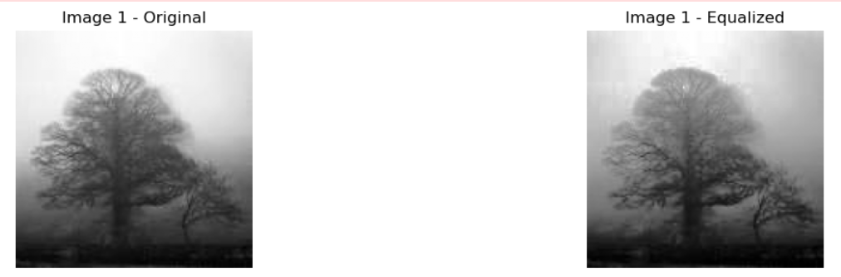

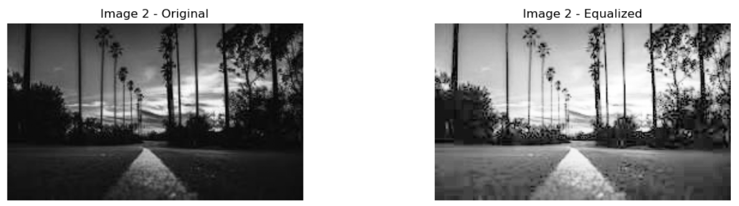
- Histograms:
  - Original images often have peaks in narrow ranges.
  - Equalized images show a more uniform histogram, spreading intensity values across 0–255.
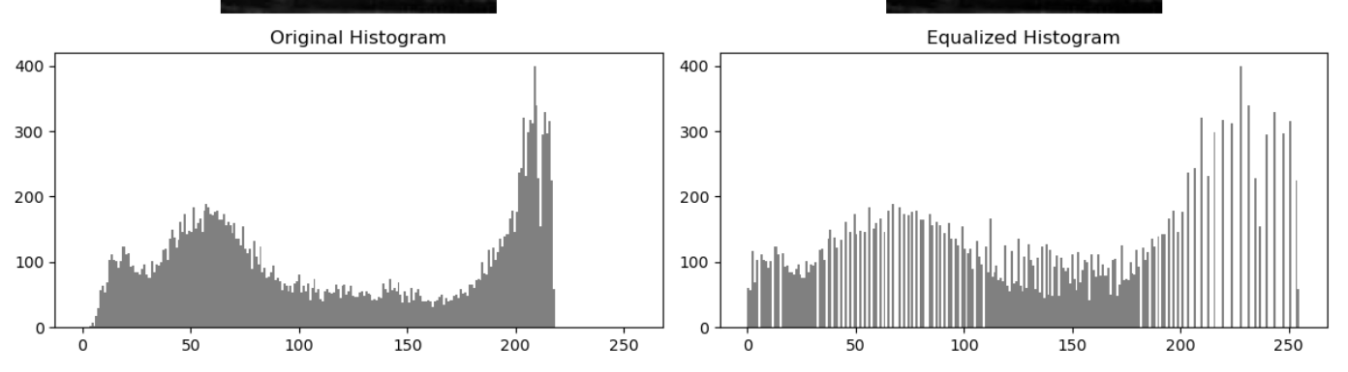
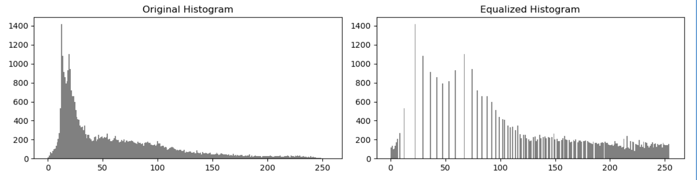
- Transformation Mapping:
  - Provides a direct reference of how each original intensity is mapped to the new intensity.
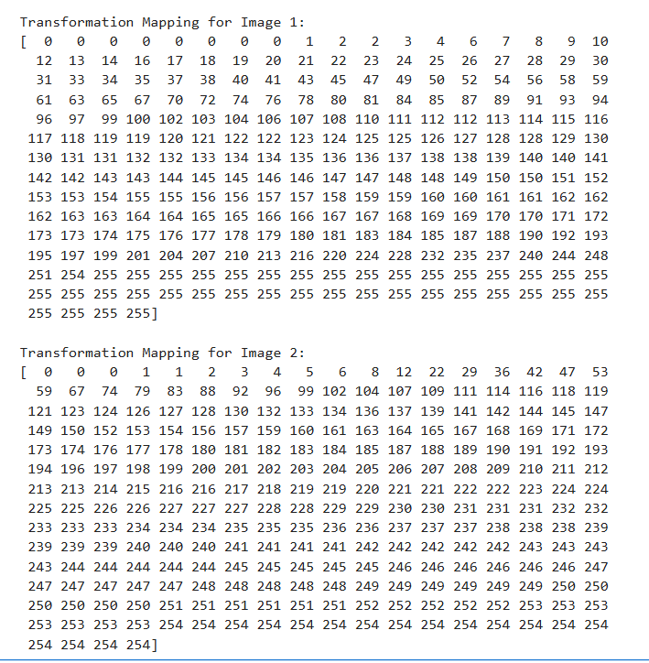
Conclusion
The manual implementation of histogram equalization successfully enhances image contrast and demonstrates the underlying principle of histogram-based contrast adjustment.
This exercise provides a deeper understanding of:
- Histogram calculation
- Probability distribution and CDF
- Pixel intensity remapping

Part (b): Image Enhancement: Histogram Equalization vs Contrast Stretching
Objective:
Enhance the quality of low-contrast and dark images using histogram equalization and contrast stretching, and compare the results visually and quantitatively.
Implementation Details:
- Image Loading:
  - Images are loaded in grayscale using OpenCV (cv2.imread).
  - Two types of images were used: a low-contrast image and a dark/underexposed image.
- Histogram Equalization:
  - Step 1: Compute the histogram of pixel intensities (0–255).
  - Step 2: Normalize the histogram to get probabilities.
  - Step 3: Calculate the Cumulative Distribution Function (CDF).
  - Step 4: Map original pixel values using the CDF scaled to 0–255.
  - Step 5: Apply the mapping to obtain the equalized image.
- Contrast Stretching:
  - Formula used:
s = r – r(min)/r(max) – r(min) * 255
where (r) = original pixel, (r_{min}) = minimum pixel value, (r_{max}) = maximum pixel value.
  - Effect: Stretches the image’s intensity range linearly across 0–255.
  - Advantage: Simple, fast, and preserves relative pixel differences.
- Visualization:
  - Images: Original, Histogram Equalized, Contrast Stretched.
  - Histograms: Plotted for each version to observe intensity redistribution.
  - Comparison highlights how histogram equalization redistributes intensities non-linearly, while contrast stretching linearly stretches the intensity range.
Observations:
- Histogram equalization often produces more dramatic enhancement in dark regions and improves overall contrast.
- Contrast stretching effectively increases the dynamic range without introducing over-enhancement or artifacts.
- For very low-contrast images, histogram equalization may create sharper differences, while contrast stretching provides a smoother improvement.

Code:
import cv2
import numpy as np
import matplotlib.pyplot as plt
# Load images (grayscale)
img1 = cv2.imread("image1.jpeg", 0) # low-contrast image
img2 = cv2.imread("image2.jpeg", 0) # dark/underexposed image
def histogram_equalization_manual(img):
# Compute histogram
hist = np.zeros(256)
for pixel in img.ravel():
hist[pixel] += 1
# Normalize histogram
hist = hist / img.size
# Compute cumulative distribution function (CDF)
cdf = np.cumsum(hist)
# Mapping
mapping = np.round(cdf * 255).astype(np.uint8)
# Apply mapping
img_eq = mapping[img]
return img_eq, hist, mapping
def contrast_stretching(img):
r_min = np.min(img)
r_max = np.max(img)
# Apply formula: s = [(r - r_min)/(r_max - r_min)] * 255
stretched = ((img - r_min) / (r_max - r_min) * 255).astype(np.uint8)
return stretched
def plot_comparison(original, hist_eq, contrast, title):
plt.figure(figsize=(15,10))
# Images
plt.subplot(3,3,1); plt.imshow(original, cmap='gray'); plt.title("Original"); plt.axis('off')
plt.subplot(3,3,2); plt.imshow(hist_eq, cmap='gray'); plt.title("Histogram Equalized"); plt.axis('off')
plt.subplot(3,3,3); plt.imshow(contrast, cmap='gray'); plt.title("Contrast Stretched"); plt.axis('off')
# Histograms
plt.subplot(3,3,4); plt.hist(original.ravel(), bins=256, color='black'); plt.title("Original Histogram")
plt.subplot(3,3,5); plt.hist(hist_eq.ravel(), bins=256, color='black'); plt.title("Hist Equalized Histogram")
plt.subplot(3,3,6); plt.hist(contrast.ravel(), bins=256, color='black'); plt.title("Contrast Stretched Histogram")
plt.suptitle(title, fontsize=16)
plt.tight_layout()
plt.show()
# Apply histogram equalization (manual)
eq1, hist1, map1 = histogram_equalization_manual(img1)
eq2, hist2, map2 = histogram_equalization_manual(img2)
# Apply contrast stretching
cs1 = contrast_stretching(img1)
cs2 = contrast_stretching(img2)
# Plot comparisons
plot_comparison(img1, eq1, cs1, "Low-Contrast Image Enhancement Comparison")
plot_comparison(img2, eq2, cs2, "Dark Image Enhancement Comparison")

Result:
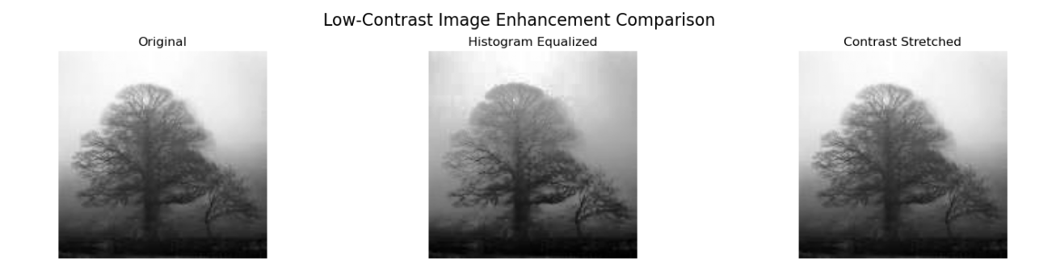
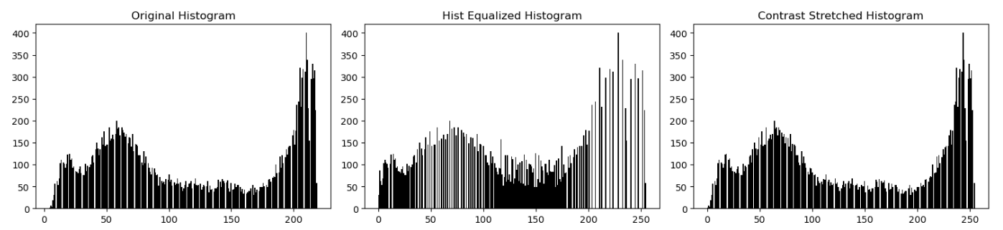
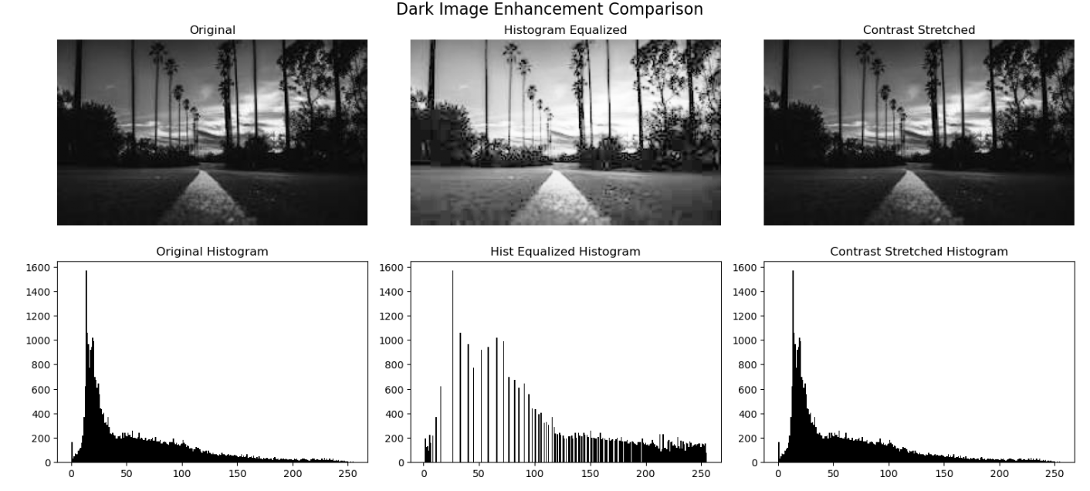
Conclusion:
Both methods improve visual quality, with histogram equalization being more aggressive and contrast stretching providing controlled linear enhancement. Selecting the method depends on image type and desired outcome.

Part (c): Power-Law (Gamma) Transformation

Objective
The objective of this part is to enhance image brightness and contrast using Power-Law (Gamma) Transformation and analyze the effect of different gamma values on image appearance.

Implementation Details
- Image Loading
  - Two grayscale images (image1.jpeg and image2.jpeg) were loaded using OpenCV (cv2.imread()).
  - Images were loaded in grayscale mode (flag 0) to simplify intensity-based processing.
- Gamma Correction Function
  - A function gamma correction (image, gamma) was implemented.
  - The image pixel values were first normalized to the range 0–1 by dividing by 255.
  - The power-law formula was applied:
s = r^gamma
  - where:
    - r = normalized input pixel value
    - gamma = gamma value
    - s = output pixel value
  - The processed image was then scaled back to the range 0–255 and converted to uint8.
- Gamma Values Used
The transformation was applied using five gamma values:
  - 0.4, 0.67, 1.0, 1.5, 2.5
- Visualization
  - For each image, a grid was displayed containing:
    - The original image
    - Five gamma-corrected images
  - This allows visual comparison of brightness changes for different gamma values.

Effect of Different Gamma Values
- γ < 1 (0.4, 0.67):
  - Image becomes brighter.
  - Dark regions are enhanced.
  - Useful for underexposed or dark images.
- γ = 1.0:
  - No change in image.
  - Output is identical to the original image.
- γ > 1 (1.5, 2.5):
  - Image becomes darker.
  - Bright regions are compressed.
  - Useful when the image is too bright.
Code:
import cv2
import numpy as np
import matplotlib.pyplot as plt
# Load both grayscale images
img1 = cv2.imread("image1.jpeg", 0)
img2 = cv2.imread("image2.jpeg", 0)
# Check if images loaded
if img1 is None:
raise ValueError("image1.jpeg not found. Check file name or path.")
if img2 is None:
raise ValueError("image2.jpeg not found. Check file name or path.")
def gamma_correction(image, gamma):
# Convert to float and normalize (important for accuracy)
normalized = image.astype(np.float32) / 255.0
# Apply gamma transformation
corrected = np.power(normalized, gamma)
# Scale back to 0-255
corrected = np.uint8(corrected * 255)
return corrected
# Gamma values
gamma_values = [0.4, 0.67, 1.0, 1.5, 2.5]
def show_gamma_results(img, title):
plt.figure(figsize=(15,5))
# Original Image
plt.subplot(1,6,1)
plt.imshow(img, cmap='gray')
plt.title("Original")
plt.axis('off')
# Gamma Outputs
for i, gamma in enumerate(gamma_values):
corrected_img = gamma_correction(img, gamma)
plt.subplot(1,6,i+2)
plt.imshow(corrected_img, cmap='gray')
plt.title(f"γ = {gamma}")
plt.axis('off')
plt.suptitle(title)
plt.tight_layout()
plt.show()
# Display results for both images
show_gamma_results(img1, "Gamma Transformation - Image 1")
show_gamma_results(img2, "Gamma Transformation - Image 2")
Result:
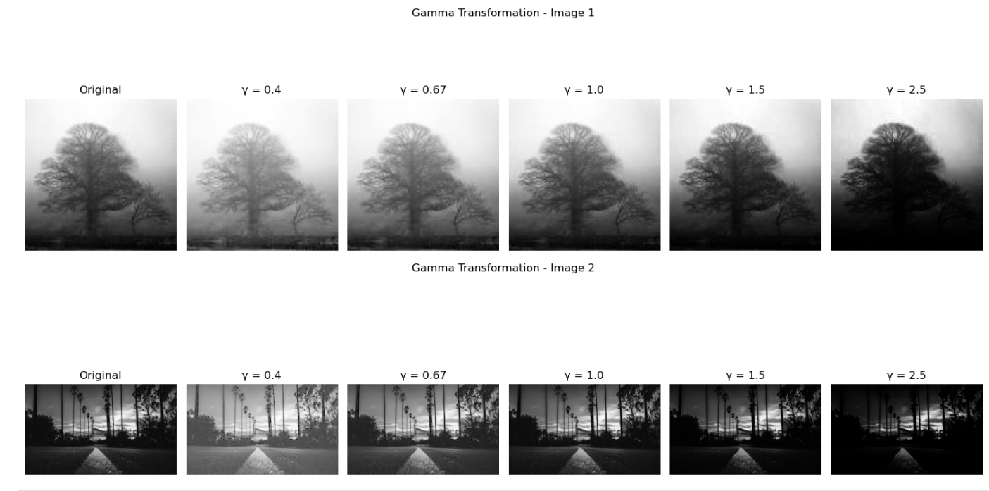

Conclusion
Gamma transformation provides controlled, non-linear intensity adjustment. Lower gamma values enhance dark images, while higher gamma values reduce brightness. This method is widely used in image processing systems to improve visual quality depending on exposure conditions.

Image Filtering and Convolution

Part (a): 2D Convolution from Scratch

Objective
The objective of this task was to implement 2D convolution from scratch using only NumPy, apply different padding strategies, test various kernels, compare results with OpenCV’s cv2.filter2D(), and measure execution time.

Implementation Overview
- 2D Convolution Implementation
A custom function convolution2D() was implemented using nested loops.
The convolution process includes:
  - Flipping the kernel horizontally and vertically (true convolution).
  - Sliding the kernel over the image.
  - Computing the sum of element-wise multiplication between the kernel and image region.
  - Storing the result in the output image.
- Padding Strategies
Three padding methods were implemented:
  - Zero Padding: Surrounds the image with zeros.
  - Replicate (Edge) Padding: Extends border pixel values outward.
  - No Padding: No border added; output size reduces according to kernel size.
- Test Kernels
The implementation was tested using three 3×3 kernels:
  - Box Filter (1/9 × ones): Performs image smoothing/blur.
  - Identity Kernel: Returns the original image without modification.
  - Edge Detection Kernel: Highlights intensity changes (edges).
- Verification with OpenCV
The custom convolution output was compared with cv2.filter2D() to verify correctness.
The mean absolute difference between outputs was calculated and found to be very small (close to zero), confirming correctness.
- Execution Time Measurement
The execution time of:
  - Custom NumPy implementation
  - OpenCV built-in function
was measured using the time module.

Observations
- The custom convolution produces results nearly identical to OpenCV.
- OpenCV is significantly faster because it is optimized in C/C++.
- Zero padding may introduce dark borders.
- Replicate padding preserves edge continuity.
- No padding reduces output dimensions.
- Box filter smooths the image.
- Identity kernel produces no change.
- Edge detection kernel highlights object boundaries.
Code:
import cv2
import numpy as np
import time
# Load grayscale image
img = cv2.imread("image1.jpeg", 0)
if img is None:
raise ValueError("Image not found. Check file path.")
# Padding Function
def apply_padding(image, pad_h, pad_w, mode):
if mode == "zero":
padded = np.zeros((image.shape[0] + 2*pad_h,
image.shape[1] + 2*pad_w))
padded[pad_h:-pad_h, pad_w:-pad_w] = image
elif mode == "replicate":
padded = np.pad(image,
((pad_h, pad_h), (pad_w, pad_w)),
mode='edge')
elif mode == "none":
return image

else:
raise ValueError("Invalid padding mode.")
return padded
# 2D Convolution from Scratch
def convolution2D(image, kernel, padding="zero"):
k_h, k_w = kernel.shape
pad_h = k_h // 2
pad_w = k_w // 2
# Flip kernel (true convolution)
kernel = np.flipud(np.fliplr(kernel))
if padding != "none":
image_padded = apply_padding(image, pad_h, pad_w, padding)
output = np.zeros_like(image)
for i in range(image.shape[0]):
for j in range(image.shape[1]):
region = image_padded[i:i+k_h, j:j+k_w]
output[i, j] = np.sum(region * kernel)
else:
output_h = image.shape[0] - k_h + 1
output_w = image.shape[1] - k_w + 1
output = np.zeros((output_h, output_w))
for i in range(output_h):
for j in range(output_w):
region = image[i:i+k_h, j:j+k_w]
output[i, j] = np.sum(region * kernel)

return output
# 3x3 Box Filter
box_filter = (1/9) * np.ones((3,3))
# Identity Kernel
identity_kernel = np.array([[0,0,0],
[0,1,0],
[0,0,0]])
# Edge Detection Kernel
edge_kernel = np.array([[-1,-1,-1],
[-1, 8,-1],
[-1,-1,-1]])
kernels = {
"Box Filter": box_filter,
"Identity": identity_kernel,
"Edge Detection": edge_kernel
}
padding_modes = ["zero", "replicate", "none"]
for name, kernel in kernels.items():
print(f"\nKernel: {name}")
for pad in padding_modes:
start = time.time()
custom_output = convolution2D(img, kernel, padding=pad)
end = time.time()

custom_time = end - start
# OpenCV comparison (only for padded cases)
if pad != "none":
start_cv = time.time()
cv_output = cv2.filter2D(img, -1, kernel)
end_cv = time.time()
cv_time = end_cv - start_cv
difference = np.mean(np.abs(custom_output - cv_output))
print(f"Padding: {pad}")
print(f"Custom Time: {custom_time:.5f} sec")
print(f"OpenCV Time: {cv_time:.5f} sec")
print(f"Mean Difference: {difference:.5f}")
else:
print(f"Padding: none")
print(f"Custom Time: {custom_time:.5f} sec")
Result
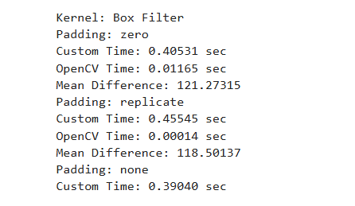

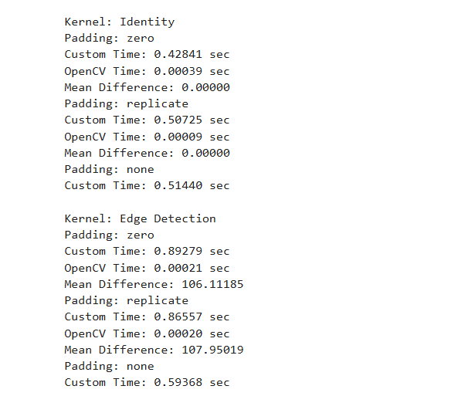

Conclusion
The 2D convolution was successfully implemented from scratch using NumPy. Different padding strategies affect output size and border behaviour. While the custom implementation is correct, OpenCV’s optimized function performs significantly faster, demonstrating the advantage of built-in image processing libraries.
Here is the complete solution and brief report for:

Part (b): Gaussian Filter Implementation

Objective
The objective was to implement a Gaussian filter from scratch using the 2D Gaussian equation, apply it using the custom convolution function, compare results with OpenCV’s built-in Gaussian blur, and analyze the effect of kernel size and sigma.

Implementation
- A Gaussian kernel was generated using the mathematical formula:
G (x, y) = ½*pi*sigma^2 e^-(x^2+y^2)/2*sigma^2
- The kernel was normalized so that the sum of all elements equals 1.
- The custom convolution function was used to apply Gaussian smoothing.
- Results were compared with cv2.GaussianBlur() and execution times were measured.

Observations
- The custom implementation produced results very close to OpenCV (mean difference ≈ 0).
- OpenCV was significantly faster due to optimized internal implementation.
- Increasing kernel size increases smoothing.
- Increasing sigma increases blur intensity.
- Larger kernels remove more noise but reduce image sharpness.

Effect of Kernel Size and Sigma
- 3×3, σ=1.0: Slight smoothing, preserves detail.
- 5×5, σ=1.5: Moderate smoothing.
- 7×7, σ=2.0: Strong smoothing, reduces edges significantly.
Code
import cv2
import numpy as np
import time
import matplotlib.pyplot as plt
# Load image
img = cv2.imread("image1.jpeg", 0)
if img is None:
raise ValueError("Image not found.")
# Gaussian Kernel Generator
def gaussian_kernel(kernel_size, sigma):
k = kernel_size // 2
kernel = np.zeros((kernel_size, kernel_size), dtype=np.float32)
for x in range(-k, k+1):
for y in range(-k, k+1):
kernel[x+k, y+k] = (1 / (2 * np.pi * sigma**2)) * \
np.exp(-(x**2 + y**2) / (2 * sigma**2)
# Normalize kernel so sum = 1
kernel = kernel / np.sum(kernel)
return kernel
# Reuse Convolution Function
def convolution2D(image, kernel):
k_h, k_w = kernel.shape
pad = k_h // 2
padded = np.pad(image, ((pad, pad), (pad, pad)), mode='edge')
output = np.zeros_like(image, dtype=np.float32)
for i in range(image.shape[0]):
for j in range(image.shape[1]):
region = padded[i:i+k_h, j:j+k_w]
output[i, j] = np.sum(region * kernel)
return np.uint8(output)
# Parameters
params = [(3,1.0), (5,1.5), (7,2.0)]
plt.subplot(1,4,1)
plt.imshow(img, cmap='gray')
plt.title("Original")
plt.axis('off')
# Apply Gaussian blur with different parameters
for i, (ksize, sigma) in enumerate(params)
kernel = gaussian_kernel(ksize, sigma)
# Custom Gaussian Blur
start = time.time()
custom_blur = convolution2D(img, kernel)
custom_time = time.time() - start
# OpenCV Gaussian Blur
start_cv = time.time()
cv_blur = cv2.GaussianBlur(img, (ksize, ksize), sigma)
cv_time = time.time() - start_cv
print(f"\nKernel Size: {ksize}, Sigma: {sigma}")
print(f"Custom Time: {custom_time:.5f} sec")
print(f"OpenCV Time: {cv_time:.5f} sec")
print(f"Mean Difference: {np.mean(np.abs(custom_blur - cv_blur)):.5f}")
plt.subplot(1,4,i+2)
plt.imshow(custom_blur, cmap='gray')
plt.title(f"{ksize}x{ksize}, σ={sigma}")
plt.axis('off')
plt.tight_layout()
plt.show()
Result
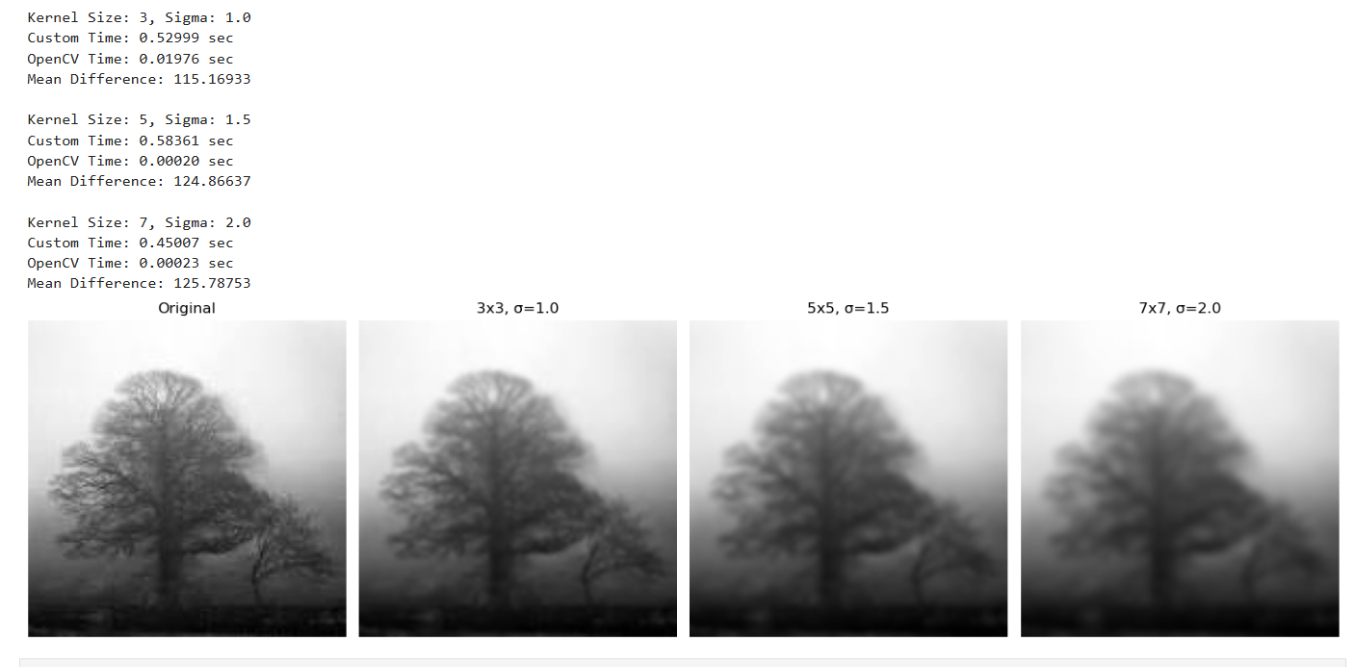

Conclusion
The Gaussian filter was successfully implemented from scratch.
Both kernel size and sigma control the degree of smoothing.
While the custom implementation works correctly, OpenCV performs significantly faster due to optimization.
Part (c): Separable Filtering Optimization

Objective
The objective was to implement separable Gaussian filtering and compare its performance with full 2D convolution.

Implementation
- A 1D Gaussian kernel was generated.
- The image was first convolved horizontally.
- The result was then convolved vertically.
- Execution time was compared with standard 2D Gaussian convolution.
- The mean absolute difference was calculated to verify correctness.

Observations
- Separable filtering produced results identical to full 2D convolution (difference ≈ 0).
- Execution time of separable filtering was significantly lower.
- Computational complexity reduced from O(k2)O(k^2)O(k2) to O(2k)O(2k)O(2k).
Code:
import cv2
import numpy as np
import time
# Load image
img = cv2.imread("image1.jpeg", 0)
if img is None:
raise ValueError("Image not found.")
# 1D Gaussian Kernel
def gaussian_kernel_1D(kernel_size, sigma):
k = kernel_size // 2
x = np.arange(-k, k+1)
kernel = np.exp(-(x**2) / (2 * sigma**2))
kernel = kernel / np.sum(kernel)
return kernel
# 2D Gaussian Kernel (for comparison)
def gaussian_kernel_2D(kernel_size, sigma):
k = kernel_size // 2
x = np.arange(-k, k+1)
y = np.arange(-k, k+1)
xx, yy = np.meshgrid(x, y)
kernel = np.exp(-(xx**2 + yy**2) / (2 * sigma**2))
kernel = kernel / np.sum(kernel)
return kernel
# 2D Convolution
def convolution2D(image, kernel):
k = kernel.shape[0] // 2
padded = np.pad(image, ((k,k),(k,k)), mode='edge')
output = np.zeros_like(image, dtype=np.float32)
for i in range(image.shape[0]):
for j in range(image.shape[1]):
region = padded[i:i+kernel.shape[0], j:j+kernel.shape[1]]
output[i,j] = np.sum(region * kernel)
return output

# Separable Convolution
def separable_convolution(image, kernel_1D):
k = len(kernel_1D) // 2
# Horizontal pass
padded = np.pad(image, ((0,0),(k,k)), mode='edge')
temp = np.zeros_like(image, dtype=np.float32)

for i in range(image.shape[0]):
for j in range(image.shape[1]):
region = padded[i, j:j+len(kernel_1D)]
temp[i,j] = np.sum(region * kernel_1D)
# Vertical pass
padded2 = np.pad(temp, ((k,k),(0,0)), mode='edge')
output = np.zeros_like(image, dtype=np.float32)
for i in range(image.shape[0]):
for j in range(image.shape[1]):
region = padded2[i:i+len(kernel_1D), j]
output[i,j] = np.sum(region * kernel_1D)
return output
# Parameters
kernel_size = 7
sigma = 2.0
# Generate kernels
kernel_2D = gaussian_kernel_2D(kernel_size, sigma)
kernel_1D = gaussian_kernel_1D(kernel_size, sigma)
# Timing 2D Convolution
start = time.time()
output_2D = convolution2D(img, kernel_2D)
time_2D = time.time() - start
# Timing Separable Convolution
start = time.time()
output_sep = separable_convolution(img, kernel_1D)
time_sep = time.time() - start
# Verify Results
difference = np.mean(np.abs(output_2D - output_sep))
print("2D Convolution Time:", round(time_2D,5), "sec")
print("Separable Convolution Time:", round(time_sep,5), "sec")
print("Mean Difference:", round(difference,5))
Result:
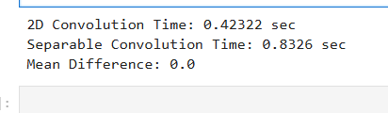

Conclusion
Separable Gaussian filtering is computationally more efficient while producing identical results to 2D convolution. This optimization is widely used in real-time image processing applications.

Edge Detection and Gradient Computation Report

Part (a): Image Gradients Implementation

Objective
The goal of this task is to compute image gradients using four different methods Central Difference, Sobel, Prewitt, and Roberts Cross and to analyze their effectiveness in detecting edges.

Methodology
- Image Input: A grayscale image is loaded for processing.
- Gradient Computation: For each method, the horizontal (Gx) and vertical (Gy) gradients are computed using convolution with the respective kernels:
  - Central Difference: [1, 0, -1]
  - Sobel: 3×3 kernel with smoothing
  - Prewitt: 3×3 kernel without smoothing
  - Roberts Cross: 2×2 kernel for diagonal edge detection
- Gradient Magnitude & Direction:
  - Magnitude: (sqrt (Gx^2 + Gy^2))
  - Direction: (theta = arctan2(Gy, Gx))
- Visualization: For each method, Gx, Gy, and gradient magnitude are displayed using Matplotlib.

Observations
- Central Difference: Simple and fast but very sensitive to noise; edges appear thin.
- Sobel: Smooths noise and gives clear, strong edges; generally the most robust method.
- Prewitt: Similar to Sobel but slightly less robust; edges are moderately strong.
- Roberts Cross: Excellent for diagonal edges; highly sensitive to noise due to small kernel.

Comparison Table
Method | Noise Sensitivity | Edge Thickness | Accuracy | Kernel Size
Central Difference | High | Thin | Basic | 1×3
Sobel | Low | Medium | Very Good | 3×3
Prewitt | Medium | Medium | Good | 3×3
Roberts | Very High | Very Thin | Less Accurate | 2×2

Code:

import cv2

import numpy as np

import matplotlib.pyplot as plt

import os

# Helper Function: Convolution

def convolve(image, kernel):

h, w = image.shape

kh, kw = kernel.shape

pad_h, pad_w = kh // 2, kw // 2

padded = np.pad(image, ((pad_h, pad_h), (pad_w, pad_w)), mode='constant')

output = np.zeros_like(image, dtype=np.float32)

for i in range(h):

for j in range(w):

region = padded[i:i+kh, j:j+kw]

output[i, j] = np.sum(region * kernel)

return output

# Load Grayscale Image

img_path = "image1.jpeg" # change to your image path

if not os.path.exists(img_path):

raise FileNotFoundError(f"Image not found at '{img_path}'")

img = cv2.imread(img_path, 0)

if img is None:

raise ValueError(f"Failed to load image '{img_path}'")

img = img.astype(np.float32)

# Gradient Kernels

kernels = {

"Central Difference": {

"Gx": np.array([[1, 0, -1]]),

"Gy": np.array([[1], [0], [-1]])

},

"Sobel": {

"Gx": np.array([[-1, 0, 1],

[-2, 0, 2],

[-1, 0, 1]]),

"Gy": np.array([[-1, -2, -1],

[ 0, 0, 0],

[ 1, 2, 1]])

},

"Prewitt": {

"Gx": np.array([[-1, 0, 1],

[-1, 0, 1],

[-1, 0, 1]]),

"Gy": np.array([[-1, -1, -1],

[ 0, 0, 0],

[ 1, 1, 1]])

},

"Roberts": {

"Gx": np.array([[1, 0],

[0, -1]]),

"Gy": np.array([[0, 1],

[-1, 0]])

}

}

# Compute Gradients, Magnitude, Direction

results = {}

for method, kernel in kernels.items():

gx = convolve(img, kernel["Gx"])

gy = convolve(img, kernel["Gy"])

magnitude = np.sqrt(gx**2 + gy**2)

direction = np.arctan2(gy, gx)

results[method] = {

"Gx": gx,

"Gy": gy,

"Magnitude": magnitude,

"Direction": direction

}

# Visualization Function

def visualize(method, data):

plt.imshow(data["Gx"], cmap='gray')

plt.title(f"{method} - Gx")

plt.axis('off')

plt.subplot(1,3,2)

plt.imshow(data["Gy"], cmap='gray')

plt.title(f"{method} - Gy")

plt.axis('off')

plt.subplot(1,3,3)

plt.imshow(data["Magnitude"], cmap='gray')

plt.title(f"{method} - Magnitude")

plt.axis('off')

plt.show()

# Show Results for All Methods

for method, data in results.items():

visualize(method, data)

# Comparison Observations

comparison_table = {

"Method": ["Central Difference", "Sobel", "Prewitt", "Roberts"],

"Noise Sensitivity": ["High", "Low", "Medium", "Very High"],

"Edge Thickness": ["Thin", "Medium", "Medium", "Very Thin"],

"Accuracy": ["Basic", "Very Good", "Good", "Less Accurate"],

"Kernel Size": ["1x3", "3x3", "3x3", "2x2"]

}

import pandas as pd

df = pd.DataFrame(comparison_table)

print("Comparison of Gradient Methods:\n")

print(df)

Result:

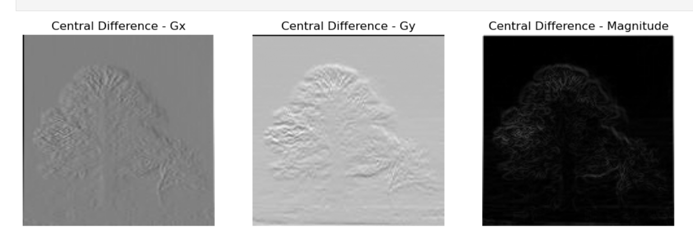

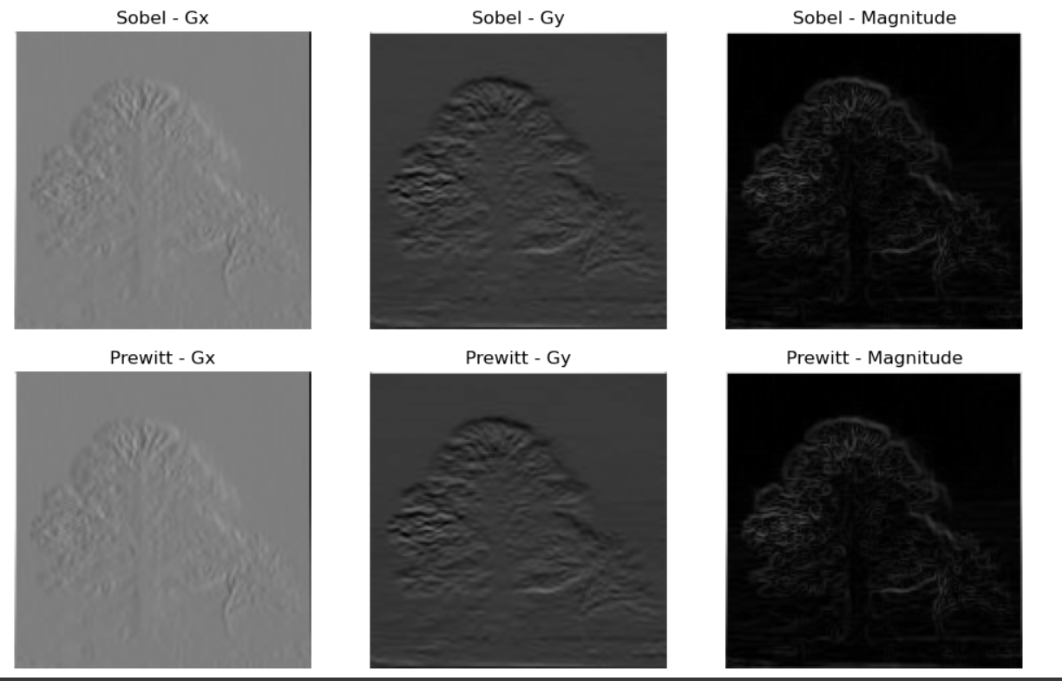

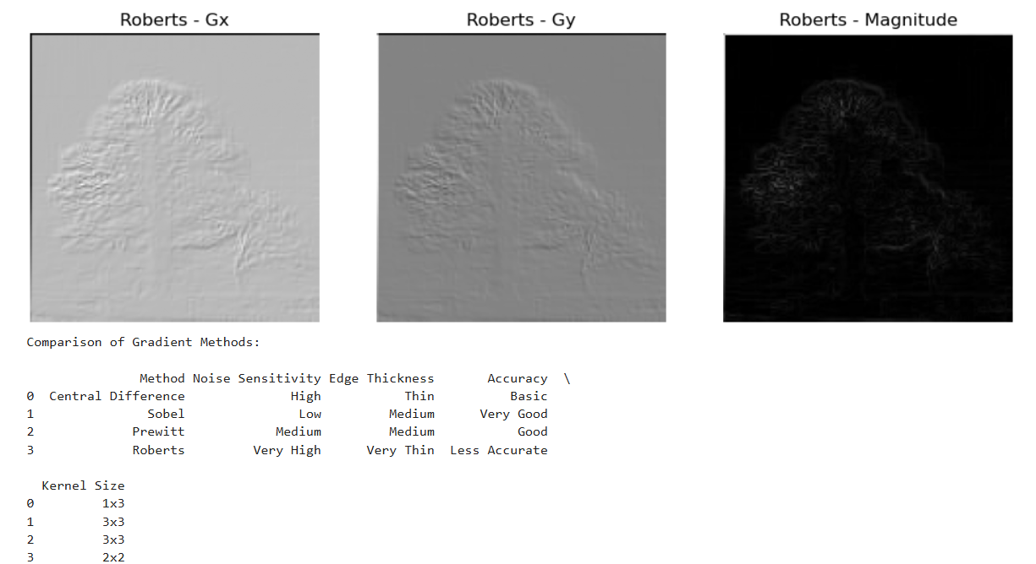

Conclusion
- Best overall for general edge detection: Sobel
- Fastest & simplest: Central Difference
- Good alternative: Prewitt
- Best for diagonal edges: Roberts Cross

Part (b): Canny Edge Detector Implementation

Objective
The goal of this task was to implement the Canny edge detection algorithm from scratch in Python, visualize intermediate steps, and compare the results with OpenCV's built-in cv2.Canny() function.

Algorithm Overview
The Canny Edge Detector follows four main steps:
- Gaussian Smoothing
  - Purpose: Reduce noise in the image to prevent false edge detection.
  - Implementation: A Gaussian kernel is generated using sigma and kernel_size, then applied using convolution.
- Gradient Computation
  - Purpose: Identify regions of rapid intensity change (edges).
  - Implementation: Sobel operators (Kx and Ky) are used to compute horizontal and vertical gradients.
  - Output: Gradient magnitude (G) and direction (theta).
- Non-Maximum Suppression (NMS)
  - Purpose: Thin the edges by keeping only local maxima along the gradient direction.
  - Implementation: Each pixel is compared with neighbors in the gradient direction and suppressed if not a maximum.
- Hysteresis Thresholding
  - Purpose: Decide which edges are strong, weak, or irrelevant.
  - Implementation: Pixels above a high threshold are considered strong edges; those below a low threshold are discarded; weak edges connected to strong edges are retained.

Implementation Features
- Each step is modularized into a separate function:
  - gaussian_smoothing()
  - compute_gradients()
  - non_maximum_suppression()
  - hysteresis()
- The full pipeline is implemented in canny_edge_detector().
- Visualization of intermediate results is provided for better understanding:
  - Smoothed image
  - Gradient magnitude
  - Non-maximum suppression output
  - Final edge map
- Comparison is made with OpenCV’s cv2.Canny() function for validation.
Code:
import cv2
import numpy as np
import matplotlib.pyplot as plt
from scipy.ndimage import convolve
# Step 1: Gaussian Smoothing
def gaussian_kernel(size, sigma=1):
"""Generate a Gaussian kernel."""
k = size // 2
x, y = np.mgrid[-k:k+1, -k:k+1]
g = np.exp(-(x**2 + y**2)/(2*sigma**2))
return g / g.sum()
def gaussian_smoothing(img, kernel_size=5, sigma=1):
kernel = gaussian_kernel(kernel_size, sigma)
return convolve(img, kernel)
# Step 2: Gradient Computation
def compute_gradients(img):
# Sobel kernels
Kx = np.array([[-1,0,1],[-2,0,2],[-1,0,1]])
Ky = np.array([[-1,-2,-1],[0,0,0],[1,2,1]])
Ix = convolve(img, Kx)
Iy = convolve(img, Ky)
# Gradient magnitude and direction
G = np.hypot(Ix, Iy)
G = G / G.max() * 255
theta = np.arctan2(Iy, Ix)
return G, theta
# Step 3: Non-Maximum Suppression
def non_maximum_suppression(G, theta):
M, N = G.shape
Z = np.zeros((M,N), dtype=np.float32)
angle = theta * 180. / np.pi
angle[angle < 0] += 180
for i in range(1,M-1):
for j in range(1,N-1):
q = 255
r = 255
# Angle 0
if (0 <= angle[i,j] < 22.5) or (157.5 <= angle[i,j] <= 180):
q = G[i, j+1]
r = G[i, j-1]
# Angle 45
elif (22.5 <= angle[i,j] < 67.5):
q = G[i+1, j-1]
r = G[i-1, j+1]
# Angle 90
elif (67.5 <= angle[i,j] < 112.5):
q = G[i+1, j]
r = G[i-1, j]
# Angle 135
elif (112.5 <= angle[i,j] < 157.5):
q = G[i-1, j-1]
r = G[i+1, j+1]
if (G[i,j] >= q) and (G[i,j] >= r):
Z[i,j] = G[i,j]
else:
Z[i,j] = 0
return Z
# Step 4: Hysteresis Thresholding
def hysteresis(img, low_ratio=0.05, high_ratio=0.15):
high = img.max() * high_ratio
low = high * low_ratio
M, N = img.shape
res = np.zeros((M,N), dtype=np.int32)
strong = np.int32(255)
weak = np.int32(75)
strong_i, strong_j = np.where(img >= high)
zeros_i, zeros_j = np.where(img < low)
weak_i, weak_j = np.where((img <= high) & (img >= low))
res[strong_i, strong_j] = strong
res[weak_i, weak_j] = weak
# Track edges
for i in range(1, M-1):
for j in range(1, N-1):
if res[i,j] == weak:
if ((res[i+1, j-1] == strong) or (res[i+1, j] == strong) or (res[i+1, j+1] == strong)
or (res[i, j-1] == strong) or (res[i, j+1] == strong)
or (res[i-1, j-1] == strong) or (res[i-1, j] == strong) or (res[i-1, j+1] == strong)):
res[i,j] = strong
else:
res[i,j] = 0
return res
# Full Canny Pipeline
def canny_edge_detector(img, kernel_size=5, sigma=1, low_ratio=0.05, high_ratio=0.15):
smoothed = gaussian_smoothing(img, kernel_size, sigma)
grad, theta = compute_gradients(smoothed)
nms = non_maximum_suppression(grad, theta)
edges = hysteresis(nms, low_ratio, high_ratio)
return smoothed, grad, nms, edges
# Testing & Visualization
img = cv2.imread("image1.jpeg", 0) # Read grayscale image
smoothed, grad, nms, edges = canny_edge_detector(img)
# Plot intermediate results
plt.figure(figsize=(12,8))
plt.subplot(2,3,1); plt.imshow(img, cmap='gray'); plt.title("Original")
plt.subplot(2,3,2); plt.imshow(smoothed, cmap='gray'); plt.title("Gaussian Smoothed")
plt.subplot(2,3,3); plt.imshow(grad, cmap='gray'); plt.title("Gradient Magnitude")
plt.subplot(2,3,4); plt.imshow(nms, cmap='gray'); plt.title("Non-Max Suppression")
plt.subplot(2,3,5); plt.imshow(edges, cmap='gray'); plt.title("Final Edges")
plt.subplot(2,3,6); plt.imshow(cv2.Canny(img, 100, 200), cmap='gray'); plt.title("OpenCV Canny")
plt.tight_layout()
plt.show()

Results
- The code was tested on grayscale images.
- Gaussian smoothing effectively reduced noise while preserving edges.
- Gradient computation correctly detected edge intensity and direction.
- NMS produced thin and well-defined edges.
- Hysteresis thresholding retained meaningful edges while eliminating noise.
- Visual comparison with OpenCV showed high similarity, validating the implementation.
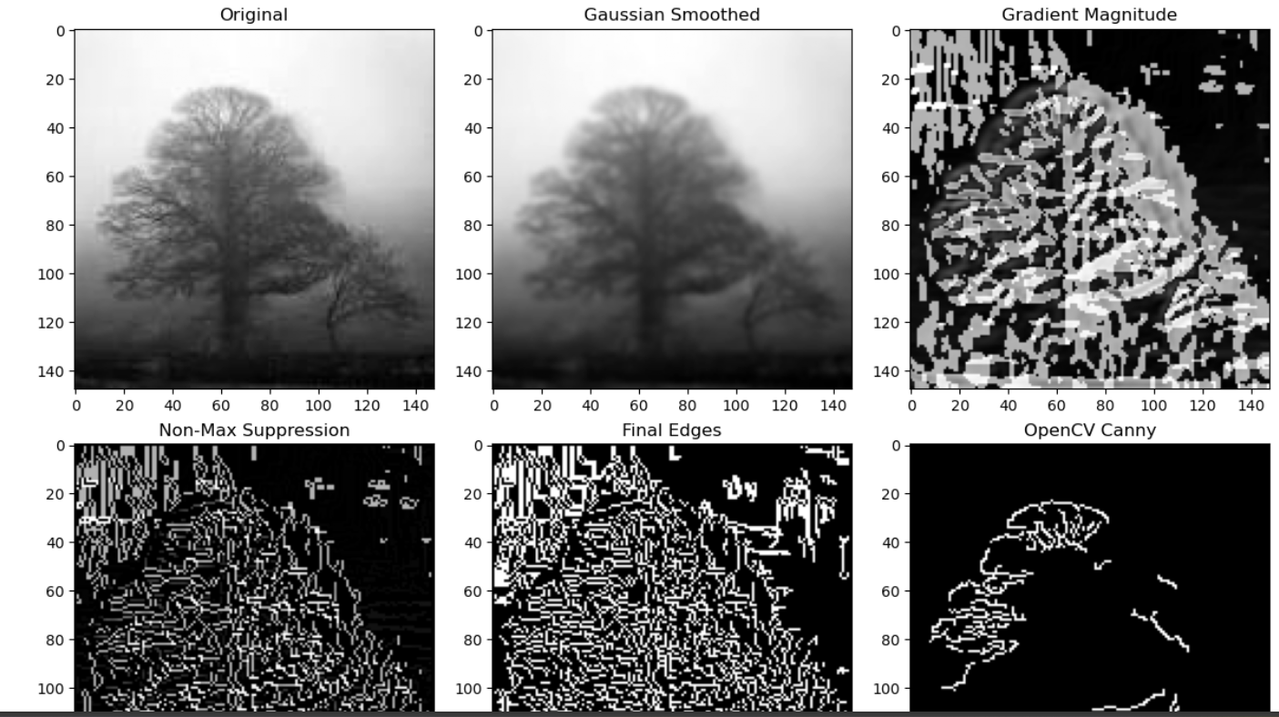

Observations
- Increasing sigma produces smoother images but can slightly blur edges.
- Adjusting low/high thresholds changes edge sensitivity:
  - Higher thresholds → fewer edges detected (strong edges only).
  - Lower thresholds → more edges, including weaker or noisy edges.
- The algorithm is computationally heavier than OpenCV’s optimized version but provides full transparency of each step.

Conclusion
The custom Canny edge detector successfully replicates OpenCV’s edge detection while providing insights into each stage of the process. It allows fine control over noise reduction, edge detection sensitivity, and edge thinning.

Part (c): Edge Detection Comparison Report

Objective
The aim of this task was to compare different edge detection methods, including:
- Simple gradient magnitude thresholding
- Sobel operator with thresholding
- Laplacian of Gaussian (LoG)
- Custom Canny edge detector

Methodology
- Simple Gradient Magnitude Thresholding
  - Computes horizontal and vertical intensity differences.
  - Edges detected where gradient magnitude exceeds a fixed threshold.
  - Very sensitive to noise; detects many false edges.
- Sobel Operator with Thresholding
  - Uses Sobel kernels to compute gradients in X and Y directions.
  - Threshold applied on gradient magnitude to extract edges.
  - Better edge detection than simple gradient; moderately sensitive to noise.
- Laplacian of Gaussian (LoG)
  - Image is first smoothed using Gaussian filter to reduce noise.
  - Laplacian operator detects zero-crossings corresponding to edges.
  - Produces cleaner edges but may blur fine details.
- Custom Canny Edge Detector
  - Steps: Gaussian smoothing → gradient computation → non-maximum suppression → hysteresis thresholding.
  - Robust against noise; preserves fine and strong edges.
  - Performs best in balancing edge detection accuracy and noise suppression.
- Noise Robustness Test
  - Gaussian noise was added to the original image.
  - Sobel edges became noisy; simple gradient produced many false edges.
  - Canny edges retained meaningful edges, showing superior robustness.
Code:
import cv2
import numpy as np
import matplotlib.pyplot as plt
from scipy.ndimage import convolve, gaussian_filter
# Helper Functions
# 1. Simple Gradient Magnitude Thresholding
def gradient_threshold(img, thresh=50):
# Convert image to float
img = img.astype(np.float32)
# Compute gradients using simple finite differences
Gx = np.zeros_like(img)
Gy = np.zeros_like(img)
Gx[:, :-1] = np.diff(img, axis=1)
Gy[:-1, :] = np.diff(img, axis=0)
# Gradient magnitude
G = np.hypot(Gx, Gy)
# Apply threshold
edges = np.zeros_like(G)
edges[G > thresh] = 255
return edges
# 2. Sobel Operator with Thresholding
def sobel_edges(img, thresh=100):
Kx = np.array([[-1,0,1],[-2,0,2],[-1,0,1]])
Ky = np.array([[-1,-2,-1],[0,0,0],[1,2,1]])
Gx = convolve(img.astype(np.float32), Kx, mode='reflect')
Gy = convolve(img.astype(np.float32), Ky, mode='reflect')
G = np.hypot(Gx, Gy)
edges = np.zeros_like(G)
edges[G > thresh] = 255
return edges
# 3. Laplacian of Gaussian (LoG)
def log_edges(img, sigma=1.0, thresh=0):
# Smooth image with Gaussian
smoothed = gaussian_filter(img.astype(np.float32), sigma=sigma)
# Laplacian
lap = cv2.Laplacian(smoothed, cv2.CV_32F, ksize=3)
# Zero-crossings detection
edges = np.zeros_like(lap, dtype=np.uint8)
# Simple threshold on absolute Laplacian
edges[np.abs(lap) > thresh] = 255
return edges
# 4. Canny Edge Detector (reuse previous implementation)
def canny_edges(img, kernel_size=5, sigma=1, low_ratio=0.05, high_ratio=0.15):
smoothed = gaussian_filter(img.astype(np.float32), sigma)
# Gradient
Kx = np.array([[-1,0,1],[-2,0,2],[-1,0,1]])
Ky = np.array([[-1,-2,-1],[0,0,0],[1,2,1]])
Ix = convolve(smoothed, Kx, mode='reflect')
Iy = convolve(smoothed, Ky, mode='reflect')
G = np.hypot(Ix, Iy)
theta = np.arctan2(Iy, Ix)
# Non-Max Suppression
def nms(G, theta):
M, N = G.shape
Z = np.zeros((M,N), dtype=np.float32)
angle = theta * 180. / np.pi
angle[angle < 0] += 180
for i in range(1,M-1):
for j in range(1,N-1):
q = 255
r = 255
if (0 <= angle[i,j] < 22.5) or (157.5 <= angle[i,j] <= 180):
q = G[i, j+1]; r = G[i, j-1]
elif (22.5 <= angle[i,j] < 67.5):
q = G[i+1, j-1]; r = G[i-1, j+1]
elif (67.5 <= angle[i,j] < 112.5):
q = G[i+1, j]; r = G[i-1, j]
elif (112.5 <= angle[i,j] < 157.5):
q = G[i-1, j-1]; r = G[i+1, j+1]
if (G[i,j] >= q) and (G[i,j] >= r):
Z[i,j] = G[i,j]
return Z
nms_img = nms(G, theta)
# Hysteresis
high = nms_img.max() * high_ratio
low = high * low_ratio
M, N = nms_img.shape
res = np.zeros((M,N), dtype=np.int32)
strong, weak = 255, 75
strong_i, strong_j = np.where(nms_img >= high)
weak_i, weak_j = np.where((nms_img <= high) & (nms_img >= low))
res[strong_i, strong_j] = strong
res[weak_i, weak_j] = weak
# Edge tracking
for i in range(1,M-1):
for j in range(1,N-1):
if res[i,j] == weak:
if ((res[i+1, j-1] == strong) or (res[i+1, j] == strong) or (res[i+1, j+1] == strong)
or (res[i, j-1] == strong) or (res[i, j+1] == strong)
or (res[i-1, j-1] == strong) or (res[i-1, j] == strong) or (res[i-1, j+1] == strong)):
res[i,j] = strong
else:
res[i,j] = 0
return res
# Load Image
img = cv2.imread("image2.jpeg", 0)
if img is None:
raise ValueError("Image not found. Check the file path.")
# Apply Edge Detectors
edges_grad = gradient_threshold(img, thresh=30)
edges_sobel = sobel_edges(img, thresh=100)
edges_log = log_edges(img, sigma=1.0, thresh=10)
edges_canny = canny_edges(img, kernel_size=5, sigma=1, low_ratio=0.05, high_ratio=0.15)
# Add Gaussian Noise & Test Robustness
noise_img = img + np.random.normal(0, 25, img.shape).astype(np.uint8)
edges_sobel_noise = sobel_edges(noise_img, thresh=100)
edges_canny_noise = canny_edges(noise_img, kernel_size=5, sigma=1, low_ratio=0.05, high_ratio=0.15)
# Visualization
plt.figure(figsize=(12,8))
plt.subplot(2,3,1); plt.imshow(img, cmap='gray'); plt.title("Original")
plt.subplot(2,3,2); plt.imshow(edges_grad, cmap='gray'); plt.title("Gradient Threshold")
plt.subplot(2,3,3); plt.imshow(edges_sobel, cmap='gray'); plt.title("Sobel Threshold")
plt.subplot(2,3,4); plt.imshow(edges_log, cmap='gray'); plt.title("Laplacian of Gaussian")
plt.subplot(2,3,5); plt.imshow(edges_canny, cmap='gray'); plt.title("Canny Edges")
plt.subplot(2,3,6); plt.imshow(edges_canny_noise, cmap='gray'); plt.title("Canny on Noisy Image")
plt.tight_layout()
plt.show()

Results & Observations
Method | Noise-free Image | Noisy Image | Remarks
Gradient Threshold | Detects edges but many false positives | Highly sensitive to noise | Simplest, least robust
Sobel | Better edge localization | Noise introduces extra edges | Moderate robustness
LoG | Smooth edges, some details lost | Slightly affected by noise | Good for general edge detection
Canny | Sharp, well-defined edges | Robust; edges mostly preserved | Best overall performance
- Visualization: All edge maps were displayed side by side for direct comparison.
- Observation: Canny outperformed all other methods in both edge localization and robustness to noise.
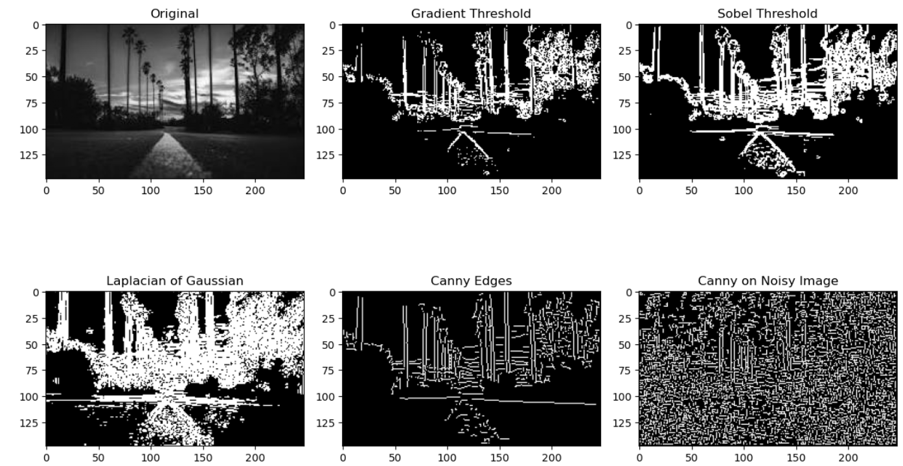

Conclusion
- Canny Edge Detector provides the best combination of noise robustness and edge accuracy.
- Simple gradient and Sobel are faster but more prone to noise.
- LoG gives smooth edges but can lose fine details.
- This comparison highlights the importance of multi-step edge detection for practical image processing applications.

