**SMART INTERNSHIP RECOMMENDATION SYSTEM**



**Project ID- 10**

**Project Advisor: FARRAH ASLAM Submitted By**

## Muhammad Hammad Ali bsf2104198

## Arslan Haider bsf2103968

**University of Education**

**SMART INTERNSHIP RECOMMENDATION SYSTEM**

**BS in Information Technology-2025**

## A project submitted in partial fulfillment of the requirements for the award of the degree of

## BS in information Technology

**JAUHARABAD CAMPUS UNIVERSITY OF EDUCATION**

**LAHORE**

## May 2025

## © Copyright UOE, 2025

### “I hereby declare that I have read this project documentation and in my opinion this project is sufficient in terms of scope and quality for the award of the degree of BS in Information Technology”

Project Primary Supervisor Name: Farrah Aslam Designation: Lecturer University of Education.

Project Examiner Name: Designation:

University of Education.

# DECLARATION

I declare that this project title entitled “**SMART INTERNSHIP RECOMMENDTION SYSTEM**” is the result of my own research and development except as cited in the references. This project has not been accepted for any degree and is not concurrently submitted in candidate for any other degree. At any time if my statement is found to be incorrect even afterwards of BS in Information Technology, the university has the right withdraw my BS in Information Technology.

Signature: Signature:

Name:

Name:

Date:

Date:

# PLAGIARISM UNDERTAKEN

I solemnly declare that project work presented in this documentation entitles **“SMART INTERNSHIP RECOMMENDATION SYSTEM**” is solely my work with no significant contribution from any other person. Small contribution/help wherever taken has been acknowledged and that complete project has been written by me.

I understand that zero tolerance policy of the HEC and University of Education, Lahore towards plagiarism. Therefore, we as an author of the above titled project declare that no portion of my project documentation and any material used as reference is properly referred/ cited.

I undertake that of I am found guilty of any formal plagiarism in the above titled project even after award of BS, the University reserve the rights to withdraw/revoke my BS degree and that HEC and the University has the right to publish my name on the HEC/University Website on which names of students are place who submitted plagiarized projects.

Signature: Name:

Date:

Signature: Name: Date:

# CERTIFICATE OF APPROVAL

This is to certify that the project work presented in this documentation entitled, “**SMART INTERNSHIP RECOMMENDATION SYSTEM”**, was conducted by

**“MUHAMMAD HAMMAD ALI”, “ARSLAN HAIDER”** under the supervision of **“FARRAH ASLAM”**. No part of this project has been submitted anywhere else for any degree. This project is submitted to the **“Jauharabad University of Education”** is partial fulfillment of the requirements of the degree of BS in Information Technology.

Signature:

Signature:

Name: Name:

Date: Date:

Project Primary Supervisor Name: Farrah Aslam Designation: Lecturer University of Education.

Project Examiner Name: Designation:

University of Education.

# OFFICE OF CONTROLLER OF EXAMINATION NOTIFICATION

No: Date:

It is notified for the nomination of all the concerned that Mr./Ms. (MUHAMMAD HAMMAD ALI), (ARSLAN HAIDER) BS student of Information Technology of University of Education has completed all the requirements for the award of BS Degree in the discipline of Information Technology as per detail given hereunder:

#### BS in Information Technology

#### Credit Hours:

|  |  |  |  |  |  |
| --- | --- | --- | --- | --- | --- |
| **Registration No** | **Complete Name** | **Course work** | **Project** | **Total** | **Cumulative Grade Point Average (CGPA)** |
|  |  |  |  |  |  |
|  |  |  |  |  |  |
|  |  |  |  |  |  |
|  |  |  |  |  |  |

Project Title: **Smart Internship Recommendation System**

Name of Supervisor: **Farrah Aslam**

#### Signed by

#### Controller of Examination

# ACKNOWLEDGEMENT

We truly acknowledge the cooperation and help make by **Farrah Aslam**, **Lecturer of University of Education**. She has been a constant source of guidance throughout the course of this project. We would also like to thank **Dr Irfan, Lecturer of University of Education** for his help and guidance throughout this project. We are also thankful to our friends and families whose silent support led us to complete our project.

1. Muhammad Hammad Ali
2. Arslan Haider

Date:

# ABSTRACT

The **Smart Internship Recommendation System** is a user-friendly web application designed to simplify the internship search process for students. It provides personalized internship recommendations based on users' skills, academic background, and career interests. The system aggregates internship listings from various platforms, displaying information such as company details, skill requirements, duration, and location to help users make informed decisions.

The platform features intelligent matching algorithms that suggest internships tailored to each student’s profile. Users can create personalized s to track their preferred internship opportunities and receive customizable notifications for new or recommended listings that align with their interests.

With secure user authentication and password encryption, the system ensures data privacy and protection. It also offers a straightforward, intuitive design for easy navigation and provides real-time industry news to keep students updated on trends in their chosen fields. Overall, this platform aims to enhance the internship search experience by consolidating essential tools and information in one place, empowering students to efficiently connect with relevant opportunities.

Table of Contents

DECLARATION 5

PLAGIARISM UNDERTAKEN 6

CERTIFICATE OF APPROVAL 7

OFFICE OF CONTROLLER OF EXAMINATION NOTIFICATION 8

ACKNOWLEDGEMENT 9

ABSTRACT 10

Chapter 1. Gathering & Analyzing Information 12

* 1. Introduction **Error! Bookmark not defined.**
  2. Problem Statement **Error! Bookmark not defined.**
  3. Goal & Objectives **Error! Bookmark not defined.**
  4. Research Question **Error! Bookmark not defined.**
  5. Methodology **Error! Bookmark not defined.**
     1. Available Methodology **Error! Bookmark not defined.**
     2. Chosen Methodology **Error! Bookmark not defined.**
     3. Justification for Agile Methodology **Error! Bookmark not defined.**
  6. Definitions, Acronyms and Abbreviations **Error! Bookmark not defined.**

Chapter 2. Software Requirements Specification **Error! Bookmark not defined.**

**Chapter 1. Gathering & Analyzing Information**

#### Introduction

The Smart Internship Recommendation System is designed to assist students and recent graduates in finding suitable internship opportunities based on their skills, educational background, and preferences. As internship demand increases, this app provides users with personalized recommendations, real-time updates, and an easy-to-navigate design, catering to all levels of internship seekers.

One of the main features of the app is real-time internship data. Users can view an up-to- date list of internship openings, showcasing essential details such as role descriptions, company profiles, required skills, and location. This information is crucial for making informed decisions and streamlining the internship search process. The app also has a dedicated section for Top Recommendations, which highlights internships matching the user’s skills and preferences. This feature enables users to quickly identify the best-suited internships without manually filtering through countless listings.

To assist users in exploring trends and insights, the app includes interactive filters and categorization options. Users can sort and filter internships by fields such as software engineering, marketing, design, or business analytics. This functionality allows users to focus on specific career areas, helping them gain relevant experience aligned with their career goals.

Another important feature is the personalized. This allows users to save internships they are interested in and receive updates on application deadlines and status changes. Users can add or remove internships from their, making it simple to monitor and act on preferred opportunities.

To keep users informed on the latest trends, the app integrates industry-related news feeds. These feeds provide articles and updates on career advice, emerging skills, and best practices, ensuring users are well-prepared for their internships. The app curates articles based on the selected career fields, allowing users to stay informed and proactive.

In summary, the Smart Internship Recommendation System is dedicated to providing a friendly and efficient experience for users in their search for relevant internships. With powerful features like real-time data, a personalized, interactive filters, and industry news, the app aims to be an essential tool for anyone looking to enhance their career prospects.

#### Problem Statement

The Smart Internship Recommendation System is designed to simplify the process of finding relevant internships by providing users with tailored recommendations. It offers detailed information about internship opportunities, including real-time data and customized s, all presented in a clear and user-friendly interface. Unlike other job-seeking platforms that can be overwhelming, this app prioritizes simplicity and functionality.

The app features a customizable dashboard that allows users to track internships, set alerts for application deadlines, and receive recommendations aligned with their skills and career goals. By focusing on user-centered features, the app helps users actively engage with internship opportunities and discover roles that align with their aspirations.

By concentrating on user preferences and industry trends, the Smart Internship Recommendation System encourages engagement with the professional world. It is suitable for beginners aiming to gain initial experience or experienced individuals looking for specialized roles to advance their career. This app serves as a reliable guide for anyone interested in gaining practical knowledge and networking opportunities through internships.

#### Goal & Objectives

#### Goal:

The goal of the Smart Internship Recommendation System is to facilitate the process of finding relevant internships, helping users advance their careers by providing real-time, tailored recommendations.

#### Objectives:

* + - Provide users with real-time internship opportunities, including detailed information about each role.
    - Offer search functionality for finding specific internship fields and companies.
    - Integrate news feeds related to industry trends and career advice.
    - Ensure a user-friendly interface with clear navigation.
    - Include a personalized feature for tracking internship opportunities of interest.

#### Research Questions

* + - How can the user interface be designed to optimize the internship search experience for users?
    - What features and functionalities are most important to users when looking for internships?
    - What measures can be taken to ensure the accuracy and reliability of the data provided on internships?
    - How can the platform be designed to provide real-time updates on internship openings?
    - What is the optimal frequency for refreshing internship data to maintain accuracy?
    - What strategies can be implemented to optimize app performance and responsiveness?
    - What factors influence user engagement and retention on an internship app?
    - How can personalized recommendations and notifications be integrated to keep users actively engaged?
    - What measures are necessary to ensure the privacy and security of user data?
    - How can the app protect against potential data breaches or unauthorized access?
    - What trends and demands exist in the internship and job market that the app can address?

#### Methodology

The development of the Smart Internship Recommendation System follows a multi-tier architecture combined with a user-centered Agile methodology. The platform integrates real-time internship data, personalized recommendations, notifications, and secure user authentication. A backend server processes data, manages user sessions, and connects with various internship APIs to fetch opportunities, while the frontend offers an intuitive interface for seamless user interaction.

#### Available Methodologies

#### Research Methodologies:

* + - * + API Integration and Data Handling: Research on integrating and optimizing data retrieval from real-time internship APIs.
        + Data Privacy and Security Compliance: Implement best practices for managing user data securely.
        + Performance Optimization: Explore methods for balancing data-fetching frequencies and caching to enhance app performance.

#### Project Management Methodologies:

* + - * + Agile (Scrum): Allows continuous refinement of core features and user experiences.
        + Agile (Kanban): Streamlines task management and tracks progress with clear, visual boards.
        + Iterative Development: Focuses on repeated cycles of feedback and testing for each feature.

#### Software Development Methodologies:

* + - * + Agile Development: Flexible methodology well-suited for rapidly changing user needs in a live internship-tracking app.
        + V-Model: Emphasizes rigorous testing and verification, ensuring reliability in API integration and user notifications.

#### Chosen Methodology

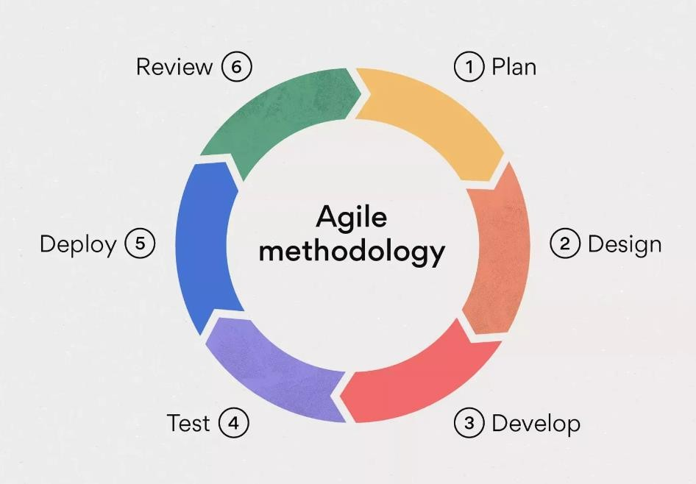

Our project uses an Agile methodology to develop the Smart Internship Recommendation System in manageable parts, gathering feedback and making improvements based on user needs. This methodology ensures we create a user-centered app that meets user expectations.

#### Sprint Planning

* + - * Each sprint includes user stories for features such as real-time internship data updates, s, and search functions.

#### UI Design and User Stories

* + - * In the initial sprint, we design an intuitive UI, gather feedback from stakeholders, and refine the UI based on user feedback.

#### Development

* + - * **Front-End Development**: Using Next.js or Node.js, build a mobile interface supporting navigation, data display, and management. Ensure that elements are optimized for financial data viewing and quick access to important information.
      * **Backend Development and API Integration**: Develop an API layer to integrate with Internship data providers, allowing the front-end to retrieve and display data in real time. Implement Firebase or similar for secure user authentication and storage.
      * **Database Setup**: Establish Firebase or MySQL to store user data, including saved s and preferences, ensuring data persistence and synchronization across devices.

#### Continuous Feedback and Iteration

* + - * Sprint reviews allow regular adjustments based on user feedback.

#### Testing

* + - * **Component Testing**: Test individual components, such as data retrieval, data visualization, and management, to verify functionality and reliability.
      * **Integration Testing**: Verify that the front-end and back-end systems work together seamlessly, particularly for real-time updates and secure user authentication.
      * **User Testing**: Conduct usability testing with a small group of target users to evaluate user experience, data accuracy, and ease of navigation. Gather feedback to refine the interface and improve app performance.

#### Review

* + - * **Quality Assurance**: Assess the app’s performance, focusing on data accuracy, UI responsiveness, and security measures. Gather user feedback on app performance and usability, especially for market data updates and management.
      * **Feature Refinement**: Analyze feedback to identify user difficulties or areas for improvement, using this information to update app features and enhance the user experience.

#### Justification for Agile Methodology

Agile was chosen due to its adaptability, speed, and user-centered design, which provides numerous advantages:

* + - * Flexibility: Agile allows for quick adaptation to user requirements, essential in a dynamic market.
      * User-Centered Development: Ensures a personalized app experience, with features like real-time data and s.
      * Incremental Progression: Allows users to experience core functionalities early, with continuous improvements.
      * Collaboration: Enables clear communication with stakeholders and users on objectives and progress.
      * Early Validation and Feedback: Regular testing and feedback provide a secure and reliable experience.

**Application Architecture Diagram**

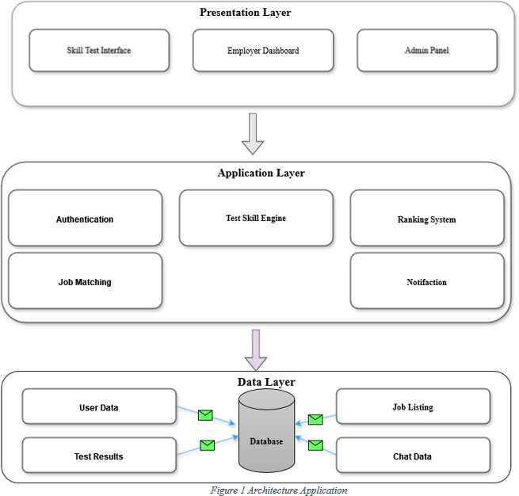

#### Definitions, Acronyms, and Abbreviations

|  |  |  |
| --- | --- | --- |
| **Acronym** | **Definition** | **Description** |
| SIRS | Smart Internship Recommendation System | Project name focused on internship matching and career insights. |
| API | Application Programming Interface | A method to access data from external internship sources. |
| NFR | Non-Functional Requirements | Criteria for performance, security, and usability. |

|  |  |  |
| --- | --- | --- |
| **Acronym** | **Definition** | **Description** |
| FR | Functional Requirements | Features the app should provide to users. |
| FIREBASE | Firebase | A platform for app development, providing tools like authentication and databases. |