开发者日志存档：
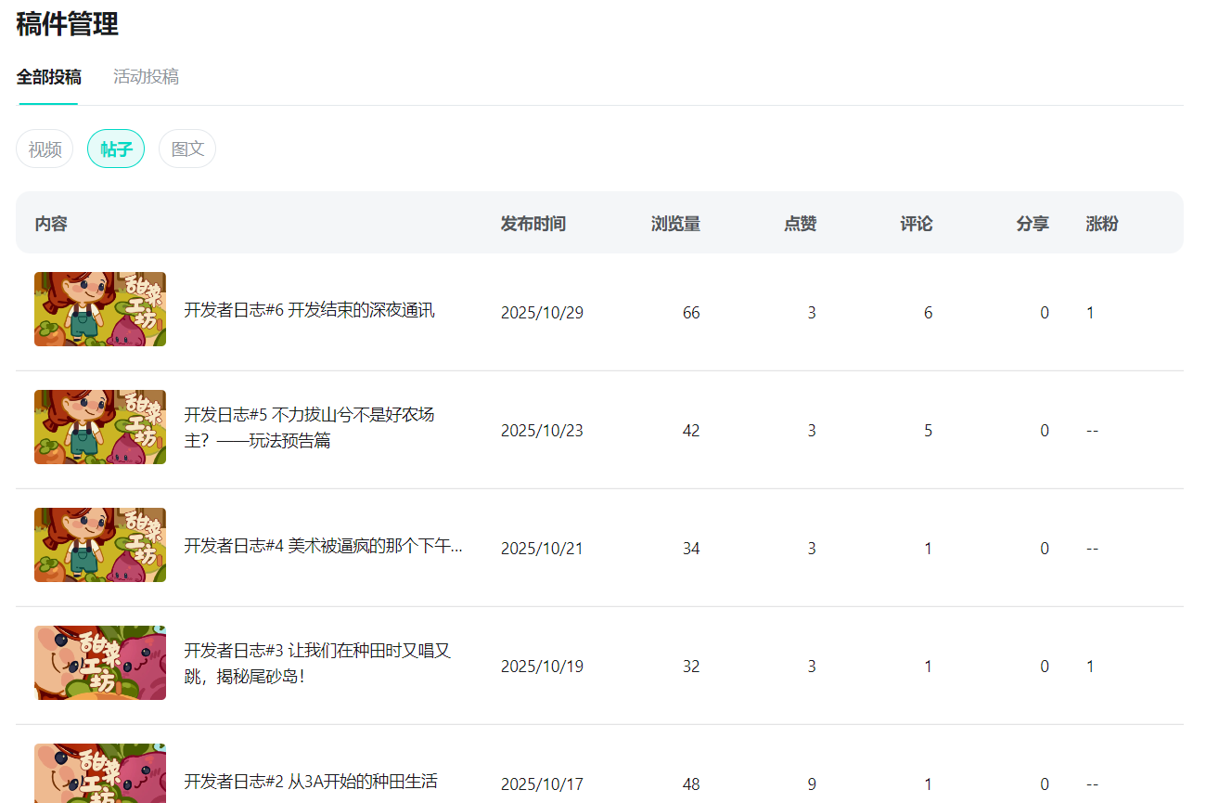

开发者日志#1 在BUG上长了个治愈游戏？
https://www.taptap.cn/moment/727683133889055174?share_id=cc9a407971bd&utm_medium=share&utm_source=copylink
开发者日志#2 从3A开始的种田生活
https://www.taptap.cn/moment/728342322596545677?share_id=9cb7015523cb&utm_medium=share&utm_source=copylink
开发者日志#3 让我们在种田时又唱又跳，揭秘尾砂岛！
https://www.taptap.cn/moment/729068786241505859?share_id=f5a1b0345e8a&utm_medium=share&utm_source=copylink
开发者日志#4 美术被逼疯的那个下午…
https://www.taptap.cn/moment/729774332045167825?share_id=1b17fcea3bd7&utm_medium=share&utm_source=copylink
开发日志#5 不力拔山兮不是好农场主？——玩法预告篇
https://www.taptap.cn/moment/730543134982800298?share_id=be50ff06e447&utm_medium=share&utm_source=copylink
开发者日志#6 开发结束的深夜通讯
https://www.taptap.cn/moment/732745565728671958?share_id=5f4f4e2c1b37&utm_medium=share&utm_source=copylink

