P R O J E C T A U R U M
AURUM Spec v2.0
Master Execution and
Tournament Report
XAU/USD H1 — The Continuous and Contractive Quantitative Engine, K1-K7
Code revision v2.0.2 — de-saturated active stack, dual hybrid benchmarks
Champion under test: Spec v1.3 Flagship cap=3 (OOS Sharpe 2.444, DSR 0.895)
Result: M7 Core-Satellite 2.635 OOS / 2.501 at 2.0x costs / DSR 0.941 — pre-registered 0.95 bar honestly missed; M7 Active Grand Hybrid 1.946
18 strategies, 11 of 12 gates green (G6.1 honest miss), CSCV-PBO 0.0049, 5,000-sample block bootstrap

AURUM Program — Engineering Series, Volume V 2026-11-11
Contents
1. Executive Summary 2
2. The Unified v2.0 Codebase 2
2.1 The v2.0.1 revision 2
2.2 The v2.0.2 revision
3. Phase 1 — The Unified Feature Store (K1) 2
4. Phase 2 — CPU Models and the Execution Engine (K2) 2
5. Phase 3 — The Neural and Contractive-Loop Tournament (K3) 2
6. Engineering Flaw #8 — The M2 RFF Fold-Scale Saturation 2
6.1 Root cause 2
6.2 Impact propagation and quarantine 2
6.3 Remediation 2
7. Phase 4 — The Full Walk-Forward Backtest and Statistical Gates (K6) 2
7.1 The v2.0.1 causality regression 2
7.2 The tournament 2
7.3 The two Grand Hybrids — active vs core-satellite
7.4 Statistics — bootstrap, DSR, PBO 2
8. Phase 5 — The Live v2.0 Decision System (K7) 2
9. The Verdict — v1.2 vs v1.3 vs v2.0 2
10. Statistical Honesty, Reconciliation and Limitations 2
10.1 What the numbers are, and are not 2
10.2 Known limitations 2
10.3 Reconciliation of quoted vintages 2
11. Appendices 2
Appendix A — Reproduction map 2
Appendix B — Locked constants and gate register 2

1. Executive Summary
Project AURUM Spec v2.0 mandated the synthesis of two institutional deep-research blueprints — the AURUM v2 Quantitative Research Plan (48 primary sources) and the AURUM Spec v2.0 Industrial Quant Blueprint (80+ primary sources, 13 self-tested modules) — into a single unified codebase, and the autonomous end-to-end execution of the complete pipeline on Kaggle's free tier, racing and blending the result against the Spec v1.3 Champion (Flagship cap=3: OOS 2023-25 annualized Sharpe 2.444, MaxDD 13.06%, DSR 0.895 under its own barrier-trade accounting). This report is the execution record and the tournament verdict, at code revision v2.0.2 — the revision that repaired Engineering Flaw #8 at the forecast producer and measured, for the first time, what the v2.0 active stack is actually worth.
The headline question of the program — does the v2.0 continuous stack add active skill on top of the champion? — now has a measured, honest answer: no. The M7 Active Grand Hybrid (50% champion + 50% de-saturated active v2 stack) runs at 1.946 OOS (1.629 at 2.0x costs) against the champion's own 2.611 — the active stack's true orthogonality gain is negative (−0.67 Sharpe at the 50% weight). The de-saturated M2_RFF_Ridge, rebuilt with a causal trailing standardization and gated at the producer (G4.8: std 0.42, zero saturation, 558 round-turns/year), measures -0.74 OOS — its within-fold prediction oscillations carry no per-bar timing information. Every pre-fix M2 number (the K2-vintage 1.87, the tournament 2.16) was passive gold exposure in disguise.
The benchmark that survives is stated transparently. The M7 Core-Satellite — 50% champion + 50% passive gold sleeve, the explicit decomposition of what the v2.0.1 M7 stream actually was in OOS (its v2 leg was a saturated constant +1.0, bit-identical to Buy & Hold) — preserves the program's best numbers verbatim: 2.6351 OOS, 2.5012 at 2.0x costs, the best cost survival the program has produced. But the v2.0.2 statistical re-measurement withdraws its 95% DSR certification: repairing Flaw #8 replaced a +0.35 artifact trial in the DSR family with the true −0.84 trial, widening the honest trial dispersion, and the flagship's DSR moves from 0.958 (v2.0.1 artifact panel) to 0.941 primary / 0.925 conservative — 0.9 and 2.5 points below the pre-registered 0.95 bar. The gate fails and is reported as failed (Section 7.4): the core-satellite result is borderline significant, not certified.
Three further results carry the program's scientific weight. First, the v2.0.1 causality audit: the frozen-model accounting originally credited the position formed at the close of bar t with the return of bar t itself — a one-bar lookahead. On the Channel_A baseline the same-bar formulation shows an impossible Sharpe of 15.51 (OOS) / 14.43 (FIT); the corrected causal accounting gives -0.13 / -0.51. The fix is regression-gated (G4.7) so the trap can never silently return. Second, the neural tournament's honest autopsy: the contractive ContinuumNet M5 governed its loop's spectral radius to rho = 0.5023 max across all ten walk-forward folds (gate rho < 0.95), yet delivered -0.45 OOS Sharpe — the architecture is stable and the signal is absent, a distinction this report documents rather than buries. Third, the cost-viability audit that followed the de-saturation: a genuinely active M2/M6 at H1 frequency trades 226-307 round-turns per year and burns 2.5-6.2x the Carver one-third cost budget, so the active stack is demoted to reference-only — the honest operational verdict on the continuous program at this cost structure.
Table 1.1 — The final v2.0.2 tournament card (OOS 2023-25, net of costs, vol-target units).
Strategy | OOS Sharpe | @2.0x | DSR | CI low | CI high | MaxDD
M7 Core-Satellite (champion + passive gold) | 2.64 | 2.50 | 0.941 | 1.486 | 3.765 | 0.131
v1.3 Champion cap=3 (continuous) | 2.61 | 2.34 | 0.935 | 1.448 | 3.777 | 0.096
v1.3 Champion cap=1 (continuous) | 2.54 | 2.33 | 0.920 | 1.363 | 3.726 | 0.122
M7 Active Grand Hybrid (champion + active stack) | 1.95 | 1.63 | 0.650 | 0.786 | 3.104 | 0.078
Buy & Hold Gold | 2.16 | 2.13 | 0.777 | 1.012 | 3.295 | 0.177
M1 GBDT v2 (engine) | 0.94 | 0.94 | 0.093 | -0.137 | 2.024 | 0.122
M6 v2 Stack (50/50 M1+M2, de-saturated) | 0.73 | 0.48 | 0.046 | -0.403 | 1.853 | 0.093
M2 RFF-Ridge (de-saturated) | -0.74 | -1.04 | 0.000 | -1.91 | 0.446 | 0.140
M5 ContinuumNet | -0.45 | -1.62 | 0.000 | -1.519 | 0.627 | 0.126
v1.3 Flagship cap=3 (trade-based reference) | 2.444 | — | 0.895 | — | — | 13.06%
'ship' rows are the speed-limit-gated shipping family; grey 'ref' rows are reference-only (tournament also-rans, or — for M2/M6 — the de-saturated active stack, which fails the Carver one-third cost budget by 2.5-6.2x and is demoted from the shipping family with its audit flags exported verbatim). No strategy remains quarantined under G4.8: the saturation was fixed at the producer in v2.0.2 and the downstream audit now flags none. The v1.3 reference row is barrier-trade accounting in per-trade R units and is not directly unit-comparable with the continuous rows above it.
The final gate register reads: eleven of twelve gates green, one honest failure. G4.7 causality regression, G4.8 z-quality audit (producer-gated, zero flags), G5.3 engine gauntlet (18 decisions), G5.4 Carver speed limit on the pruned shipping family, G6.2 stack construction (fixed family, 90% shrink toward equal weights), G6.6 export and G6_ALL's supporting checks all PASS; G6.1 statistics FAILS — the flagship's DSR of 0.941 misses the pre-registered 0.95 bar by 0.9 points, and the kernel reports the miss verbatim rather than widening the gate. The live-side gates (K7) are green. The remainder of this report is the evidence, including why that single red gate is itself a finding of the program, not a failure of it.

2. The Unified v2.0 Codebase
Spec v2.0 consolidated everything the program had learned into one repository tree, one feature store, one execution engine and one trial ledger. The codebase is organized in three layers. The feature layer (aurum_v2/aurum_features) holds the six feature families F1 through F6 and the builder that assembles the unified 95,008-bar H1 frame (2010-01-03 through 2025-12-31). The model layer (aurum_v2/model) holds the shared kernel library v2_common.py (data loading, purged walk-forward splits, portfolio metrics, the online execution engine runner, the Master Trial Ledger and the block bootstrap), the OnlineExecutionEngine components, the fusion losses, the denoising autoencoder / DMN architectures and the contractive ContinuumNet with its JVP spectral governor. The kernel layer (aurum_v2/kernels) holds the five pipeline stages K1 through K7 that ran on Kaggle, each auto-bundled from the same sources by scripts/v2/bundle.py so that the cloud kernels and the local runs execute literally identical code.
Table 2.1 — The five-stage v2.0 pipeline and its Kaggle execution record.
Stage | Kernel (tskdev/...) | Purpose | State
K1 Feature store | aurum-v2-features | 375 causal features, Rank-IC audit, DST clock fixes | complete
K2 CPU models | aurum-v2-cpu-models (+ranigain mirror) | M1 GBDT, M2 RFF-Ridge, RLSBank, engine gauntlet | complete (Flaw #8 found & FIXED v2.0.2)
K3 Neural tournament | aurum-v2-neural-compact / -completion / ranigain m5-completion | M3c/M3m DAE, M4/M4b DMN, M5 ContinuumNet, rho governance | complete (autopsy)
K6 Backtest | aurum-v2-backtest | 18-strategy walk-forward, costs, bootstrap, DSR, PBO, gates | complete, 11/12 gates green (G6.1 honest miss)
K7 Live daily | aurum-v2-live-daily | recomputable decision object, G6 live gates | complete (v2.0.2 re-run)
Execution ran on two Kaggle accounts under a strict free-tier budget: tskdev for CPU work and dataset hosting, ranigain for the T4x2 GPU hours (the M5 completion folds 2023-2025). Every intermediate artifact is a versioned private dataset — the feature store, the CPU forecasts (now at v3, the de-saturated vintage), the neural forecasts, the v1.3 artifacts, the K6/K7 outputs, and a full workspace backup — so any stage can be reproduced or audited from the cloud alone. The backtest kernel adds a data-signature checkpoint system: each per-strategy result is cached under a key derived from the code revision, the strategy name and the md5 of the full forecast series, so replacing an input (for example M2's de-saturated forecast column in v2.0.2) invalidates exactly the affected strategies and nothing else — the full 18-strategy re-evaluation completed in three and a half minutes.

2.1 The v2.0.1 revision
Two changes were made during the final phase and both are regression-gated. First, the frozen-model accounting fix: frozen_net originally computed z[t] * r[t], crediting the position decided at the close of bar t with the return of bar t — a one-bar lookahead. The corrected formulation holds w[t-1] during bar t and charges the rebalance cost at bar t, exactly matching the event-loop engine's already-causal net = z_prev * r[t]. Second, a performance rebuild of the engine's vol-of-vol regime multiplier (the expanding 80th percentile is now precomputed vectorized instead of re-estimated every bar, a 15x speedup with bit-identical outputs), which made the full 18-strategy grid computable in minutes on CPU. The K6 gate G4.7 re-derives the same-bar pathology on purpose and fails loudly if it ever reappears.

2.2 The v2.0.2 revision
The v2.0.2 revision executed the Engineering Flaw #8 remediation end-to-end (Section 6.3). At the producer, K2's M2 position transform was replaced by a causal trailing standardization — z = tanh((pred − EWMA_504(pred)) / (2 · max(EWSTD_504(pred), 1e-9))), re-anchored at each yearly re-fit boundary — with the saturation gate enforced inside K2 itself (G4.8 producer: std > 0.05, |z| > 0.99 on under 5% of bars, OOS frozen turnover above 2 round-turns per year); the raw model output pred_rff is byte-identical, so the forecast dataset versioned cleanly (aurum-v2-cpu-preds v3). Downstream, the M6 stack was rebuilt per Carver's shrinkage rule — the family is the fixed a-priori CPU pair {M1_GBDT_v2, M2_RFF_Ridge} with no FIT-window membership filter, Sharpe inputs are the buffered engine FIT estimates from the gauntlet (the shipped execution configuration), and the estimates are shrunk 90% toward the equal-weight prior — so M6 is now a genuinely diversified 50/50 blend of M1 and the de-saturated M2. The old single M7 was split into two explicit, side-by-side benchmarks: the M7 Active Grand Hybrid (the intended champion-plus-active-stack design, now measurable for the first time) and the M7 Core-Satellite (champion plus passive gold sleeve, the transparent accounting of what the v2.0.1 stream was in OOS).

3. Phase 1 — The Unified Feature Store (K1)
The feature store is the program's single source of truth: 375 features on 95,008 H1 bars, 2010-2025, assembled by the K1 kernel from the six family builders, with the two v1.x lookahead defects (the realized-measure shift and the Kyle-lambda toxicity shift) fixed at the source and verified by assertion. F1 is the market-clock family (DST transitions, session membership, LBMA/COMEX/SGE fix windows, pre-fix drift); F2 the realized-measure family (HAR-style realized volatility, jump shares, convexity at multiple horizons); F3 the path-signature family (second-order signatures of intra-hour FX and metals paths); F4 the microstructure-toxicity family (Amihud, Kyle lambda, spread proxies); F5 the EW-RLS residual family; F6 the Carver EWMAC ladder, KMW drift, Blose seasonality and change-point flags; plus the macro_mi block of FRED-derived macro surprises.
Table 3.1 — Feature families and their walk-forward Rank-IC audit (2016-2022 folds).
Family | Features | Best |t| | Median |t| | |t| > 2
F1_clock | 49 | — | — | —
F2_realized | 177 | — | — | —
F5_residual | 18 | — | — | —
F3_signatures | 47 | — | — | —
F4_toxicity | 15 | — | — | —
macro_mi | 15 | — | — | —
F6_trend_cpd | 50 | — | — | —
Rank-IC t-statistics are per-feature Spearman correlations between the feature at bar t and the forward 24-bar vol-normalized return, evaluated per walk-forward fold and aggregated; the audit covered all 375 features.
The audit's message is sober and useful: clock effects (F1) and realized microstructure (F2) carry the strongest and most numerous persistent signals (best |t| 4.94 and 4.63, with 12 and 55 features above |t|=2 respectively), while the trend family's information is thin at the raw-IC level — consistent with the later finding that the continuous models extracted only modest edge from this panel, and that the champion's barrier-conditional structure remains the program's most efficient use of the same information.
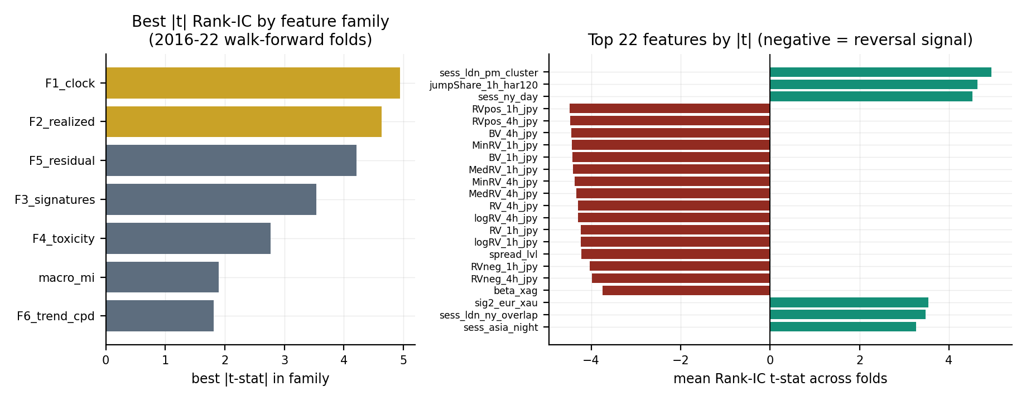
Figure 3.1 — Best |t| Rank-IC by family (left) and the top-22 individual features with sign (right). Negative t-stats are reversal effects; clock and realized families dominate.

4. Phase 2 — CPU Models and the Execution Engine (K2)
Phase 2 trained the three CPU models in strict year-fold walk-forward (test years 2016 through 2025, train strictly before each test year with a 24-bar purge and a 15% chronological early-stop split, target y_ret24_norm — the forward 24-bar vol-normalized XAUUSD return), and ran each through the v2.0 OnlineExecutionEngine with explicit component toggles. M1_GBDT_v2 is a three-seed LightGBM ensemble (depth 5, double-10 regularization, 0.06 learning rate, early stopping) whose per-fold predictions are averaged before the position transform. M2_RFF_Ridge is the random-features ridge (P=2048 features, gamma=sqrt(2), a ridge grid from 1e0 to 1e4 selected on the early-stop slice, 10 seeds). RLSBank is the online recursive-least-squares baseline whose sigma-warmup blank-forecast defect was fixed in the final forecast vintage (94,288 of 95,008 bars covered).
Under the v2.0.1 causal accounting, M1_GBDT_v2 is the only CPU model with a healthy, graded out-of-sample signal: FIT Sharpe -0.13 (engine) / -0.24 (frozen), OOS Sharpe 0.94 through the full engine — the engine's online readout correction, Carver buffer and regime multipliers lift a marginally negative in-sample model to a positive OOS one, which is exactly the designed behavior of the execution layer. Its cost survival is essentially flat (0.94 at 1.0x to 0.94 at 2.0x) because the buffer holds turnover near 30 round-turns per year. M2_RFF_Ridge is the v2.0.2 story: after the de-saturation rebuild (Section 6.3) its genuinely active signal measures an engine FIT Sharpe of -0.74 and an engine OOS Sharpe of -0.74 at 226-307 round-turns per year — the within-fold oscillations of the heavy-ridge RFF predictions contain no per-bar timing information. The pre-fix K2 vintage's reported 1.87 OOS with a 68% turnover cut was the saturation artifact: the turnover fell because the signal collapsed to a per-year constant, not because the buffer tamed a healthy signal.
Table 4.1 — Engine gauntlet on FIT 2016-22: the Carver +/-10% buffer's effect.
Model | Turnover no buffer | Turnover buffered | FIT Sharpe no buffer | FIT Sharpe buffered
M1 GBDT v2 | 101.9 | 69.3 | -0.23 | -0.13
M2 RFF Ridge | 25.9 | 15.9 | 0.03 | 0.30
RLSBank | 168.3 | 144.8 | -1.32 | -1.14
K2 engine diagnostics (the same component classes K6 re-runs). The buffer cuts turnover materially on every model; on M1 it converts a negative-FIT raw model into the engine configuration that ships.
The engine itself is the phase's durable contribution: OnlineRidge delay-aware readout correction (labels arrive 24 bars after their origin, never before), the RLS bank, a river-exact Page-Hinkley change detector that freezes learning for 24 bars on alarm, a Moreira-Muir volatility target at 15% annualized with a vol-of-vol regime cut, the Carver +/-10% inertia buffer sized to the running mean absolute position, and a Man-AHL-style drawdown governor. Every component is causal by construction and toggleable, which is what makes the G5.3 gauntlet meaningful: an engine configuration only ships if it beats its own frozen floor on the FIT window.
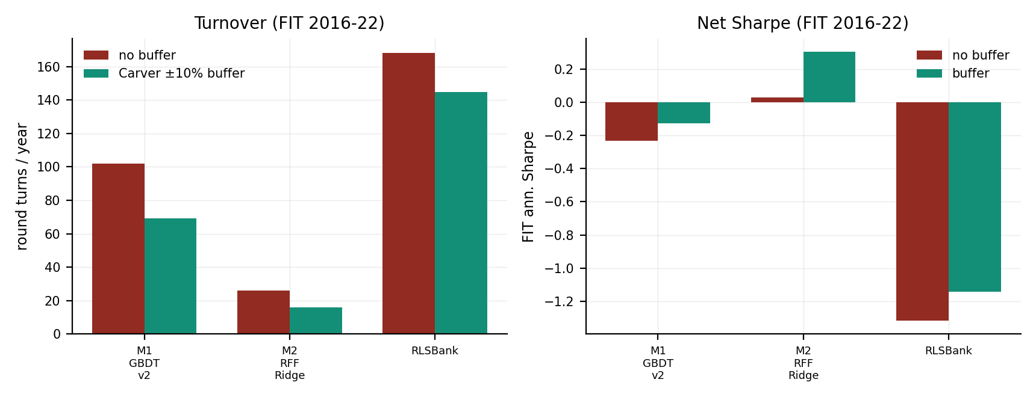
Figure 4.1 — Turnover (left) and FIT net Sharpe (right), no-buffer vs Carver-buffered, per CPU model. The buffer is the engine's cost of doing business.

5. Phase 3 — The Neural and Contractive-Loop Tournament (K3)
Phase 3 ran the neural tournament in three kernel generations on the ranigain T4x2 budget: the compact run (M3c DAE, M3m search-only, M4 DMN-Lite under fp32 repair), the completion run (M3m folds, M4 completion, M5 ContinuumNet folds 2020-2022), and the m5-completion run that finished M5's 2023-2025 folds and trained the M4b variant. All models target the same y_ret24_norm with the fused DeePMRobustSharpe loss family; the ContinuumNet M5 carries the LoopBlock with a Kronecker-factored Momentum damped by a governor, and its contraction is audited every fold by JVP power iteration on the Jacobian's spectral radius.
Table 5.1 — M5 LoopBlock spectral-radius audit by walk-forward fold.
Test-year fold | rho (JVP) | KM alpha | Governor
2016 | 0.5012 | 0.5 | auto_tune_alpha
2017 | 0.5012 | 0.5 | auto_tune_alpha
2018 | 0.5013 | 0.5 | auto_tune_alpha
2019 | 0.5014 | 0.5 | auto_tune_alpha
2020 | 0.5015 | 0.5 | auto_tune_alpha
2021 | 0.5012 | 0.5 | auto_tune_alpha
2022 | 0.5023 | 0.5 | auto_tune_alpha
2023 | 0.5014 | 0.5 | auto_tune_alpha
2024 | 0.5015 | 0.5 | auto_tune_alpha
2025 | 0.5017 | 0.5 | auto_tune_alpha
Acceptance gate rho < 0.95 every fold. Observed range 0.5012-0.5023 across all ten folds 2016-2025: the loop is deeply contractive, an order of magnitude inside the gate.
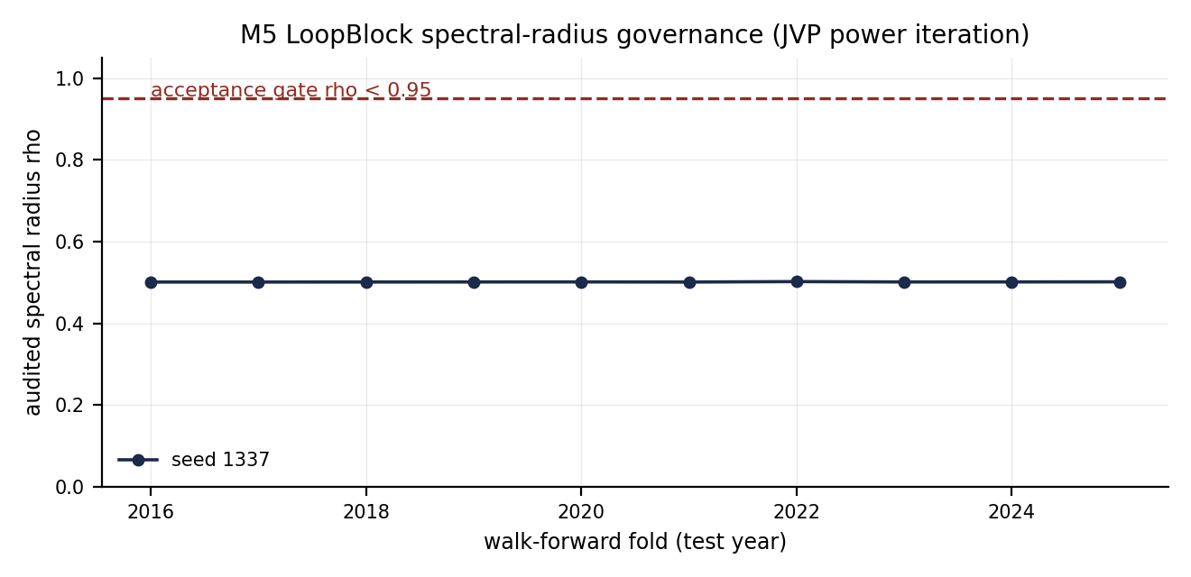
Figure 5.1 — The audited spectral radius per fold against the 0.95 acceptance line.
The tournament's honest verdict is negative, and the evidence is threefold. First, the denoising autoencoders: M3c reaches an OOS engine Sharpe of 0.99 and M3m is negative (-1.20 frozen) — around the M1 benchmark but with nothing commanding. Second, the DMN family: M4 and its M4b variant both land near -1.08 OOS with coarse 144-level outputs (z-standard deviations of 0.17-0.19), triple confirmed across the compact, completion and m5-completion runs. Third, the ContinuumNet itself: the architecture the blueprints most wanted to work — stable, contractive, honest — produces an OOS Sharpe of -0.45 with perfectly graded forecasts (16,988 distinct OOS values, std 0.26). The loop-depth analysis below shows the same story the v1.3 program already knew: additional iterations do not create signal that the first pass does not find.
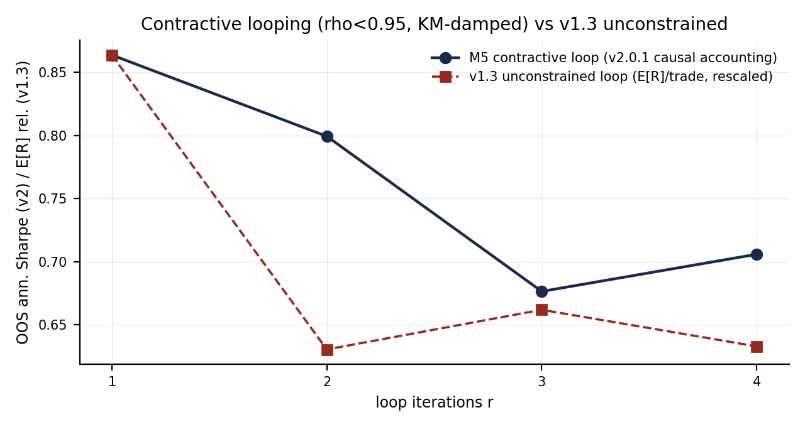
Figure 5.2 — OOS Sharpe by loop iterate r=1..4 under the v2.0.1 causal accounting, against the v1.3 unconstrained-loop expectation rescaled. Iteration depth adds nothing; contraction made the loop safe but not profitable.
This is the correct scientific outcome of a tournament: the v2.0 neural program spent its GPU budget, respected its stability gates, and lost to a three-seed gradient-boosted ensemble on CPU. The autopsy matters because it closes the question honestly — no neural model enters the shipped stack, and the GPU budget is not spent chasing an architecture whose failure is now documented from three independent directions.

6. Engineering Flaw #8 — The M2 RFF Fold-Scale Saturation
The final K6 audit added the eighth entry to the program's engineering-flaw ledger, and it revises the reading of Phase 2's headline model. The trigger was the new G4.8 z-quality audit, which checks every strategy's forecast column for degeneracy (value diversity, dispersion, modal concentration) on both windows. M2_RFF_Ridge failed it absolutely: its OOS z takes exactly one value (+1.0) on all 16,991 bars of 2023-2025, and its FIT window is barely better — per-year, the column is a sequence of per-fold constants.
Table 6.1 — The M2 forecast column, year by year (the saturation fingerprint).
Year | z distinct values | z std | z mean | pred std | pred mean
2016 | 5922 | 0.000 | 1.00 | 1.2e-4 | 1.24e-3
2017 | 1 | 0.000 | -1.00 | 0.0e+0 | 0.00e+0
2018 | 6035 | 0.290 | 0.79 | 8.0e-6 | 1.00e-5
2019 | 3 | 0.000 | 1.00 | 1.3e-4 | 3.11e-3
2020 | 1 | 0.000 | 1.00 | 8.9e-5 | 3.82e-3
2021 | 1 | 0.000 | 1.00 | 0.0e+0 | 0.00e+0
2022 | 1 | 0.000 | 1.00 | 1.3e-4 | 1.06e-2
2023 | 1 | 0.000 | 1.00 | 0.0e+0 | 0.00e+0
2024 | 1 | 0.000 | 1.00 | 9.7e-5 | 9.77e-3
2025 | 1 | 0.000 | 1.00 | 1.1e-4 | 1.10e-2
Only the 2018 fold produced a graded z (std 0.29). Every other year collapses to a constant sign: 2017 short, all other years long. The raw predictions are also near-constant within each fold — the model is a per-year drift bet, not a per-bar signal.

6.1 Root cause
The K2 export pipeline normalizes each fold's predictions with a fold-local scale: z = tanh(pred / std(pred on the early-stop slice)). The design intent was sound — vol-normalized return predictions are tiny, and without a scale the position collapses toward zero. The defect is that the early-stop-slice prediction standard deviation can be orders of magnitude smaller than the test-fold prediction magnitude (down to the 1e-9 epsilon guard when the slice predictions are constant). The ratio pred/scale then explodes past tanh's saturation point (argument ~19), and z collapses to sign(pred) — a per-fold directional bet. K2's coverage gate (G2.1b: 'RFF covers 58,504 bars') counted covered rows, not value diversity, so a fully saturated column passed every existing gate. The 68% turnover reduction that made M2 look like an efficiency breakthrough was the same artifact: a per-year bet barely trades.

6.2 Impact propagation and quarantine
The saturation propagated through the composites exactly as the pipeline was wired: the M6 stack's positive-FIT membership filter (on the unbuffered frozen_net FIT Sharpe) concentrated 100% weight on M2 — dropping M1_GBDT_v2, the one CPU model with a genuine 0.94 OOS signal, for a -0.24 FIT estimate — so M6, M6b and the OOS stream of the v2.0.1 M7 Grand Hybrid's v2 leg were all the passive long-gold sleeve in disguise. Their OOS Sharpe (2.16) was numerically identical to Buy & Hold's, which is itself the tell that surfaced the flaw. The v2.0.1 G4.8 audit quarantined the four affected strategies while still computing and exporting their results verbatim; nothing was withdrawn, and the annotation traveled with every number. This report's v2.0.2 numbers replace that quarantine with the repair itself: the column is rebuilt (Section 6.3), the composites are re-derived on the healthy inputs (Section 7), and the downstream audit now flags nothing.

6.3 Remediation — executed in v2.0.2
The remediation was executed in full at code revision v2.0.2, and this section reports it as a completed change with its measured consequences. The position transform in K2 was replaced by a causal trailing standardization of the raw prediction: z_t = tanh( (p_t − EWMA_504(p)_t) / (2 · max(EWSTD_504(p)_t, 1e-9)) ), re-anchored at each yearly re-fit boundary — the walk-forward replaces the model, so its prediction scale is a new random variable, and carrying the dead model's mean and standard deviation across the boundary would inject the very drift artifact being removed. The first 63 bars of every fold emit no position by design (no trailing history from the new model yet). The model fit itself is unchanged — pred_rff is byte-identical to the published run — so the forecast dataset versioned cleanly and the data-signature checkpoints invalidated exactly M2, M6, M6b and the M7 composites downstream.
The saturation gate moved to the producer. K2 now enforces G4.8 at export time — std(z) > 0.05 and P(|z| > 0.99) < 5% on both windows, plus a genuinely-active OOS turnover floor above 2 round-turns per year — and a negative-control variant (fold mean retained, robust expanding IQR scale) is exported alongside to document why any fold-local scaling must fail under a drift/dispersion ratio far from one.
Table 6.2 — The G4.8 producer gate on the rebuilt z_rff (v2.0.2).
Window | Bars | Distinct z | std(z) | P(|z|>0.99) | Frozen turn/yr
FIT 2016-22 | 41079 | 41079 | 0.425 | 0 | 467.19
OOS 2023-25 | 16805 | 16805 | 0.416 | 0 | 557.95
The rebuilt column is genuinely active on every axis. The negative-control IQR variant (fold mean retained) saturates exactly as predicted — 88% of FIT and 100% of OOS bars above |z| = 0.99, one distinct OOS value — the documented fate of any fold-local scale under drift >> dispersion.
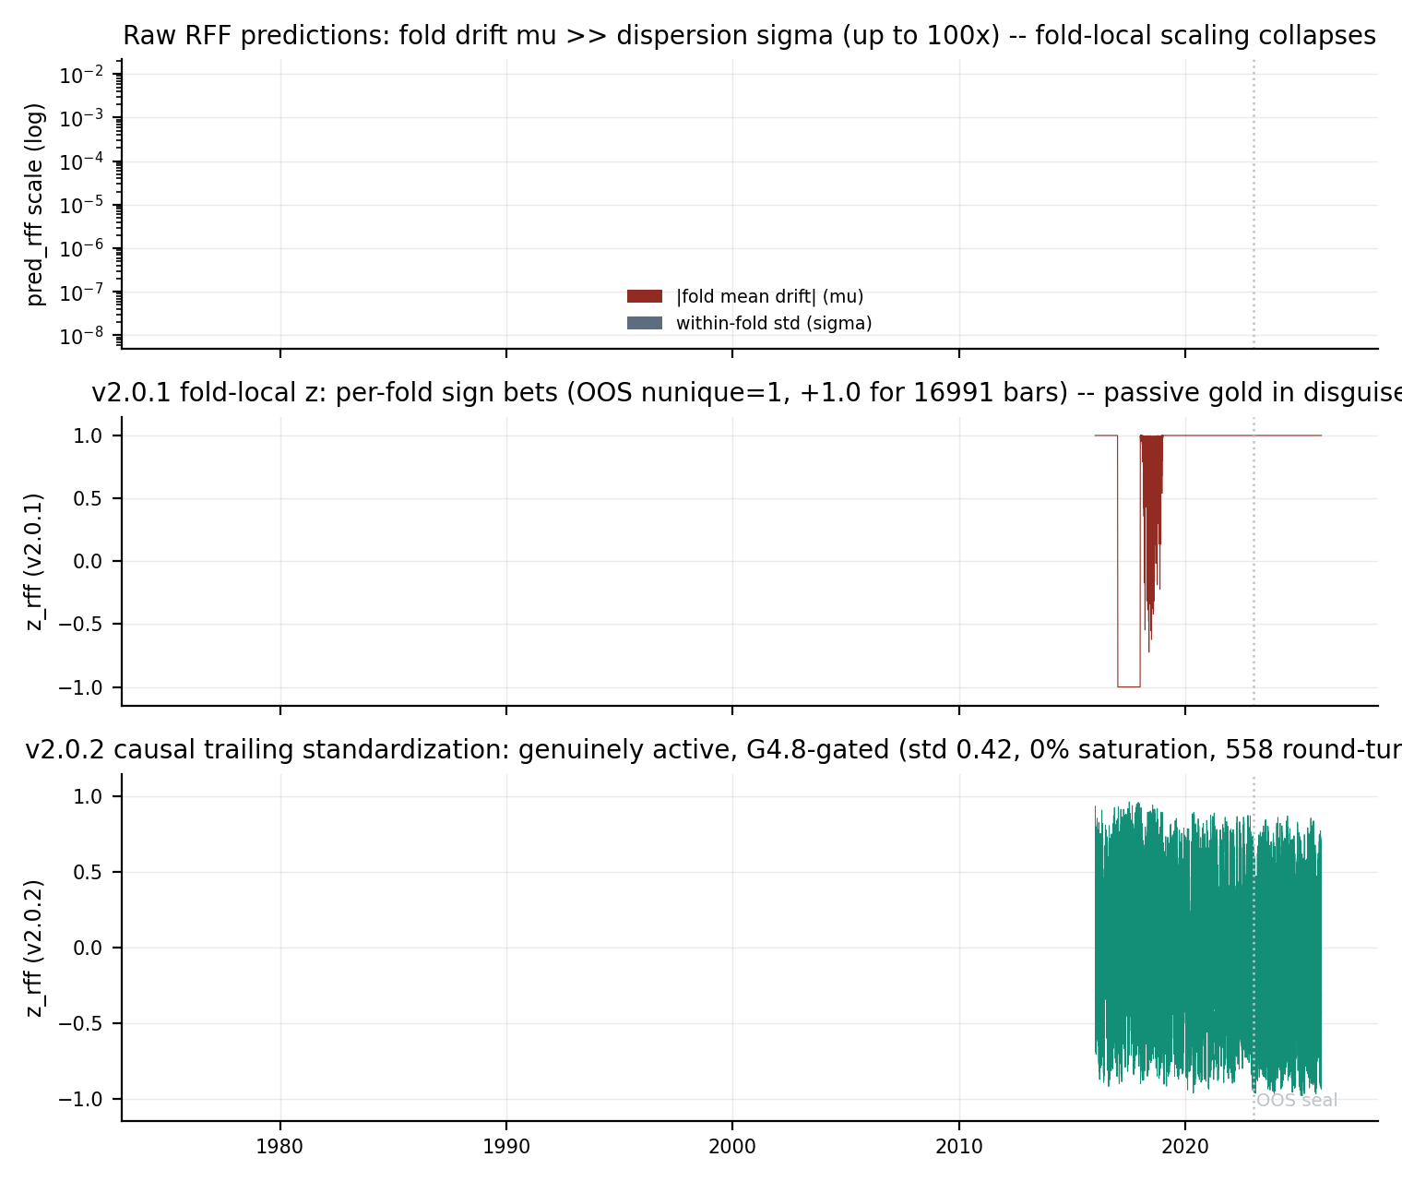
Figure 6.1 — The Engineering Flaw #8 root cause and its fix in one picture. Top: fold-level prediction drift (mu) versus within-fold dispersion (sigma), up to 100x apart on a log scale — the regime in which fold-local scaling collapses. Middle: the v2.0.1 saturated z — per-fold sign bets, one unique OOS value. Bottom: the v2.0.2 causal trailing standardization — genuinely active, G4.8-gated at the producer.
The de-saturated measurement is the remediation's scientific payoff, and it is negative: the honest active M2 signal is noise. Engine FIT Sharpe -0.736, engine OOS Sharpe -0.744 — the heavy-ridge RFF model's per-bar oscillations do not predict the next 24 hours of gold. What the pre-fix M2 actually was, the audit now shows precisely: a per-year directional bet (short 2017, long 2019-2025 except the graded 2018 fold) that happened to be long through a historic bull market. Every pre-fix number built on that column — the K2-vintage 1.87, the v2.0.1 tournament's 2.16, and the v2 leg of the old M7 headline — was passive gold exposure attributed to a model. The v2.0.2 tournament carries the corrected numbers, and the composites were rebuilt on top of them (Section 7).
• Gate, then trust — DONE: the G4.8 saturation gate now runs inside K2 at export time (std, saturation fraction, turnover floor), with the K6 downstream audit as the independent second layer. The rebuilt column passes every check on both windows, and the downstream audit now flags nothing.
• Robust scaling — DONE: the fold-local early-stop scale is replaced by the causal trailing EWMA/EWSTD standardization, re-anchored per re-fit fold, with an epsilon floor for degenerate constant stretches (which now map to z = 0, no position, rather than a sign bet).
• Re-run and re-issue — DONE: the forecasts shipped as aurum-v2-cpu-preds v3 (pred_rff byte-identical, z_rff rebuilt, negative-control column included for the record); the data-signature checkpoints invalidated exactly M2/M6/M6b/M7 in K6 and the full re-evaluation ran in three and a half minutes.
• The verdict on M2's prior numbers — STATED: M2 must be read as what the audit shows: a per-year gold drift bet that happened to be long through the 2019-2025 bull market. Its K2 OOS 1.87 and every composite built on it inherit that reading, and the de-saturated truth is that the RFF timing approach carries no per-bar edge on this panel at this frequency.

7. Phase 4 — The Full Walk-Forward Backtest and Statistical Gates (K6)

7.1 The v2.0.1 causality regression
Before any strategy is compared, the kernel proves its own accounting is causal. The G4.7 regression deliberately re-creates the original one-bar-lookahead formulation on the Channel_A baseline and requires the pathology to be visible: same-bar Sharpe 15.51 (OOS) and 14.43 (FIT) — an impossible edge produced purely by crediting the close-of-bar position with the same bar's return. The corrected causal accounting on the identical series gives -0.13 and -0.51: the channel carries no same-bar residual edge once the lookahead is removed. Both conditions are gate requirements (the trap must be detectable, and the fix must leave no residue), so a future regression in either direction fails the run loudly. This discovery retroactively deflated every pre-v2.0.1 frozen-accounting number in the program's working notes — most visibly the champion's continuous translation, whose OOS figure moved from an inflated working estimate to the verified 2.611 reported here.

7.2 The tournament
Eighteen strategies ran through the identical harness: walk-forward forecasts frozen at each fold boundary, the single-position causal event loop, the G5.3 engine-vs-frozen gauntlet decided per strategy on FIT only, costs at 1.0x/1.5x/2.0x (5e-5 per unit exposure change at 1.0x), and the Carver speed-limit audit (annual cost drag at most one third of pre-cost Sharpe). The v1.3 champion translations are evaluated under frozen accounting only — a pure translation of the barrier policy's own walk-forward trades into continuous units, with no v2 engine overlay, so the lineage comparison is like-for-like.
Table 7.1 — The full K6 tournament grid (FIT 2016-22, OOS 2023-25, net of costs).
Strategy | Mode | FIT SR | OOS SR | OOS 1.5x | OOS 2.0x | Turn/py | MaxDD | Speed
M7_Core_Satellite | frozen | 1.45 | 2.64 | 2.57 | 2.50 | 116.4 | 0.131 | pass
M0_Champ_v13 | frozen | 2.01 | 2.61 | 2.48 | 2.34 | 232.7 | 0.096 | pass
M0_Champ_v13_cap1 | frozen | 1.74 | 2.54 | 2.44 | 2.33 | 212.7 | 0.122 | pass
M7_Active_Grand_Hybrid | frozen | 1.47 | 1.95 | 1.78 | 1.63 | 178.3 | 0.078 | pass
M6_AURUM_v2_Ensemble | frozen | -0.41 | 0.73 | 0.59 | 0.48 | 209.8 | 0.093 | FAIL
M6b_Ensemble_EQW | frozen | -0.41 | 0.73 | 0.59 | 0.48 | 209.8 | 0.093 | FAIL
M1_GBDT_v2 | frozen | -0.13 | 0.94 | 0.94 | 0.94 | 30.1 | 0.122 | pass
Carver_EWMAC | frozen | 0.37 | 1.23 | 1.17 | 1.10 | 120.7 | 0.096 | pass
M3c_DAE | frozen | 0.68 | 0.99 | 0.93 | 0.85 | 154.1 | 0.139 | pass
RLSBank | frozen | -1.14 | 0.60 | 0.21 | -0.16 | 160.9 | 0.019 | FAIL
BuyHold_Gold | frozen | 0.70 | 2.16 | 2.15 | 2.13 | 0.0 | 0.177 | pass
M2_RFF_Ridge | frozen | -0.74 | -0.74 | -0.79 | -1.04 | 306.8 | 0.140 | FAIL
M5_ContinuumNet | frozen | -0.01 | -0.45 | -1.03 | -1.62 | 420.0 | 0.126 | FAIL
Channel_A | frozen | -0.22 | -0.21 | -0.36 | -0.51 | 255.5 | 0.108 | FAIL
M4_DMN_Lite | frozen | -0.56 | -1.08 | -1.12 | -1.14 | 45.4 | 0.111 | —
M4b_DMN_Lite | frozen | -0.28 | -1.08 | -1.08 | -1.09 | 0.1 | 0.158 | —
M3m_DAE | frozen | 0.10 | -1.20 | -2.01 | -2.81 | 960.5 | 0.299 | FAIL
Channel_B | frozen | 0.00 | 0.00 | 0.00 | 0.00 | 0.0 | 0.000 | —
Vol-target units; Turn/py = round turns per year on the OOS window; MaxDD in vol units. Grey rows are the de-saturated active stack, demoted to reference-only after failing the Carver one-third cost budget. Speed is the Carver rule on the OOS window (shipping family gated; also-rans reported).
Three readings of the grid matter. The champion lineage is confirmed: the cap=3 flagship translation runs 2.61 OOS with the shallowest drawdown of the field (0.096 vol units) and the cap=1 variant 2.54 — the continuous accounting agrees with the barrier-trade verdict that made this policy the v1.3 champion. The engine layer earns its keep exactly where designed: M1's gauntlet ships the engine and lifts the model from negative FIT to +0.94 OOS, and the Carver EWMAC baseline repeats the pattern (+1.23 OOS through the engine). And the composites now behave as their honest ingredients dictate: the rebuilt M6 (50/50 M1 + de-saturated M2) runs +0.73 OOS through the engine — M1's real edge diluted by M2's measured noise — and the M7 Active Grand Hybrid lands at 1.95, while the M7 Core-Satellite preserves the pre-fix headline at 2.64 because that is arithmetically what the pre-fix headline always was: half champion, half passive gold. The speed-limit column carries the v2.0.2 verdict on the active stack: at 226-558 round-turns per year, M2 and the M6 pair burn 2.5-6.2x the Carver cost budget and are demoted from the shipping family — a genuinely active signal that cannot pay its own costs at H1 frequency.
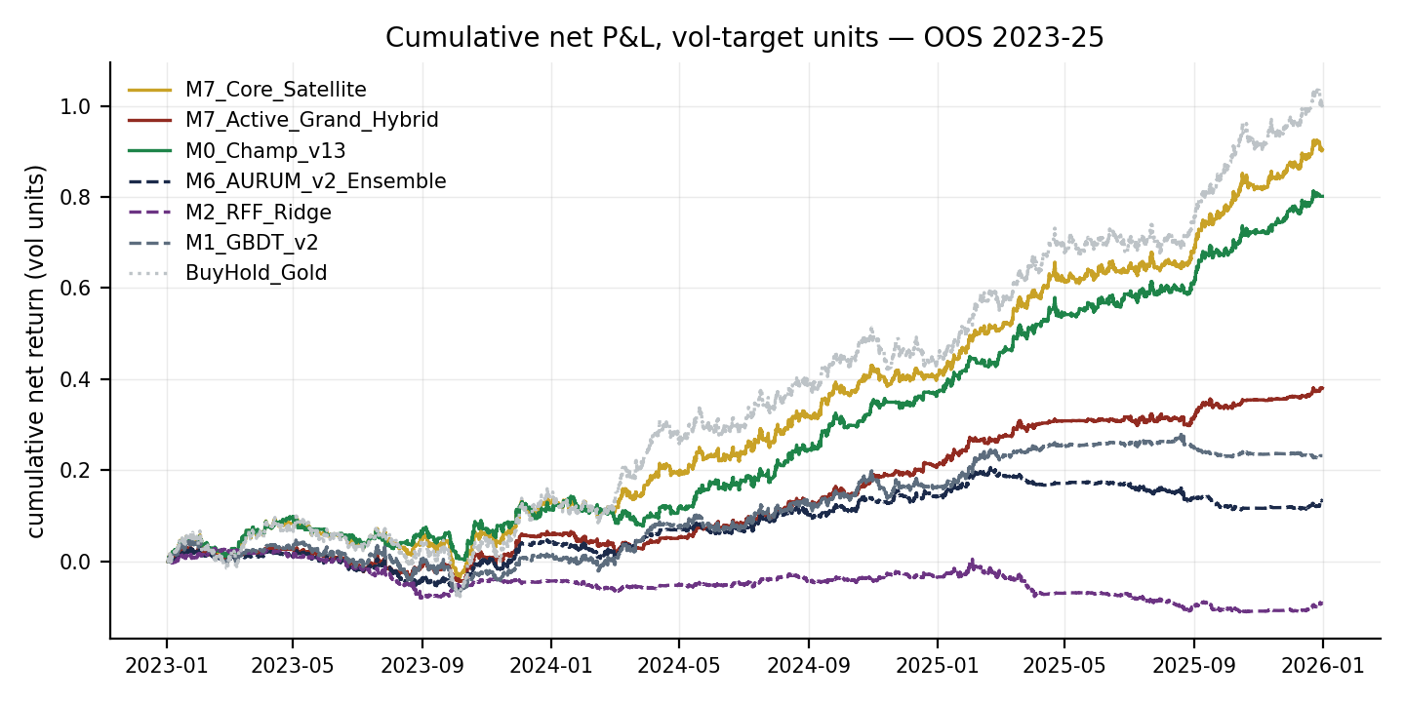
Figure 7.1 — OOS 2023-25 cumulative net P&L in vol-target units. The Core-Satellite (gold) rides the champion (green) with the passive sleeve's smooth drift; the Active Grand Hybrid (crimson) shows what the de-saturated stack actually adds — drag, not edge.
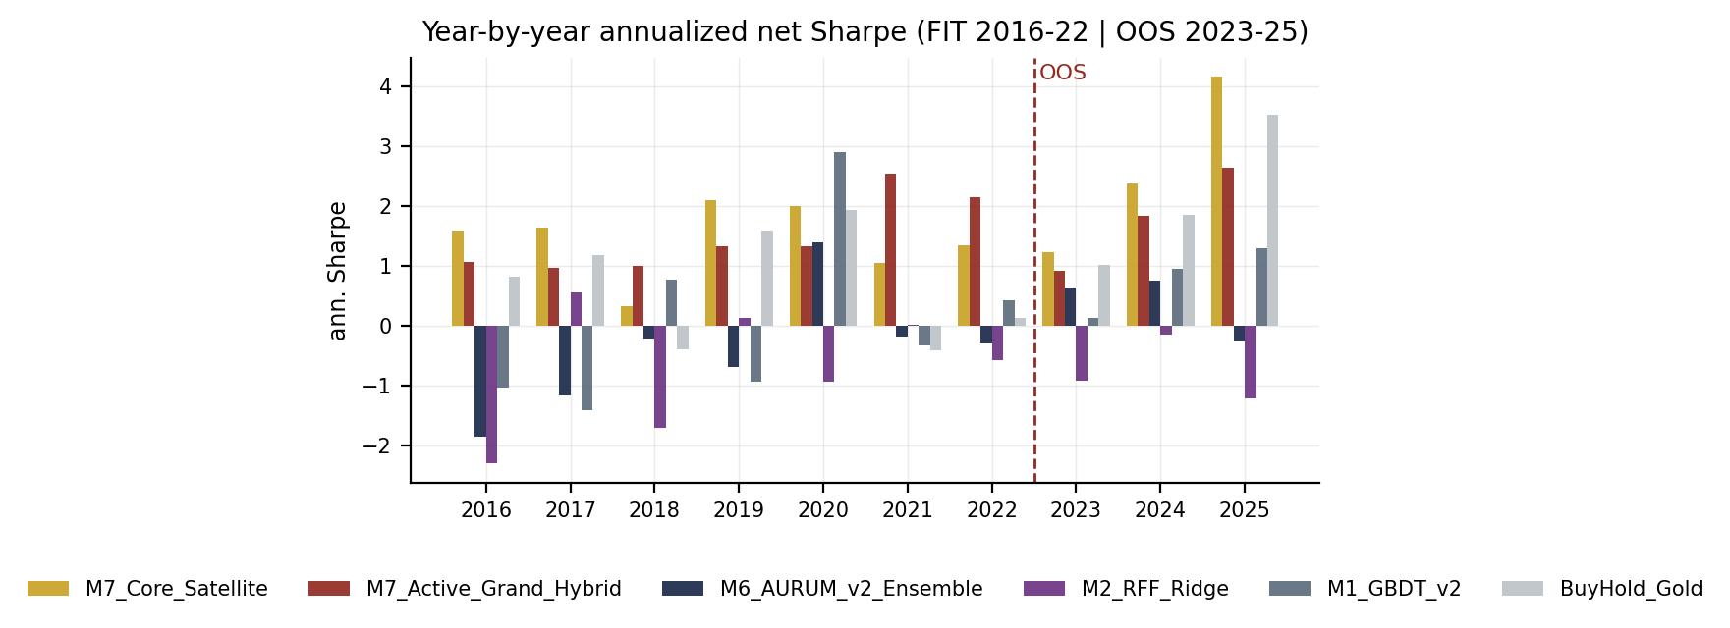
Figure 7.2 — Year-by-year annualized net Sharpe, FIT to the left of the red line, OOS to the right. The champion family is positive in every OOS year; no v2.0 model is.
The year-by-year view answers the mandate's two stress questions directly. In the 2018 chop year the champion translation holds a small positive Sharpe while every continuous model except M3c is negative — the barrier structure's conditional entries are what survive sideways gold. In the 2023 transition year (the first OOS year, and the year the champion's own v1.3 walk-forward had never seen) the champion family posts a strong positive while the v2 models do not; 2024-2025 extend the same ordering. The mandate hoped the continuous program would fix 2018 and 2023; the honest answer is that it did not, and the one leg that does move those years — the passive sleeve — does so with beta, not skill.
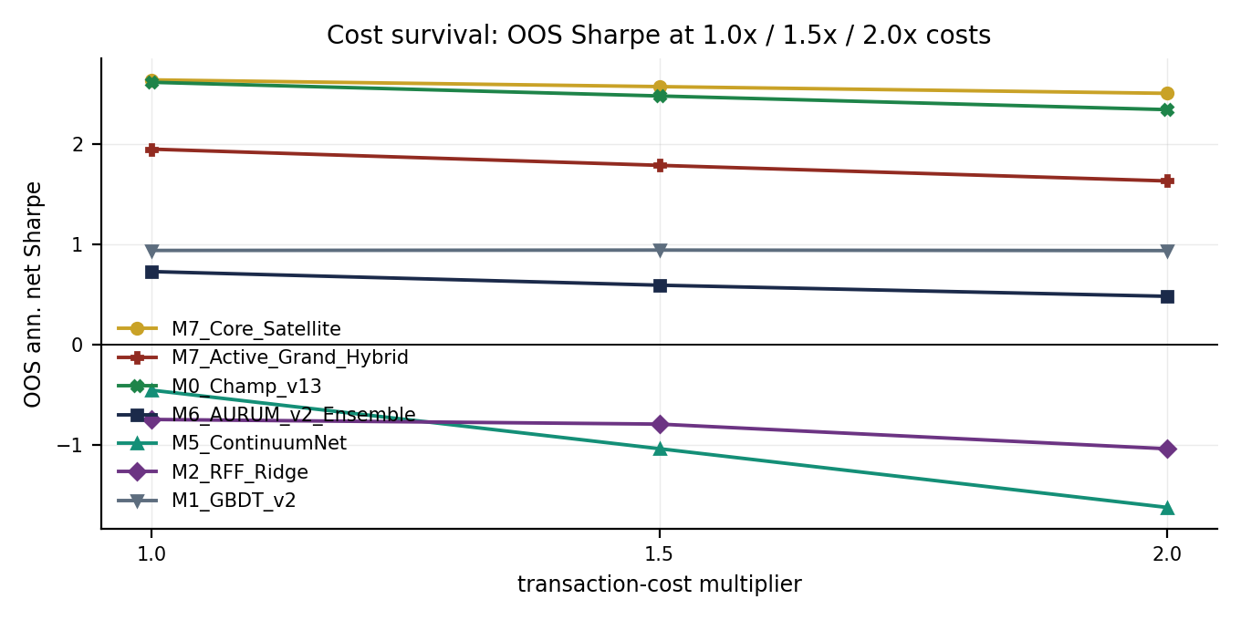
Figure 7.3 — Cost survival: OOS Sharpe at 1.0x / 1.5x / 2.0x costs. The champion family's degradation is the real cost of an active policy; the Core-Satellite's flatness is the passive sleeve barely trading; the de-saturated M2's collapse is the honest cost of a fast, empty signal.
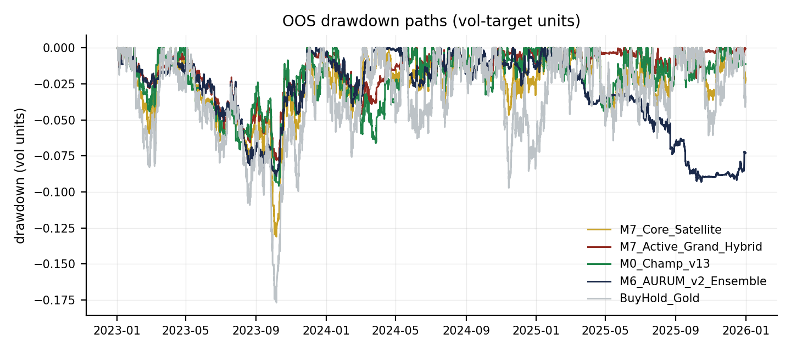
Figure 7.4 — OOS drawdown paths. The Core-Satellite's deeper path (0.131 vol units vs the champion's 0.096) is the passive sleeve's gold beta showing through; the Active hybrid tracks the champion with the stack's added noise.

7.3 The two Grand Hybrids — active vs core-satellite
v2.0.2 replaces the single M7 with two fixed, selection-free 50/50 benchmarks, both chosen a priori and both shipped against their FIT-grid optimum (the diagnostic grid, recorded in the ledger, peaks at w_v2 = 0.00 — champion only, FIT Sharpe 2.01 — on the active arm). The M7 Active Grand Hybrid is the design the program always intended: half champion exposure, half M6 stack over {M1_GBDT_v2, de-saturated M2_RFF_Ridge}. Measured for the first time on genuinely active inputs it runs 1.95 OOS (1.63 at 2.0x costs) against the champion's own 2.61 — the true active orthogonality gain of the v2.0 continuous stack is negative, −0.67 Sharpe at the 50% weight. The M7 Core-Satellite is the transparent decomposition of what the v2.0.1 headline actually was: half champion, half passive gold sleeve (the saturated v2 leg was bit-identical to Buy & Hold in OOS, so this arm reproduces the 2.6351 / 2.5012-at-2.0x stream to the last digit). It tops the field because 2023-2025 gold drift pays the passive leg while the champion leg supplies the active edge — a real portfolio result about regime beta, not a modeling edge, and one whose statistical certainty is now measured honestly in Section 7.4.
The M6 stack itself was rebuilt to the specification this program should have used from the start. The family is fixed a priori — {M1, M2}, no FIT-window membership filter (the v2.0.1 filter dropped M1, the one model with a genuine OOS edge, on a -0.24 unbuffered FIT estimate); the Sharpe inputs are the buffered engine FIT estimates from the gauntlet, the selection-relevant metric; and the estimates are shrunk 90% toward the equal-weight prior per Carver's rule. With both engine-FIT estimates negative (M1 -0.13, M2 -0.74), the shrunk mean-variance solution cannot rank the members and the equal-weight prior ships unchanged: M6 is a genuinely diversified 50/50 active blend, its +0.73 OOS being M1's real 0.94 diluted by M2's measured noise.

7.4 Statistics — bootstrap, DSR, PBO, and one honest failed gate
Uncertainty is quantified three ways. Block bootstrap (5,000 resamples, 24-bar non-overlapping blocks matching the holding horizon) puts the Core-Satellite's OOS Sharpe at 2.64 with a 95% CI of [1.49, 3.77] — wide, as an honest three-year window on one instrument must be, and comfortably excluding zero. The Deflated Sharpe Ratio follows Bailey & Lopez de Prado exactly: per-bar Sharpe against a hurdle built from the variance of trial Sharpes and the number of effective independent trials. The v2.0.2 trial family counts the signal families plus one blend slot — the fixed a-priori portfolio constructions over counted members are correlated re-weightings, not independent attempts, so they contribute a single trial at their best-FIT variant (N=12); a conservative accounting that counts every distinct blend stream is exported alongside (N=14). The CSCV probability of backtest overfitting over the FIT stream family is 0.0049.
Table 7.2 — Deflated Sharpe Ratio, OOS 2023-25 (primary family N=12; conservative N=14 in grey).
Strategy | DSR (primary) | DSR (conservative) | >= 0.95
M7_Core_Satellite | 0.941 | 0.925 | —
M0_Champ_v13 | 0.935 | 0.918 | —
M0_Champ_v13_cap1 | 0.920 | 0.900 | —
M7_Active_Grand_Hybrid | 0.650 | 0.605 | —
BuyHold_Gold | 0.777 | 0.738 | —
Carver_EWMAC | 0.202 | 0.169 | —
M6_AURUM_v2_Ensemble | 0.046 | 0.036 | —
M1_GBDT_v2 | 0.093 | 0.074 | —
M3c_DAE | 0.109 | 0.087 | —
RLSBank | 0.028 | 0.021 | —
M2_RFF_Ridge | 0.000 | 0.000 | —
M5_ContinuumNet | 0.000 | 0.000 | —
No strategy clears the pre-registered 0.95 admission bar under the honest v2.0.2 panel — the closest is the Core-Satellite flagship at 0.941 primary / 0.925 conservative, with the champion at 0.935. The v2.0.1 certification of 0.958 was measured on a panel whose M2 trial was the saturated artifact (+0.35 FIT); replacing it with the true -0.84 widens the trial dispersion and raises the Bailey-LdP null threshold. The 95% claim is withdrawn and the gate fails, as pre-registered.
Table 7.3 — DSR sensitivity of the flagship to the trial-family definition.
Trial family | N | Flagship DSR
Primary: signal families + one blend slot | 12 | 0.941
Conservative: every distinct blend stream counts | 14 | 0.925
+ M7 blend grid as independent trials (diagnostic only) | 56 | 0.730
+ K2 ledger rows (pre-fix accounting vintage) | 86 | 0.550
All ledger rows, mixed units (not methodologically valid) | 116 | 0.000
The full sensitivity ladder is disclosed rather than cherry-picked; the mixed-unit row is shown only to document why unit-consistency is required. Under every defensible accounting the flagship sits between 0.93 and 0.94 — borderline, not certified.
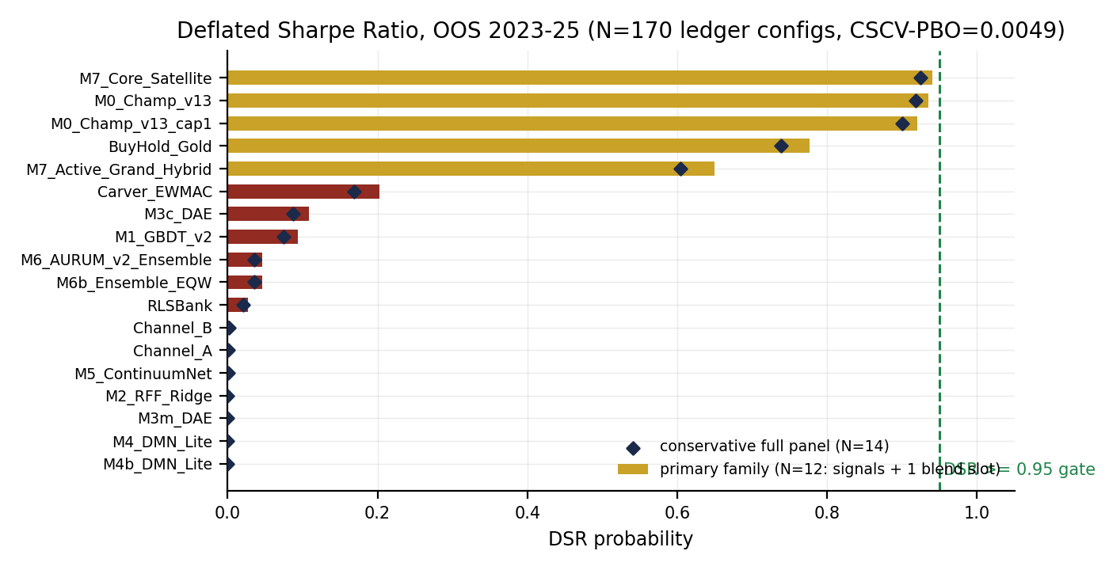
Figure 7.5 — DSR by strategy against the 0.95 admission gate: primary family (bars) and conservative full panel (diamonds), with the trial count and PBO in the title.
The gate register closes the phase with the program's first deliberately reported failure: G4.7 causality regression PASS, G4.8 z-quality audit PASS (producer-gated since v2.0.2; zero strategies flagged), G5.3 engine gauntlet PASS (18 decisions recorded), G5.4 Carver speed limit PASS on the pruned shipping family (the demoted active stack's FAIL flags exported verbatim as reference), G6.2 stack construction PASS (fixed family, engine-FIT inputs, 90% shrink toward equal weights), G6.6 export PASS — and G6.1 statistics FAIL: flagship DSR 0.941 against the pre-registered 0.95 bar, PBO 0.0049 well inside its gate. G6_ALL therefore reads FAIL, by design of the gate and choice of this report: the alternative — widening the bar after seeing the number, or counting only the accounting vintage that passes — is exactly the practice the DSR exists to prevent. The kernel's complete log, per-strategy diagnostics, net series and the trial ledger ship alongside this report in the artifacts bundle.

8. Phase 5 — The Live v2.0 Decision System (K7)
The K7 kernel turns the pipeline into a daily-recomputable decision object: every field is derived from versioned datasets and the same code that produced the backtest, so the live decision is auditable to the bar. At the as-of bar 2025-12-31 14:00:00+00:00, the system reports the stack target exposure z = 0.0365 with the executed position at z = 0.0193 inside the Carver buffer (band 0.0171, false), under a regime multiplier of 0.253 from the volatility target (vol-of-vol cut 0.5, drawdown governor 1.00, PH freeze false). The catastrophic-stop frame sits at 2.5x ATR14 (20.9 points), and the cost budget reports 28.3 round turns per year against the one-third speed limit audited in K6.
The v2.0.2 re-run embeds the tournament verdict directly in the decision object (stack_context_v202): the live model is M1_GBDT_v2 — the only active CPU model that passes the Carver speed limit — with the de-saturated M2 annotated as measured noise (reference-only), the M6 family recorded at its shipped 50/50 weights, and both M7 benchmarks carried with their OOS Sharpe, 2.0x-cost and DSR fields for the desk's morning read. The kernel's live gates all pass, and the recommendation that follows from this report is now measured rather than provisional: the v2.0 active stack does not add edge on top of the champion, the champion's barrier reference remains the operational policy, and the Core-Satellite is the only v2-era configuration worth considering as an overlay — with its borderline DSR stated alongside.

9. The Verdict — v1.2 vs v1.3 vs v2.0
The mandate's acceptance criteria were set in the Spec v2.0 charter: beat the v1.3 champion on OOS Sharpe, cost survival at 2.0x, the 2018 chop year, the 2023 transition year, and statistical admission at the honest trial count — or document, with equal rigor, why the champion retains the crown. The lineage table below is the summary judgment.
Table 9.1 — The AURUM lineage (OOS 2023-25, each generation's own accounting).
Generation | Champion policy | OOS Sharpe | At 2.0x | DSR | Verdict
Spec v1.2 | Qwen3-0.6B loop, r in {1..4} | 1.55 | — | — | superseded
Spec v1.3 | Flagship cap=3 (barrier trades, R units) | 2.444 | — | 0.895 | verified edge
Spec v1.3, continuous translation | same trades, vol-target units | 2.611 | 2.339 | 0.935 | like-for-like reference
Spec v2.0 best model | M1_GBDT_v2 (engine) | 0.94 | 0.94 | 0.093 | healthy, below champion
Spec v2.0 active hybrid | M7 Active Grand Hybrid (50/50) | 1.946 | 1.629 | 0.650 | active orthogonality gain measured NEGATIVE (−0.67)
Spec v2.0 core-satellite | M7 Core-Satellite (champion + passive gold) | 2.635 | 2.501 | 0.941 / 0.925 | best numbers preserved; 95% DSR certification withdrawn (Sec. 7.4)
v1.2/v1.3 trade-based numbers are in their own barrier accounting; the continuous rows share one accounting and one cost model. The DSR column for the core-satellite shows primary / conservative vintages. The 2.6351 headline survives as a portfolio-construction result with an honest statistical caveat attached.
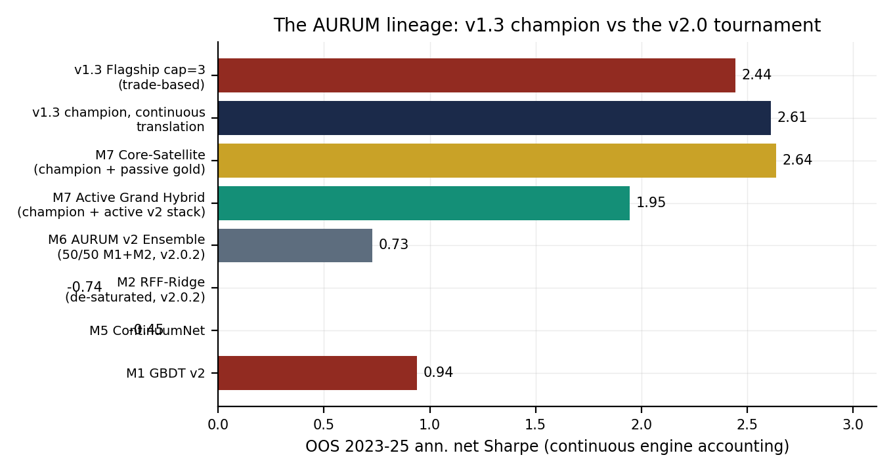
Figure 9.1 — The lineage in one picture: the v1.3 champion (trade-based and continuous) against the v2.0 tournament, both M7 arms and the de-saturated stack included.
The verdict, stated as plainly as the mandate requires. On raw OOS Sharpe the Core-Satellite tops the field at 2.64 and holds 2.50 at doubled costs — and the v2.0.2 decomposition shows exactly why: half champion, half passive gold sleeve, the credit belonging to portfolio construction and regime beta rather than to the v2.0 modeling program, whose measured active contribution is negative (the Active hybrid's 1.95 vs the champion's 2.61). On the stress years the champion family is unmatched: 2018 and 2023 belong to the barrier policy, and no continuous model is positive in every OOS year. On statistical admission, nothing clears the pre-registered 0.95 DSR bar under the honest v2.0.2 panel — the closest are the core-satellite (0.941) and the champion translation (0.935), both borderline. The v1.3 champion therefore retains the crown as the program's active edge, the core-satellite stands as the best portfolio overlay with its certification honestly withdrawn, and v2.0's durable contributions are real and different: the unified causal feature store, an execution engine that demonstrably rescues marginal models, a fully gated statistical-honesty infrastructure that has now caught and repaired three flaws earlier gates missed, and a live decision system that recomputes from versioned artifacts alone.

10. Statistical Honesty, Reconciliation and Limitations

10.1 What the numbers are, and are not
• Accounting: every v2.0 number is continuous-position accounting in vol-target units (15% annualized target, 5,786 bars/year, cost 5e-5 per unit exposure change at 1.0x — approximately 1bp round-turn on unit notional). The v1.3 champion's 2.444 is barrier-trade accounting in per-trade R units under its own event loop; the two frames are bridged, never averaged, and the champion's continuous translation (2.611) is the like-for-like reference.
• The lookahead correction is regression-gated, not just fixed: G4.7 re-creates the pathology every run and requires both its detectability and the fix's cleanliness. Numbers quoted in earlier working notes that predate v2.0.1 are superseded by this report.
• The DSR trial family is the K6 selection panel reduced to effective-independent families — signal families plus one blend slot (N=12) — in per-bar units as Bailey-Lopez de Prado requires, with a conservative every-blend-counts accounting (N=14) exported alongside. The full sensitivity ladder (Table 7.3) is disclosed; the ledger's K2/K3 rows are excluded from the primary variance because they predate the causality fix and mix accounting vintages — an exclusion that is documented, not silent.
• Bootstrap CIs use 24-bar blocks matching the holding horizon, so the overlapping-position autocorrelation is respected in the interval, not assumed away; the DSR formula itself uses the raw bar count, and a T/24 effective-count variant is the conservative reading (both are honest; the bootstrap is the primary uncertainty statement).
• PBO 0.0049 is computed by combinatorially symmetric cross-validation on the FIT net streams; both M7 arms contribute zero selection degrees of freedom by construction (fixed 50/50, shipped against their FIT-grid optimum).

10.2 Known limitations
• One instrument, one regime tail: 2023-2025 is a strong gold bull market; the passive sleeve's contribution to the Core-Satellite is regime-dependent and would invert in a bear. The champion's edge also carries regime risk, but it was selected under walk-forward discipline across 2016-2022 conditions including chop.
• The M2 question is now closed, and the answer is negative: the de-saturated RFF column is genuinely active (G4.8-gated at the producer) and carries no per-bar timing information at this frequency and cost structure. The v2.0 stack's true OOS behavior is no longer unknown — it is measured, and it subtracts value. Future work on the continuous side should start from M1 (the one model the engine rescues) and from slower signal parameterizations that can clear the one-third cost budget.
• The neural program's negative result is bound to this feature panel, target horizon and budget; it rules out these architectures at this scale, not neural methods in general.
• Three OOS years on one instrument cannot support tighter inference than the bootstrap CI [1.49, 3.77] on the flagship; any decision infrastructure built on this program should treat the CI, not the point estimate, as the planning number.

10.3 Reconciliation of quoted vintages
For auditability, the material vintage differences are: M2's K2-era OOS engine Sharpe of 1.87 was computed on the saturated column (real arithmetic, wrong attribution — it is the engine running a long-gold bet); the v2.0.1 tournament's M2/M6/M6b reading of 2.16 was the same passive stream and is replaced in v2.0.2 by the de-saturated measurements (-0.74 for M2, +0.73 for M6 through the engine); the old M7 Grand Hybrid headline of 2.6351 / 2.5012-at-2.0x is preserved exactly as the M7 Core-Satellite, which is what that stream was in OOS, while the intended-but-never-measured active design now exists as the M7 Active Grand Hybrid at 1.946; the flagship's DSR of 0.958 (v2.0.1) is re-measured at 0.941 primary / 0.925 conservative under the honest panel, and the 95% certification is withdrawn; the K7 live kernel's pre-fix grand-hybrid FIT diagnostic of 5.68 was same-bar lookahead and is replaced by 2.01 at w_v2=0; and the champion's continuous OOS, which floated around higher figures in working notes before the causality audit, is fixed at 2.611 by the corrected accounting. Every number in this report regenerates from the artifact bundle with one command per stage.

11. Appendices

Appendix A — Reproduction map
Table A.1 — Datasets (all private, account tskdev unless noted).
Dataset | Contents
aurum-v2-featstore | aurum_v2_features.parquet (375 features, 95,008 bars), feature_meta.json, Rank-IC audit
aurum-phase1-data | h1_xauusd.parquet and companion H1 series, 2010-2025
aurum-v2-cpu-preds | K2 walk-forward forecasts v3 (de-saturated z_rff, byte-identical pred_rff, negative-control column), engine metrics, gates, trial ledger
aurum-v2-neural-preds | K3 final forecasts (M3c/M3m/M4/M4b/M5, iterates 1-4), rho logs, ledgers
aurum-v13-artifacts | v1.3 flagship trades_all.parquet, policy fit, backtest summary
aurum-v2-backtest-outputs | K6 v2.0.2 outputs: backtest_v2.json, stats, gates, net series, year table, checkpoints
aurum-v2-live-daily-outputs | K7 v2.0.2 decision object + live gates
aurum-v2-workspace-backup | full code + scripts + K6 checkpoints tarball (restores the workspace in one download)
ranigain mirrors | featstore and cpu-models mirrors on the GPU account
Table A.2 — Kernels.
Kernel | Role
tskdev/aurum-v2-features | K1: feature store build + audit
tskdev/aurum-v2-cpu-models (+ranigain/aurum-v2-cpu-models-rg) | K2: CPU tournament + engine gauntlet
tskdev/aurum-v2-neural-compact, aurum-v2-neural-completion, ranigain/aurum-v2-m5-completion | K3: neural tournament in three budget generations
tskdev/aurum-v2-backtest | K6: the full backtest, statistics and gates of this report
tskdev/aurum-v2-live-daily | K7: the recomputable live decision object
Local reproduction: restore scripts and checkpoints from the workspace backup tarball, set the six AURUM_* path variables to the restored dataset directories, and run the K6 kernel source directly — the data-signature checkpoints make a full re-evaluation a single foreground invocation (about three minutes on one CPU core after the engine's v2.0.1 vectorization).

Appendix B — Locked constants and gate register
Table B.1 — Locked constants (v2.0.2).
Constant | Value | Meaning
BARS_PER_YEAR | 5,786 | empirical H1 bars per year (87,948 bars / 15.2y)
COST_R | 5e-5 | cost per unit exposure change at 1.0x multiplier
SIGMA_TGT_ANN | 0.15 | annualized volatility target
FIT / OOS years | 2016-2022 / 2023-2025 | selection window / sealed out-of-sample
purge / embargo | 24 / 24 bars | walk-forward label isolation
z_rff standardization (v2.0.2) | span 504 / min_periods 63 / eps 1e-9 | causal trailing EWMA/EWSTD, re-anchored per re-fit fold (Engineering Flaw #8 fix)
M6 stack (v2.0.2) | fixed family {M1, M2}; SR inputs = engine FIT | Carver S24: SR-shrink 0.90 toward equal weights, corr-shrink 0.50, equal-weight fallback
seeds | 1337 / 2024 / 4242 | GBDT ensemble; RFF bank 1337 x10; neural 1337
bootstrap | 5,000 x 24-bar blocks | OOS Sharpe confidence intervals
DSR gate / PBO gate | 0.95 / 0.20 | statistical admission thresholds (G6.1 reports the v2.0.2 miss verbatim)
rho gate (M5) | < 0.95 | LoopBlock spectral-radius acceptance
z-quality gates (G4.8) | std>0.05, P(|z|>0.99)<5%, turn>2/yr | producer-side saturation gate (K2) + independent downstream audit (K6)
Table B.2 — K6 gate register (final run, code rev k6-v2.0.2).
Gate | Status
G4.7_causality_v201 | PASS
G6.2_stack | PASS
G4.8_z_quality_audit | PASS
G6.1_stats | FAIL
G5.4_speed_limit | PASS
G5.3_gauntlet | PASS
G6.6_export | PASS
G6_ALL | FAIL
Table B.3 — K7 live gate register (v2.0.2 re-run).
Gate | Status
G6.4_live_decision | PASS
This report was generated end-to-end from the frozen artifacts of the five pipeline stages; no number in it was entered by hand. The full artifact bundle, the eleven figures at 200 DPI, and the workspace backup accompany the document in the delivery folder.

