TMC Quote
Pre-Sales Web App — Function-by-Function Walkthrough
Demo & presentation document
Prepared by: Safi Ullah · TMC
Date: 6 May 2026

Overview
TMC Quote aik web app hai jo pre-sales team ke liye banaayi gayi hai — Excel-based quote authoring se nikal kar structured, version-controlled, approval-driven workflow par shift karne ke liye. App Odoo (system of record) ke saath hybrid model par chalti hai: customer / employee / opportunity master data Odoo se read hota hai, magar saari authoring, scenarios, approvals aur versioning web app ke andar hote hain. Sirf final approved quote Odoo mein push hota hai (sale.order + lines + project.coding etc.).
Yeh document app ke har function (10 views) ko aik aik kar ke walk-through karta hai, har view ke saath actual screenshot, summary, aur key features list ke saath.

Quick Stats
- 10 functional views: Dashboard, New Quote, Quote Builder, Travel Plans, Payment Plan, Scenarios, Approvals, Versions, Push to Odoo, Architecture
- Backend: Python stdlib HTTP server (server.py) + JSON-RPC bridge to Odoo at http://localhost:8090
- Frontend: single-page index.html (~107 KB) + app.js (~78 KB), no framework dependency on the demo build
- Run command: run.bat → server listens on http://127.0.0.1:5066/

1. Quote Dashboard
All active, pending and won quotations for pre-sales team
Yeh app ka home screen hai. Pre-sales team yahan apni saari quotations dekhti hai — kaunsi draft mein hain, kaunsi L1 / L2 / L3 approval ke liye lagi hain, kaunsi Odoo mein push ho chuki hain, aur kaunsi reject ho gayi hain. Top par 4 KPI cards hain: Active Quotes, Pending My Approval, Won Value (current quarter), aur Win Rate.

Screenshot
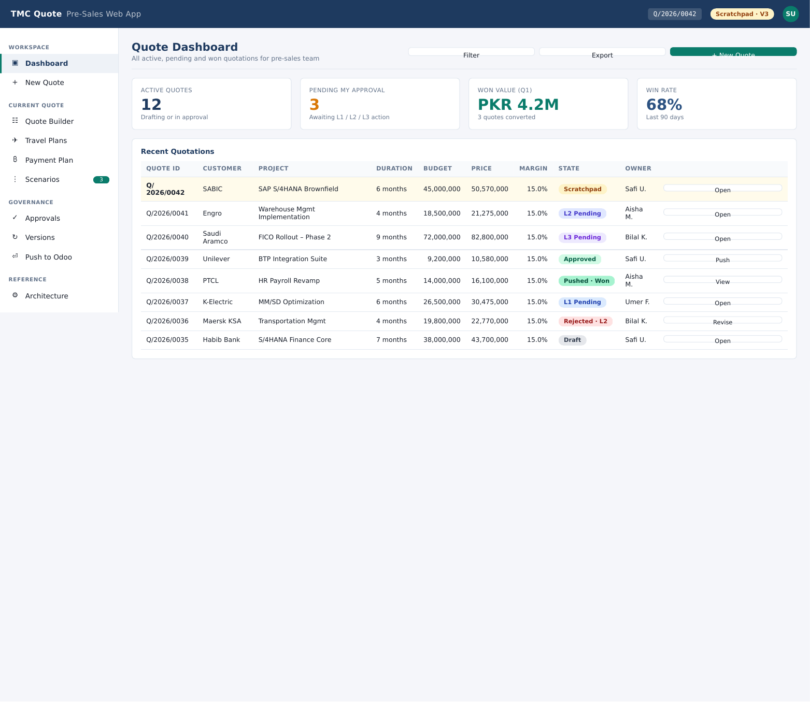
Figure: Quote Dashboard view from the running web app.

Key Features
- Top 4 KPIs: active count, pending approval, won value (PKR), win rate
- Recent Quotations table: Quote ID, Customer, Project, Duration, Budget, Price, Margin, State, Owner
- State pills: Scratchpad / Draft / L1 / L2 / L3 Pending / Approved / Pushed-Won / Rejected
- Row actions: Open, Push, View, Revise (state ke hisaab se)

2. New Quote — Form Entry
Pre-sales fills structured inputs · grid is generated automatically
New Quote view aik structured form hai jahan pre-sales team Excel ke bajaye directly fields fill karti hai. Customer, opportunity, project name, dates, budget, costing basis (HR / margin / inflation), aur skill / resource plan yahin se enter hote hain. Grid khud ban-ti hai — koi ad-hoc cells nahi.

Screenshot
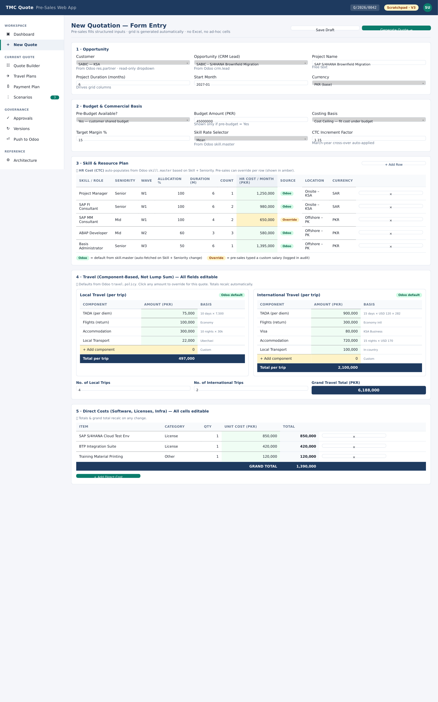
Figure: New Quote — Form Entry view from the running web app.

Key Features
- Sections: Opportunity → Budget & Commercial Basis → Skill & Resource Plan
- Travel (component-based, not lump sum) — local + international plans
- Direct Costs (software, licenses, infra) editable per line item
- Validation: budget vs price, margin %, gauge meters

3. Quote Builder — Grid Workspace
Wave-by-wave resource allocation with monthly cost rollup
Builder Excel-style grid hai jahan resources ko months par distribute kiya jaata hai. Har wave (Discovery, Build, Stabilize) apni tab mein hoti hai. Allocation %, location (onsite/offshore), seniority, aur monthly counts edit karne par totals real-time recalculate hote hain.

Screenshot
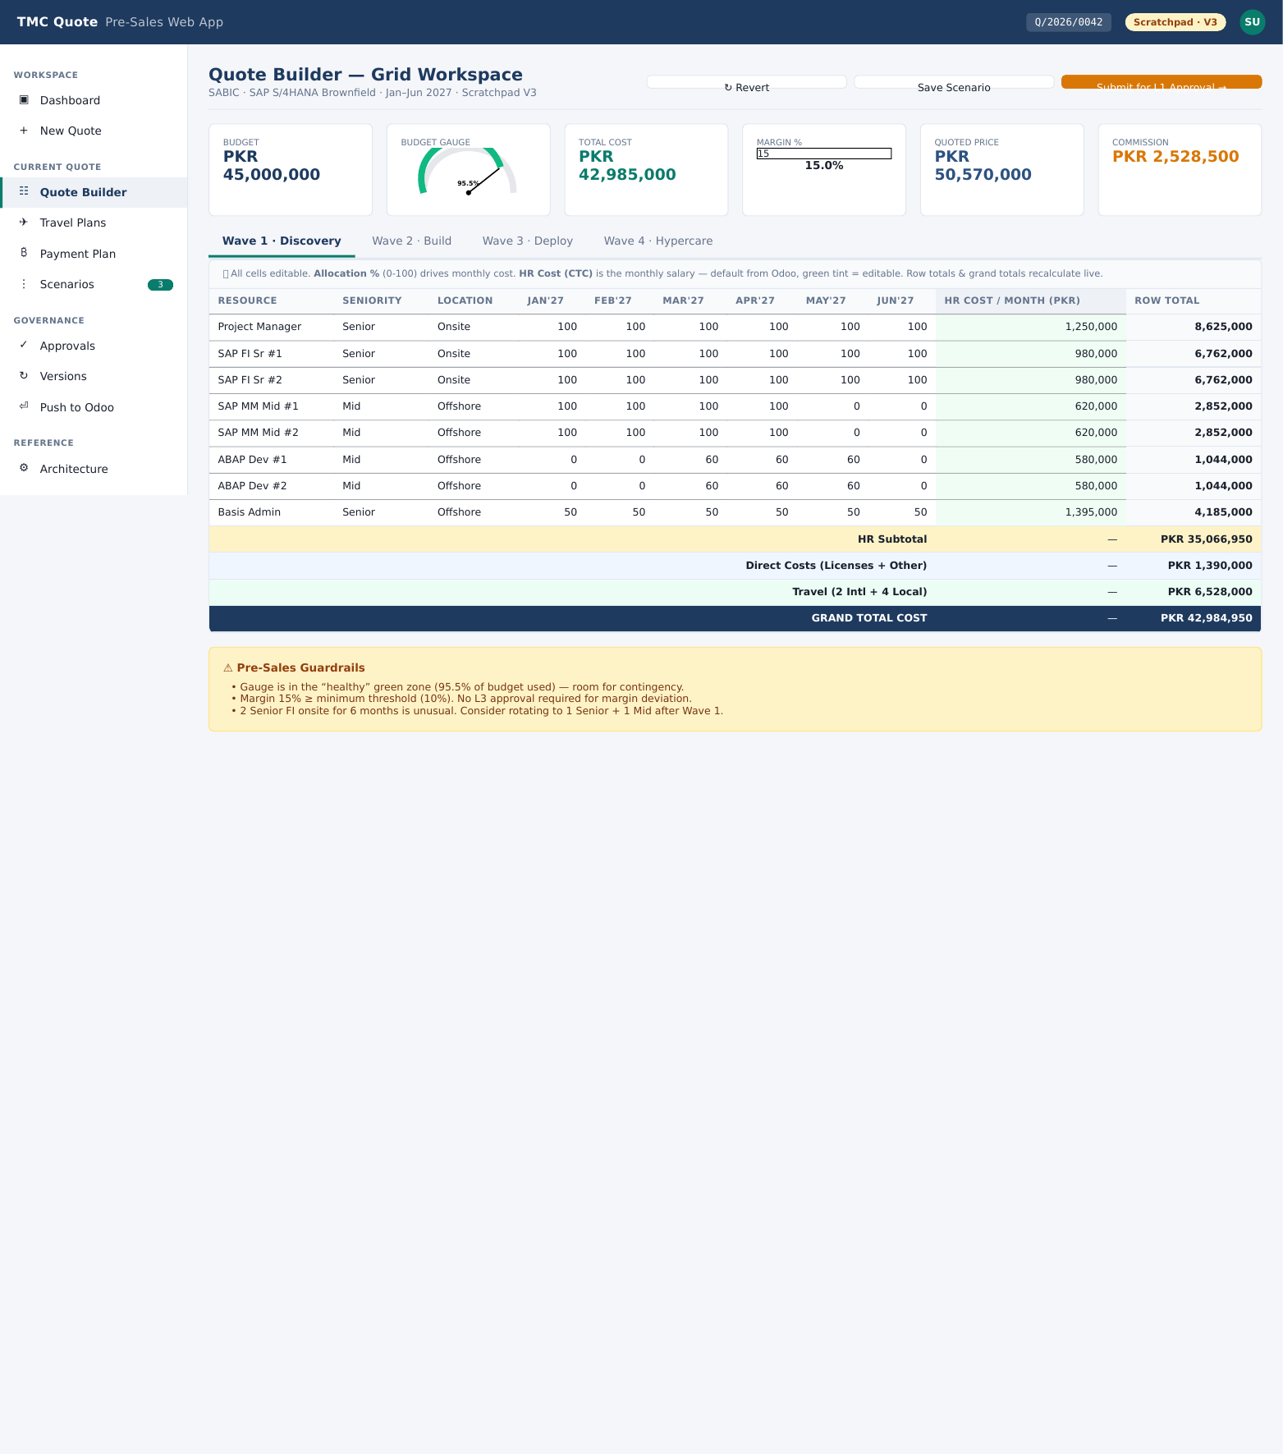
Figure: Quote Builder — Grid Workspace view from the running web app.

Key Features
- Tabs: Wave 1 Discovery / Wave 2 / Wave 3 / Deploy / Hypercare
- HR Subtotal + Direct Costs + Travel auto-rollup to Grand Total Cost
- Pre-Sales Guardrails: HR % >= 70%, ARAP & Senior PM month thresholds
- Inline alerts when allocation breaks rules

4. Travel Plans
Local + international travel detail per wave
Travel ko component-wise modeled kiya jaata hai (lump sum nahi). Local trips (per-trip ticket + accommodation + local transport) aur international trips (visa, flight, lodging) alag alag track hote hain. Total travel cost grand total cost mein automatic add ho jaata hai.

Screenshot
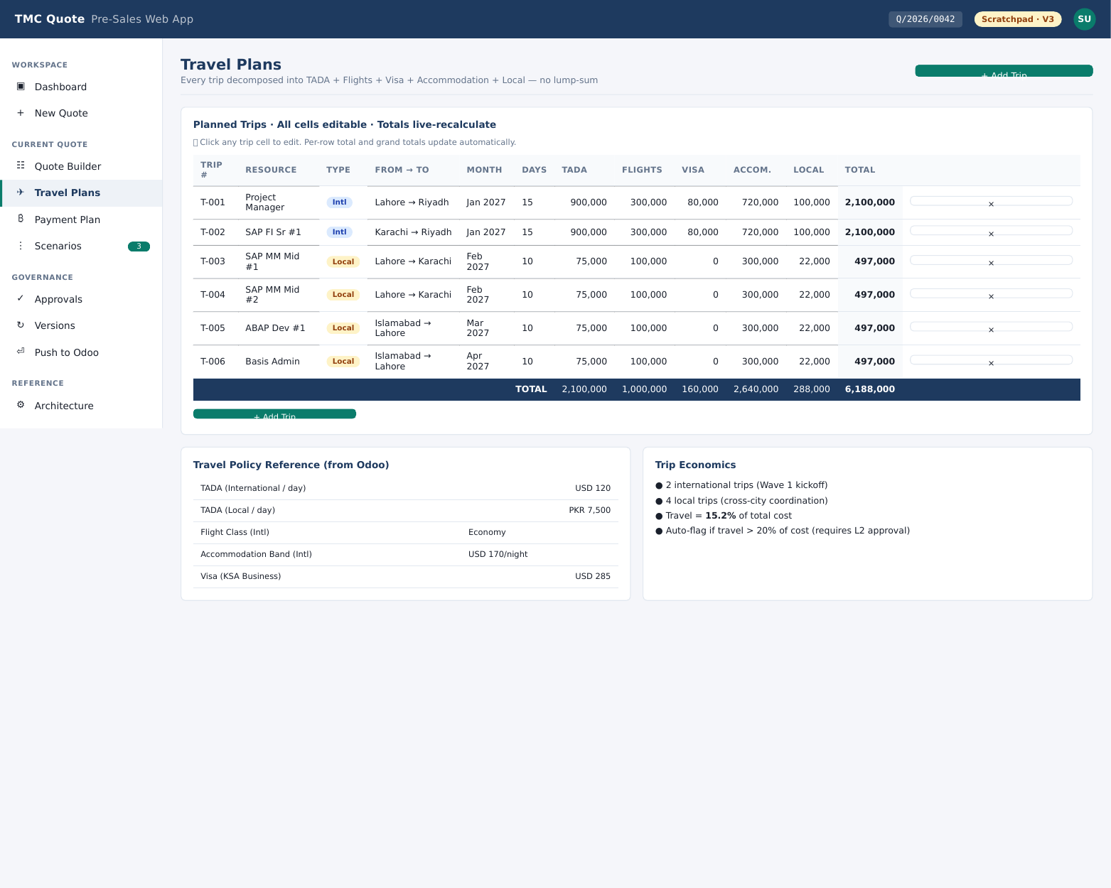
Figure: Travel Plans view from the running web app.

Key Features
- Local trips section + International trips section
- Editable per-trip rates with auto-calculated totals
- No. of trips × rate = leg cost; legs sum to grand travel total
- Approved values flow into final price calculation

5. Payment Plan
Milestone schedule and finance terms for the customer
Payment Plan section quote ke commercial side ko cover karta hai — kab kab invoice raise hogi, milestones kya hongi, aur kis percentage par. Yeh data later Odoo mein push hone par sale order ke payment terms ban jaata hai.

Screenshot
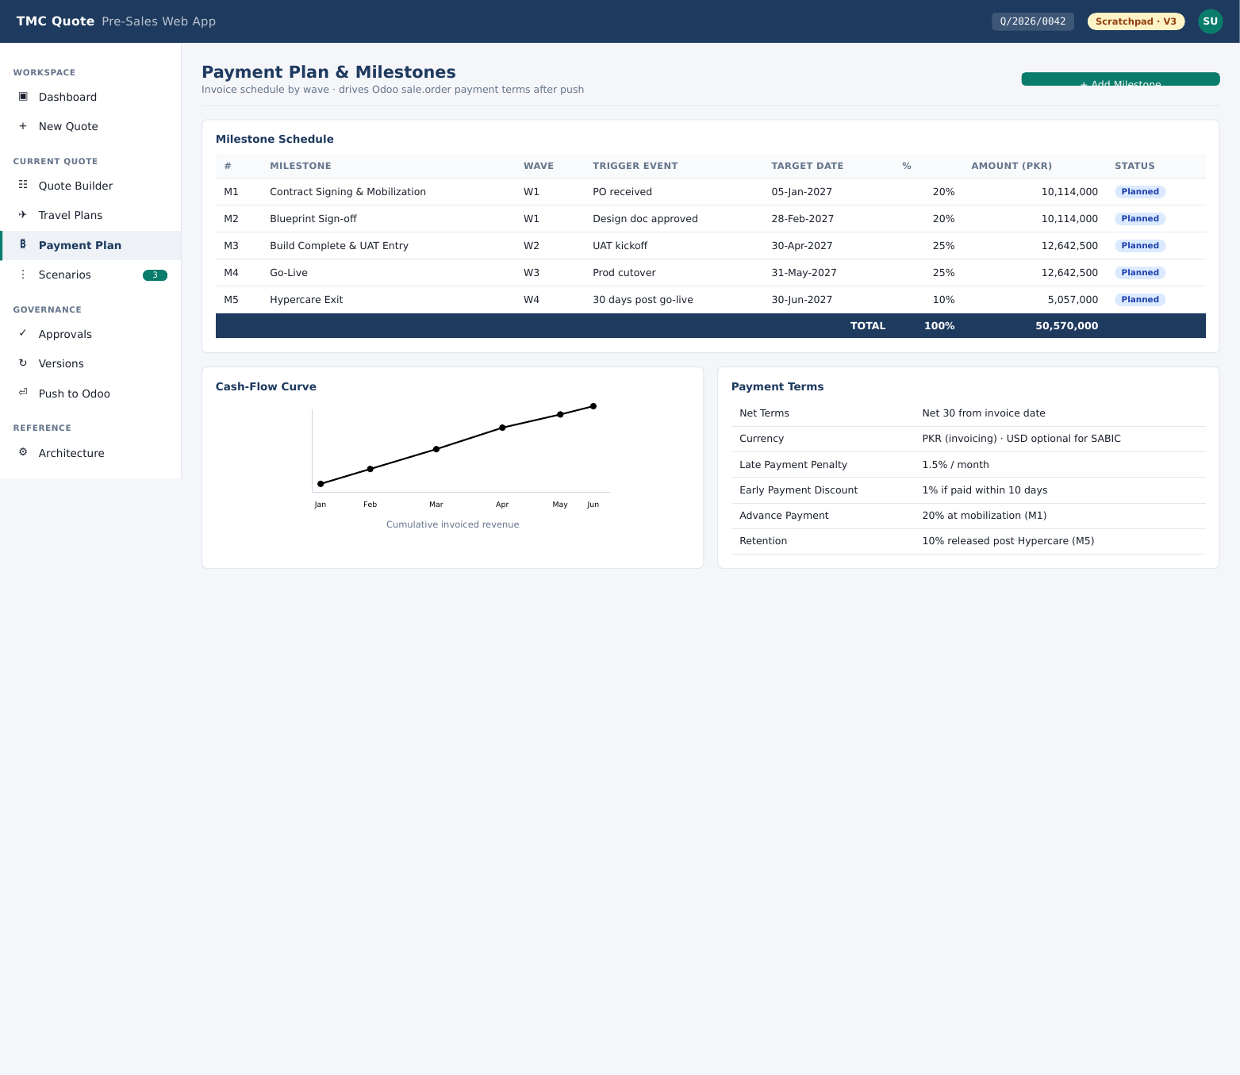
Figure: Payment Plan view from the running web app.

Key Features
- Milestone-based percentage breakdown
- Currency, tax basis, retention amount fields
- Linked to project schedule (waves)

6. Scenarios
Compare alternate pricing/resource cases side-by-side
Pre-sales akser 2-3 scenarios bana ti hai — base case, aggressive case, fallback case. Yeh view unko side-by-side compare karta hai bina alag alag Excel files banaye. Choose karne ke baad winning scenario approval mein jaati hai.

Screenshot
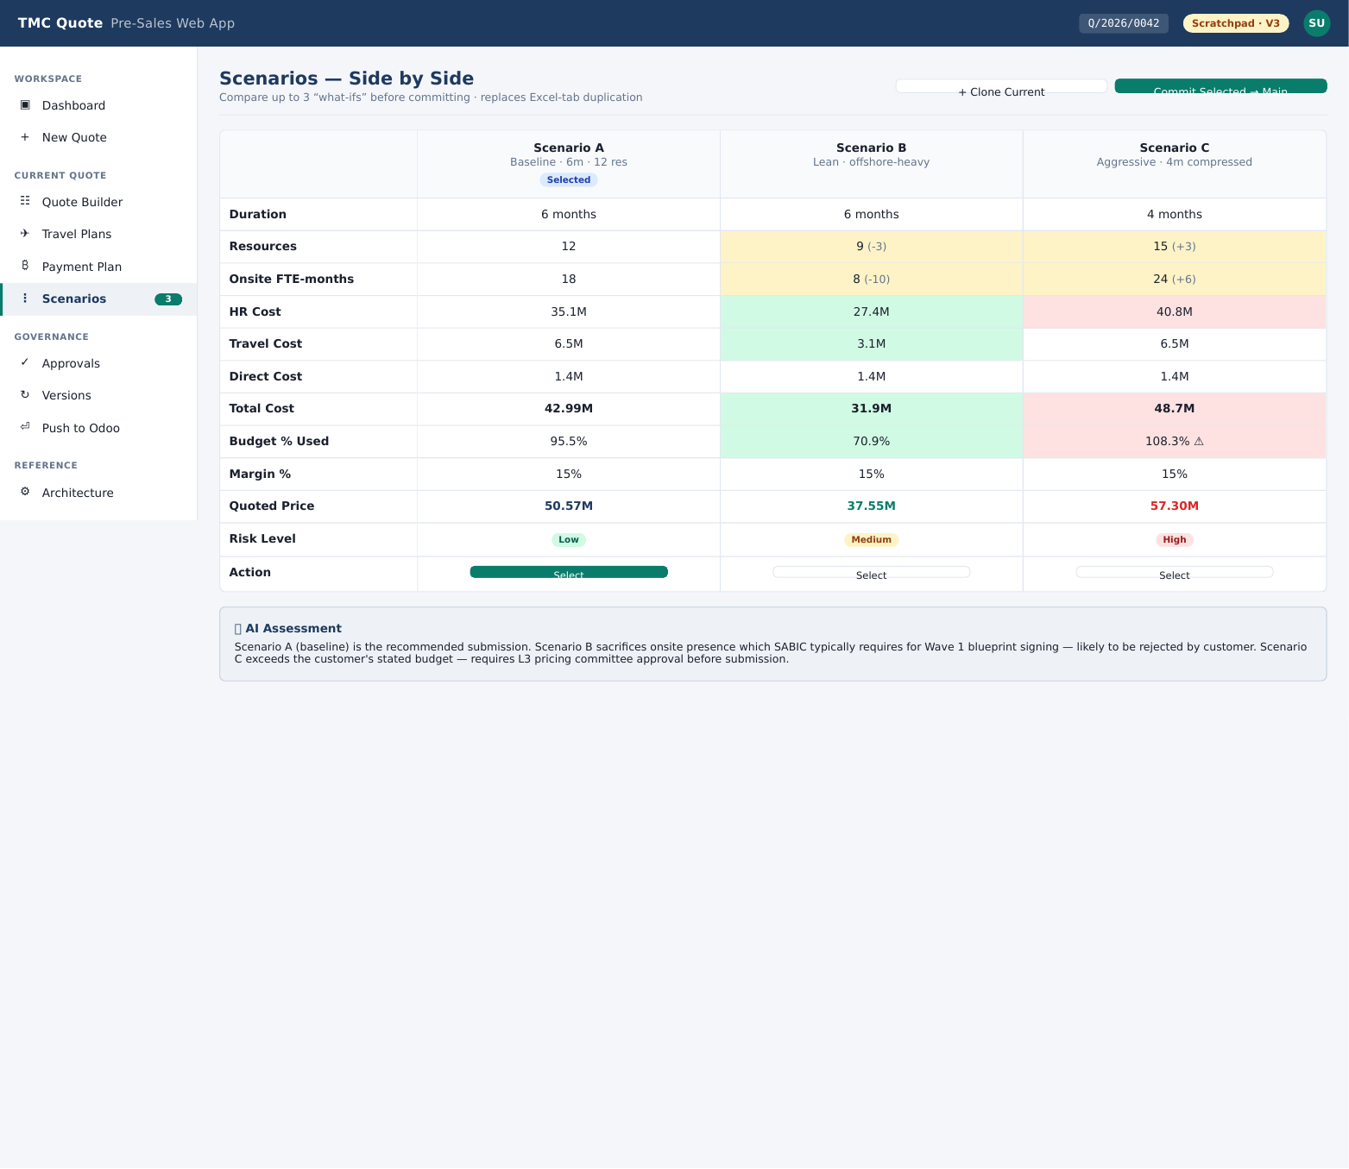
Figure: Scenarios view from the running web app.

Key Features
- 3-column comparison: assumptions, totals, margin %
- Mark winner → submitted to approval flow
- Versions retained for audit trail

7. Approvals (L1 / L2 / L3)
Web app approval workflow — Odoo only sees the final approved payload
Yeh app ka governance heart hai. Approvals web app ke andar hote hain (Odoo ke andar nahi), kyun ke web app par custom SLAs, threads, diffs, aur contextual deviation checks possible hain jo Odoo ke generic approval engine se nahi ho saktay. Sirf last approved quote Odoo mein push hota hai.

Screenshot
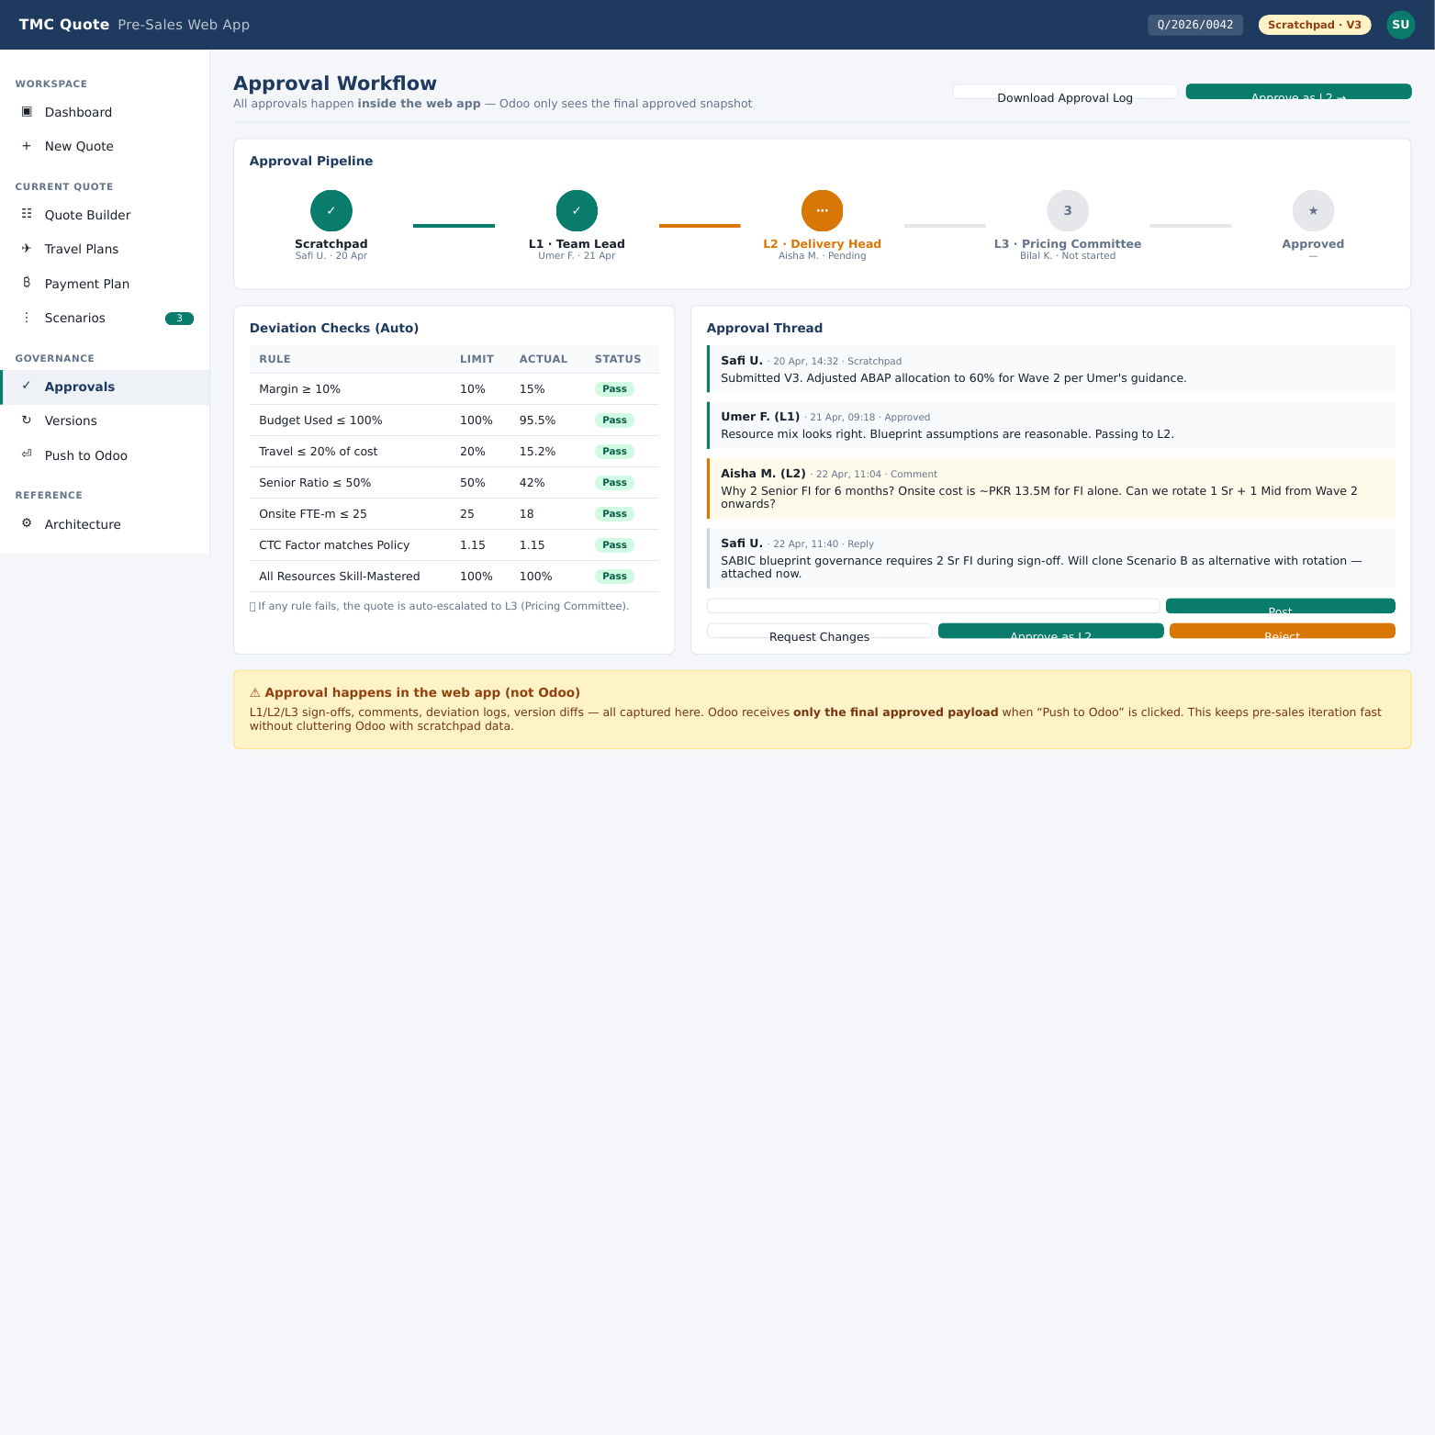
Figure: Approvals (L1 / L2 / L3) view from the running web app.

Key Features
- Pipeline: Scratchpad → L1 Team Lead → L2 Practice Head → L3 Pricing Committee → Approved
- Deviation Checks panel: margin, budget headroom, travel %, senior PM months, CTC factor, retained allowance
- Approval Thread with author + date + comments per level
- Request Changes & Approve actions per role

8. Versions
Audit trail of every revision with diff against previous
Har time pre-sales kuch change karti hai aur save karti hai, aik new version create ho jaati hai. Yeh page un sab versions ka chronological list dikhata hai with author, timestamp, aur key field deltas. Click karne par diff view khulta hai.

Screenshot
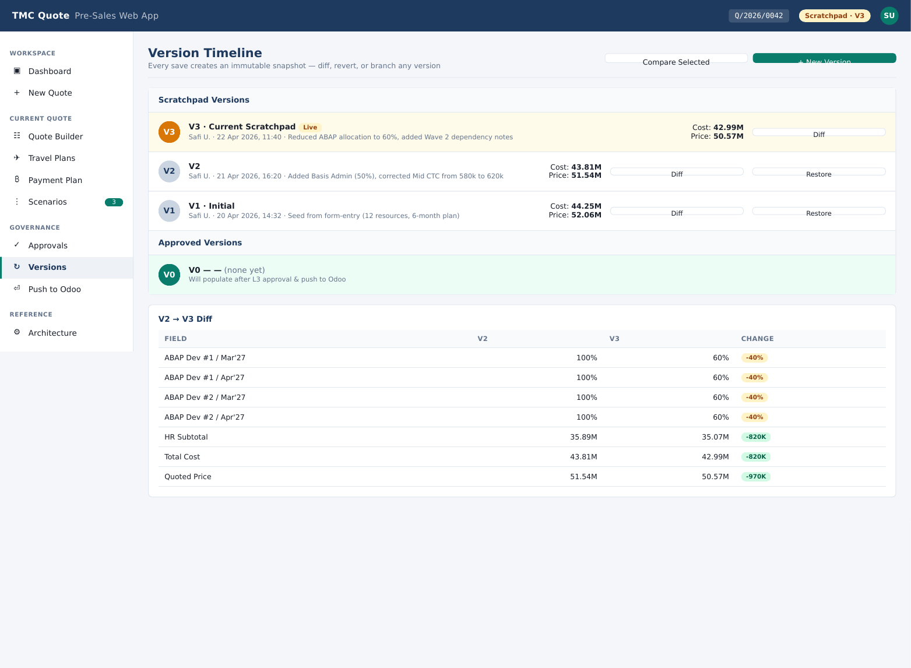
Figure: Versions view from the running web app.

Key Features
- Linear history of saves: V1, V2, V3 …
- Per-version: author, timestamp, change summary
- Diff view (added / removed / modified rows)
- Restore-to-version option for rollback

9. Push to Odoo — Final Gate
Only this step touches Odoo; everything else stays in the web app
Yeh aakhri stage hai. Jab L3 ne approve kar dia hai, tab ek approved payload Odoo ke target tables (sale.order, sale.order.line, project.coding, etc.) ko INSERT karta hai via tmc_api custom addon endpoints. Push ke baad confirmation preview aur Odoo doc URL show hoti hai.

Screenshot
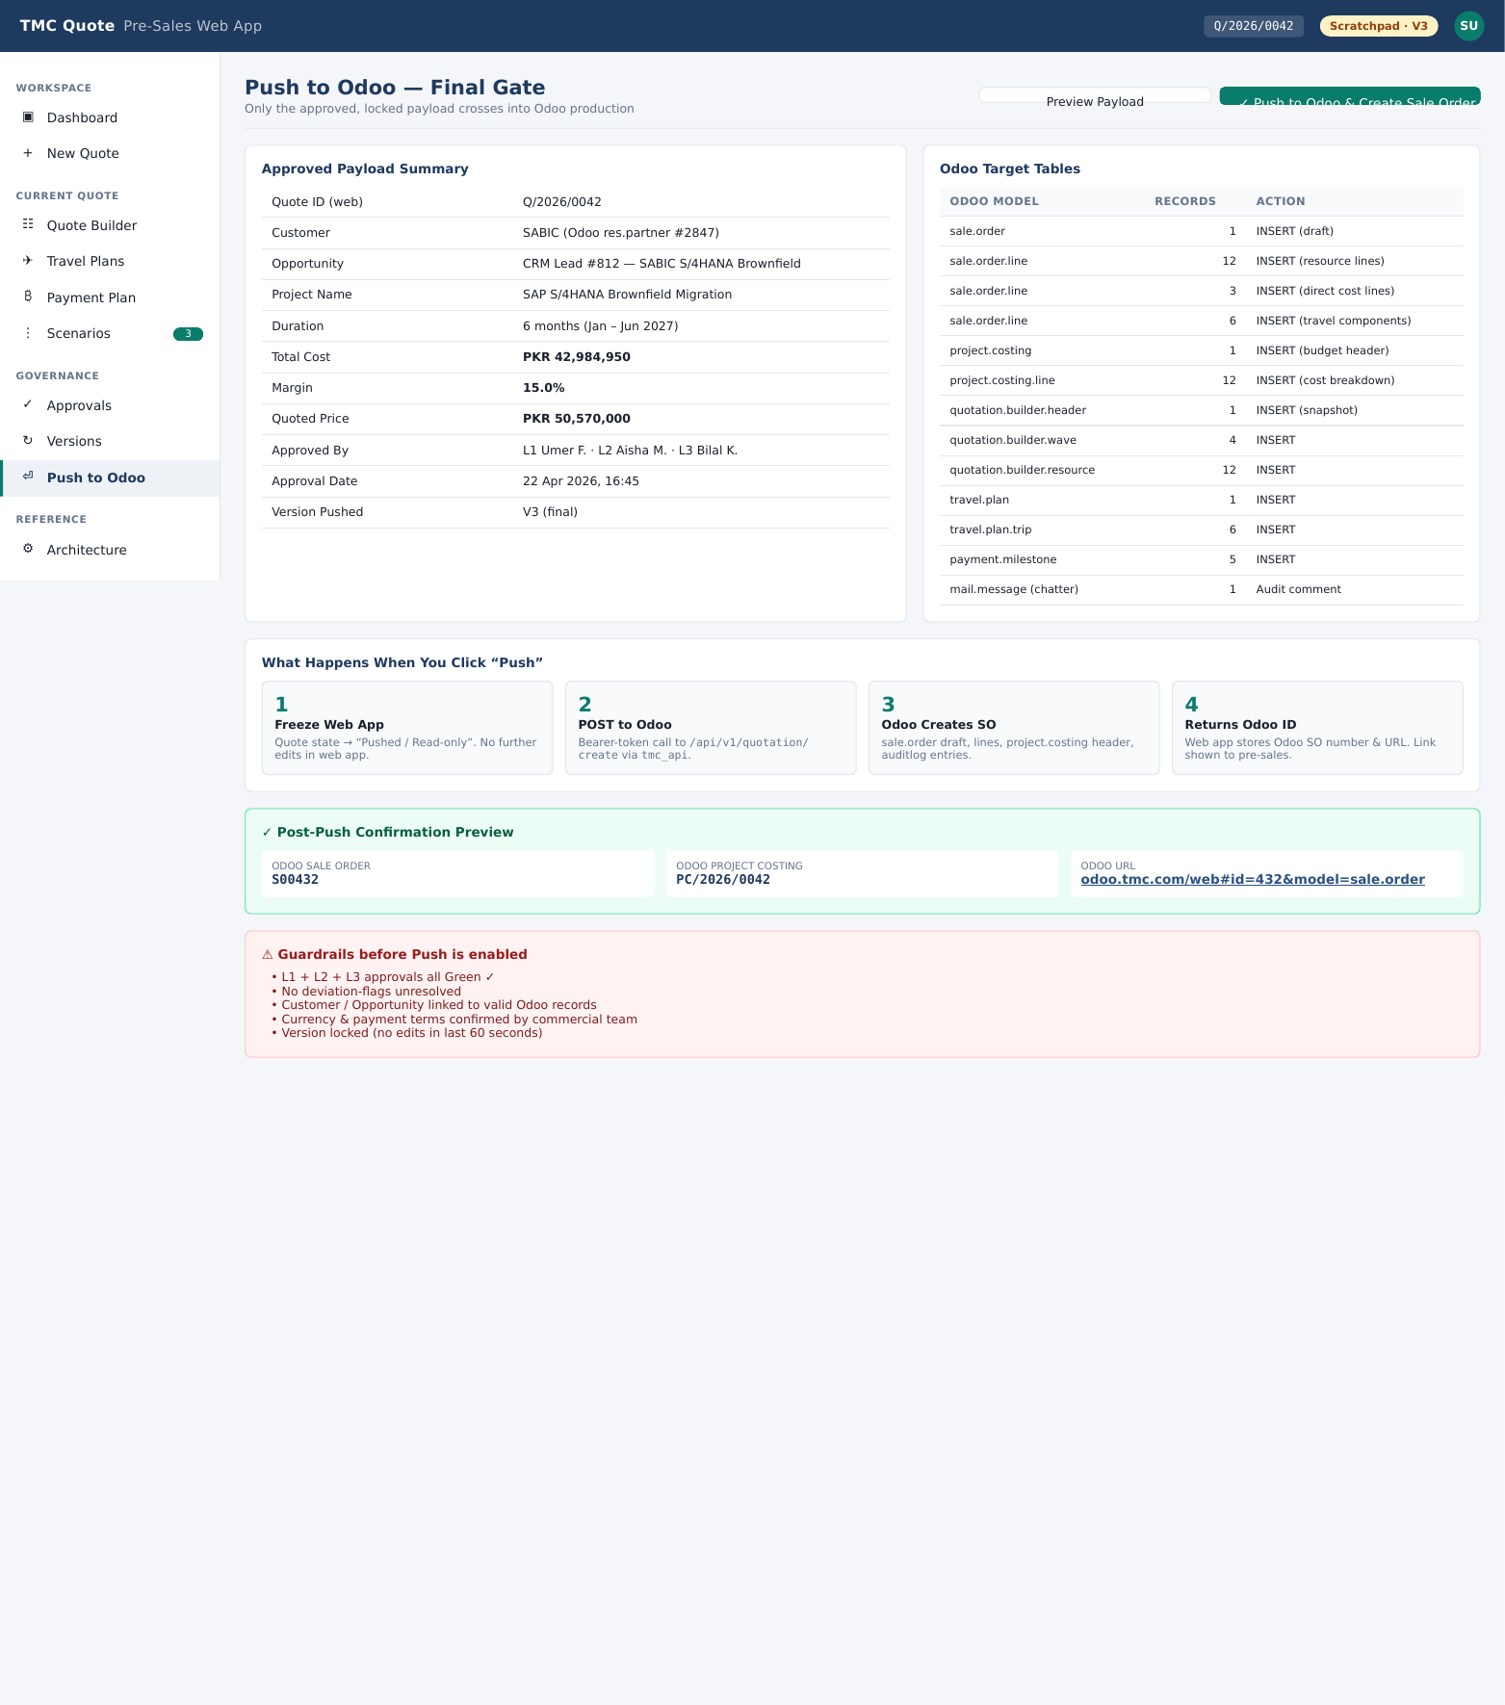
Figure: Push to Odoo — Final Gate view from the running web app.

Key Features
- Approved Payload Summary panel (left) — final figures snapshot
- Odoo Target Tables panel (right) — sale.order, sale.order.line, project.coding, payment terms…
- 4-step flow: Freeze → POST → Odoo creates SO → Returns Odoo ID
- Quadrants before push enabled: L3 OK, sign-off, rate card valid, currency match
- Confirmation preview with bearer-token Odoo link

10. Architecture Reference
Hybrid architecture — web app for authoring & approvals, Odoo as system of record after push
Architecture page in-app reference hai team aur new joiners ke liye. Data flow, field sourcing map (kaunsa field kahan se aata hai), technology stack, aur rationale (why web app owns everything until push) yahan documented hain.

Screenshot
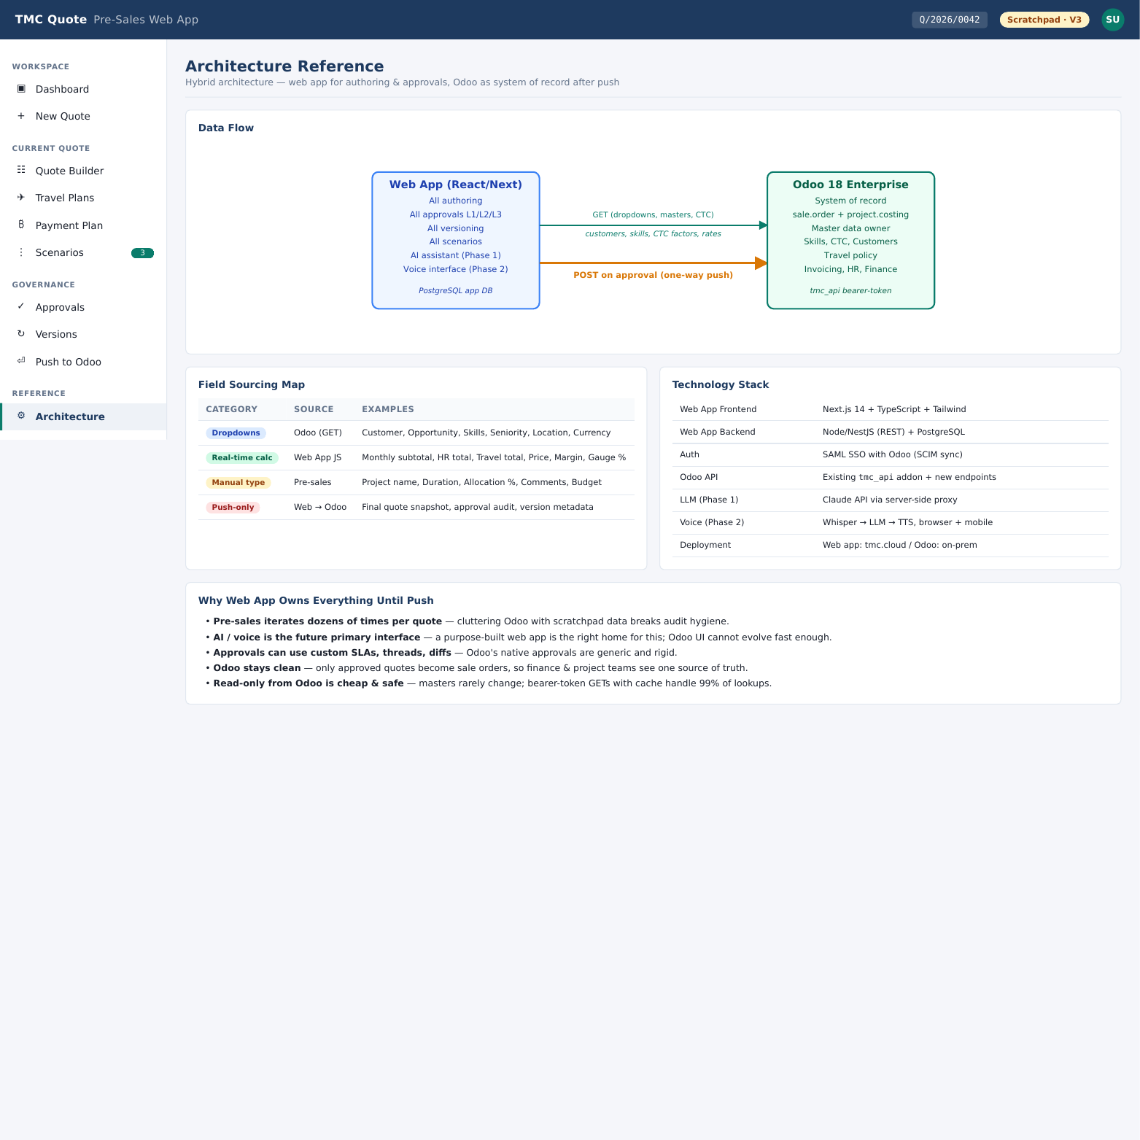
Figure: Architecture Reference view from the running web app.

Key Features
- Data Flow diagram: Web App ↔ tmc_api ↔ Odoo
- Field Sourcing Map: Dropdowns (Odoo GET), Real-time calc (Web App JS), Manual type (Pre-sales), Push-only (Web → Odoo)
- Tech Stack: Next.js 14 + Tailwind, Node/Nest (REST) + PostgreSQL, SAML SSO with Odoo, Whisper → LLM → TTS voice (Phase 2)
- Why Web App owns everything until push: pre-sales iterates dozens of times per quote; Odoo stays clean

Closing Notes
Yeh document app ke current demo build par based hai (April 2026 cut). Screenshots app ki UI sample data ke saath ho rahi hain — production mein actual quotation records aur Odoo se live data dikhega. Voice + LLM phase 2 mein add hone wala hai (Whisper → LLM → TTS), iska detail Architecture page par mojud hai.
End of document.

