**Full Project with Frontend Using MERN**

# **Name:** Muaaz Ahmad

# **Reg No.:** SP22-BSE-042

**Repo Link:**

[**https://github.com/muaaz042/employeeProject**](https://github.com/muaaz042/employeeProject)

**Output:**

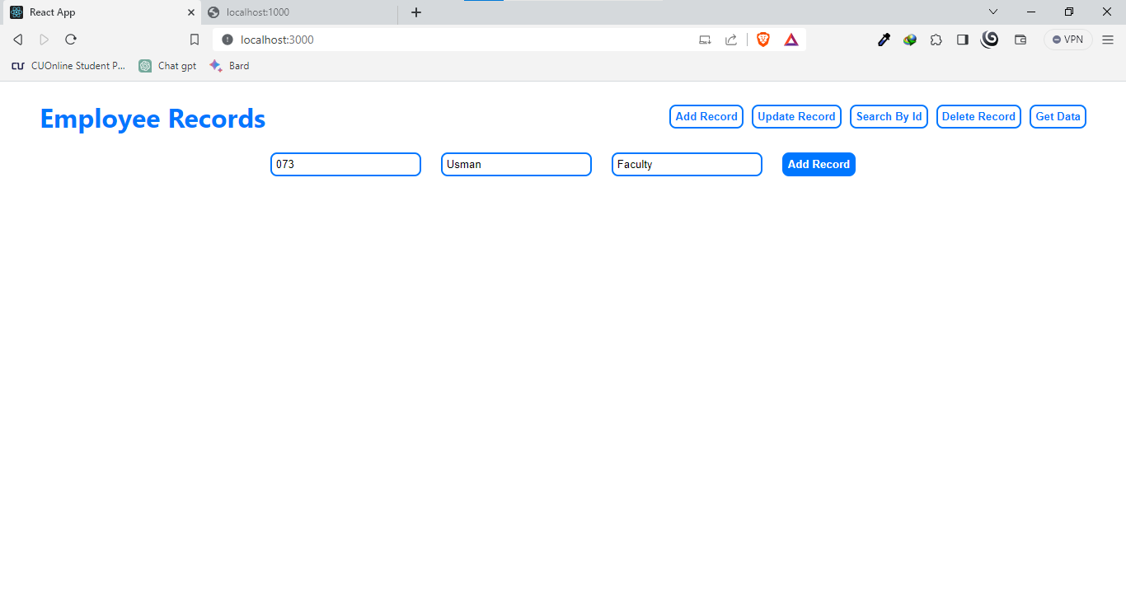

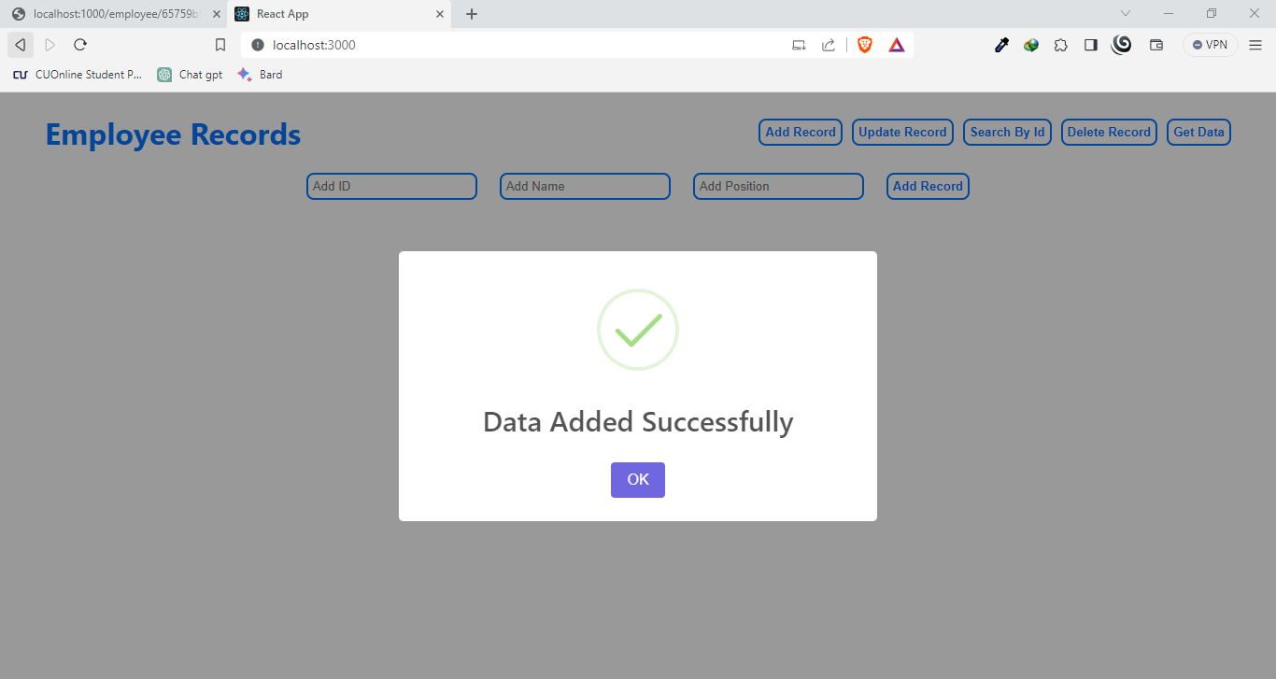

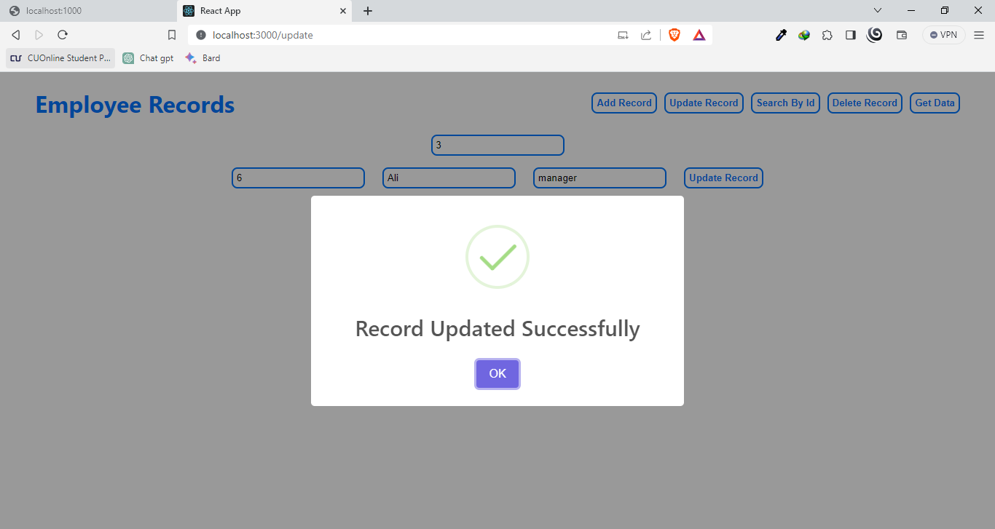

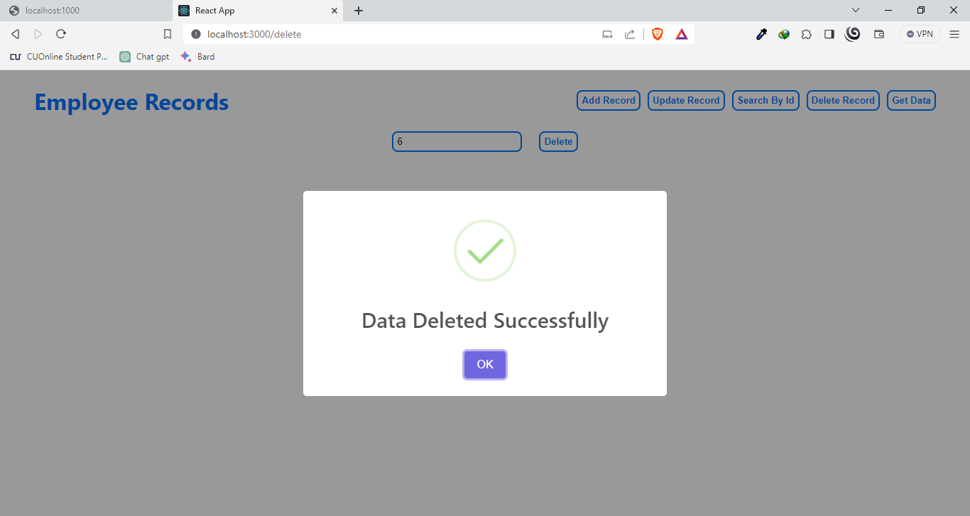

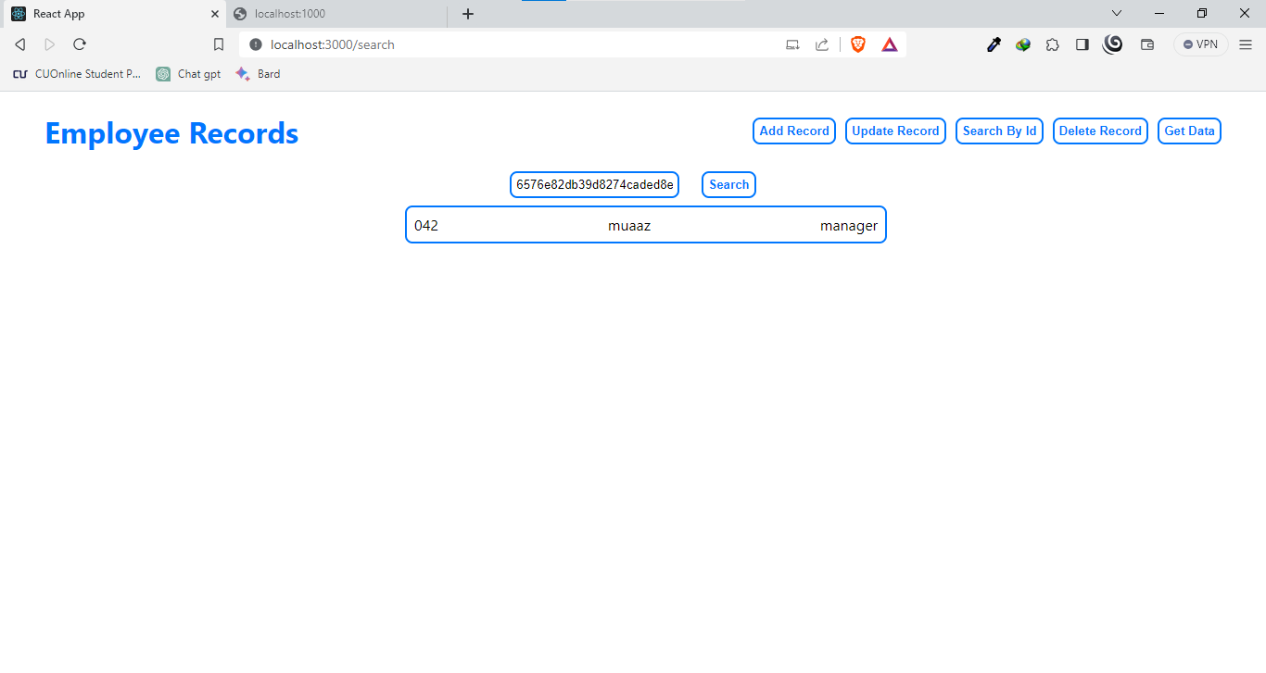

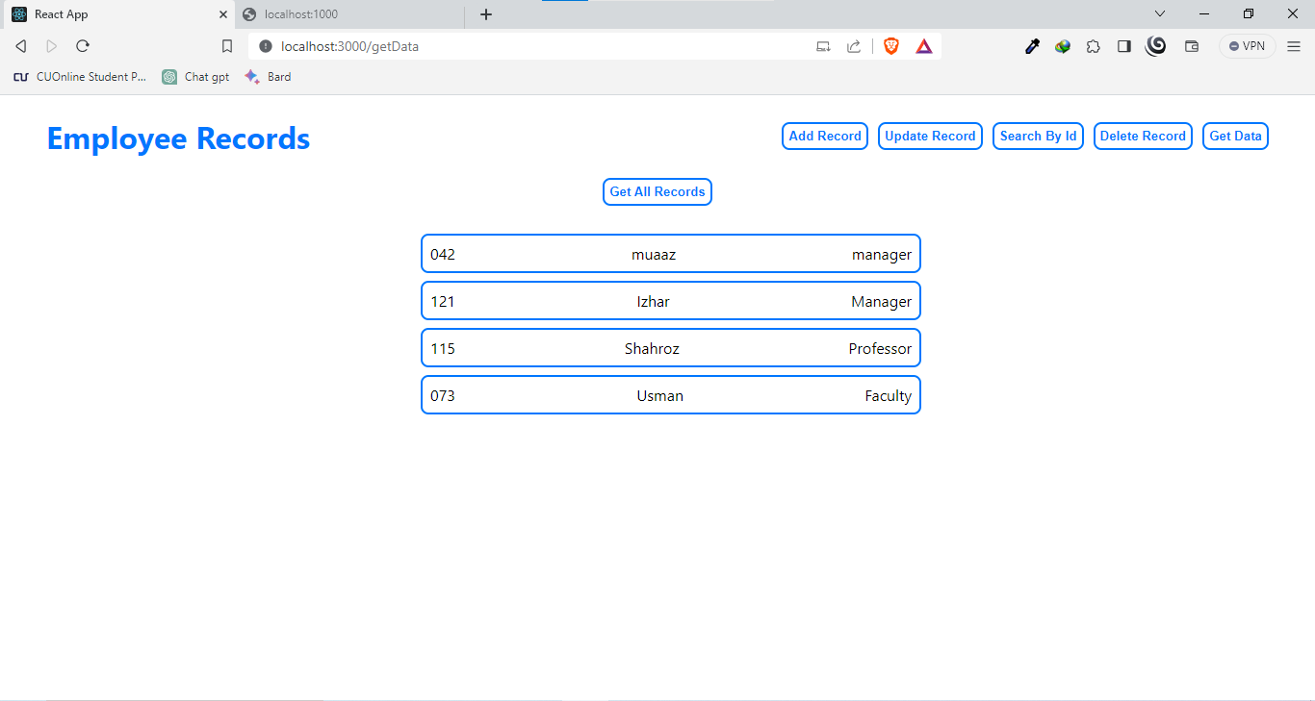

**After Deleting Izhar**

