***FLIGHT PRICE PREDICTION WIREFRAME DOCUMENTATION***

TEAM MEMBERS

SOHAM PAWAR

DIPALI BHANUSHALI

MUAAZ PATEL

KHUSHABU PATIL

Pursuing Masters in Data Science & Business Analytics.

**USER INTERFACE**

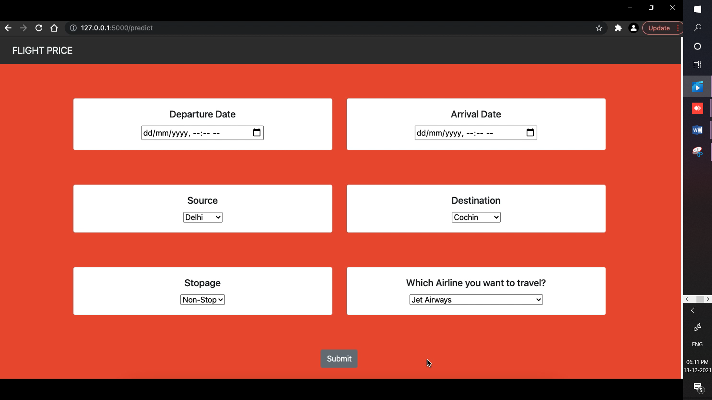

As you can see our prediction page is in a horizontal format containing six drop-down menu’s which is required to predict flight price as per user need i.e. Departure Date and Arrival Date destination, travelling from and Name of Airline and number of halts.

**FORM VALIDATION**

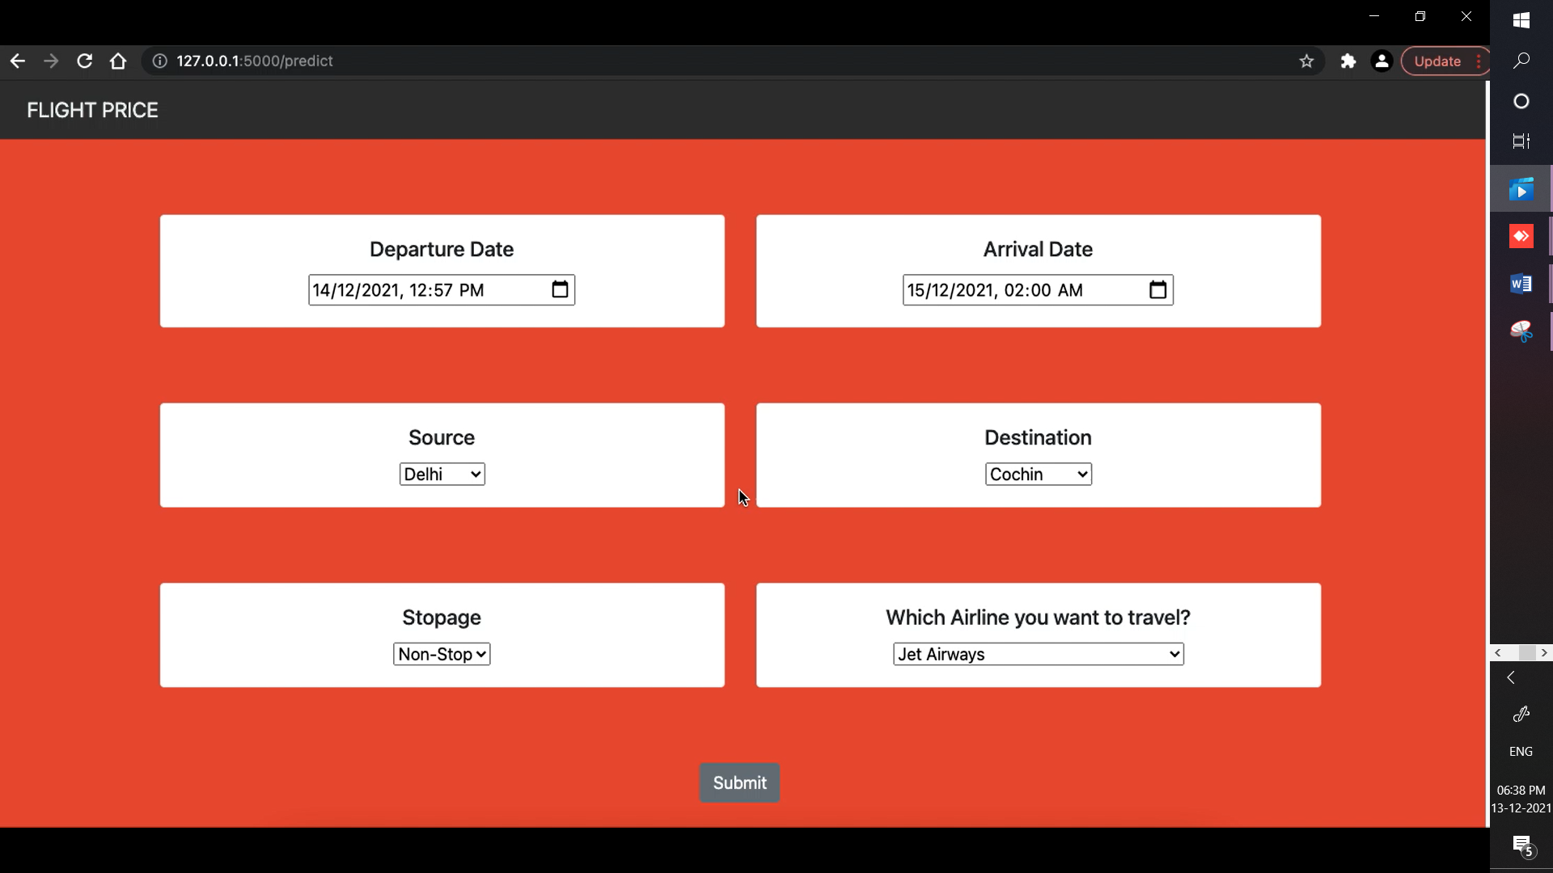

Selecting appropriate options as per user needs to predict the flight price for e.g. we have selected a person travelling on 14/12/2021 at 12:57 boarding the flight from Delhi and arriving at Cochin on 15/12/2021 at 2:00 am with a non-stop travel with Jet Airways airline.

**YOU CANNOT LEAVE ANY INPUT FIELD BLANK**

**PREDICTION RESULT**

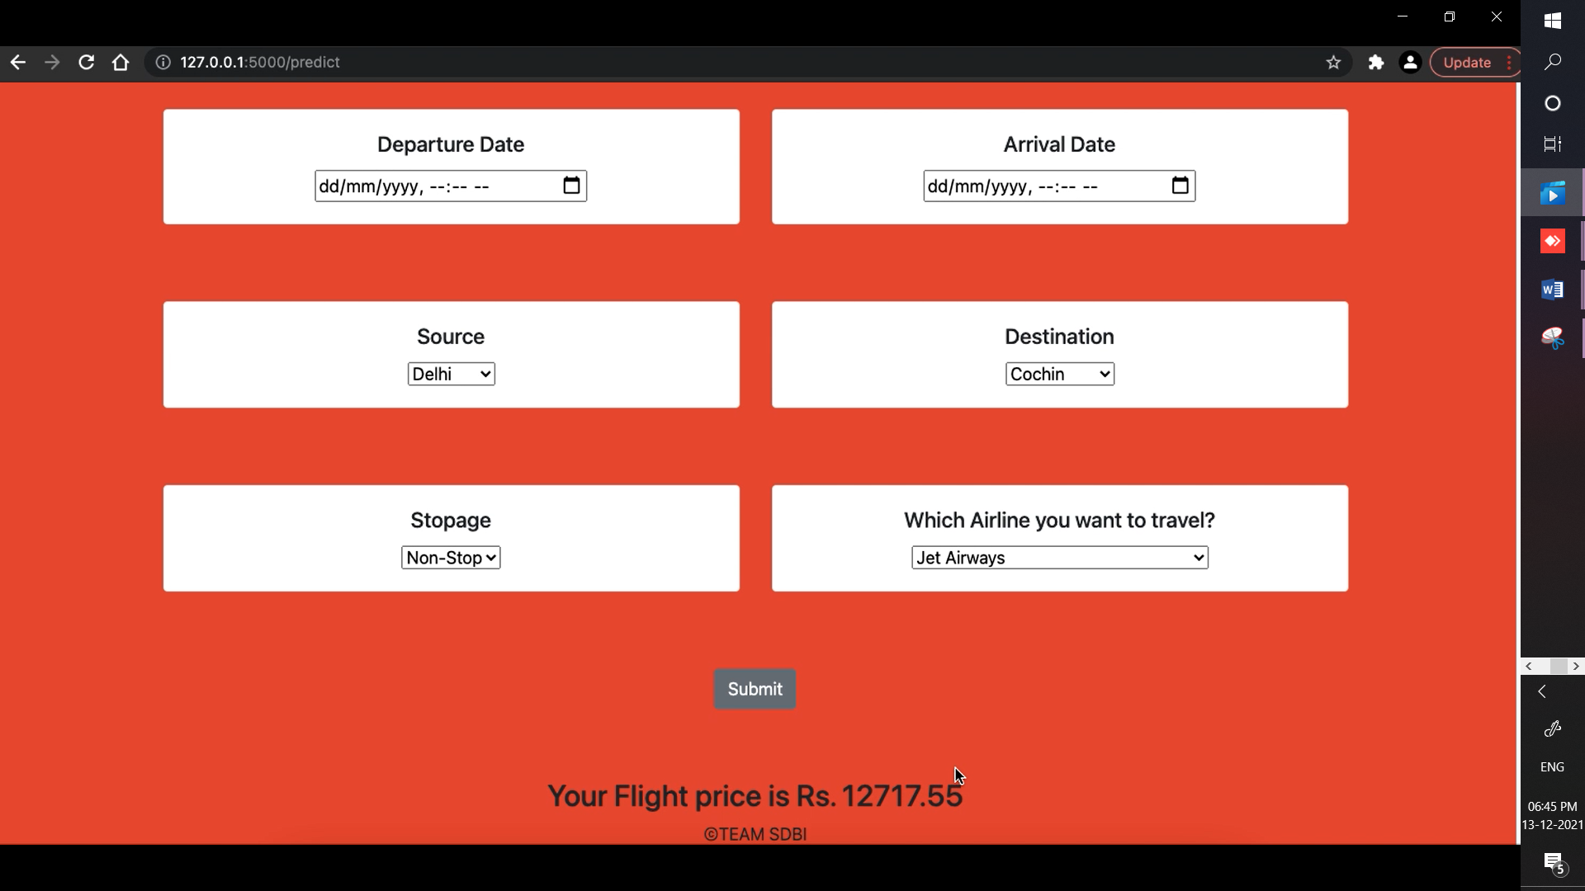

After selecting appropriate options click on submit button to see the predicted price of the flight based on the above conditions. In our case the predicted price of flight from Delhi to Cochin on above mentioned date time, choice of airline and stoppage is **Rs 12717.55/-**