**PUNJAB UNIVERSITY OF INFORMATION AND TECHNOLOGY**



**Submitted to: Prof. Haq Nawaz**

**Submitted by: Muhammad Tayyab**

**Roll no.: mcsf19a037**

**Mobile Computing Classwork**

**Lecture 1**

**Task 1:** Creating GitHub Repository, simple text file and uploading it on GitHub.

**Steps: -**

**Step 1:** Create an Account on github.com.

**Step 2:** Create a Repository on GitHub.

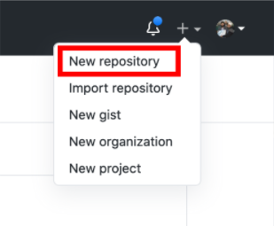

**Step 3**: Provide details of repository on your account.

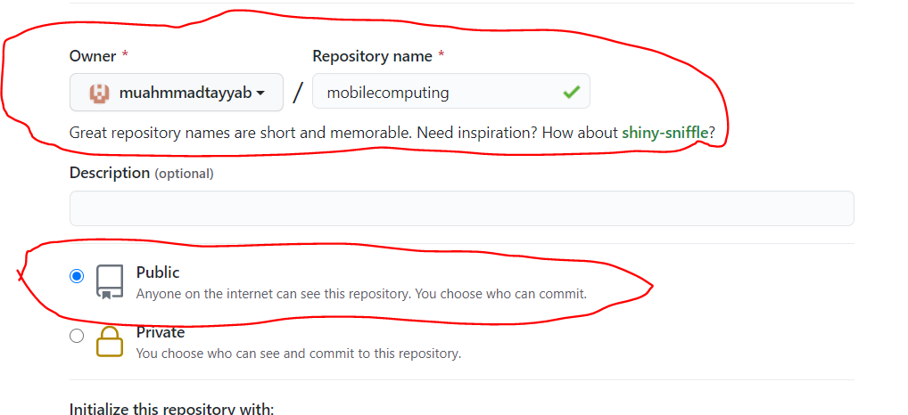

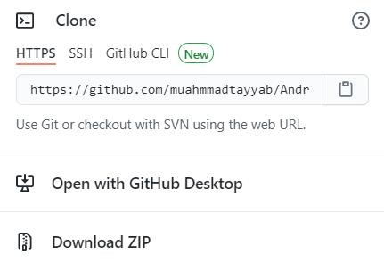**Step 4**: URL of repository on your account.

**Step 5:** Clone a repository

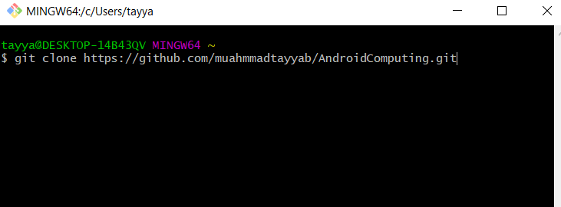

**Step 6:** Create simple text file by clicking right click and then click on New and then Text Document.

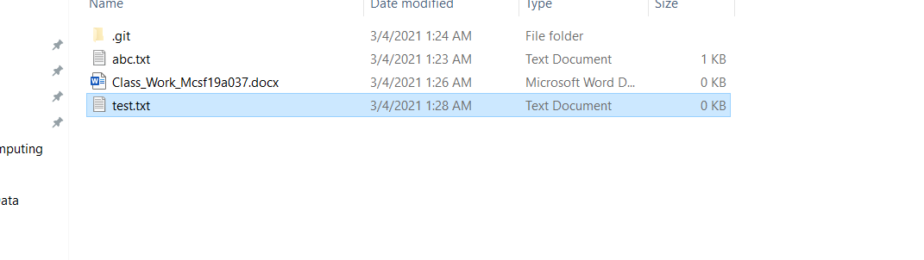

**Step 7:** Now open git from start menu by searching git.

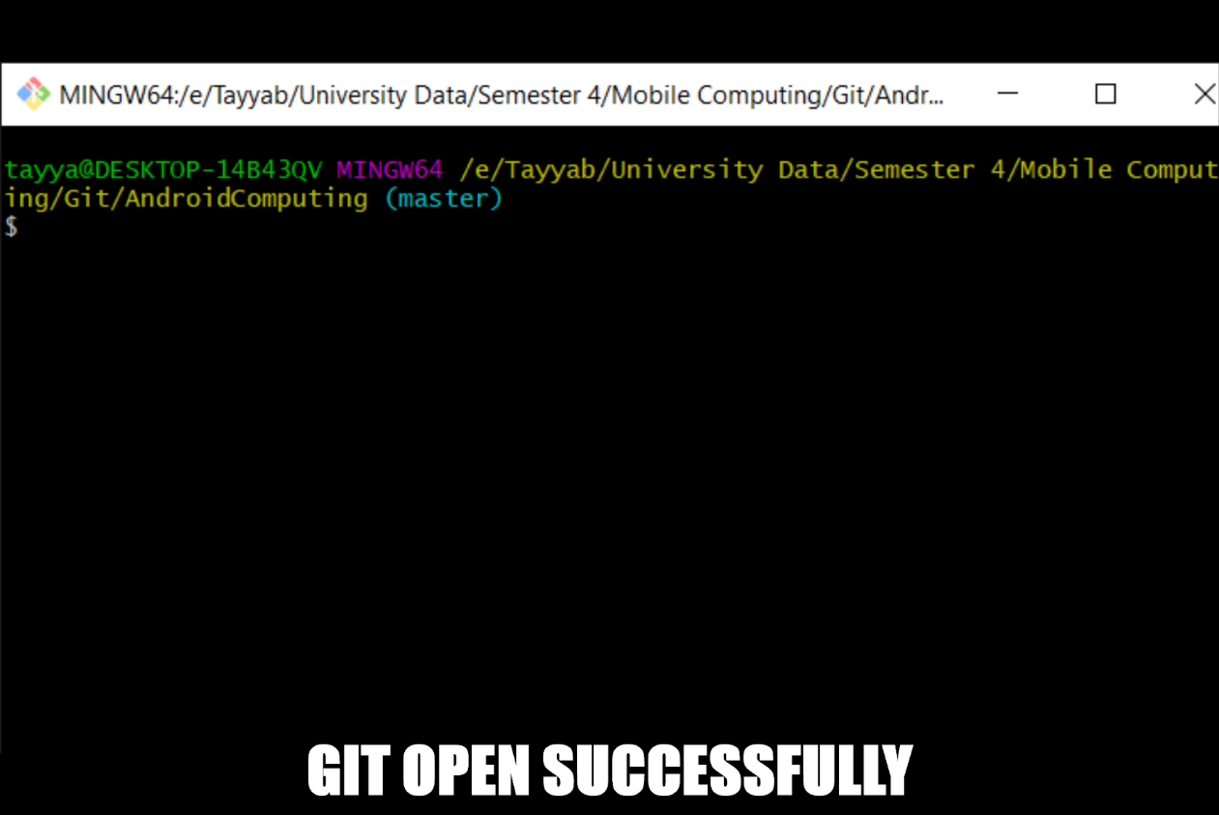

**Step 8:** Now Add text file in git by writing command “git add test.txt”.

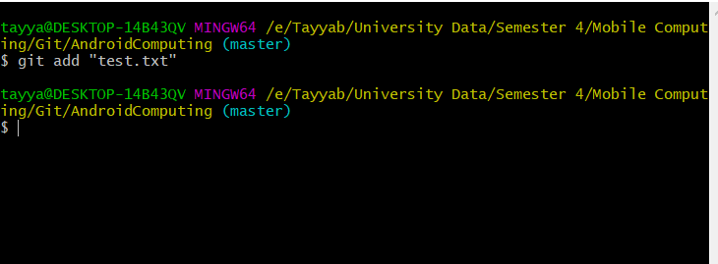

**Step 9:** Changes made with message to track.

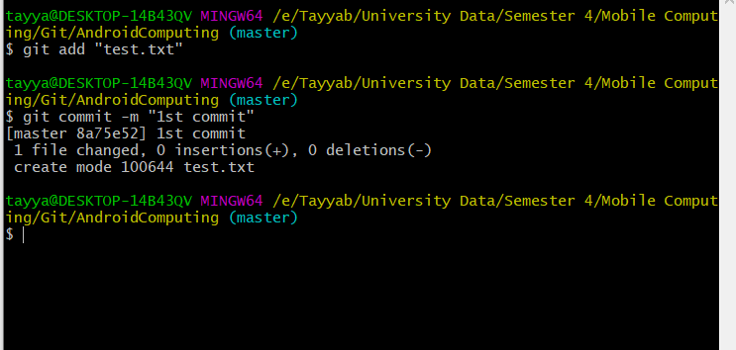

**Step 10**: Now push changes to server.

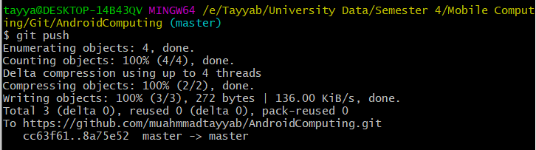

**Step 11**: Now made some changing in text file.

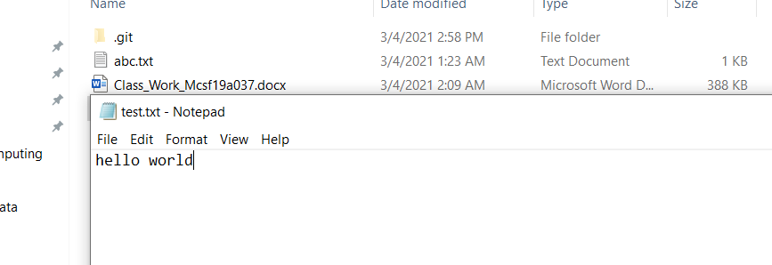

**Step 12**: Now check status on git by writing command “git status”.

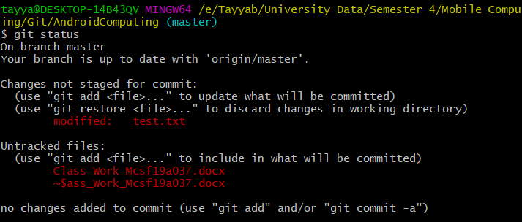

**Step 13**: Now again add file to git and commit change made with message to track and then push it to server git.

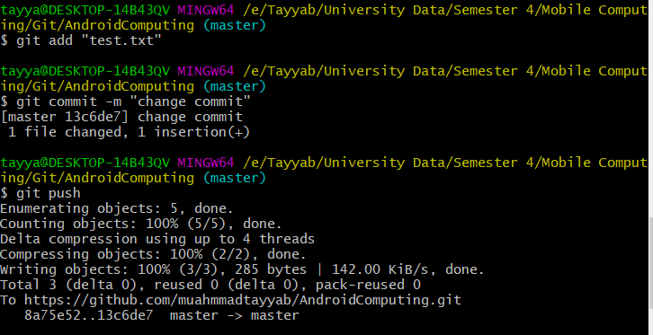

**Step 14**: view of repository after push by opening git website on browser.



**Step 15**: Content of file in repository.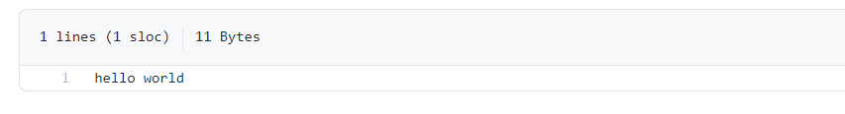

**Lecture 2**

**Task 2:** To solve merge conflict.

**Steps: -**

**Step 1:** Open text file.

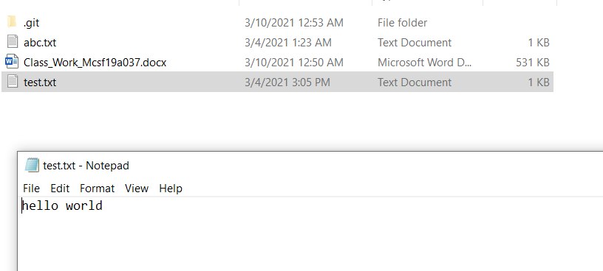

**Step 2:** Add some text. After that, add this file to git, then run commit and then push it into central repository.

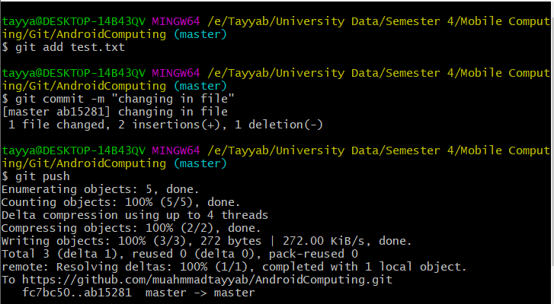

**Step 3:** Now, to merge central and local repository, first, edit code into central repository and then commitchanges.

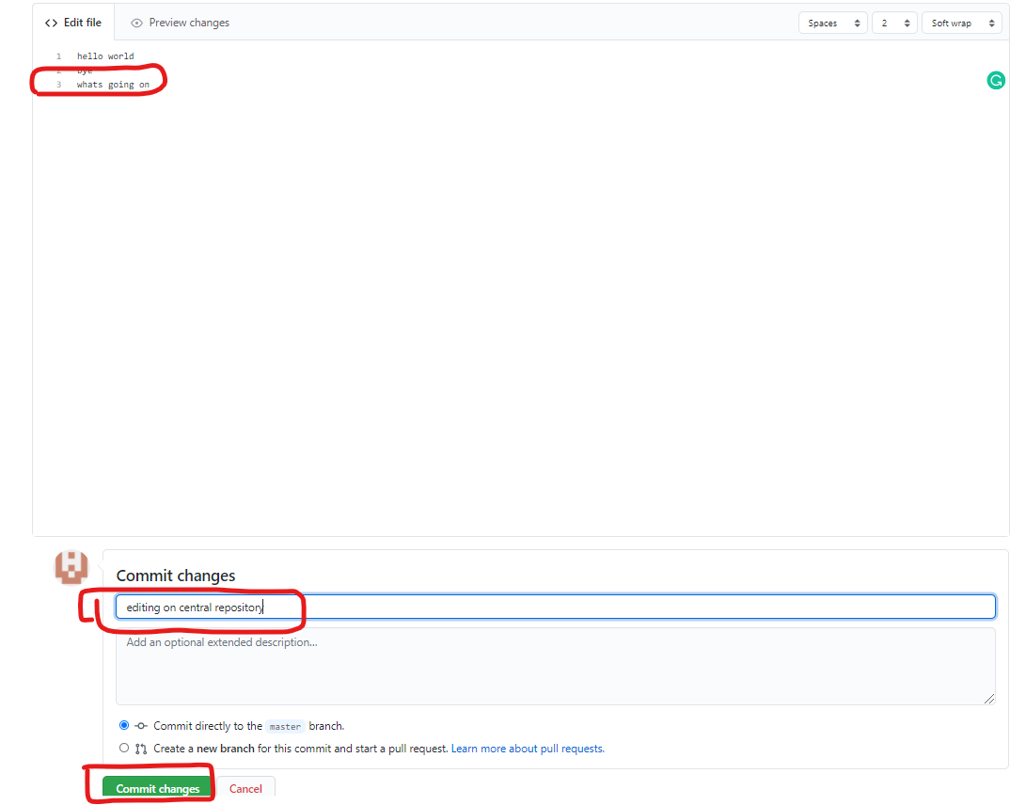

**Step 4:** Now, without pulling central data, just go into local repository and add some text to same line at the same time.

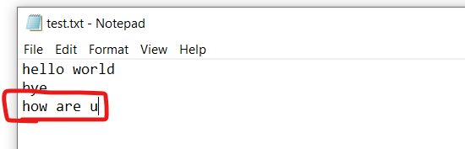

**Step 5:** Then add that file into git and commit, now, when you push it, it gives an error to firstly pull central repository data into it.

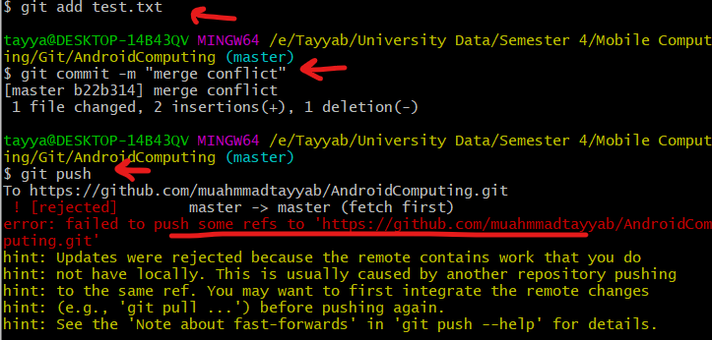

**Step 6:** So, run git pull command and it gives an error which tells you that there is a conflict in merging.

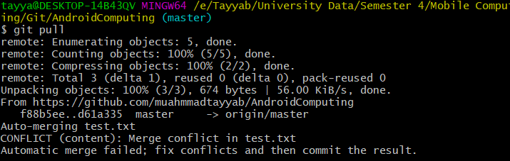

**Step 7:** So, open your file from local repository, you can see there are two statements showing (one of local and 1 of central repository). Select the data you want to add and del other one, then save. After Selection error resolve.

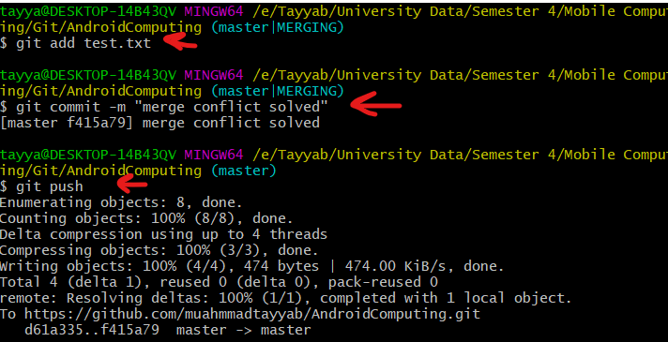

**Step 8:** so, now, the new changes can be seen on repository.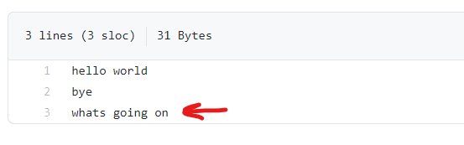

**Task 3**: Check History of command and action you perform using git log command.

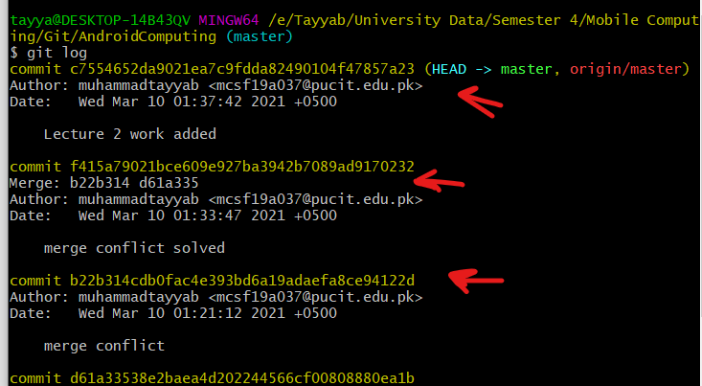

**Task 4**: Delete file using rm command.

git rm <filename>

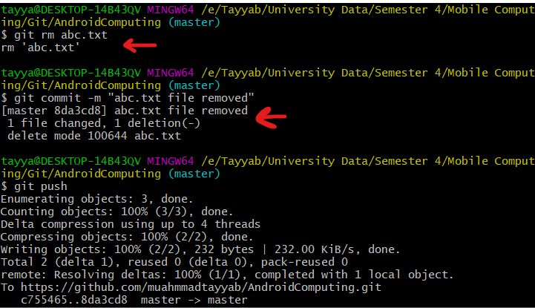

Here you can see file deleted successfully.

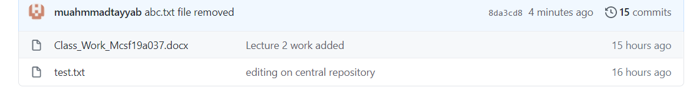

**Task 5:** Creating Branches, Merging Branches

**Step 1:** At first, check your branch status which is master branch by default, then create a new branch using git checkout –b newbranch command. Then again check your branch status**,** it will be changed.

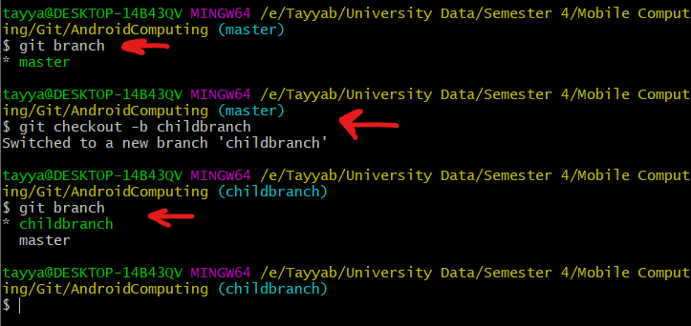

**Step 2:** Now apply some changes in text file. Then add file to git, commit it and push

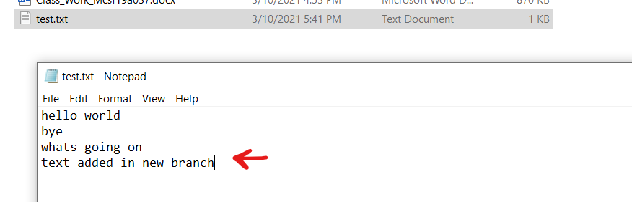

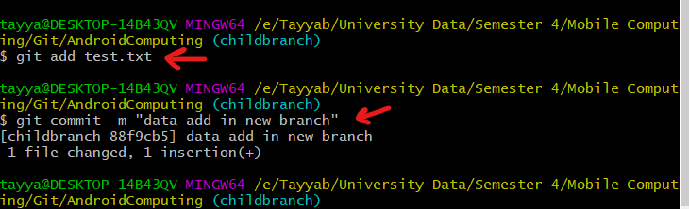

**Step 3:** Now change branch to master branch using command git checkout master. After changing here, you can see data in master branch.

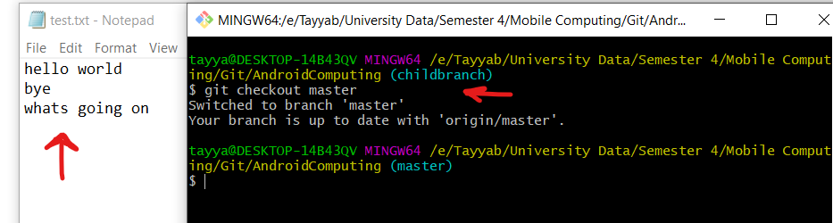

**Step 4:** Now again change branch to childBranch and you will see childBranch data.

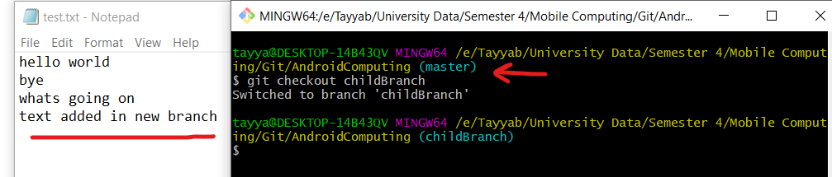

**Step 5:** Now to merge both branches switch to that branch first in which you want to merge the data and then merge data using git merge [branch_name] command.

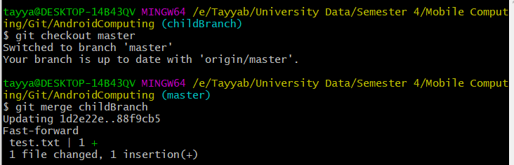

**Step 6:** After merging add file to git, commit it and then push it to git central repository to update.

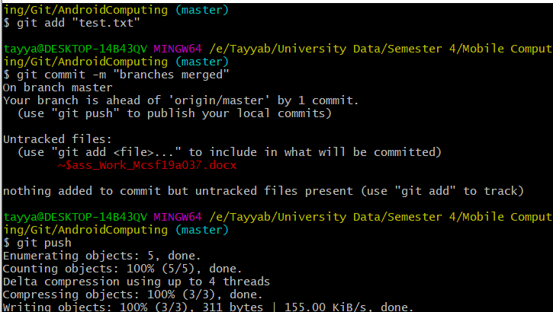

**Step 7:** After pushing delete childBranch with command git branch -d childbranch, and check branch status by git branch command, and then push.

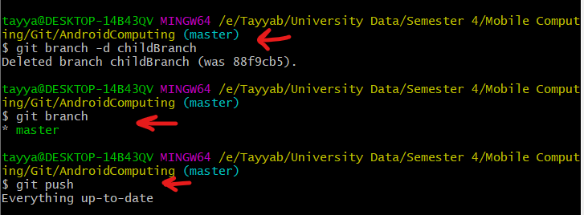

So, that’s all the git practice.

**___________________________________________________________________________**