Add Aspire Host and Services:

This step can be done anytime as it does not play any role in core library

Before starting Ensure you are using Visual Studio Version 17.14.2

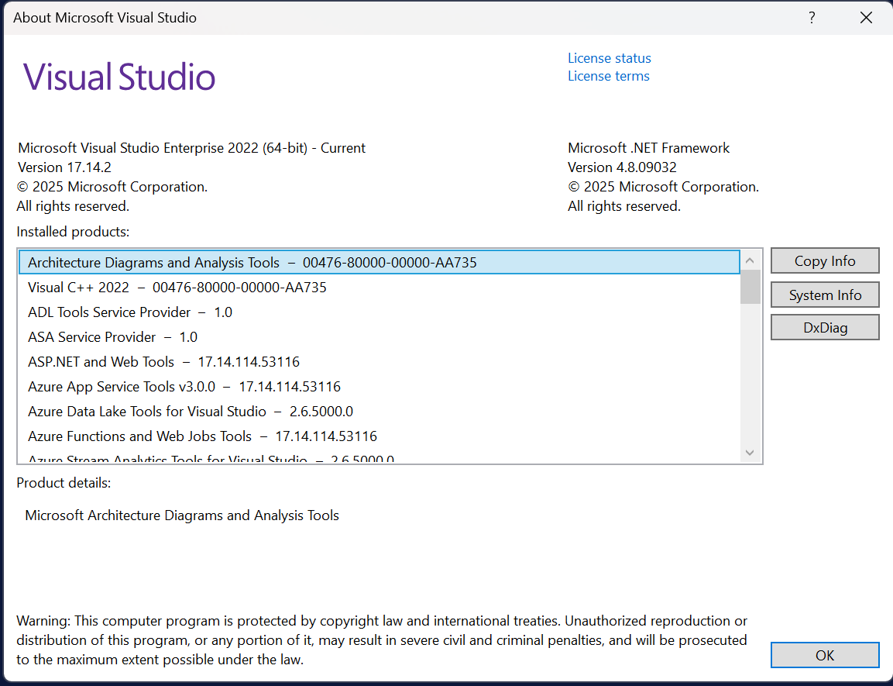

1. Right Click on Core Project and Select Add>.net Aspire Orchestrator Support

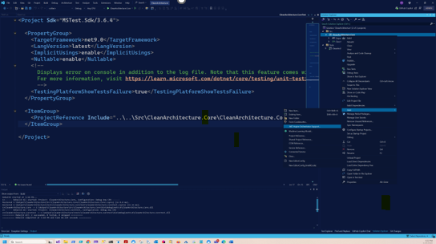

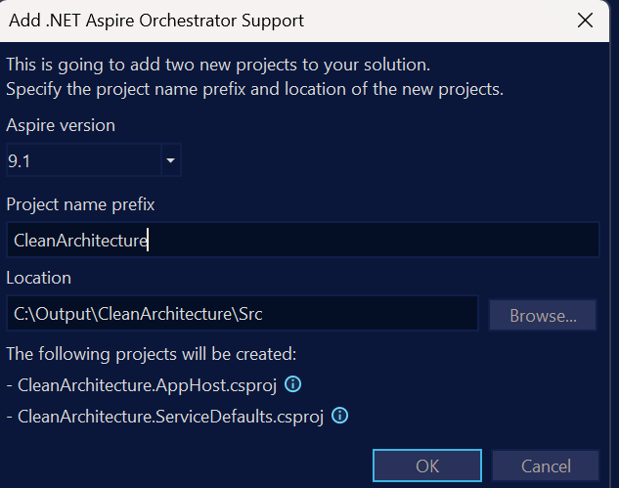

This will add two projects in your Solution, AppHost and ServiceDefaults

Move projects to Src solution folder if it is not inside the Src Solution.

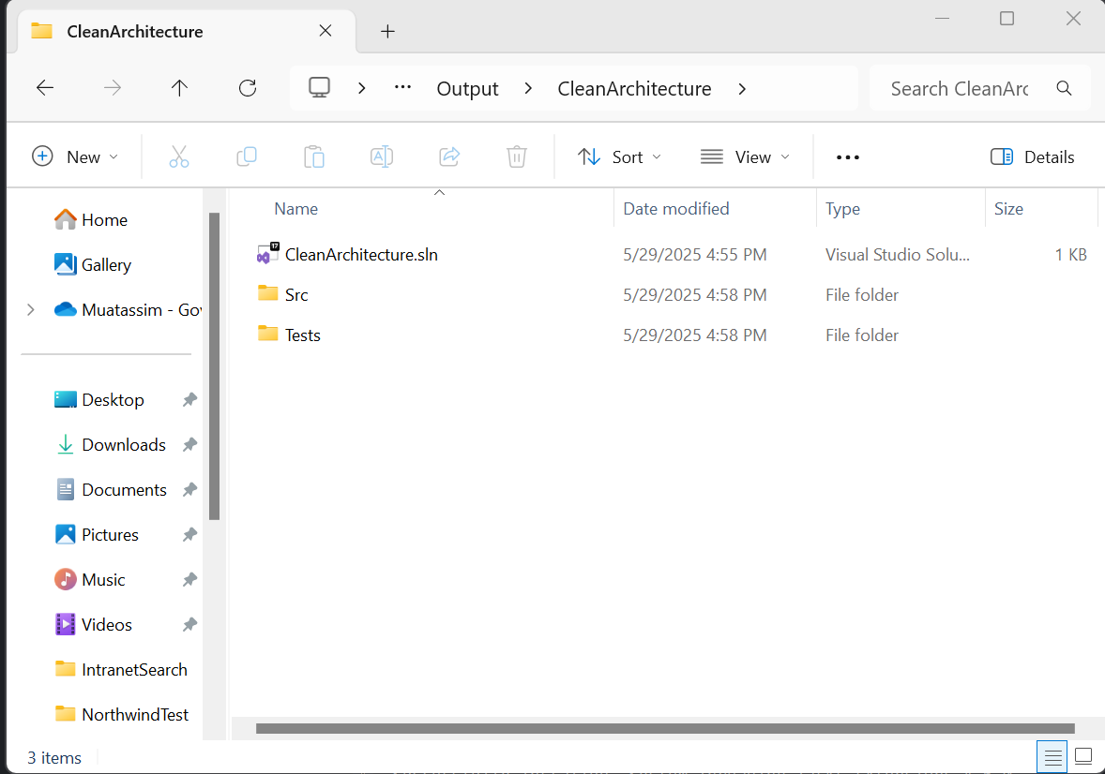

Also Add two solution folders in the solution with the same name:

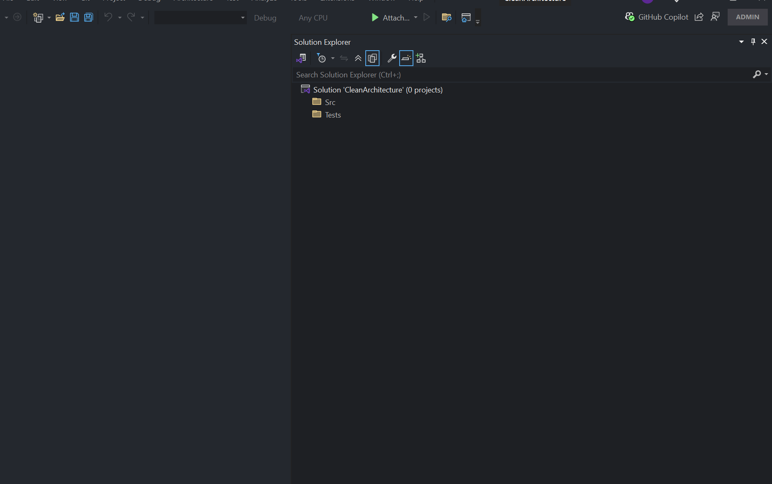

Your project should look like the screen above.

Right click on Src and add select a new project to add Class library Project: