Clean Architecture Project Template -- Application

Open the Clean Architecture Application Project, and it should contain Core and Core Test Project.

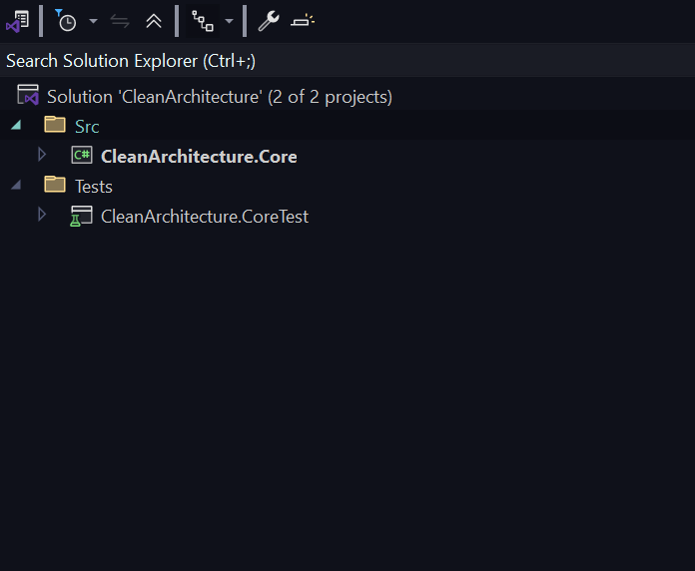

Add the following files from Core Folder to the respective locations:

1. From Entities Folder, copy Builders, Errors, Events, and the Categories.cs file to Entities Folder
2. From Validations folder Copy Services Folder to Services in Validation which contain CategoriesValidationService.cs file
3. From Abstractions Folder Copy Specification/CategoriesCompleteSpecification.cs file to Specification Folder
4. Change name of Method in Interface ILookupDataRepository to GetDboCategoriesAsync 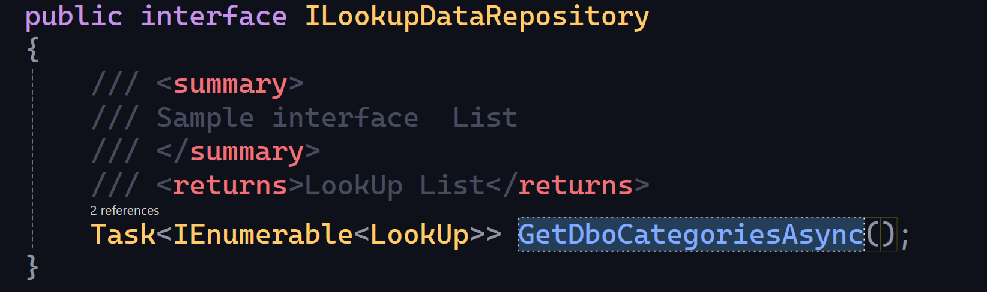
5. Copy Interfaces from Interface folder to Interfaces folder

Core Project should now contain all necessary files for the Categories Entity.

Application Project

Right click on Src folder and select to add new Project, Pick the Class library template, make sure to select the Src folder location. In my case the location is

C:\Tutorials_UsefulCodes\Clean-Architecture\Template\Application\CleanArchitecture\Src\

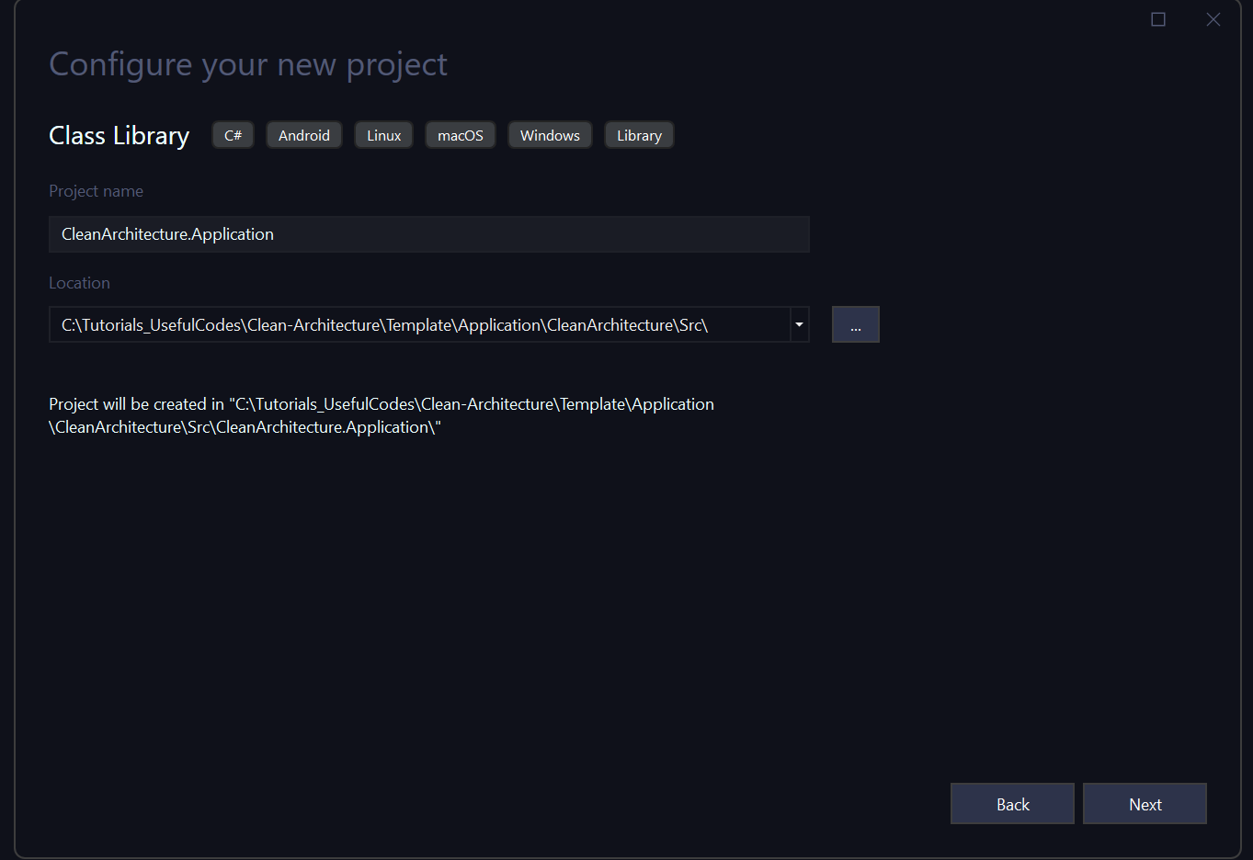

Click Next, accept default as .NET 9.0 to Create the Project.

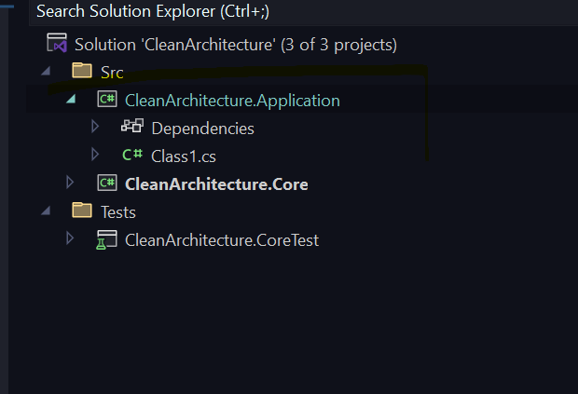

Copy All Files/Folders from Application Folder to root of this application

Ensure Nuget Packages and add Shared Project reference once that is in place below (Details)

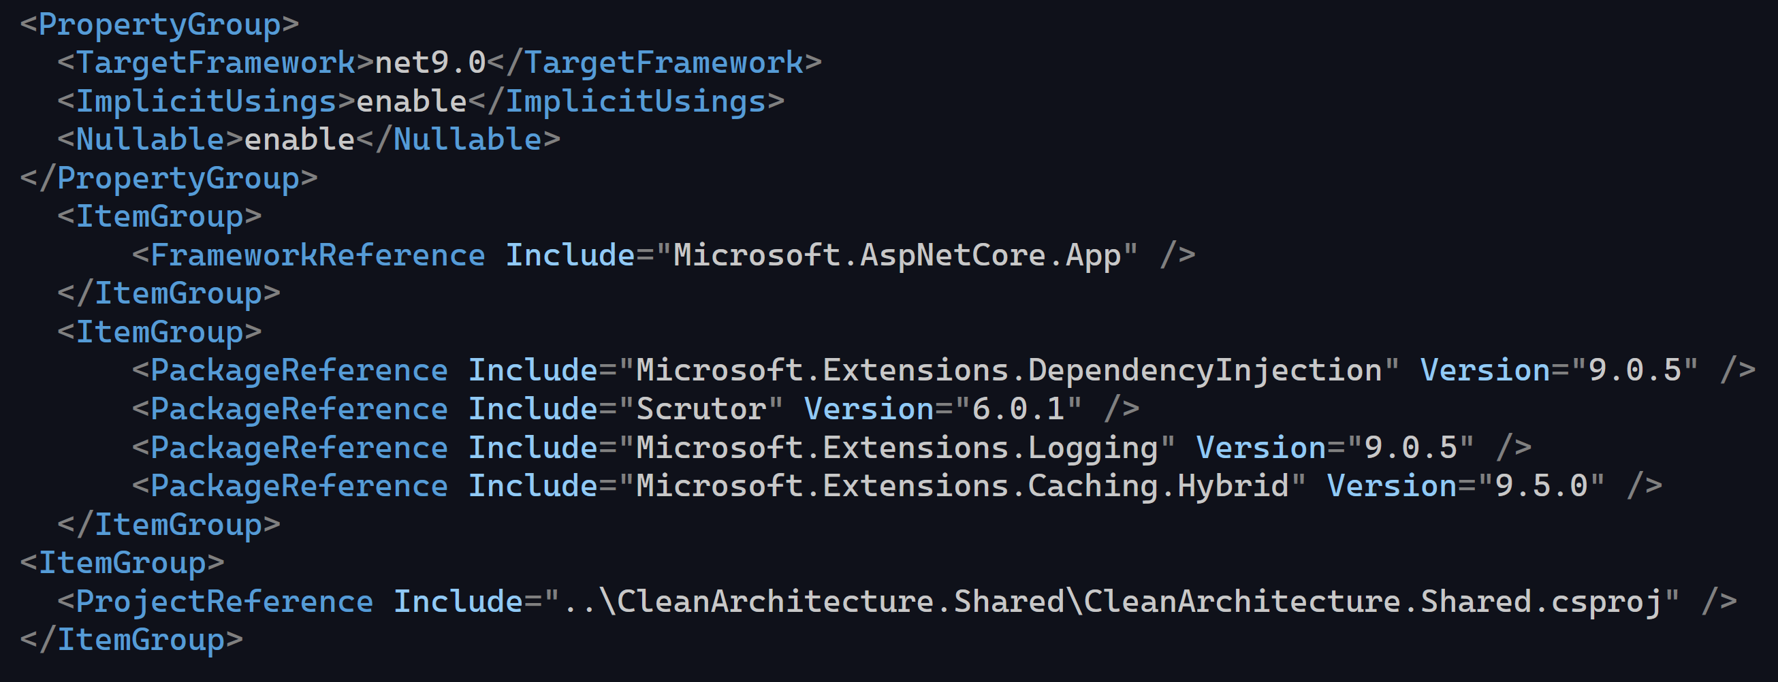

Project should look like the following:

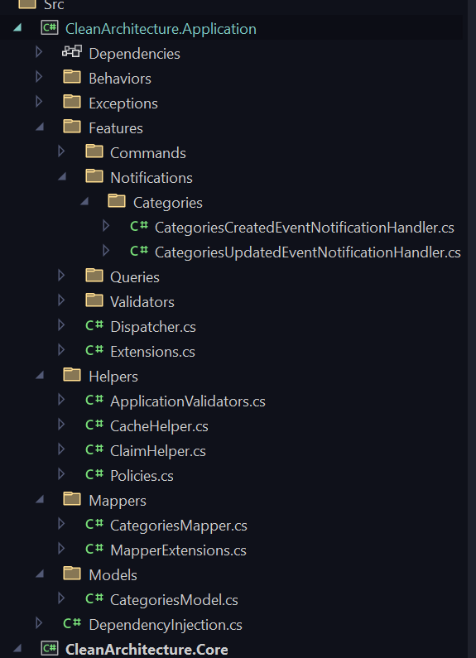

Shared Project

Similarly Create the Shared Project in the Src Folder

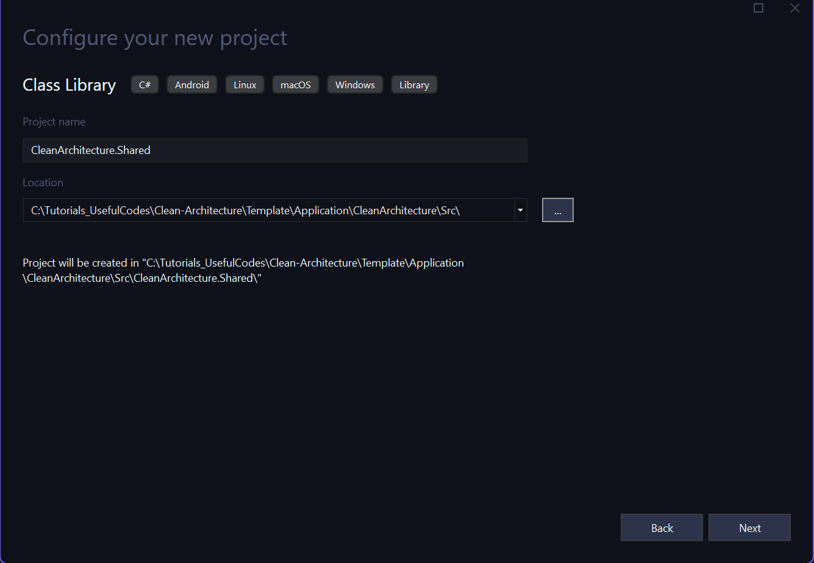

Take defaults and Click Create

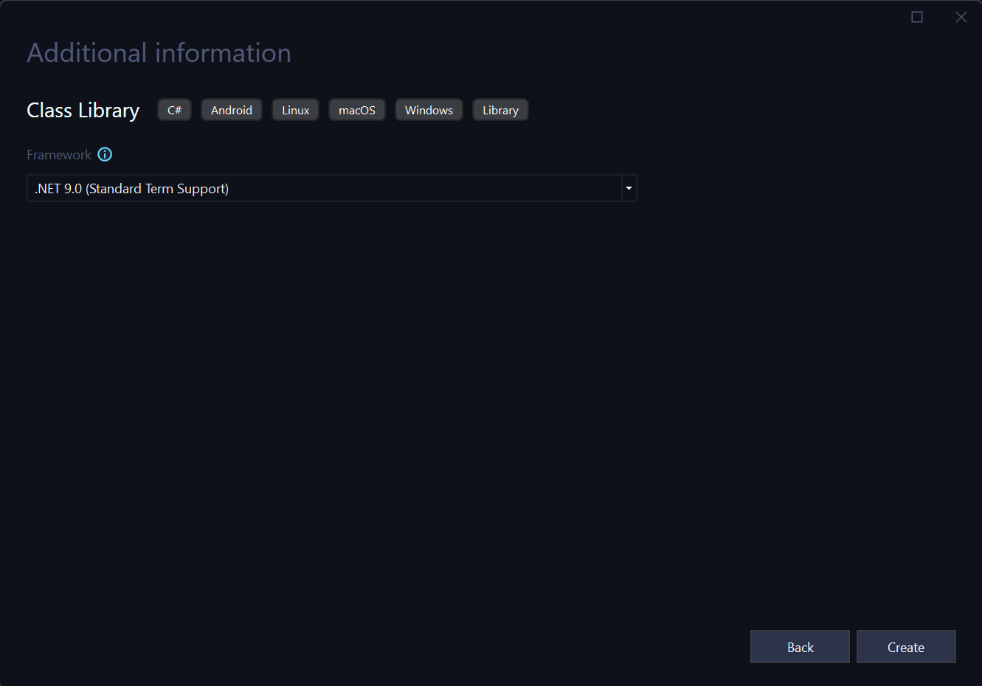

Solution in the Src Folder should look like the Following:

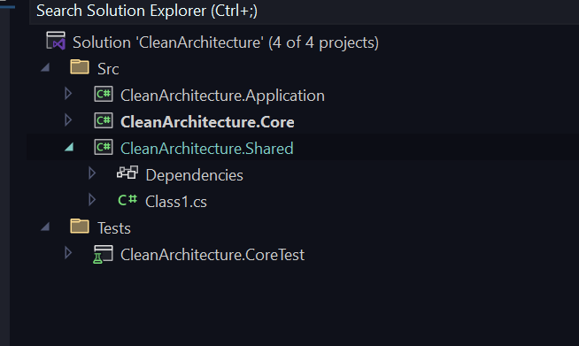

Copy Files for the Shared Project from Shared Project Folder to root folder of Shared Project and Change Namespace if needed and add a reference to the Core Project. Below is the Project file for Shared Project:

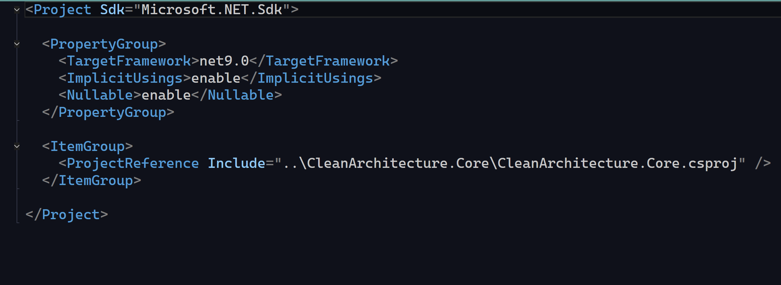

Test Application Project

Right click on Tests folder and add the Test Application Project.

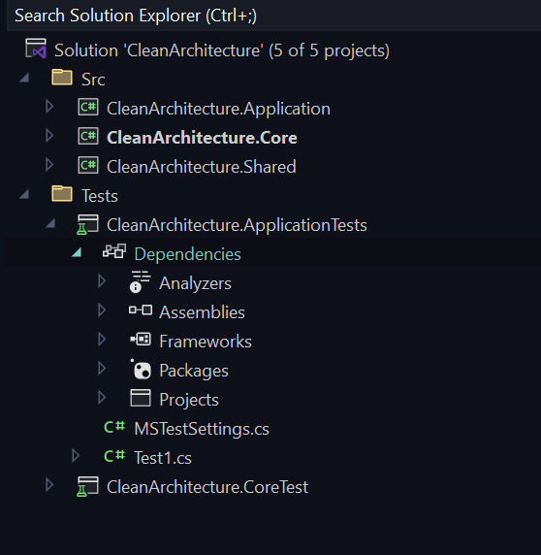

Copy files from ApplicatonTest Folder to root of the ApplicationTest Project. Adjust Namespace if needed.

Ensure AppSettings.json file is set to copy if newer in properties