Clean Architecture Project Template -- Initializer

Right Click on Src Folder and Add a new Library Project, name CleanArchitecture.DataInitializer

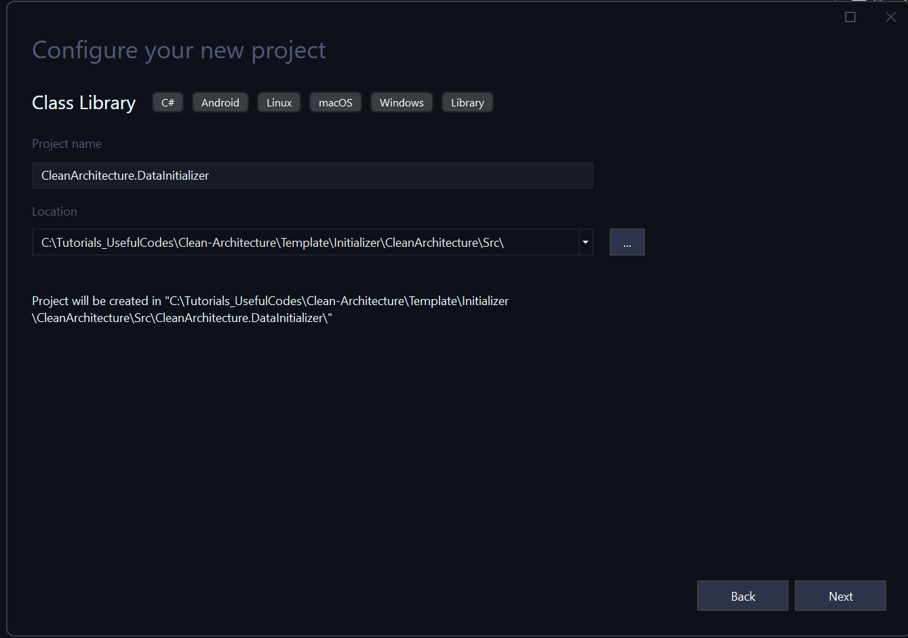

Take Default and Click to Create the Project. Your Project Structure now look like the following: 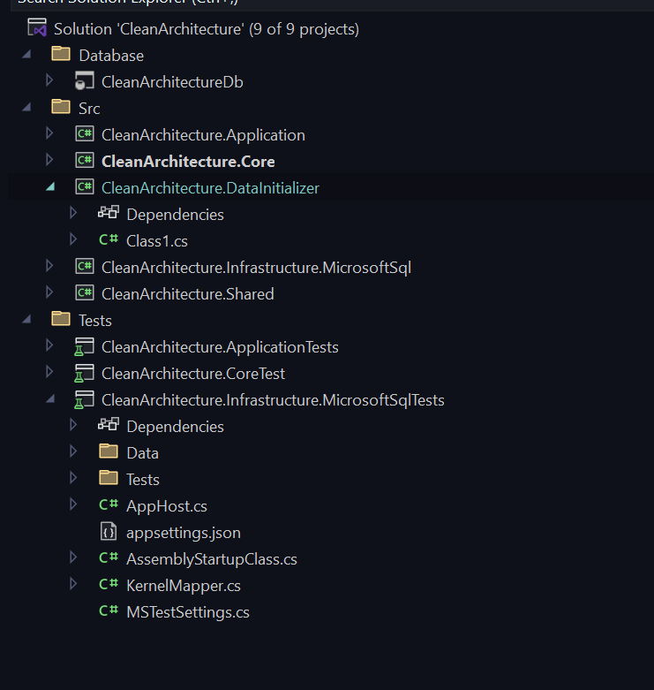

Create a Folder DacPac in the Project, and Unload Database Project, Once Unloaded select to Edit Project File, Add the following in the Project file. Reload the Project and Build

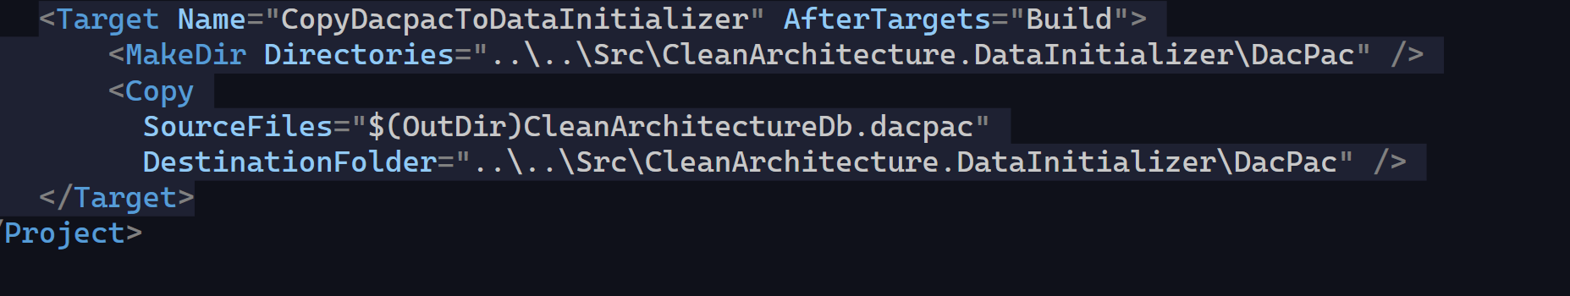

Once the Build is finish, inspect the DacPac folder it should contain the latest DacPac file.

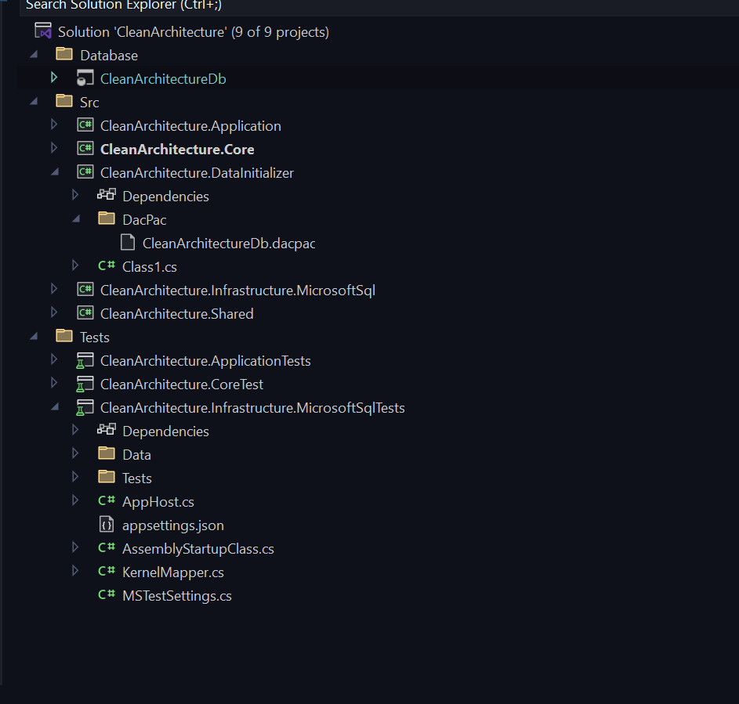

Copy Files from Initializer Folder to the Root of the Project. Ensure to add the following nuget packages

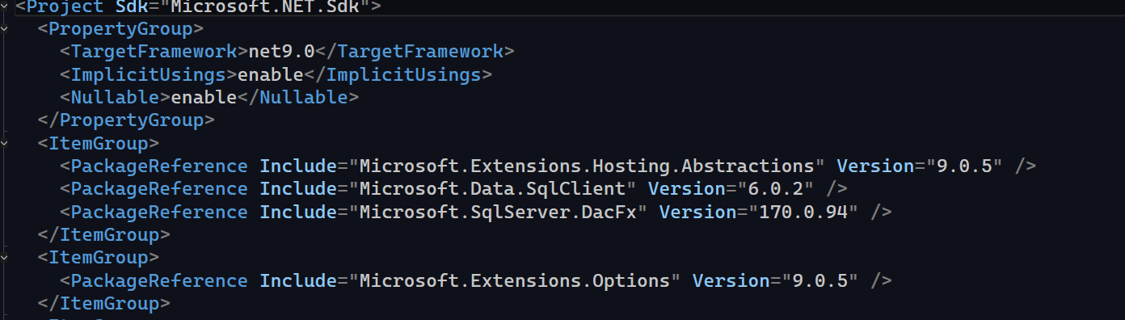

Also Add a Reference to Core Project.

Ensure All Files in Script Folder are Set to copy to output.

Go to CleanArchitecture.Infrastructure.SQl project and add a reference to Database Initializer.

Copy file DatabaseInitializerHostedService to Repositories folder.

Add the following in Dependency Inject in SQL Project



Change Name in the Test Project AppSettings.json to “CleanArchitectureDbTest”

Also ensure dacpac file in the Database Initializer is set to copy on the out put folder. Run the Project and your Test Database should be created.

Run your Tests