Clean Architecture Project Template -- Sql

Right Click on Src Folder and Create another project Name it CleanArchitecture.Infrastructure. MicrosoftSql Project, ensure to create in the Src Folder

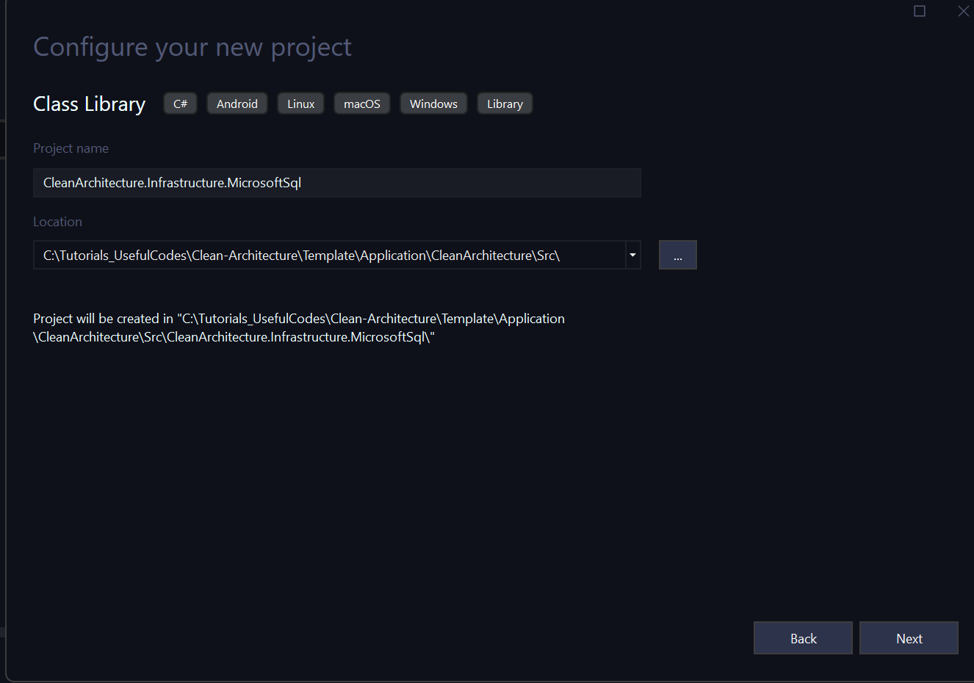

Click Next and Accept default as .net 9. And create the project. Your project Structure should look like

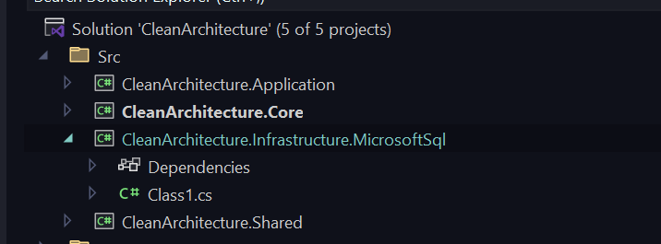

Copy Files from Infrastructure.Sql to Root folder, also add reference to Core Project, Add Nuget packages as shown in screen Shot below

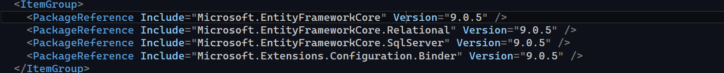

Project should look like:

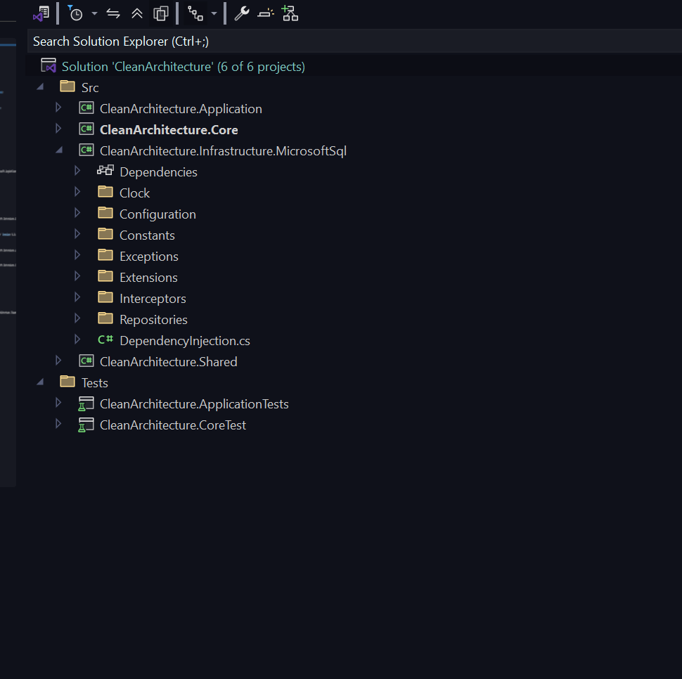

Test Sql Project

Right Click and Add the Sql Test Project ensure to save it in Tests Folder

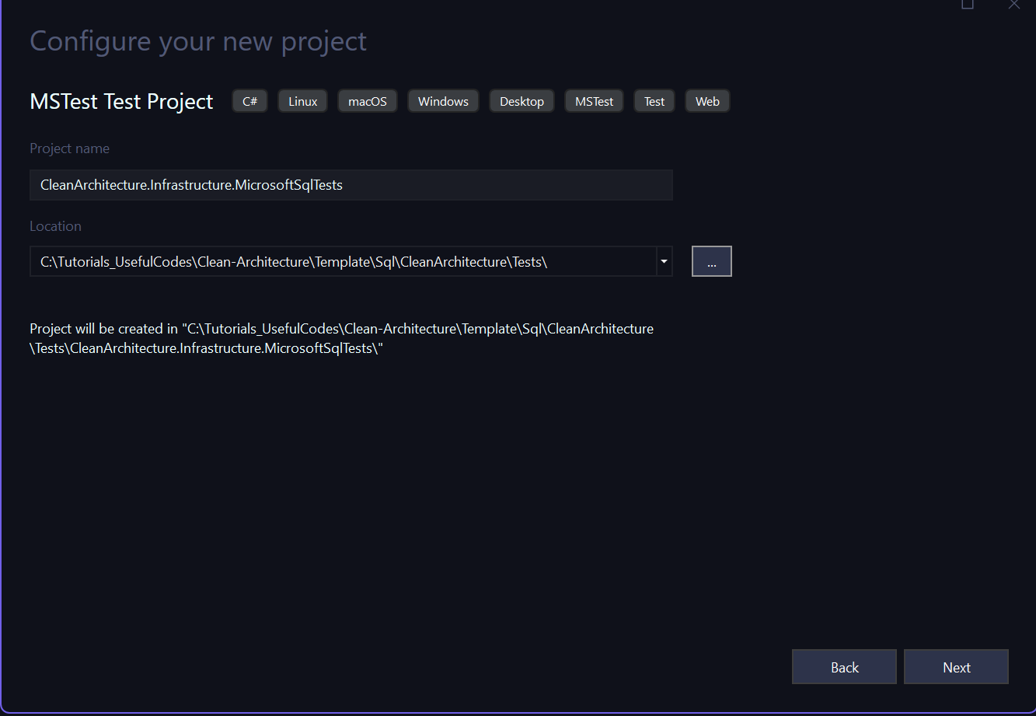

Click Next and Take the Default to create the Project,

Copy All Files from Infrastructure test folder to root and ensure Project file looks like the following with all nuget packages installed:

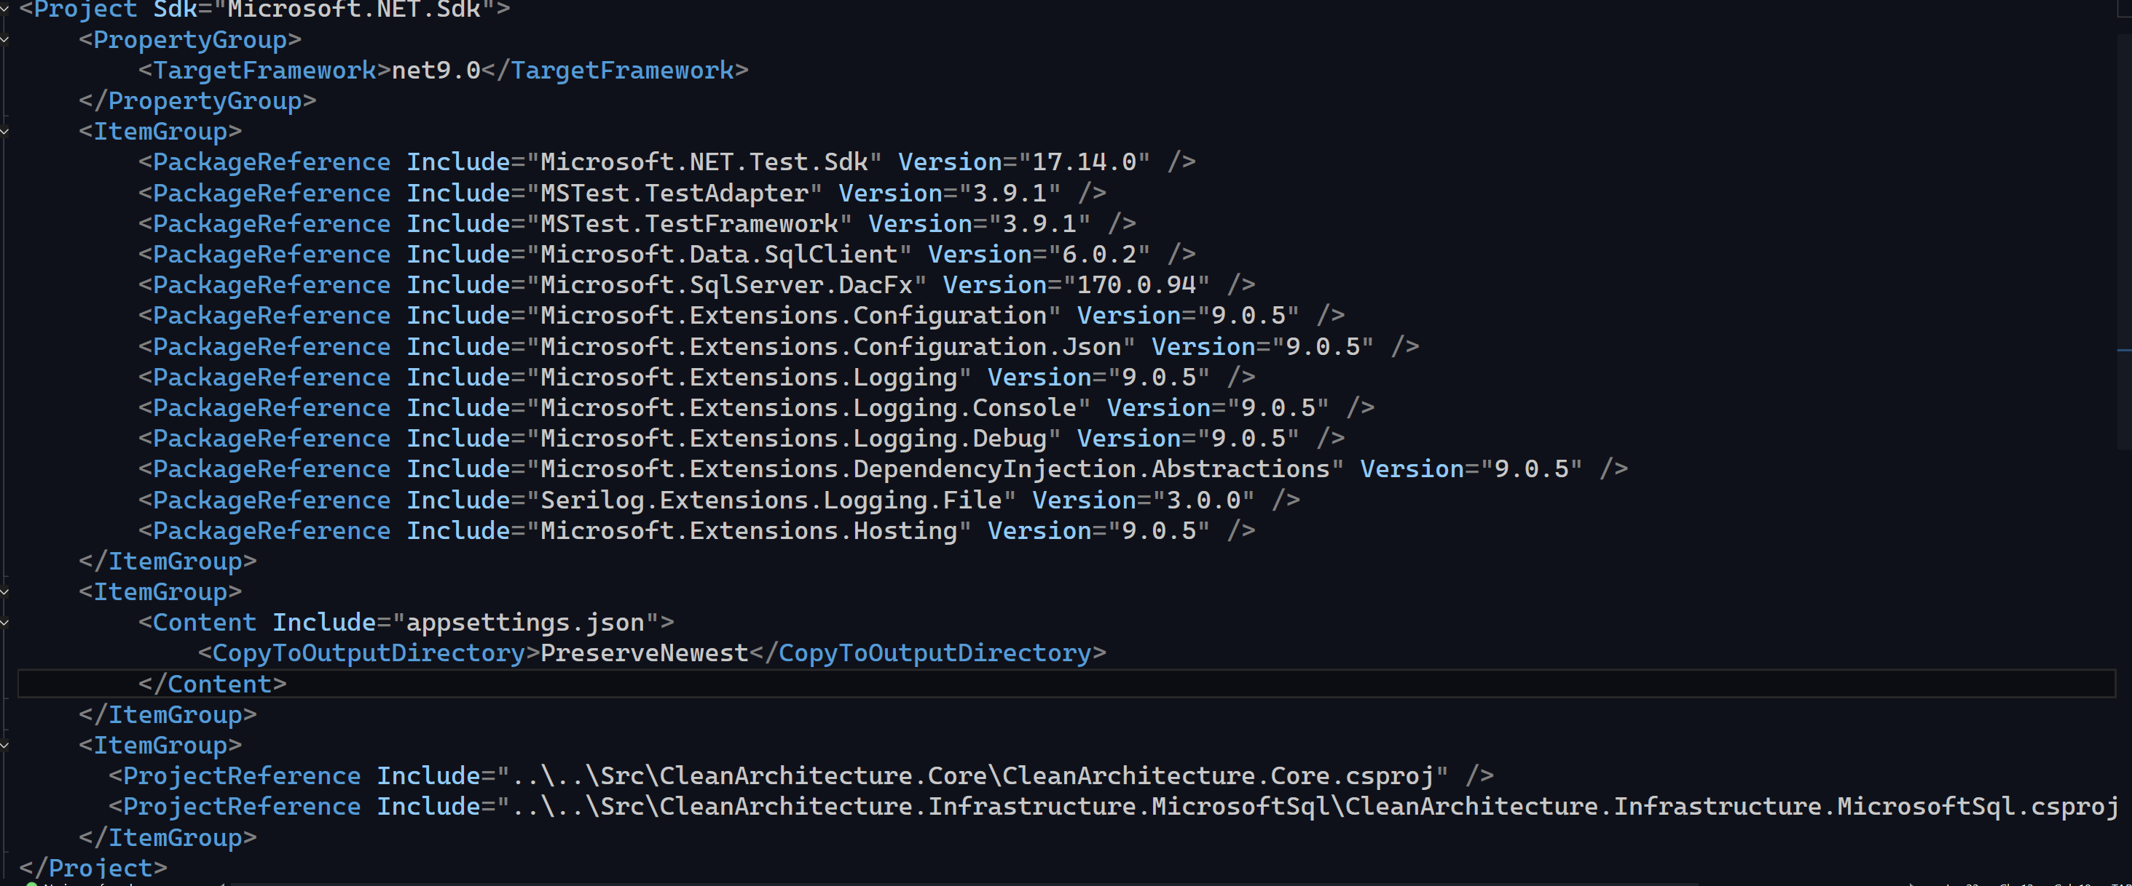

Add Reference to Core and Sql Project. Copy Files from Infrastructure.SqlTest folder to root folder

Database Project

Create a new Folder in the Solution Folder, and named it Database, and Create a new Solution Folder with the same Name.

Right Click to Add a new SQL Serv er Database Project, make sure to use the Database folder. Name of the Project: CleanArchitectureDb

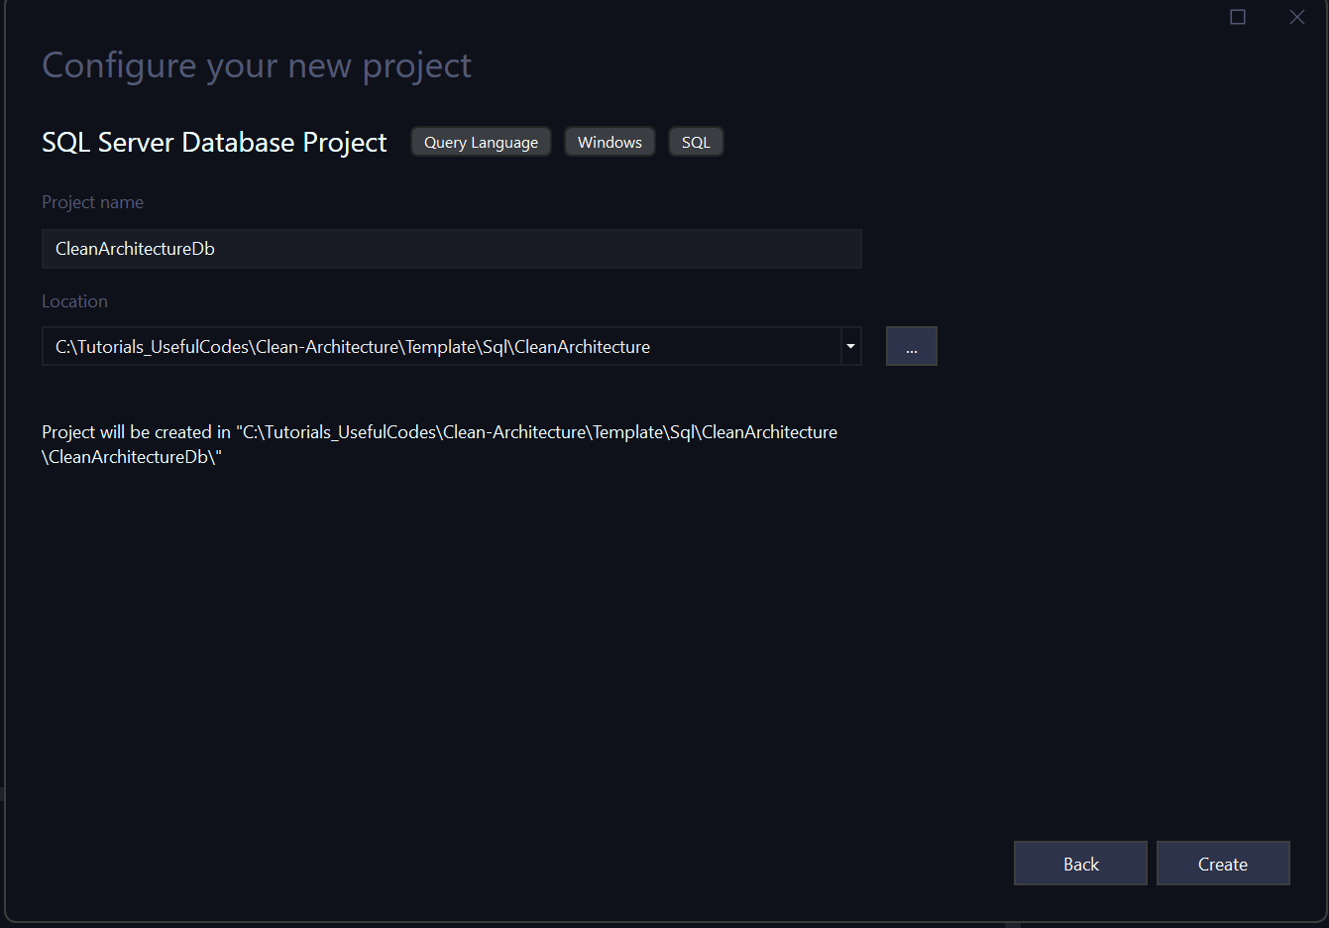

Above Screen Shot is showing wrong where the project will be create, ensure it is Selected as Database folder, which you created above.

Copy Files from Database Folder to Root of the Project, Publish the Project

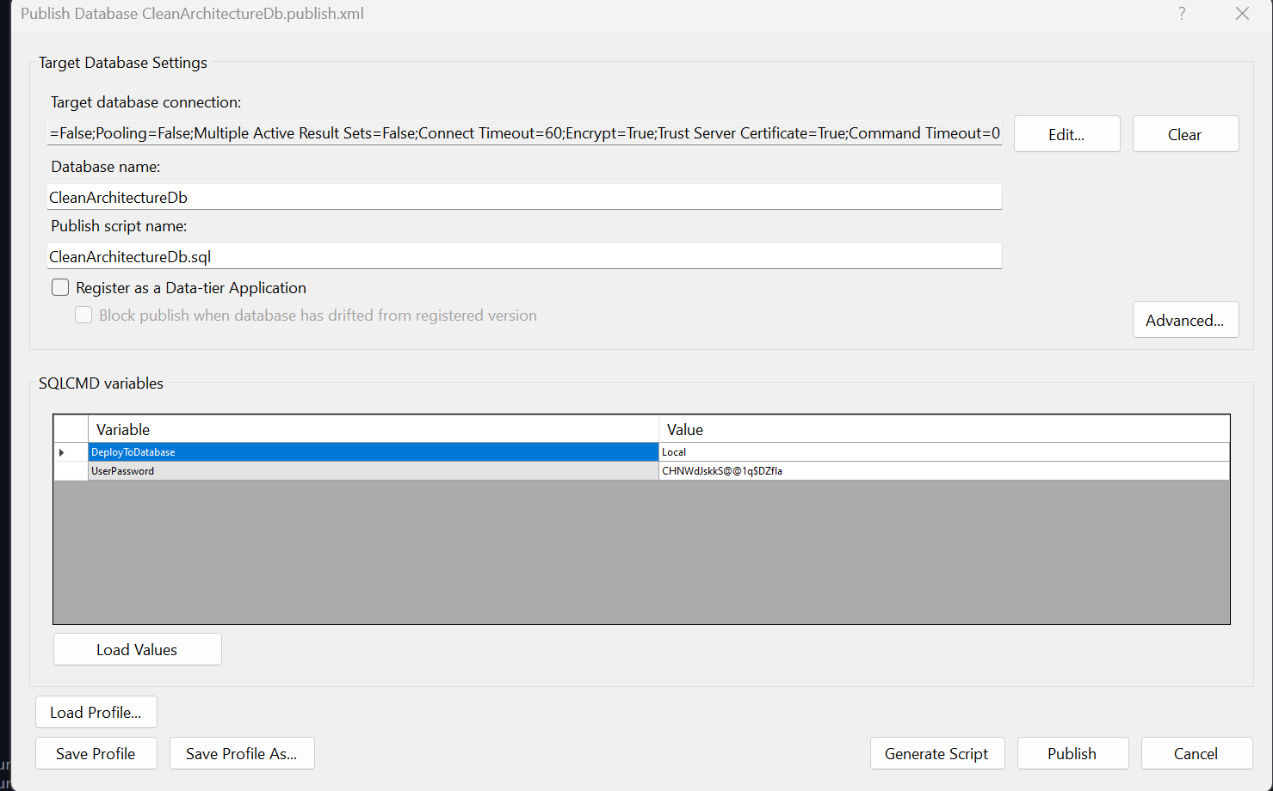

Database project should look like:

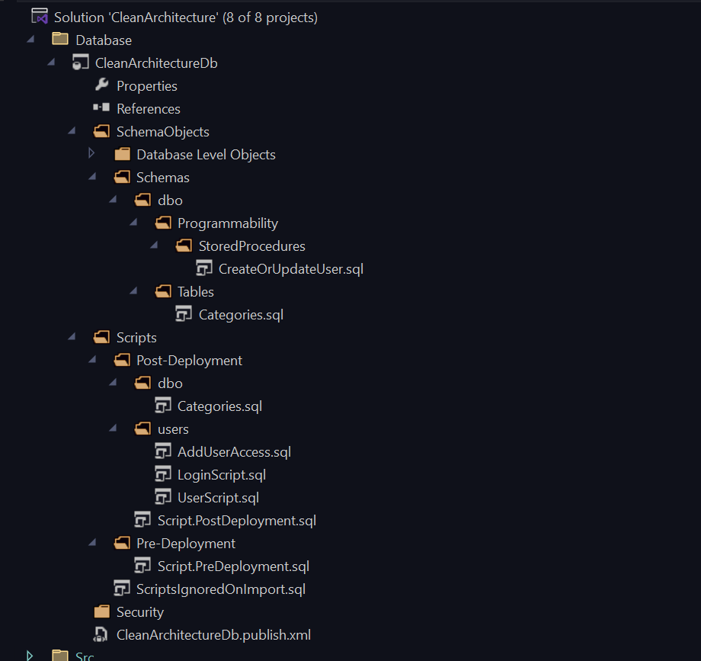

Once you deploy the database, run your database SQL Tests.