**King Saud University**

**Collage of Computer and Information Sciences**

**Computer Science Department**

**LOGO**

**“Project Title”**

*CSC 496 – Midterm Report*

**Prepared by:**

Student 1 Name Student 1 ID

Student 2 Name Student 2 ID

Student 3 Name Student 3 ID

Student 4 Name Student 4 ID

Student 5 Name Student 5 ID

**Supervised by:**

Dr. Name

[Research/Software] project for the degree of Bachelor in Computer Science

First/Second Semester 14##/14##

Autumn/Spring 20##

# Acknowledgements

# English Abstract

The abstract should complement your proposal abstract and might include additions that do not contradict the previously proposed abstract.

# Arabic Abstract

Your abstract translated to Arabic.

Table of Contents

I. Acknowledgements 2

II. English Abstract 2

III. Arabic Abstract 2

Chapter 1: Introduction 4

1.1 Problem Statement 4

1.2 Goals and Objectives 4

1.3 Solution 4

1.4 Research Scope 4

Chapter 2: Background 5

Chapter 3: Literature Review 5

Chapter 4: Summary 5

References 5

List of Tables

Table of Figures

# Chapter 1: Introduction

As students we have a common problem on finding the course resources, searching for a lecture materials may take time and with unpleasant outcome.

We tend to solve this by building a web app which allows students to interact with each other and share courses material.

Web app could be built in many languages, such as JAVA ,JAVASCRIPT and C#.

We tend to build the app using PYTHON DJANGO, a powerful language with a powerful tool which give us a variety of features that we can build on.

Python created in 1989 and according to “edureka.co” in 2019 it’s the number one programming language in the world and it have taken the leadership because of:

* Open-source programming language
* Extensive support modules and community development
* Easy integration with web services
* User-friendly data structures
* GUI-based desktop applications

This project will focus on tackling this issue and build an environment for students to share there course resources using DJANGO, we tend to build a statics that is focused on a sample of KSU IT students ,which we be a good backup and will lead our project making it more stable while seeing the point of interest of most of the students.

The unique thing about our project that its made for KSU IT students and it can be latter expanded to other departments and even universities, and luckly it can be achievable by PYTHON and DJANGO.

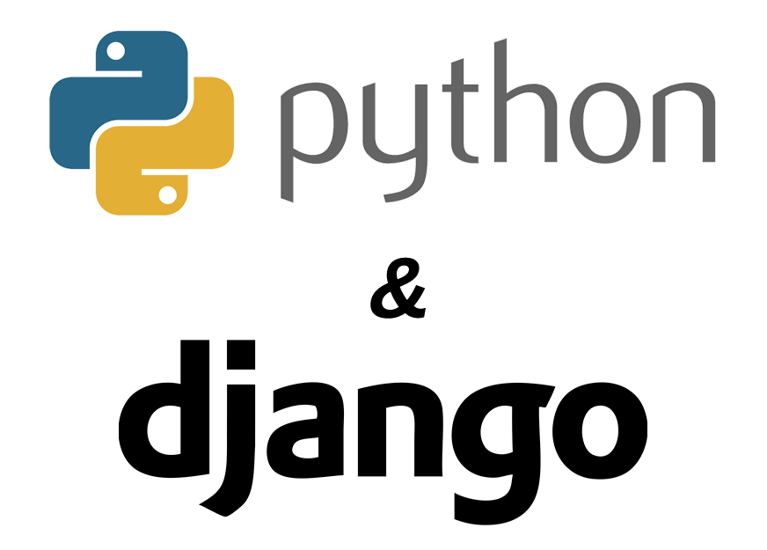

## Problem Statement

Student have always faced a problem in finding there courses resources which they need in intend to achieve the maximum grades possible and that can them help achieve a good GPA that they set there goals on.

Some courses material are either sold in bookstore, sometimes with high prices that student cant afford, or kept as a secret between students.

On the other student could be an absent due to a critical reason and in this a day the lecturer could say and important notes to students.

These are some of the examples that regular student could face which results in loosing marks.

Videos have always been helpful and are easy to understand, they are like lectures but are recorded.

Speaking about videos, videos which are directed to IT student are regularly detailed and take a lot of time until you take what you need of it.

You could be watching a 15min video and at the end the outcome is zero while there is a student watching a 3min video which is address the problem you need.

another problem students could be facing is knowing details about there upcoming courses that they will take later, student in general like having a brief outlook about what there upcoming looks like.

So they can be well prepared and know what there are facing in the feature, they ask question like:

* Does the course require knowing a specific language?
* How is the grading like?
* Is there a project ?
* How does the past exams look like?
* Ect….

These questions are always ringing in the student ears, sometimes not knowing what the upcoming course looks like my effect the student grading or result to an “F” or withdrawing from a course.

## Goals and Objectives

Goal :

our goal is to make the students life's easier ,improving their scientific level and saving their time with a positive outcome.

We tend to let them focus on courses Instead of wasting their time searching for resources. also Encourages the cooperation

between students and make them close to each other in one place .

how you will achieve it:

We aspire achieve it, By creating a plan Start with setting the goals of the project , and writing the specifications

and gathering the requirements including (User requirement and System requirements ) then writing the software system requirement

which is classified into functional requirements and non-functional requirements that we'll need, , then construct the use case model and description.

then starting the implementation using python "Django" and other language like HTML ..etc. which is needed to design User interface

and make it easy to Develop the web , also setting the database using "SQLite" that'll save the data . after that we should create a prototype

that we'll testing it and debug it , the last thing we'll do the Maintenance .

**Specific :**

**...**

**Measureable:**

Our success lies in make an Integrated web that have features That helps students For a better understanding of their courses

and Developing their academic skills , and make it easy to share resources by upload it and easy to read it and download it.

**Achievable:**

**...**

**Realistic:**

**...**

**Time constrained:**

**...**

## Solution

## Research Scope

# Chapter 2: Background

This chapter should give an overview of the knowledge domain where your research takes place. You should define the notations you will be using later in your report, and introduce the user to any concepts, terms, algorithms, or tools you will be using in your project.

# Chapter 3: Literature Review

In this chapter, you should show familiarity with the literature. By exposing the reader to the relevant published work. The literature review should be comprehensive for the problem you are writing about. The purpose of this chapter is to put your work in context with others, and benefit from their experience. You may mention any changes that you have made to your original solution after you have conducted the literature review. Your conclusions should be included in a discussion section by the end of this chapter.

# Chapter 4: Summary

Provide a clear, insightful summary of what you concluded from the literature review and how you plan on proceeding with your project.

# References

A bibliography of all cited works and sources you have used throughout this report. All references should follow IEEE format and should be ordered by their occurrence in the report.