Contents
1 Database and DBMS design 2
1.1 Database Requirements 2
1.1.1 Scenario 2
1.1.2 Data Requirements 3
1.1.3 User and system requirements 3
1.2 Database Design 3
1.2.1 Conceptual model 3
1.2.2 Model mapping and logical design 3
1.2.3 Physical model 3
1.3 DBMS Architecture and Programming Techniques 3
1.4 Data Transfer 3
1.4.1 Flowchart and DFD 3
1.4.2 Evaluaiton of data transfer 3
1.5 Effectiveness of the database and DBMS 3
2 DBMS Development 3
2.1 SQL Queries 3
2.2 Data structures 3
2.3 Indexing 3
2.4 Criticizing the mapping of SQL queries 4
3 Concurrency Control (CC) 4
3.1 Standard DBMS CC Techniques 4
3.2 Implementation of CC 4
4 User Interface and Testing Plan 4
4.1 User Interface Development 4
4.2 Testing Plan 4
4.3 Evaluation 4
References 4

Database and DBMS design

Database Requirements

Scenario
In this project, we developed a simple library management system using the C programming language. The main goal was to simulate a basic database system without relying on actual database software. Instead, we used dynamic data structures like linked lists and binary search trees to manage the data in memory and file handling to simulate persistent storage.
The system allows users to add, update, delete, and display records for books, library members, borrowed books, and library cards. We also implemented features like enforcing unique IDs, checking constraints (like preventing multiple library cards for the same member), and saving/loading data from files. The idea was to make the system behave similarly to an SQL-based system but using manual C code logic to handle everything.
Throughout the project, we focused on simulating database operations and making sure the system was consistent, efficient, and user-friendly, even though it was all done in C.

Data Requirements
- • The system manages information about books in the library. Each book has some details like its ISBN number, name, and which shelf it belongs to.
- • It also keeps track of members who are registered in the library. For every member, we store their ID, full name, and address.
- • Every member can be issued a library card, which has its own card ID along with the dates when it was issued and when it expires. A member should only have one active card.
- • The system keeps a record of which books have been borrowed and by which members. When a member borrows a book, we log their ID and the ISBN of the borrowed book.
- • Before allowing a book to be borrowed, the system checks to make sure that both the member and the book exist.
- • A member can return a borrowed book, and the system removes the record once the book is returned.
- • The system prevents duplicate IDs for books, members, and library cards to avoid confusion and errors.
- • Everything that’s added or updated gets saved in files so the data is not lost if the program is closed. When it starts again, it reloads all the saved data automatically.

User and system requirements
- The main people who would use this library database system can be grouped into:
  - Administrators: They manage everything in the library. This includes adding books, registering members, issuing library cards, recording borrowed books, and handling returns.
  - Librarians: They help members borrow and return books and check member details or book availability.
  - Members (Library Users): These are students or visitors who use the library to borrow books. They would ideally be able to search the system and see their borrowed books and due dates.
- In our project, we only created an interface for the administrator, who has full access to all features. This user can:
  - Add or remove books
  - Add or remove members
  - Issue and update library cards
  - Record when a book is borrowed or returned
  - View all records and reset the entire system if needed
- As for system requirements, we wanted the system to be:
  - Easy to use through a menu-based interface in C
  - Fast in accessing data, which is why we used indexing (hashing) to speed up searches
  - Reliable, with all data saved to files and reloaded on startup
  - Safe from errors, by checking that IDs are unique and that members or books exist before making changes

Database Design

Conceptual model

it is a high level representation that demonstrates the first process in database it shows the entities and the relationship between them and its goal is to provide a clear understanding of the project’s structure ,it is the foundation for future steps

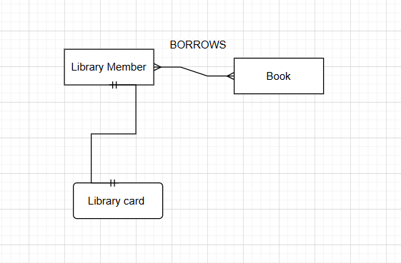
This diagram shows how the main parts of the system are connected. Each library member has one library card, and they can use it to borrow books. The arrows show the relationships — for example, a member can borrow many books, and each book can be borrowed by different members over time. It’s a simple way to show how things are linked in the system without getting into technical details.

Model mapping and logical design
Library_Member (
Member_ID INT PRIMARY KEY,
Name VARCHAR(50),
Address VARCHAR(100)
)

Book (
ISBN INT PRIMARY KEY,
Book_Name VARCHAR(50),
Shelf_ID INT
)

Library_Card (
Card_ID INT PRIMARY KEY,
Member_ID INT UNIQUE,
Issue_Date DATE,
Expiry_Date DATE,
FOREIGN KEY (Member_ID) REFERENCES Library_Member(Member_ID)
)

Borrowed_Book (
Member_ID INT,
ISBN INT,
Borrowed_Date DATE,
Return_Date DATE,
PRIMARY KEY (Member_ID, ISBN),
FOREIGN KEY (Member_ID) REFERENCES Library_Member(Member_ID),
FOREIGN KEY (ISBN) REFERENCES Book(ISBN)
)

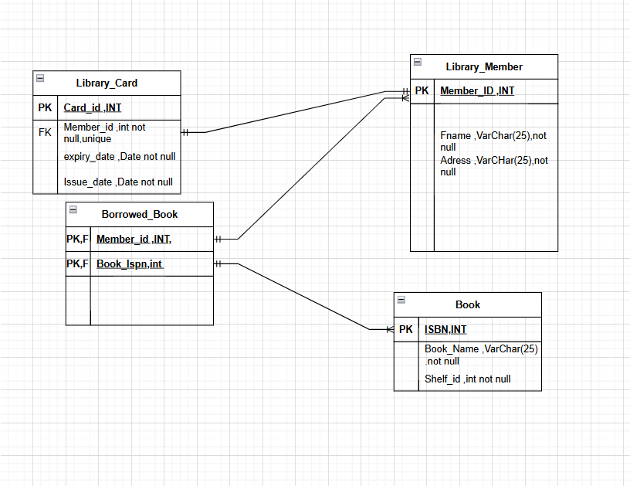
The diagram shows how the main parts of our library system are connected. Here's a quick breakdown of what each part does and how they relate to each other:
- Library Member: This is the main user of the system. Each member has a unique ID, a name, and an address.
- Library Card: Each member is assigned one card. The card includes an ID, issue date, and expiry date. It's linked to the member by their ID.
- Book: Each book in the system has a unique ISBN, a title, and the ID of the shelf it’s placed on. These are stored in a binary search tree in the code to keep them sorted and easy to search.
- Borrowed Book: This keeps track of which member has borrowed which book. It connects a member ID with a book ISBN and acts like a history or log of borrowings. In the actual program, this is handled using a linked list.
Overall, the figure gives a clear picture of how members, books, and library cards are related in the system. It follows a simple and organized structure that makes it easy to understand and implement in code.

Physical model
You need to describe your physical design, its goal, and its components. Add the figure/diagram of the Physical design. In addition to the diagram of the physical design, please fill the following table. In the table, you should fill in all your tables, NOT just 4 of them. The description should be comprehensive and should include: The purpose of each table, Stored information such as the attributes, types, and constraints, along with their rationale. Also, identify the Primary Key (PK) and, if there are any Foreign Keys (FKs), explain how they are connected to other tables and the reasons for these connections.
Our physical design focuses on organizing how the library data is stored, accessed, and connected between different parts of the system. The main goal is to ensure that all important information—like members, books, library cards, and borrowing activities—is saved in a structured and efficient way. We used separate tables for each main component: Library_Member, Book, Library_Card, and Borrowed_Book. Each table includes fields (like names, IDs, dates) with specific data types and rules to make sure the information stays accurate and consistent. For example, Member_ID is used to uniquely identify each member and is linked across other tables to keep the data connected. We also used foreign keys to show relationships—like how each borrow record connects a member to a specific book. Overall, the physical design helps keep our system reliable, scalable, and easy to manage.
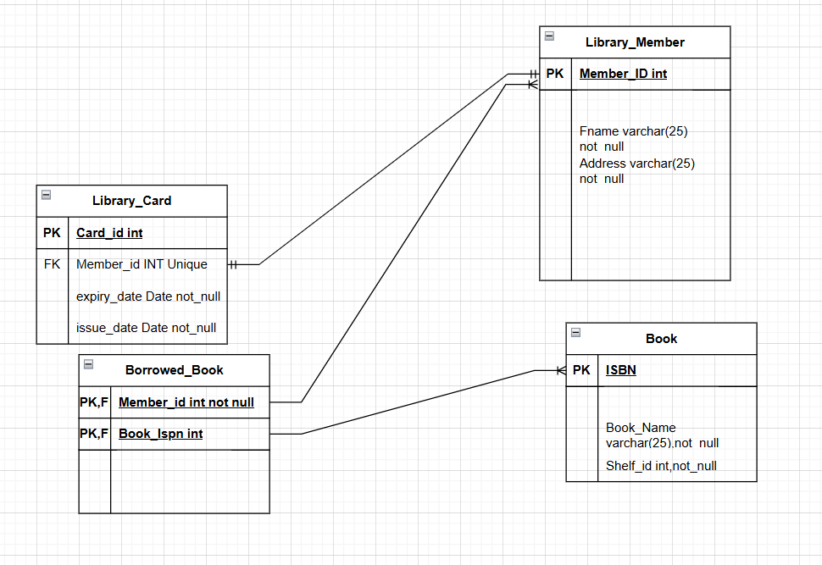

Table | Name | Description
 | Library_Member | This table stores all registered library members. Each member is uniquely identified by a Member_ID, which serves as the primary key. It also contains the member’s first name (Fname) and address (Address), both stored as text (VARCHAR) and marked as required (not null). This table is central to the system, as it connects to other tables like Library_Card and Borrowed_Book through foreign keys, ensuring we can track which member owns a card or has borrowed a book.
 | Book | This table contains the list of books available in the library. Each book is uniquely identified by its ISBN, which acts as the primary key. The table also stores the book's name (Book_Name) and its shelf location (Shelf_ID), both required fields. Shelf_ID represents where the book is physically stored (in case shelf tracking is implemented). The table is linked to the Borrowed_Book table to track lending activity.
 | Library_card | This table holds information about library cards issued to members. The Card_ID is the primary key and uniquely identifies each card. The Member_ID is a foreign key that links each card to a member, with a uniqueness constraint to ensure that one member can only have one card. It also stores the card’s issue and expiry dates (Issue_Date and Expiry_Date) as required fields. This structure enforces the rule that each member has a single active card at a time.
 | Borrowed_book | his table keeps track of all borrowing transactions. It uses a composite primary key made up of Member_ID and Book_ISBN to ensure that the same book cannot be borrowed more than once at the same time by the same member. Both fields are foreign keys—Member_ID links to the Library_Member table and Book_ISBN links to the Book table. This setup maintains accurate and consistent borrowing records in the system.

DBMS Architecture and Programming Techniques

1Query Compiler
The Query Compiler is responsible for transforming high-level SQL queries into a query execution plan that the DBMS can understand and process efficiently. It performs syntax and semantic checks to validate the structure and logic of the query. Once verified, it generates an optimized internal representation known as a query plan. This step ensures that user queries are prepared correctly before execution and helps optimize performance by identifying the most efficient way to access data.

- DDL Compiler
The DDL (Data Definition Language) Compiler interprets structural commands from the database administrator, such as CREATE, ALTER, or DROP. These commands define or modify the schema of the database. Once processed, the DDL compiler updates the system's metadata catalog to reflect any structural changes. This ensures that all components of the DBMS are aware of the most up-to-date database design and structure.

- Transaction Manager
The Transaction Manager is in charge of coordinating all database transactions. It ensures that all transactions follow the ACID properties (Atomicity, Consistency, Isolation, Durability). It works closely with both the Concurrency Control and Logging modules to track the status of each transaction, allowing for proper commit or rollback based on the success or failure of operations. This ensures the consistency and integrity of the database even in the presence of concurrent user operations or system failures.

- Concurrency Control Manager
Concurrency Control ensures that multiple users can access the database at the same time without interfering with each other. It uses a Lock Table to apply mechanisms such as read/write locks, ensuring that no two transactions conflict when accessing or modifying the same data simultaneously. By enforcing isolation, this component prevents issues like dirty reads, lost updates, or unrepeatable reads, allowing for safe concurrent transactions.

- Logging and Recovery
This component maintains a transaction log of all actions that modify the database. In case of a crash or failure, the Logging and Recovery system can restore the database to a consistent state using these logs. The logging process is essential to ensure durability, where committed transactions remain in the system even if a failure occurs afterward. Techniques such as write-ahead logging (WAL) are used to make sure updates are safely recorded before being applied to the database.

- Execution Engine
The Execution Engine receives the query plan generated by the Query Compiler and carries out the operations specified in it. This component interacts with other modules such as the Record Manager and Buffer Manager to retrieve, update, or delete data as needed. It is the core processor of the DBMS that translates compiled logic into concrete data actions and drives the interaction between logical query operations and physical data access.

- Index/File/Record Manager
This manager handles low-level data management, including access to tables, indexes, and individual records. It takes requests from the Execution Engine and translates them into actions like reading or writing files and searching records. It is also responsible for managing the structure of files and the organization of records within them, enabling efficient data retrieval and manipulation.

- Buffer Manager
The Buffer Manager serves as an intermediary between main memory and disk storage. It temporarily holds frequently accessed data pages in memory (buffers) to reduce the number of disk I/O operations. It decides which data should be loaded into memory and which data can be replaced when memory is full. Efficient buffer management significantly improves query response times and system performance.

- Storage Manager
The Storage Manager interacts directly with the physical storage devices (e.g., hard drives or SSDs). It executes the read and write operations passed down by the Buffer Manager, ensuring that data is persistently stored and retrieved as needed. It also manages the layout of data on disk and ensures that file structures remain intact over time. This component is critical for maintaining the long-term durability and reliability of the stored data.

- Buffers
The Buffers act as temporary storage areas for pages read from or written to disk. They play a crucial role in minimizing disk access by caching data in memory, allowing frequently used pages to be reused without repeated I/O operations. The Buffer Manager controls these buffers to improve performance and system responsiveness.

- Lock Table
The Lock Table is a part of the Concurrency Control mechanism. It records which transactions hold locks on which data items, and whether the locks are read or write locks. The Lock Table ensures that concurrent access is properly synchronized and conflicts are avoided. It is vital in maintaining transaction isolation and avoiding anomalies such as race conditions or deadlocks.
Components Used in My DBMS Implementation
In building our DBMS system, we didn’t implement every single sub-component from the full database architecture (like a commercial DBMS would), but we did apply simplified versions of many key parts.

1. Query Compiler (Manually Handled)
In our system, users select operations (like inserting a book or borrowing one) through a menu-based interface. While we don’t have a real query compiler, the menu options simulate query types (e.g., Insert, Select, Delete) and determine which function should run. So the menu acts like a simplified version of a query parser and compiler.

2. Execution Engine
This part is fully implemented. Each menu option maps to a function — like insertBook(), borrowBook(), etc. These functions represent the execution of the corresponding database operation. They validate inputs, access the data structures, and perform logic like searching or updating.

3. Transaction and Concurrency Manager
We added pthread-based concurrency control. A global mutex (pthread_mutex_t data_lock) was used to ensure only one thread modifies the shared data at a time (e.g., during borrowing). This simulates transaction isolation and avoids race conditions.

4. Logging and Recovery (Partially Implemented)
Our system doesn’t have full rollback recovery, but we simulate persistence by using file storage. Every time the program ends, functions like saveAllBooks() and saveMembersToFile() write current memory data into files. So if we relaunch the system, it loads the saved data — mimicking recovery from shutdown.

5. Index/File/Record Manager
We use binary search trees for books and hash tables with linked lists for members and library cards. These structures handle fast searching and organization, similar to how index and record managers optimize access paths in a real DBMS.

6. Buffer and Storage Manager
Instead of managing RAM/disk pages directly, we use in-memory data structures and save them to CSV files with "r" (read) and "w" (write) modes for saving and loading data.The read/write file operations simulate the buffer and storage manager interaction in a simpler way — loading data at the start, and saving at exit.

7. Concurrency Control & Lock Table
As mentioned earlier, our global mutex lock is like a very basic lock table. It doesn’t allow concurrent updates, so it ensures consistency and prevents data corruption.

8. DDL Compiler (Not Implemented)
We did not include functionality to define new tables or change schema using DDL commands. All data structures (like books, members, cards) are fixed in the code.

Data Transfer

Flowchart and DFD
Provide and discuss diagrams to show data movement through the system components (Data Flow Diagram) and flowcharts to describe how the system works.

Level 0 DFD
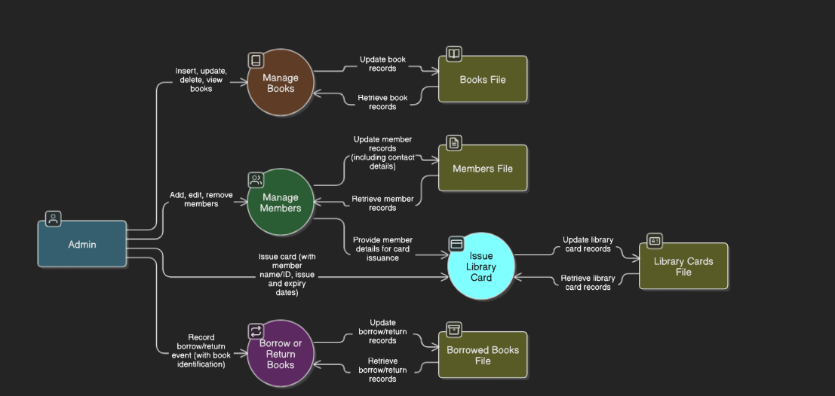

Level 1 DFD
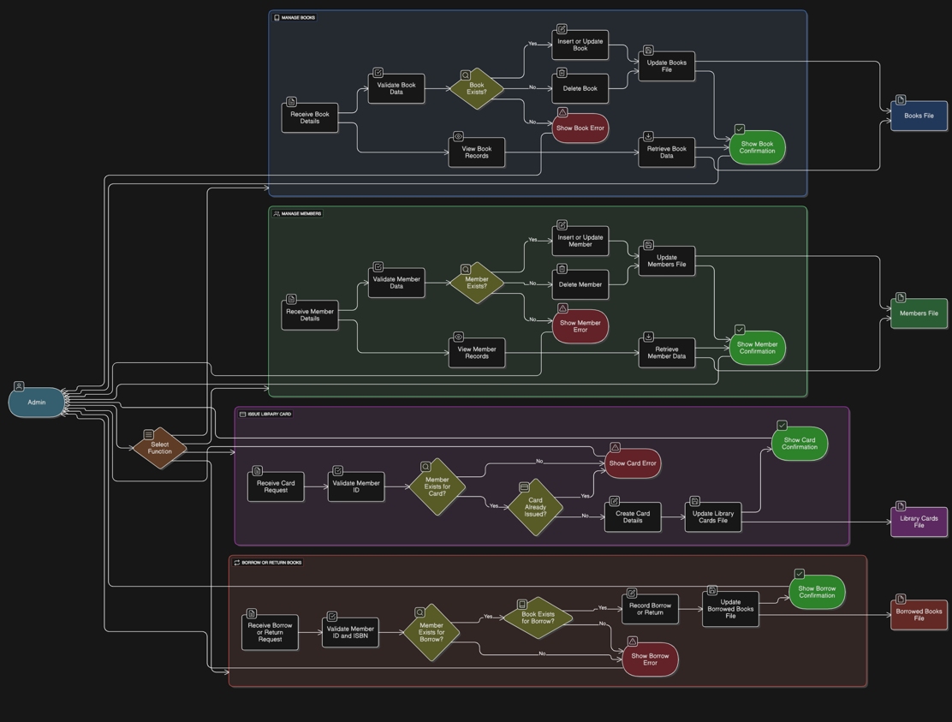

Flowcharts
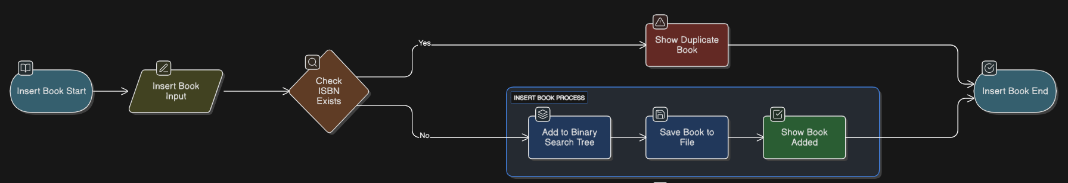

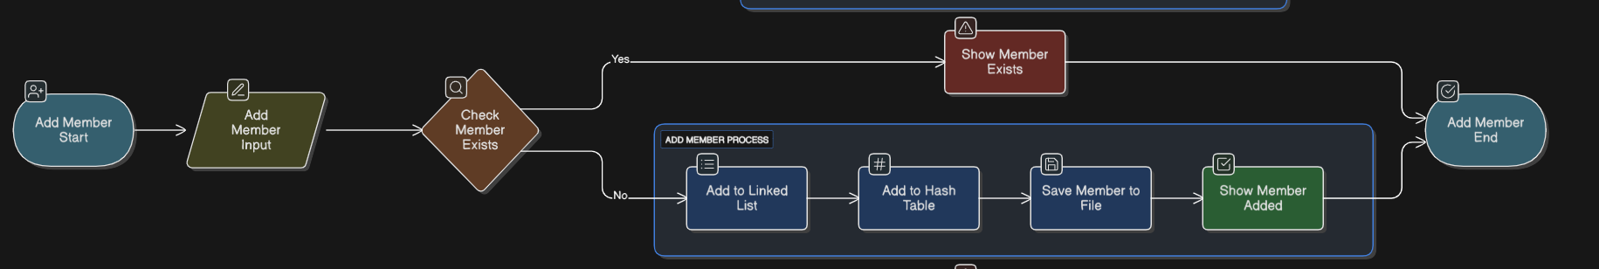
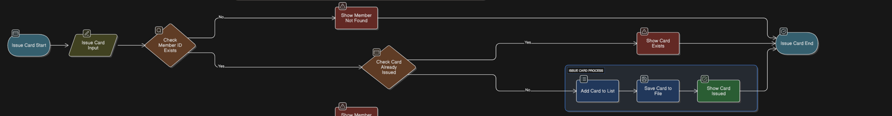

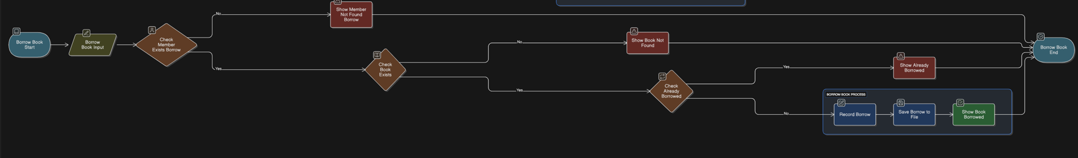

Evaluation of data transfer

In our library management system, data transfer between DBMS components is handled smoothly through well-structured function calls and memory-resident data structures. For example, when a user borrows a book, data flows from the hash-indexed member structure and the binary search tree (BST) of books into the linked list that stores borrowed records. This integration ensures that only valid members and books can be involved in transactions, maintaining consistency. Additionally, each component (books, members, borrowed books, library cards) has its own persistent binary file (*.dat) that is updated after every operation. The system effectively transfers data between in-memory structures and disk storage using standard I/O operations like fwrite() and fread(). These transfers are triggered after insertions, updates, or deletions to ensure the data is both current in memory and saved permanently. This flow allows different parts of the system to stay in sync and enables smooth interaction between components like member management and borrowing logic, without data loss or duplication.

Effectiveness of the database and DBMS
The database and DBMS design we implemented is quite effective in meeting both the user and system requirements outlined at the beginning of the project. From a user perspective, the admin is able to perform all core tasks with ease, such as adding and managing members, issuing library cards, inserting or deleting books, and borrowing/returning books. The interface is straightforward and menu-driven, making it simple to navigate each operation without confusion. On the system side, we made sure that data consistency is preserved using proper data structures like hashing for member indexing, BST for book storage, and linked lists for dynamic records like borrow logs and cards. The system ensures integrity by validating IDs and preventing duplicate entries, and concurrency was handled safely by using mutex locks when needed (especially in book borrowing), ensuring data isn’t corrupted during parallel actions. Additionally, our use of binary file storage allows data to be saved and loaded across sessions, which means information isn’t lost when the system is closed. Overall, the database structure and DBMS logic support all intended features while remaining efficient, scalable, and stable.

DBMS Development

SQL Queries

1. INSERT
The INSERT command in SQL is used to add new records to a table. In our C-based system, we replicate this through functions like insertBook(), insertMember(), and insertLibraryCard(). Each function collects the necessary data from the user and inserts it into the appropriate data structure—whether it’s a binary search tree for books, a linked list for members and cards, or a hash index for fast member lookup. These functions also enforce constraints, such as preventing duplicate primary keys, by checking if the record already exists before adding it, just like SQL would reject an insert with a duplicate ID.

2. SELECT
SQL’s SELECT command allows users to retrieve specific records or entire tables. In our system, this is handled through display functions like displayBooks(), displayMembers(), and displayBorrowedBooks(). For targeted retrieval, such as looking up a member by their ID, we use searchMemberByID(), which applies a hash-based indexing mechanism for fast lookup. These operations mimic the behavior of SELECT * FROM table WHERE ... by fetching only the matching records and displaying them in a readable format.

3. UPDATE
To mimic the SQL UPDATE statement, we implemented functions such as updateMember() and updateLibraryCard(). These functions allow the user to modify the details of an existing record by first validating the identifier (like Member ID or Card ID). If the record is found, the system prompts the user for new data and updates the fields accordingly. This logic ensures that only existing records can be updated—mirroring how SQL doesn’t update rows unless a match is found in the WHERE clause.

4. DELETE
The DELETE command in SQL removes data from a table. In our system, we mirror this behavior using functions like deleteBook(), deleteMember(), and deleteLibraryCard(). These functions search for the specific record and, if found, remove it from the corresponding data structure and free its memory. This ensures clean and safe deletion of records, just like a SQL DELETE FROM ... WHERE ... statement, which only removes rows that match a given condition.

While we didn’t implement full SQL aggregate functions like SUM() or AVG(), we could easily simulate a COUNT(*) operation by iterating through lists or trees and tallying the number of entries. This would allow the system to provide insights like how many books are currently borrowed.
We also simulated constraints such as unique primary keys, foreign key checks (e.g., a member_id must exist before borrowing a book), and uniqueness rules (e.g., preventing multiple library cards per member). Though our system does not support SQL views, functions like displayBorrowedBooks() conceptually behave like predefined views by combining and presenting relevant data to the user.

Data structures

In our Library Management System, we developed dynamic data structures to support both the storage manager and the buffer manager, ensuring that data is persistently stored and efficiently managed in memory. At the storage level, We implemented CSV file handling using fprintf() and fscanf()/sscanf() to save and load records such as books, members, and borrowed books. This ensures that data persists between program executions in a human-readable format. Each major entity (e.g., books, members, borrowed books) is serialized into CSV format and written into corresponding files (books.csv, members.csv, borrowed.csv). When the program starts, these files are read line by line, parsed, and the data is reconstructed into memory structures like the binary search tree for books and linked lists for members and borrow records.
On the buffer (in-memory) side, we used several dynamic data structures that rely on malloc() for memory allocation and free() for deallocation. For example, books are stored in a binary search tree (BST), which supports fast ordered traversal and efficient insertions/deletions. Members and library cards are stored using singly linked lists, allowing us to dynamically grow or shrink the list as users are added or removed. To enable fast searching, especially for member records, we also implemented a hash table with linear probing, using the member ID as the hash key.
This dual-layered system—with in-memory structures acting as buffers and csv files providing persistent storage—ensures that the program maintains data integrity, performance, and scalability. Each function that modifies the data (insert, delete, update) ensures that changes are reflected both in memory and in the file storage when the program exits or when the user explicitly saves.

Indexing
In our Library Management System, we implemented a hash-based indexing technique to improve the performance of simulated SQL queries—particularly for searching library members by their ID. This indexing method allows us to mimic the behavior of a SELECT ... WHERE SQL statement with significantly faster lookup times compared to a linear search.
The indexing is built on a hash table using an array of pointers to LibraryMember nodes. Each member's member_id is processed through a simple hash function (member_id % HASH_TABLE_SIZE) to determine its position in the index. In cases of collision—where two different member IDs hash to the same index—we apply linear probing to find the next available slot in the array. This ensures that even in the presence of collisions, the system can store all members without losing any entries.
When the user performs a search, the system hashes the input ID and probes the index sequentially (if necessary) until the correct member is found or confirmed absent. This technique significantly reduces search time, especially compared to traversing the entire linked list of members.
Overall, this indexing strategy enhances the performance of retrieval operations, supports constraint enforcement (like primary key uniqueness), and aligns with how real databases internally optimize access paths for indexed columns.

Criticizing the mapping of SQL queries
Mapping SQL queries to our custom-developed CRUD statements was a valuable learning process, but it also revealed several challenges and limitations that could be improved for better efficiency, maintainability, and scalability.
One of the main issues was that SQL provides built-in mechanisms for enforcing constraints like primary keys, foreign keys, and uniqueness, whereas in our C-based implementation, we had to manually validate these constraints. This required writing additional logic for checking conditions (e.g., duplicate IDs, or verifying foreign key existence), which increased code complexity and made the CRUD operations more error-prone and harder to maintain.
Additionally, while SQL naturally handles atomic transactions and rollback mechanisms, our system only simulates these behaviors using mutex locks for concurrency and basic conditional checks. This means operations like borrowBook() or insertMember() might still suffer from data inconsistency in edge cases, especially when involving concurrent threads or unexpected crashes. A more robust implementation would include transaction queues or rollback capabilities for failure scenarios.
Another limitation is lack of modularity. In SQL, queries are abstract and modular, whereas our CRUD logic is tightly coupled with user interface logic and specific data structures. This makes it harder to reuse or scale the code. Separating the logic into distinct modules (e.g., one for data validation, another for file I/O) would improve maintainability and testability.
To improve the current system:
- We could abstract query functions to be more reusable and parameterized, similar to prepared statements in SQL.
- Implement transaction management for critical operations like borrowing or deleting, to ensure atomicity.
- Integrate a more flexible indexing mechanism, such as secondary indexes, for non-primary key searches.
- Create a query parser or interpreter that allows users to input simplified SQL-like commands, which are then mapped to the correct C functions.
Overall, while our system successfully mimics the behavior of SQL at a basic level, it could benefit from structural improvements, better abstraction, and transaction safety mechanisms to fully reflect the robustness of a real DBMS.

Concurrency Control (CC)

Standard DBMS CC Techniques
In database systems, concurrency control is really important because it helps manage what happens when multiple users or transactions try to access the same data at the same time. Without proper control, things can go wrong—like lost updates or inconsistent data. One common method is the use of locks. There are simple binary locks, where data is either locked or not, but more advanced systems use shared and exclusive locks. Shared locks allow multiple transactions to read a piece of data at once, while exclusive locks only let one transaction write to it at a time. To make sure everything stays consistent, a technique called Two-Phase Locking (2PL) is often used. It splits the process into two phases—first, where a transaction can acquire locks, and second, where it only releases them. This ensures proper order but might lead to deadlocks if transactions end up waiting on each other.
Another popular technique is the timestamp-based protocol. This approach gives every transaction a unique timestamp when it starts, and uses those timestamps to decide who gets access to what. If two transactions want the same data, the one with the earlier timestamp usually gets priority. This helps avoid deadlocks but can cause problems for transactions that keep getting delayed. Then there's optimistic concurrency control, which works best when conflicts are rare. It lets transactions do their work without locking anything, then checks at the end if anything went wrong. If there’s no conflict, the changes are saved. If there is, the transaction is rolled back. It's a good method when there are mostly read operations and very few conflicting updates.
Another method that's used in many modern databases is Multiversion Concurrency Control (MVCC). This technique avoids locking by keeping several versions of a data item. Readers get a snapshot of the data from before a change happened, while writers work on creating a new version. This way, readers and writers don’t block each other. It’s more complex, but it can be very efficient and keeps things consistent even with lots of users working at once. Of course, since locking can still lead to deadlocks in some cases, there are different ways to deal with those. Some systems try to prevent deadlocks using techniques like the wait-die or wound-wait schemes, where the age of transactions decides who waits and who gets aborted. Others just let deadlocks happen and then detect them using graphs that show who’s waiting for what, and break the cycle.
Lastly, DBMSs also support different isolation levels to let developers balance between performance and accuracy. For example, Read Uncommitted allows maximum concurrency but risks showing uncommitted changes (which could be incorrect), while Serializable is the strictest and safest level, but also the slowest. In our system, we applied a basic version of concurrency control using pthread mutex locks. This allowed us to simulate exclusive locking and ensure that shared data structures like the borrowed book list weren’t corrupted by simultaneous access. While not as advanced as full DBMS-level control, it gave us a clear idea of how important concurrency is in real-world systems.

Implementation of CC
In our library management system, we implemented parallel data processing using basic POSIX threads to simulate concurrent database operations. The idea was to allow multiple actions—like borrowing books or inserting new records—to happen in parallel, similar to how real database systems support multiple users at once. To safely manage access to shared data, we used a mutex lock (from the pthread library) to ensure that only one thread could modify the core data structures at a time. For example, in our borrowBook() function, we wrapped the logic that updates the borrowed book list with pthread_mutex_lock() and pthread_mutex_unlock() calls. This way, if two users tried to borrow a book at the same time, only one thread would be allowed to access and modify the list, avoiding issues like race conditions or inconsistent state. This simple locking mechanism mimics exclusive locking in real DBMS concurrency control. We also tested this by launching multiple threads that perform different data operations and confirmed that the system maintained correctness. Even though we didn’t implement more complex concurrency handling like deadlock detection or transaction isolation levels, this approach gave us a practical and hands-on understanding of how real-world databases use parallel processing and synchronization to ensure consistency.

User Interface and Testing Plan

User Interface Development

The developed interface for our DBMS system is a basic, menu-driven console application that allows the administrator to manage all aspects of the library database. The interface is entirely text-based and runs within the terminal, providing a simple and user-friendly way to interact with the system. Upon launching the program, users are presented with a numbered main menu listing all available operations. These include inserting and displaying books, members, borrowed books, and library cards, as well as updating, deleting, and searching for records.
Each operation is triggered by entering the corresponding menu number. Once selected, the system prompts the user for the necessary input, such as ISBN, Member ID, or shelf location. The program includes validation to check that entries are unique when required and that foreign key constraints are respected. For example, a book cannot be borrowed unless both the member and the book exist in the system. The interface also allows searching for members using a hashed index structure, providing fast lookups. All insertions, deletions, and updates are immediately reflected in both the in-memory data structures and the saved csv files.
To simulate parallel access and ensure consistency, concurrency control is integrated into key operations like borrowing books using mutex locks from the pthread library. This allows multiple threads to operate on the system without causing data corruption. Furthermore, the system ensures persistence by saving data to csv files and reloading it at startup, so information is not lost when the program exits. Overall, the interface may be basic in design, but it effectively supports all CRUD operations and ensures data integrity through careful programming logic and structured user interaction.
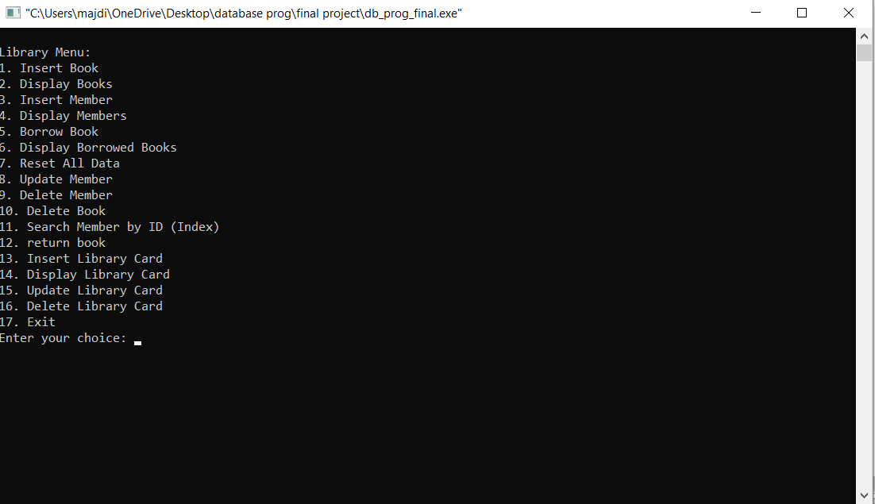
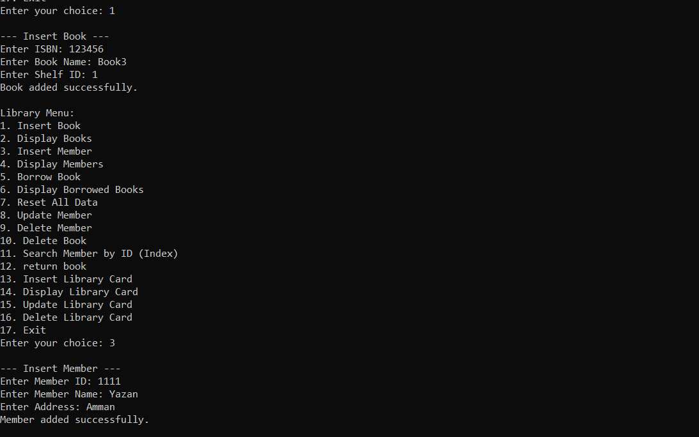
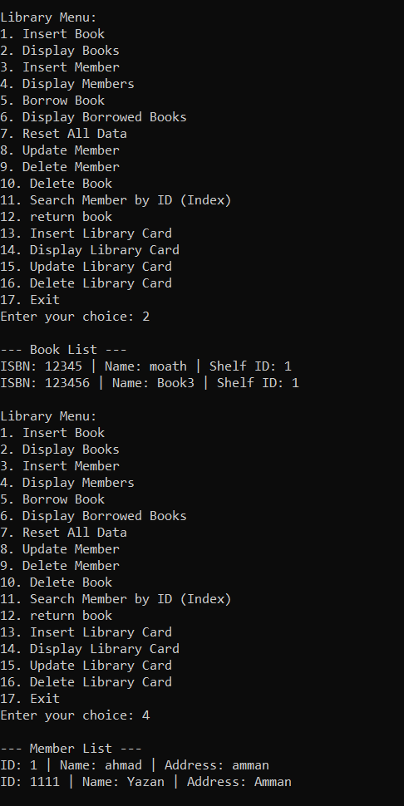
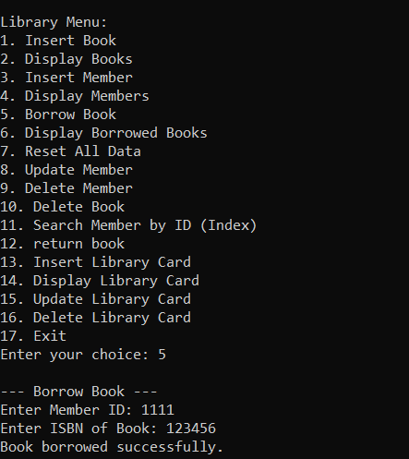
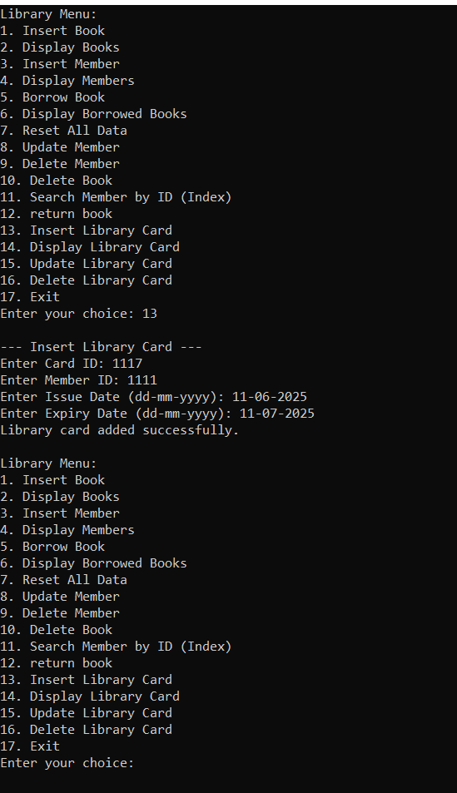

Testing Plan
- 1. Testing Plan Overview
To ensure the stability, accuracy, and reliability of the developed DBMS system, a comprehensive testing plan was designed and executed. The goal of the testing process was to verify that each DBMS component—Books, Members, Library Cards, and Borrowed Books—functions correctly, handles edge cases, and supports data persistence and concurrency. The plan includes functional testing, file-based persistence validation, and concurrency behavior testing to reflect a realistic multi-user environment.

- 2. Functional Testing of CRUD Operations
Each CRUD function was thoroughly tested to reflect the behavior of SQL queries. For the Book component, tests included inserting unique and duplicate books, deleting records, and displaying book data in-order. The Member module was tested for insertion, updating, deleting, and searching members using the hash table with linear probing. Library card issuance was validated to ensure that each member could only hold one unique card, and that the member must exist before a card could be issued. For borrowed books, we tested successful borrowing, attempted re-borrowing, and return operations, ensuring borrowed entries were accurately updated.

- 3. Data Persistence and File Compatibility Testing
Persistence testing was conducted to ensure that data stored in files (books.csv, members.csv, and borrowed.csv) remained intact between program sessions. After adding records, the program was terminated and restarted. The data was automatically loaded from disk, confirming that the storage manager properly saved and retrieved structured data. Each component’s save and load routines were validated through this cycle for accuracy.

- 4. Concurrency Testing and Synchronization
To evaluate concurrent data access handling, the borrowBook() function was protected using pthread_mutex_lock to prevent race conditions. Multiple threads were simulated to borrow the same book concurrently. The system ensured that only one thread successfully executed the operation at a time, maintaining data integrity. The use of POSIX threads and mutex locks provided a reliable mechanism for synchronization during write operations.

Insert Book (Valid)
Input: ISBN: 123, Name: “DBMS”
Expected Output: Book should be successfully added to the BST.
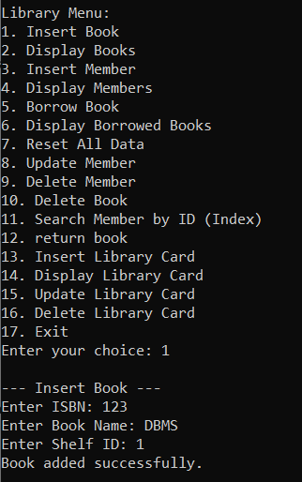
Result: ✅ Passed
Insert Book (Duplicate ISBN)
Input: ISBN: 123
Expected Output: System should reject the duplicate and show a message.
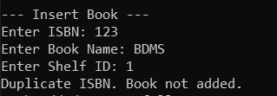
Result: ✅ Passed

Add Member (Valid)
Input: ID: 101, Name: “Ali”
Expected Output: Member added and hashed correctly.
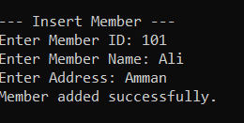
Result: ✅ Passed
Add Member (Duplicate ID)
Input: ID: 101
Expected Output: Duplicate member ID should be rejected.
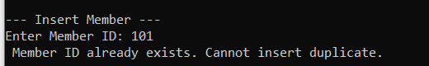
Result: ✅ Passed
Borrow Book (Valid)
Input: Member ID: 101, ISBN: 123
Expected Output: Book should be marked as borrowed by the member.
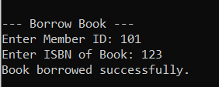
Result: ✅ Passed
Borrow Book (Member Not Found)
Input: Member ID: 999
Expected Output: System should show an error for invalid member.
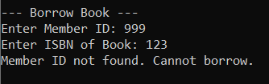
Result: ✅ Passed

Borrow Book (Book Not Found)
Input: ISBN: 999
Expected Output: System should show an error for invalid ISBN.
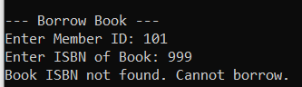
Result: ✅ Passed
Borrow Book (Already Borrowed)
Input: Repeated borrow attempt by same member for same ISBN
Expected Output: Duplicate borrowing should be blocked.
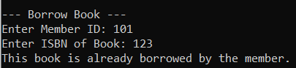
Result: ✅ Passed
Return Book
Input: Member ID: 101, ISBN: 123
Expected Output: System should successfully remove the borrowed entry.
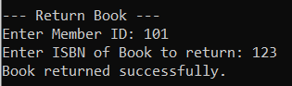
Result: ✅ Passed

Delete Member
Input: Member ID: 101
Expected Output: Member should be removed from the list and hash index.
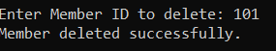
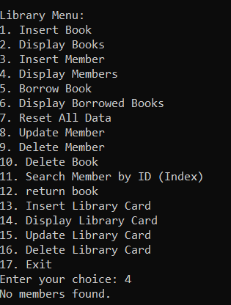
Result: ✅ Passed

Data Reload After Restart
Input: Relaunch program after inserting data
Expected Output: Previously saved records should be loaded automatically.
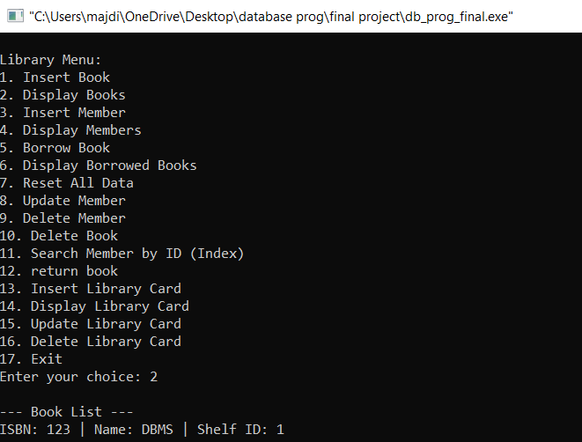
Result: ✅ Passed
Concurrency Test
Input: Five threads were created to simulate a single member (ID: 101) borrowing five different books (ISBNs: 1000–1004) at the same time.
Expected Output: All borrow operations should succeed without conflict, since each thread targets a different book. Mutex locking should ensure that the linked list is updated safely.
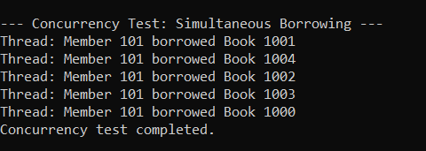
Result: ✅ Passed

Evaluation
1. User Interface Enhancement
While the current DBMS interface uses a simple menu-driven approach, its usability could be significantly improved by developing a graphical user interface (GUI). A GUI would allow users to interact with the system through clickable elements, dropdowns, and visual feedback instead of typing numeric choices. This would make the system more user-friendly, especially for non-technical users or future scalability in educational environments.

2. Storage and Scalability
The system currently relies on csv files for persistent storage, which is suitable for small-scale applications. However, as the volume of data grows, this method becomes inefficient and harder to maintain. A major improvement would be transitioning to a lightweight relational database management system (like SQLite or MySQL), which would support larger datasets, advanced indexing, and more optimized query handling.

3. Concurrency and Transaction Control
The DBMS currently uses a basic concurrency mechanism with mutex locks to ensure thread safety during operations like book borrowing. While this is a good start, more advanced concurrency control techniques such as finer-grained locks, deadlock detection, or optimistic concurrency would improve data consistency and system responsiveness, especially under heavier loads or in multi-user environments. Adding transaction management with rollback support would further enhance data reliability.

4. Aggregate Functions and Analytics
Currently, the system does not support any aggregate queries such as total borrowed books, average shelf occupancy, or most active members. Implementing such functions would not only improve analytical capabilities but also bring the system closer to standard SQL functionality. This could be achieved by building functions that traverse data structures and summarize key metrics in real-time or on-demand.

5. Data Validation and Error Handling
Improved validation mechanisms are necessary to prevent incorrect or duplicate data entries. While some checks exist (like preventing duplicate IDs), deeper validation—such as date formatting, empty input detection, and invalid cross-references—would make the system more robust. Additionally, implementing standardized error messages and logging mechanisms would help users and developers troubleshoot issues more effectively.

References
You need to write the references here using Harvard style of referencing.
- Storage layer concepts – Persistent data handling using files (related to Slide 3: Storage Manager layer)
- Buffer management using dynamic data structures – BSTs, Linked Lists, Hash Tables (related to Slide 3: Buffer Manager)
- CRUD logic and query interface – Logical data manipulation and constraints (related to Slide 2: Query Processor)
- Concurrency techniques – Mutex and thread-safe functions (pthread_mutex_lock) (based on Slides 20–25: Concurrency Control)
- Transaction simulation – Atomic-like logic in critical operations (based on Slide 5 and Slide 21: Transaction Concepts)

