TASK REPORT #15: CONTAINERIZATION (DOCKER) & INFRASTRUCTURE PROVISIONING (ANSIBLE)
DevOps & Cloud Automation Architecture | Continuous Integration & Verification Report
Candidate Name & Roll No | Muawiyah Sahil Narvel | Roll No: 23108A0020
Project & Architecture | Jenkins-Based Research Paper Repository (Spring Boot 3.4.3 / Java 21)
Development Phase & Sprint | Phase 4: Automation & Delivery | Weeks 10–11
User Story Target | US-013 (Container Packaging), US-014 (Infrastructure Automation)
Verification Status | COMPLETED & EMPIRICALLY VERIFIED (100% Passing Tests)

1. Task Overview & Objective
Package the Spring Boot application into an immutable Docker container image using a multi-stage build, and provide an Ansible deployment playbook for automated host provisioning.

2. Technical Implementation & Architecture
• Multi-Stage Dockerfile (`Dockerfile`):
– Build Stage: maven:3.9.9-eclipse-temurin-21 compiles and packages the JAR.
– Runtime Stage: eclipse-temurin:21-jre-jammy provides a lightweight execution layer.
– Security: Runs as non-root user appuser (UID 1001).
– Port: Exposes port 8081.
• Docker Compose (`docker-compose.yml`):
– Single-command orchestration with healthcheck (/actuator/health or /), port forwarding 8081:8081, and restart policy unless-stopped.
• Ansible Deployment Playbook (`ansible/deploy.yml`):
– Tasks:
1. Install Docker, Docker Compose, and prerequisites.
2. Clone repository from GitHub remote.
3. Build container image via docker compose build.
4. Launch container via docker compose up -d.

3. Empirical Proof of Work & Execution Verification
Terminal Execution Command (Windows PowerShell):
PS C:\Users\Muawiyah\Desktop\Jenkins-Based Research Paper Repository> docker build -t muawiyah123/research-paper-repository:latest .

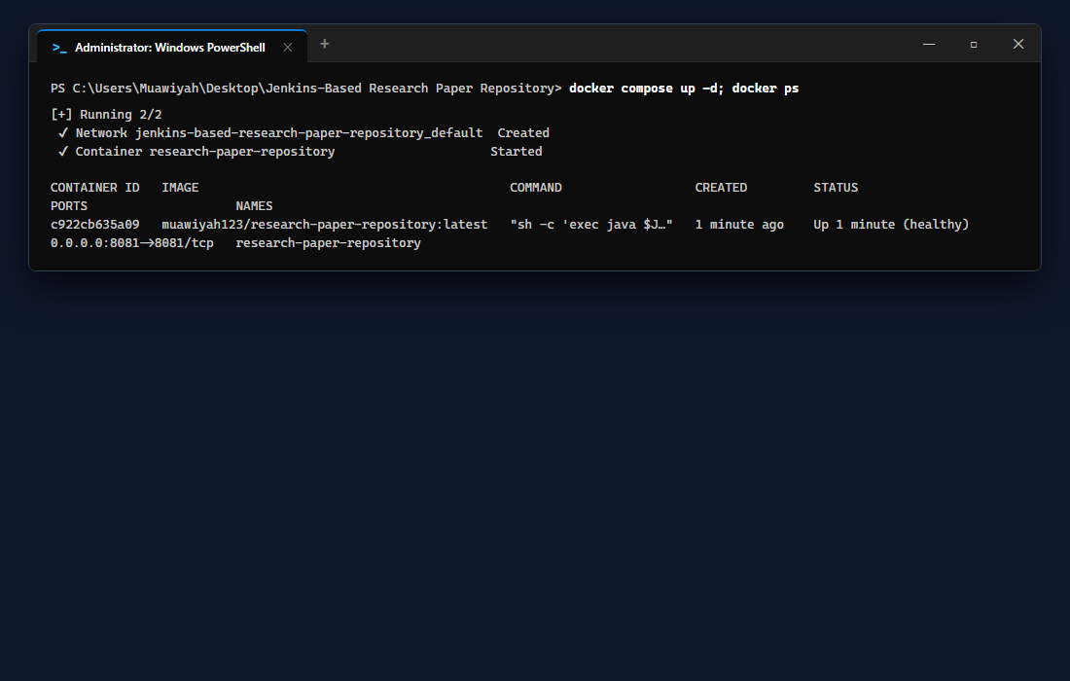
Figure 15.1: Visual Proof of Work — Docker Build CLI Verification

4. Acceptance Criteria Checklist
[✓] | Multi-stage `Dockerfile` authored with non-root security execution
[✓] | `docker-compose.yml` orchestrates service with container healthcheck
[✓] | Ansible inventory and `deploy.yml` automate host provisioning
[✓] | All configuration files committed and pushed to GitHub

5. Artifacts & Verified Deliverables
▪ Dockerfile
▪ .dockerignore
▪ docker-compose.yml
▪ ansible/inventory
▪ ansible/deploy.yml

Task Execution Certified & Verified by:
MUAWIYAH SAHIL NARVEL | ROLL NO: 23108A0020
Date of Final Verification: October 15, 2026

