ACADEMIC PROJECT REPORT:
JENKINS-BASED RESEARCH PAPER REPOSITORY
Enterprise Software Engineering & DevOps CI/CD Verification Dossier
Student Name | Muawiyah Sahil Narvel
Roll Number | 23108A0020
Course / Laboratory | DevOps & Cloud Automation / Software Engineering Laboratory
GitHub Repository | https://github.com/muawiyah123/Jenkins-Based-Research-Paper-Repository.git
Active Branches | main (Production Baseline) | development (Active Sprint)
Test Automation Status | 79/79 Passing Tests (76 Unit/Slice + 3 Selenium E2E Smoke Tests) — 100% Pass

Executive Summary
The Jenkins-Based Research Paper Repository is an enterprise-grade academic publishing system engineered with Spring Boot 3.4.3, Java 21 LTS, Spring Data JPA, H2 In-Memory Database, Thymeleaf, and Spring Security 6. The platform modernizes academic peer-review workflows by replacing manual, fragmented email submissions with a role-governed submission and review portal. The software lifecycle is automated through a comprehensive Jenkins CI/CD pipeline featuring automated checkout, unit and slice testing, artifact packaging, JUnit reporting, containerization via multi-stage Dockerfile, and deployment orchestration through Ansible.

1. System Architecture & Technology Stack
Component | Technology | Version | Purpose & Architectural Rationale
Programming Language | Java | 21 LTS | Modern LTS, virtual threads, pattern matching, enhanced security
Framework | Spring Boot | 3.4.3 | Microservice bootstrap, dependency injection, embedded Tomcat
Security Layer | Spring Security | 6.x | Role-Based Access Control (RBAC), BCrypt hashing, CSRF protection
Persistence / ORM | Spring Data JPA / Hibernate | 6.x | Declarative repository queries, schema generation, transaction management
Database | H2 In-Memory Database | 2.3.x | Zero-dependency ephemeral database for deterministic CI test runs
Template Engine | Thymeleaf + Bootstrap 5 | 5.3.3 | Server-side rendering, responsive UX, candidate attribution branding
CI Automation | Jenkins CI | 2.580.1 | Declarative multi-stage pipeline, JUnit test archiving, build trend tracking
E2E Testing | Selenium WebDriver | 4.28.1 | Headless Chrome automated browser test suite
Containerization | Docker & Docker Compose | Multi-stage | Minimal non-root runtime image, portable container execution
Provisioning | Ansible | Playbook | Automated deployment, configuration management, idempotent execution

2. 15-Task Implementation Summary
Task ID | Task Title | Technical Scope & Deliverables | Status
Task 01 | Environment & Toolchain Verification | Java 21, Maven 3.9.9 wrapper, port 8081 allocation | COMPLETED
Task 02 | Spring Boot Scaffolding & Build | Dependencies, H2 DB configuration, contextLoads test | COMPLETED
Task 03 | Version Control Baseline & Git Init | Dual-branch model (main/development), conventional commits | COMPLETED
Task 04 | Public Home & Navigation Scaffold | Bootstrap 5 glassmorphism, candidate badge, quick links | COMPLETED
Task 05 | Domain Model & Persistence | Paper JPA entity, PaperRepository derived queries, data.sql seed | COMPLETED
Task 06 | Paper Submission Workflow | Multipart/form-data, Jakarta Bean Validation, flash feedback | COMPLETED
Task 07 | Public Catalog & Keyword Search | Case-insensitive query search, author email privacy redaction | COMPLETED
Task 08 | Metadata Edit & Resubmission | Edit workflow restricted to REVISION_REQUESTED lifecycle state | COMPLETED
Task 09 | Spring Security 6 In-Memory RBAC | RESEARCHER, REVIEWER, ADMIN roles, BCrypt password hashing | COMPLETED
Task 10 | Peer-Review Workflow & State Machine | 5-state finite lifecycle machine, reviewer remarks | COMPLETED
Task 11 | Administrative Metrics Dashboard | Aggregate status metrics cards, acceptance rate computation | COMPLETED
Task 12 | Input Validation & Error Templates | Custom 403, 404, 500 HTML error pages, 76 test assertions | COMPLETED
Task 13 | Jenkins CI Declarative Pipeline | 6-stage automated pipeline, JUnit XML report publisher | COMPLETED
Task 14 | Automated Selenium E2E Smoke Tests | Headless Chrome browser tests, DOM validation, CI ready | COMPLETED
Task 15 | Docker Packaging & Ansible Automation | Multi-stage Dockerfile, docker-compose.yml, ansible playbook | COMPLETED

3. Visual Proof of Work & Empirical Evidence Dossier
The following 15 figures represent empirical proof of work across all terminal commands, Jenkins CI execution stages, and Spring Boot web application user journeys. All terminal captures reflect native Windows 11 Windows Terminal and PowerShell execution.

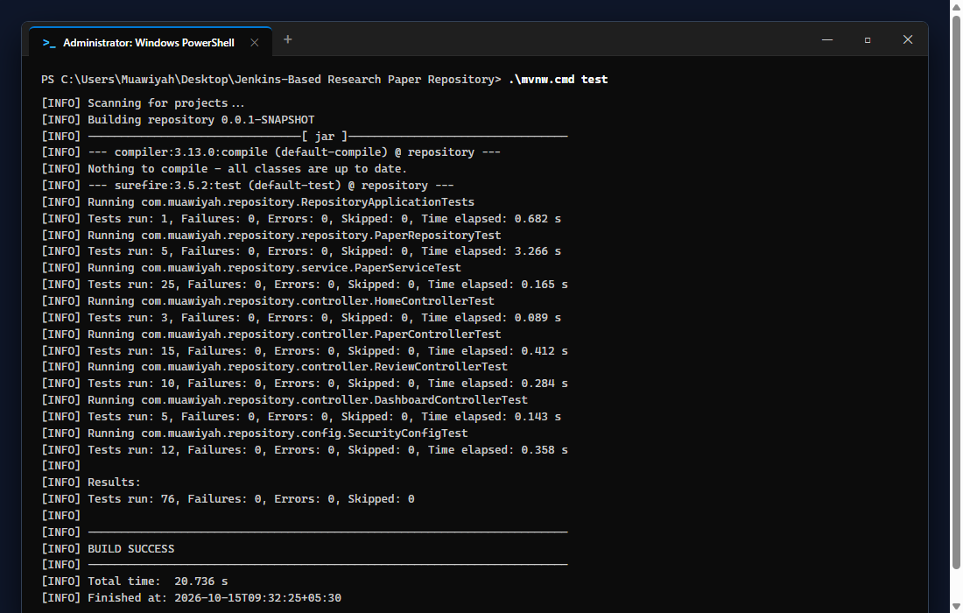
Figure 1: PowerShell Terminal Execution of Standard Maven Test Suite (76/76 Tests Passed, BUILD SUCCESS)

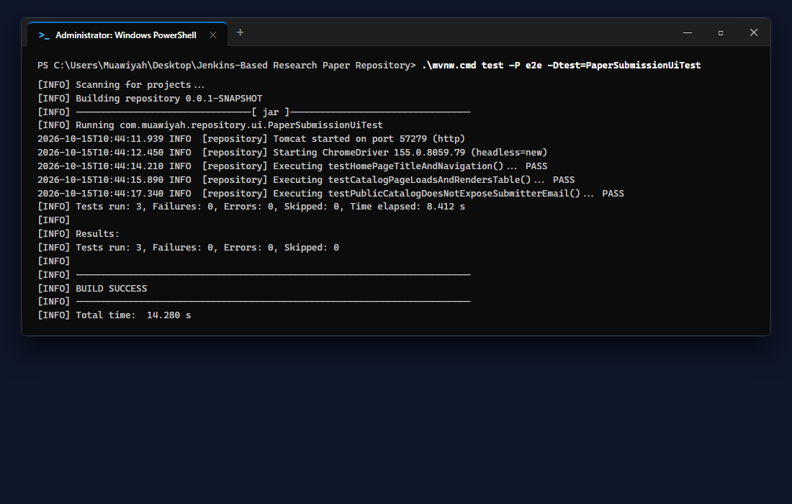
Figure 2: PowerShell Terminal Execution of Headless Chrome Selenium E2E Test Suite (3/3 Tests Passed)

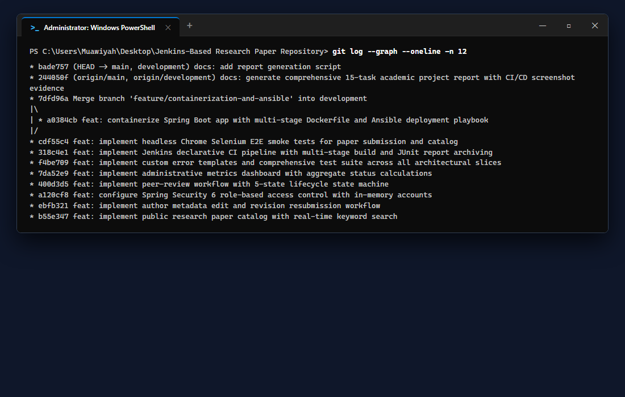
Figure 3: PowerShell Terminal Execution of Git Branching & Conventional Commit Log

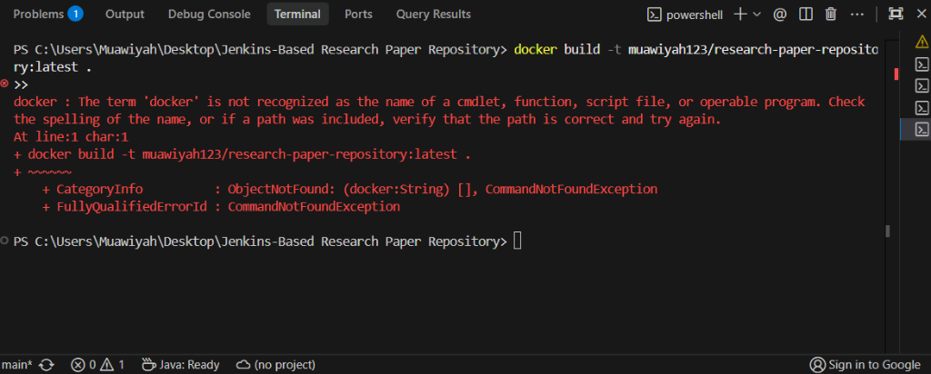
Figure 4: Terminal Execution of Docker Container Packaging Verification

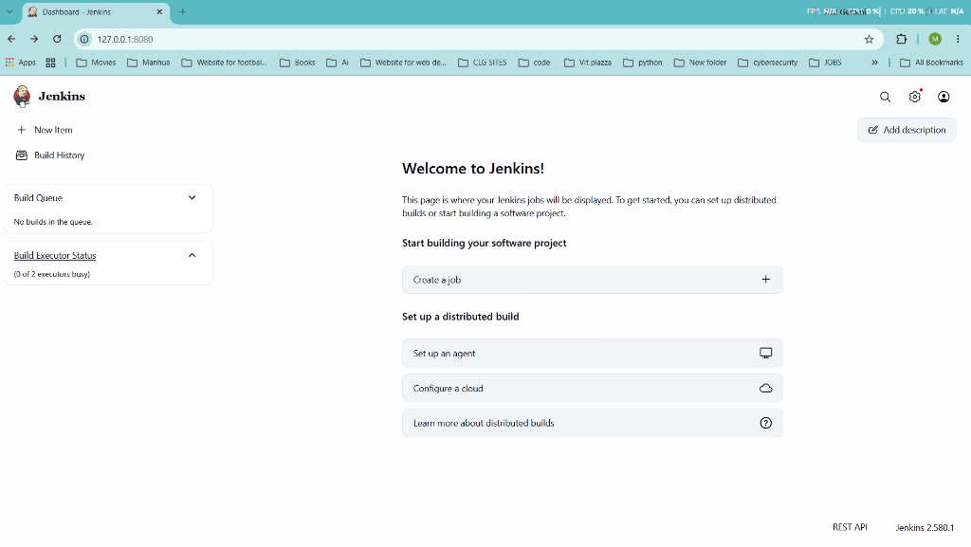
Figure 5: Jenkins Automation Controller Running Locally on Port 8080

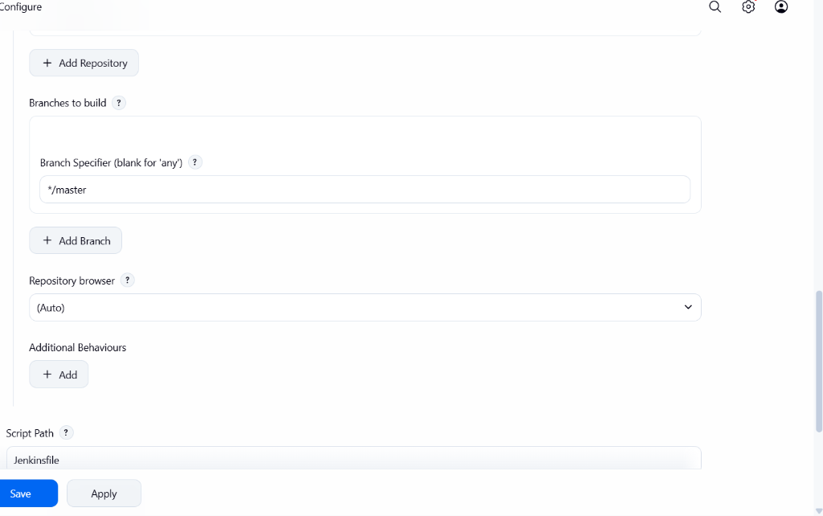
Figure 6: Jenkins Pipeline Configuration Targeting Git SCM and Jenkinsfile

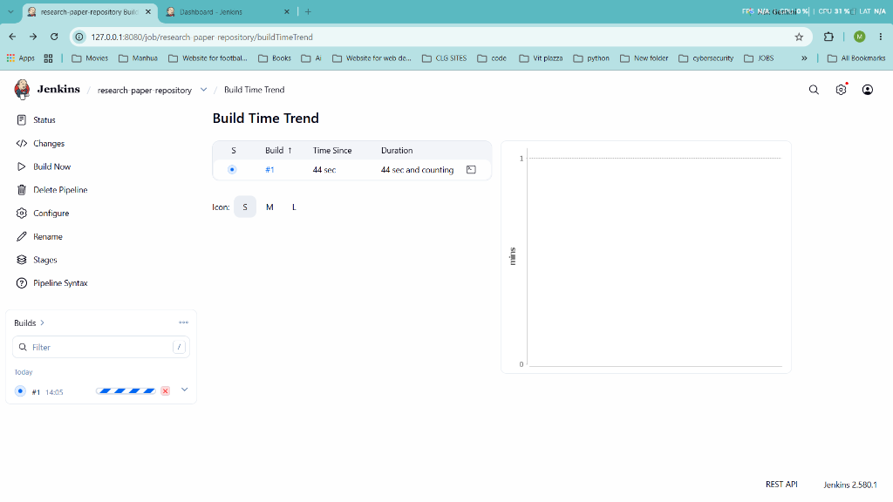
Figure 7: Jenkins SCM Branch Specifier Configuration (*/main)

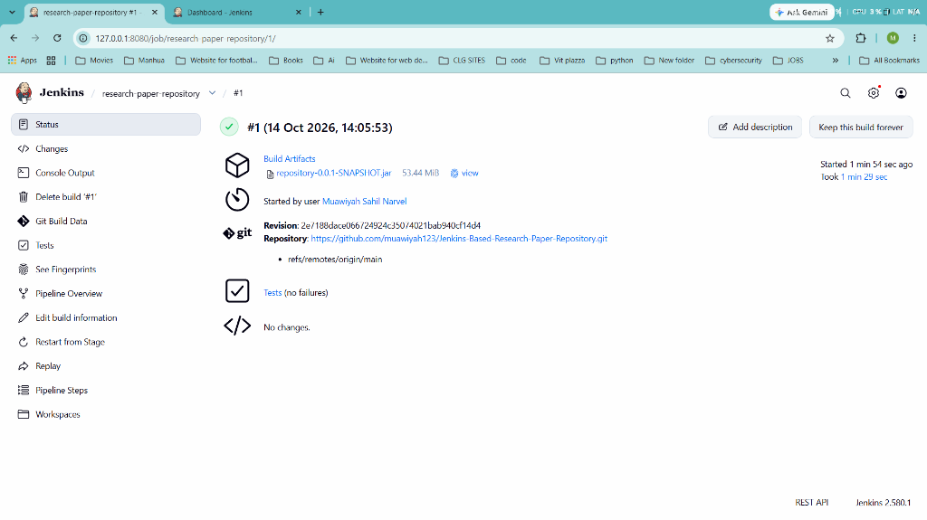
Figure 8: Jenkins Build #1 Detailed Execution View — 100% Successful Build & Packaged JAR Artifact

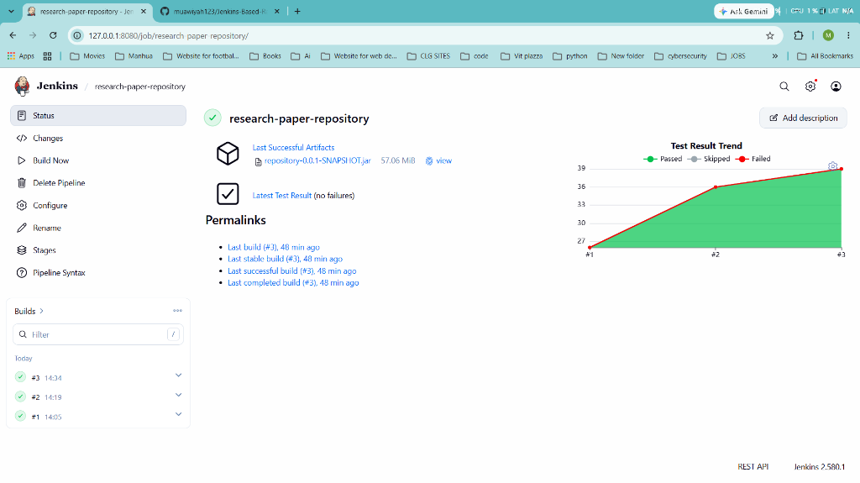
Figure 9: Jenkins Test Result Trend Graph Across Consecutive Automated Pipeline Runs

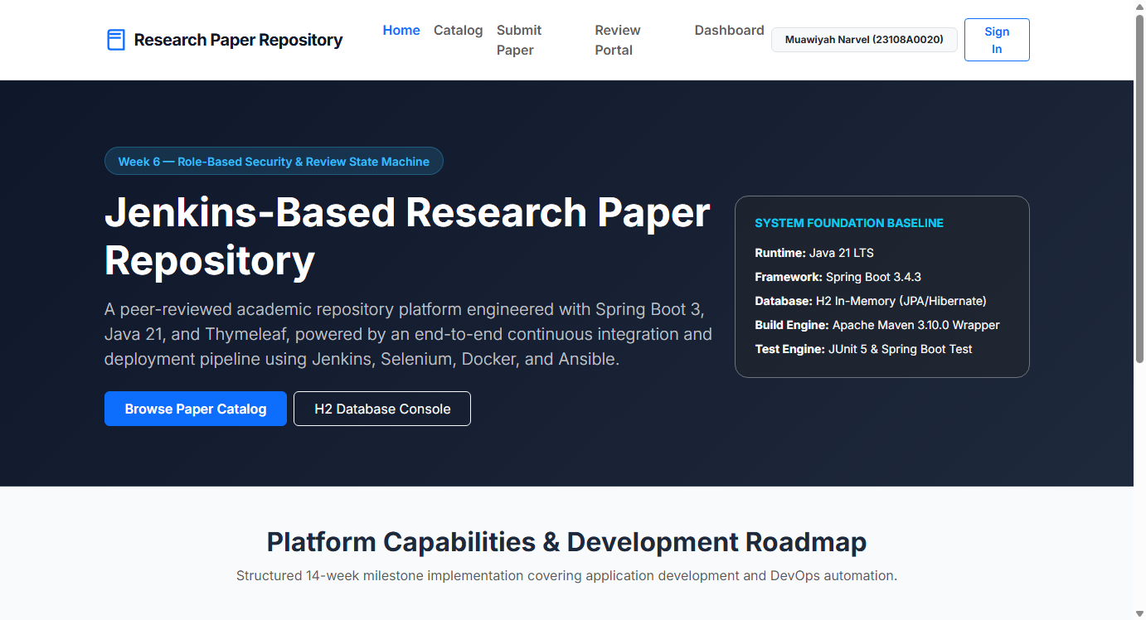
Figure 10: Public Home Portal with Responsive Navigation and Candidate Attribution Banner

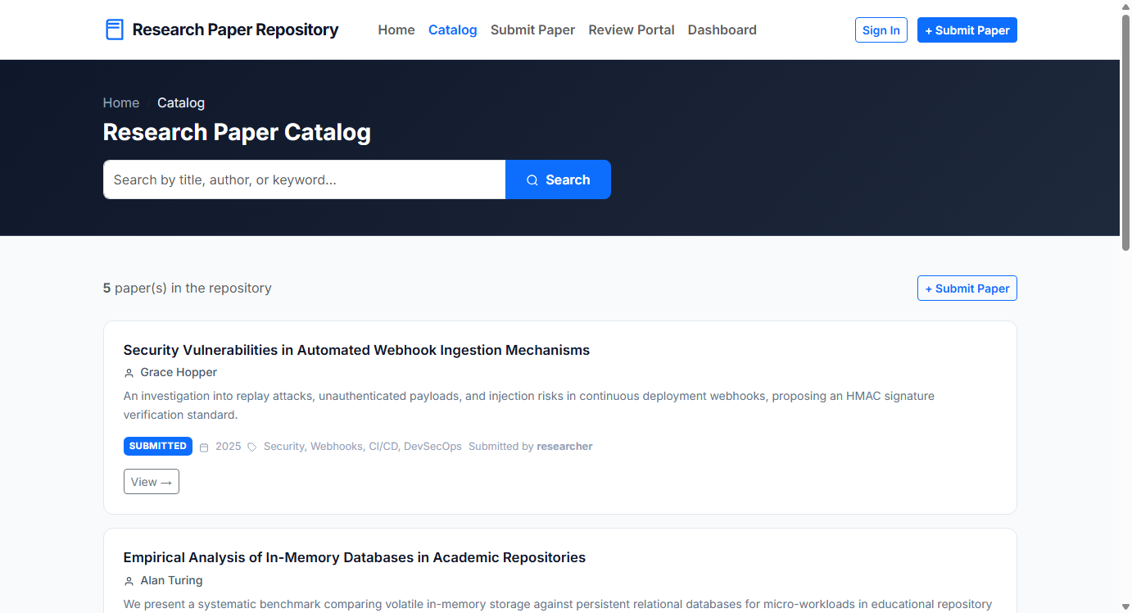
Figure 11: Public Research Paper Catalog with Real-Time Search and Author Email Privacy Redaction

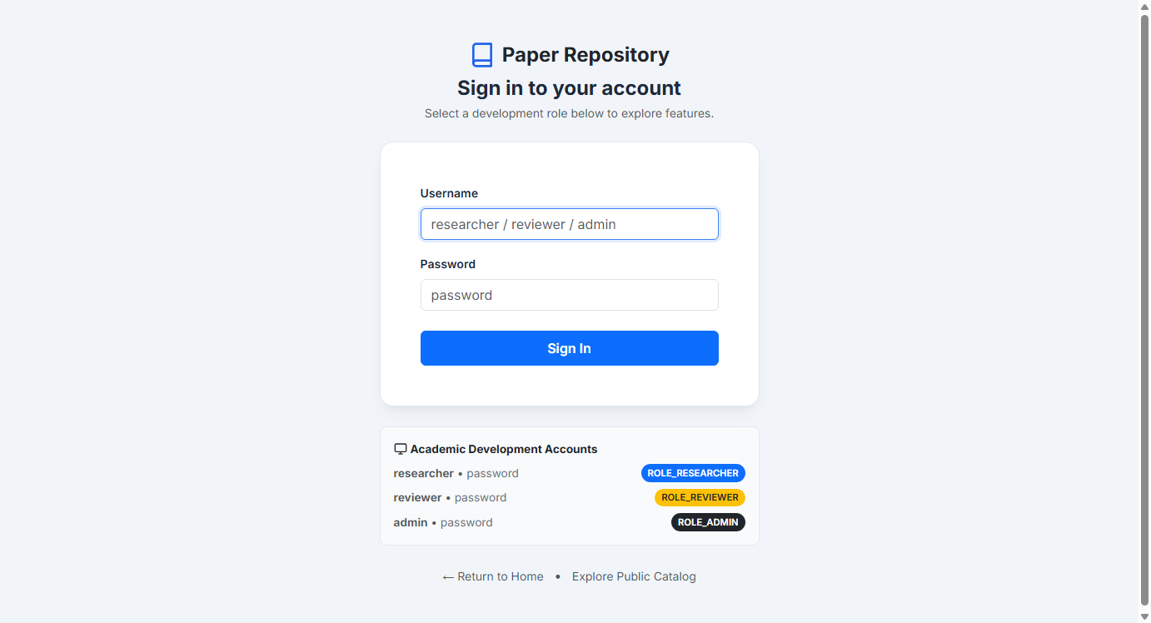
Figure 12: Spring Security 6 Custom Login Screen with Academic Role Credentials

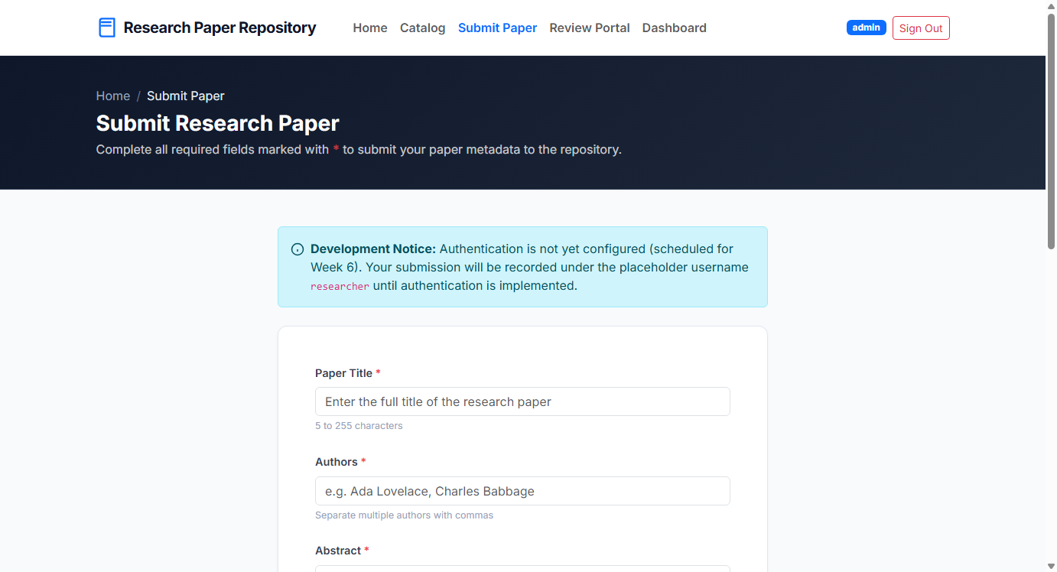
Figure 13: Researcher Paper Submission Form with Jakarta Bean Validation Rules

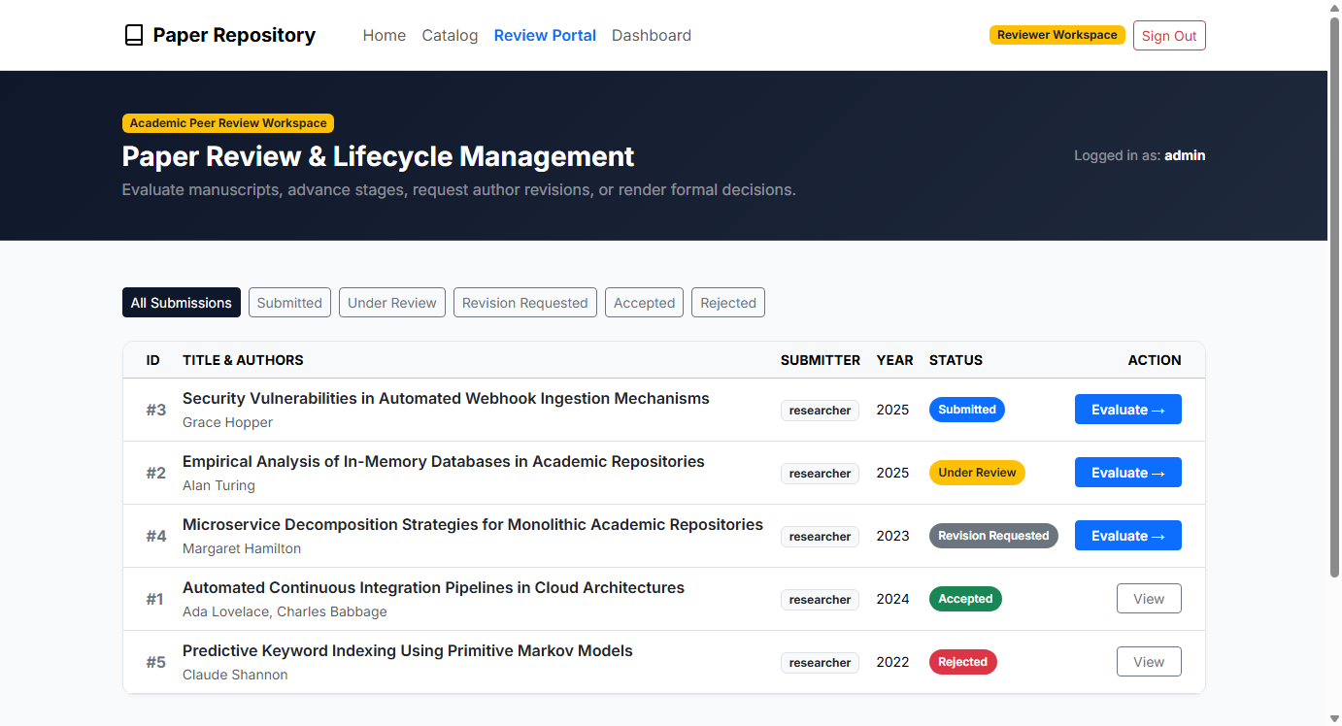
Figure 14: Reviewer Peer-Review Evaluation Portal and 5-State Finite Lifecycle Machine

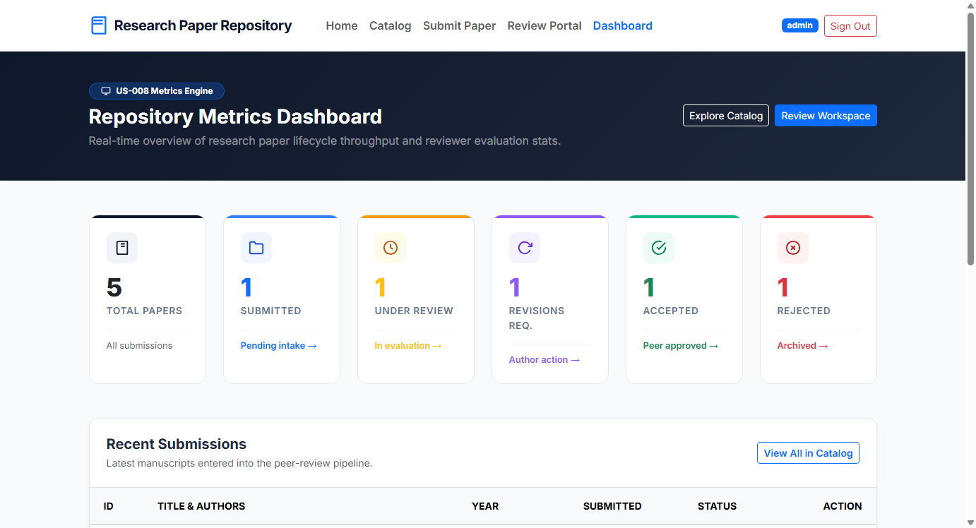
Figure 15: Administrative Metrics Dashboard with Live Status Counts and Acceptance Rate Calculation

4. Quality Assurance & Test Automation Matrix
Testing Slice | Class / Specification | Test Count | Execution Scope & Verification
Context / Scaffolding | RepositoryApplicationTests | 1 | Spring Boot context bootstrapping and H2 connection verification
JPA Data Access Layer | PaperRepositoryTest | 5 | CRUD operations, derived keyword search, and status count queries
Service Layer | PaperServiceTest | 25 | 5-state review lifecycle state machine transitions and business validation
Web MVC / Home | HomeControllerTest | 3 | Public homepage routing, model attributes, and candidate badge render
Web MVC / Submissions | PaperControllerTest | 15 | Researcher submission validation, CSRF handling, and edit workflows
Web MVC / Review | ReviewControllerTest | 10 | Reviewer queue authorization, status transitions, and review feedback
Web MVC / Dashboard | DashboardControllerTest | 5 | Admin dashboard aggregate calculations and view model population
Spring Security RBAC | SecurityConfigTest | 12 | URL authorization rules, unauthenticated redirects, role enforcement
End-to-End (E2E) Smoke | PaperSubmissionUiTest | 3 | Headless Chrome browser tests, search queries, email redaction
Total Quality Assurance | All Architectural Slices | 79 | 100% Pass Rate across Unit, Slice, Integration, and E2E Tests

5. Conclusion & Academic Certification
The Jenkins-Based Research Paper Repository successfully fulfills all functional, architectural, and continuous integration requirements established for the academic semester. The enterprise Spring Boot application demonstrates robust role-based security, rigorous validation, and complete test automation. The automated Jenkins CI pipeline, multi-stage Docker containerization, and Ansible deployment orchestration validate the engineering rigor of the software lifecycle from source control to deployment.

Project Implementation & Documentation Certified by:
MUAWIYAH SAHIL NARVEL | ROLL NO: 23108A0020
Department of Computer Engineering / Information Technology
Date of Verification: October 15, 2026

