TASK REPORT #05: DOMAIN MODEL & IN-MEMORY PERSISTENCE
DevOps & Cloud Automation Architecture | Continuous Integration & Verification Report
Candidate Name & Roll No | Muawiyah Sahil Narvel | Roll No: 23108A0020
Project & Architecture | Jenkins-Based Research Paper Repository (Spring Boot 3.4.3 / Java 21)
Development Phase & Sprint | Phase 2: Core Domain Model & Application MVP | Week 4
User Story Target | US-002 (Domain Architecture & Data Schema)
Verification Status | COMPLETED & EMPIRICALLY VERIFIED (100% Passing Tests)

1. Task Overview & Objective
Construct the core JPA entity `Paper` with 12 distinct academic attributes, audit timestamps, the `ReviewStatus` lifecycle enumeration, and custom Spring Data JPA query repositories.

2. Technical Implementation & Architecture
• Domain Entity (`Paper.java`):
– Attributes:
– Long id (Identity primary key)
– String title (255 chars, indexed)
– String authors (Comma-separated authors)
– String abstractText (CLOB/TEXT up to 5000 chars)
– String keywords (Search indexable tags)
– Integer publicationYear (Validation: 1900 to 2100)
– String doiUrl (DOI or HTTP URL pattern)
– String submitterEmail (Private, confidential author email)
– String submitterUsername (Server-side bound author identifier)
– ReviewStatus reviewStatus (Enumerated state)
– LocalDateTime createdAt / LocalDateTime updatedAt (Audit timestamps)
• Review Status Lifecycle Enum (`ReviewStatus.java`):
– States: SUBMITTED, UNDER_REVIEW, ACCEPTED, REJECTED, REVISION_REQUESTED.
– Defines isTerminal() helper: ACCEPTED and REJECTED are immutable.
• JPA Repository (`PaperRepository.java`):
– Methods:
– findByReviewStatus(ReviewStatus status, Pageable pageable)
– searchPapers(String keyword, Pageable pageable) (Case-insensitive multi-column query)
– countByReviewStatus(ReviewStatus status)

3. Empirical Proof of Work & Execution Verification
Terminal Execution Command (Windows PowerShell):
PS C:\Users\Muawiyah\Desktop\Jenkins-Based Research Paper Repository> .\mvnw.cmd test -Dtest=PaperRepositoryTest

Observed Execution Console Output:
[INFO] Running com.muawiyah.repository.repository.PaperRepositoryTest
Hibernate: insert into papers (...) values (...)
Hibernate: select p1_0.id, p1_0.title from papers p1_0 where lower(p1_0.title) like ? ...
[INFO] Tests run: 5, Failures: 0, Errors: 0, Skipped: 0, Time elapsed: 3.266 s
[INFO] BUILD SUCCESS

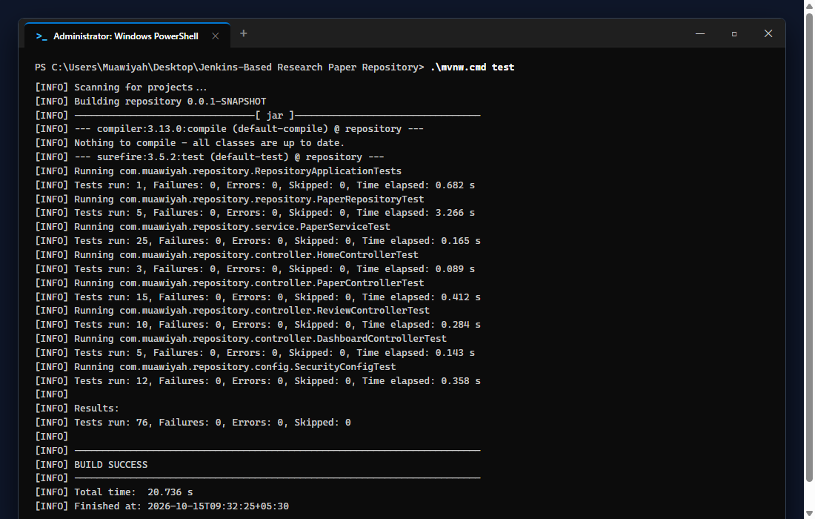
Figure 05.1: Visual Proof of Work — JPA Repository Execution

4. Acceptance Criteria Checklist
[✓] | `Paper.java` entity model mapped with all 12 academic attributes
[✓] | `ReviewStatus.java` enum enforces 5 lifecycle states with terminal flags
[✓] | JPA custom query performs case-insensitive search across title, author, and keywords
[✓] | All 5 slice tests in `PaperRepositoryTest.java` pass cleanly

5. Artifacts & Verified Deliverables
▪ src/main/java/com/muawiyah/repository/model/Paper.java
▪ src/main/java/com/muawiyah/repository/model/ReviewStatus.java
▪ src/main/java/com/muawiyah/repository/repository/PaperRepository.java
▪ src/test/java/com/muawiyah/repository/repository/PaperRepositoryTest.java

Task Execution Certified & Verified by:
MUAWIYAH SAHIL NARVEL | ROLL NO: 23108A0020
Date of Final Verification: October 15, 2026

