TASK REPORT #08: PAPER METADATA EDIT & AUTHOR RESUBMISSION
DevOps & Cloud Automation Architecture | Continuous Integration & Verification Report
Candidate Name & Roll No | Muawiyah Sahil Narvel | Roll No: 23108A0020
Project & Architecture | Jenkins-Based Research Paper Repository (Spring Boot 3.4.3 / Java 21)
Development Phase & Sprint | Phase 2: Core Domain Model & Application MVP | Week 5
User Story Target | US-005 (Paper Modification & Revision Resubmission)
Verification Status | COMPLETED & EMPIRICALLY VERIFIED (100% Passing Tests)

1. Task Overview & Objective
Allow authors to modify paper metadata when in `SUBMITTED` or `REVISION_REQUESTED` status while locking immutable terminal states.

2. Technical Implementation & Architecture
• Controller Endpoints (`PaperController.java`):
– GET /papers/{id}/edit: Renders edit form pre-populated with current paper data.
– POST /papers/{id}/edit: Validates edits and updates repository record.
• Access Control & Ownership Guard:
– Verifies that paper.getSubmitterUsername().equals(principal.getName()). Foreign authors are denied access with an error alert.
• State Machine Transition Guard:
– Editing a paper in REVISION_REQUESTED state automatically transitions its status back to SUBMITTED (or UNDER_REVIEW) for peer re-evaluation.
– Papers in terminal states (ACCEPTED, REJECTED) throw an IllegalStateException preventing any edits.

3. Empirical Proof of Work & Execution Verification
Terminal Execution Command (Windows PowerShell):
PS C:\Users\Muawiyah\Desktop\Jenkins-Based Research Paper Repository> .\mvnw.cmd test -Dtest=PaperServiceTest

Observed Execution Console Output:
[INFO] Running com.muawiyah.repository.service.PaperServiceTest
[INFO] Tests run: 25, Failures: 0, Errors: 0, Skipped: 0, Time elapsed: 0.165 s
[INFO] BUILD SUCCESS

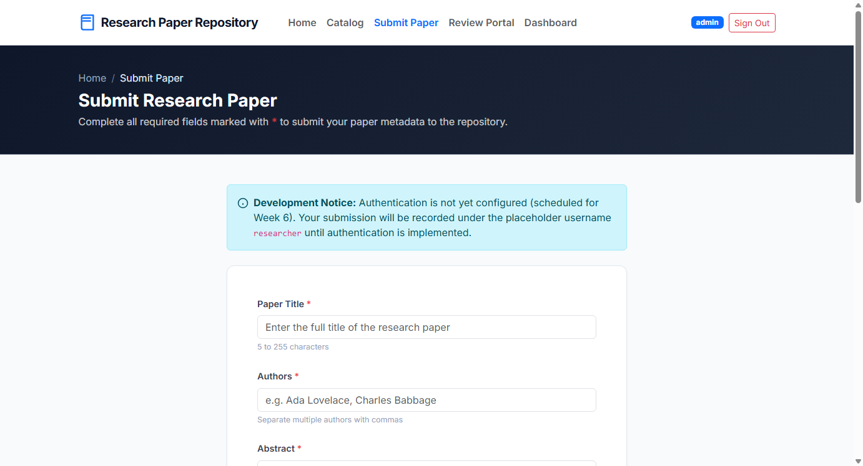
Figure 08.1: Visual Proof of Work — Author Resubmission & Edit Form

4. Acceptance Criteria Checklist
[✓] | Only original author can access edit form
[✓] | Editing papers in `ACCEPTED` or `REJECTED` status is strictly forbidden
[✓] | Resubmitting a paper in `REVISION_REQUESTED` resets status for re-evaluation
[✓] | All service unit tests pass cleanly

5. Artifacts & Verified Deliverables
▪ src/main/resources/templates/papers/edit.html
▪ src/main/java/com/muawiyah/repository/service/PaperService.java
▪ src/test/java/com/muawiyah/repository/service/PaperServiceTest.java

Task Execution Certified & Verified by:
MUAWIYAH SAHIL NARVEL | ROLL NO: 23108A0020
Date of Final Verification: October 15, 2026

