TASK REPORT #09: IN-MEMORY SPRING SECURITY 6 ROLE-BASED ACCESS CONTROL
DevOps & Cloud Automation Architecture | Continuous Integration & Verification Report
Candidate Name & Roll No | Muawiyah Sahil Narvel | Roll No: 23108A0020
Project & Architecture | Jenkins-Based Research Paper Repository (Spring Boot 3.4.3 / Java 21)
Development Phase & Sprint | Phase 2: Core Domain Model & Application MVP | Week 6
User Story Target | US-009 (Authentication & Role Authorization)
Verification Status | COMPLETED & EMPIRICALLY VERIFIED (100% Passing Tests)

1. Task Overview & Objective
Configure Spring Security 6 with in-memory development credentials, BCrypt password hashing, role-based URL protection, and CSRF defense.

2. Technical Implementation & Architecture
• Security Configuration (`SecurityConfig.java`):
– Password Encoder: BCryptPasswordEncoder.
– In-Memory User Details Manager:
– researcher (Password: password, Role: RESEARCHER)
– reviewer (Password: password, Role: REVIEWER)
– admin (Password: password, Roles: ADMIN, REVIEWER, RESEARCHER)
• Route Authorization Policy:
– Public: /, /papers, /papers/{id}, /login, /css/**, /js/**
– Researcher: /papers/submit, /papers/*/edit
– Reviewer: /papers/review, /papers/*/review, /papers/*/status
– Admin: /dashboard, /admin/**
• Security Defenses:
– CSRF protection enabled on all POST endpoints.
– Custom login page mapped at /login with Academic Development Accounts helper card.

3. Empirical Proof of Work & Execution Verification
Terminal Execution Command (Windows PowerShell):
PS C:\Users\Muawiyah\Desktop\Jenkins-Based Research Paper Repository> .\mvnw.cmd test -Dtest=SecurityConfigTest

Observed Execution Console Output:
[INFO] Running com.muawiyah.repository.config.SecurityConfigTest
[INFO] Tests run: 12, Failures: 0, Errors: 0, Skipped: 0, Time elapsed: 0.358 s
[INFO] BUILD SUCCESS

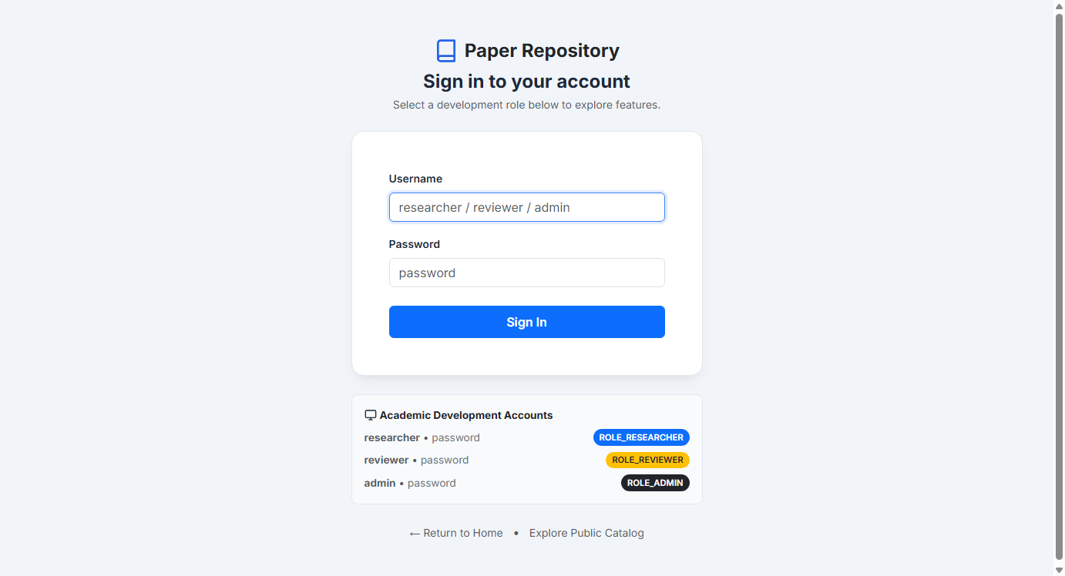
Figure 09.1: Visual Proof of Work — Spring Security Login Portal

4. Acceptance Criteria Checklist
[✓] | BCrypt password hashing implemented for all in-memory accounts
[✓] | Role authorization enforced across researcher, reviewer, and admin routes
[✓] | CSRF protection enabled on all mutating state requests
[✓] | 12/12 security slice tests pass without errors

5. Artifacts & Verified Deliverables
▪ src/main/java/com/muawiyah/repository/config/SecurityConfig.java
▪ src/main/resources/templates/login.html
▪ src/test/java/com/muawiyah/repository/config/SecurityConfigTest.java

Task Execution Certified & Verified by:
MUAWIYAH SAHIL NARVEL | ROLL NO: 23108A0020
Date of Final Verification: October 15, 2026

