TASK REPORT #10: PEER-REVIEW WORKFLOW & 5-STATE LIFECYCLE STATE MACHINE
DevOps & Cloud Automation Architecture | Continuous Integration & Verification Report
Candidate Name & Roll No | Muawiyah Sahil Narvel | Roll No: 23108A0020
Project & Architecture | Jenkins-Based Research Paper Repository (Spring Boot 3.4.3 / Java 21)
Development Phase & Sprint | Phase 2: Core Domain Model & Application MVP | Week 6
User Story Target | US-006 (Reviewer Queue), US-007 (Status Decision Execution)
Verification Status | COMPLETED & EMPIRICALLY VERIFIED (100% Passing Tests)

1. Task Overview & Objective
Build the peer-review queue and implement a validated, immutable 5-state lifecycle state machine for evaluating academic submissions.

2. Technical Implementation & Architecture
• Review Portal Controller (`PaperController.java`):
– GET /papers/review: Reviewer portal displaying submission queue with status filter tabs.
– GET /papers/{id}/review: Decision execution form showing permitted next transitions.
– POST /papers/{id}/status: Executes status update with reviewer feedback comments.
• State Machine Transition Rules:
– SUBMITTED &rarr; UNDER_REVIEW
– UNDER_REVIEW &rarr; ACCEPTED (Terminal)
– UNDER_REVIEW &rarr; REJECTED (Terminal)
– UNDER_REVIEW &rarr; REVISION_REQUESTED
– REVISION_REQUESTED &rarr; SUBMITTED (Upon author resubmission)
• Terminal State Immutability:
– Attempting illegal transitions (e.g. ACCEPTED &rarr; SUBMITTED) throws IllegalStateException.

3. Empirical Proof of Work & Execution Verification

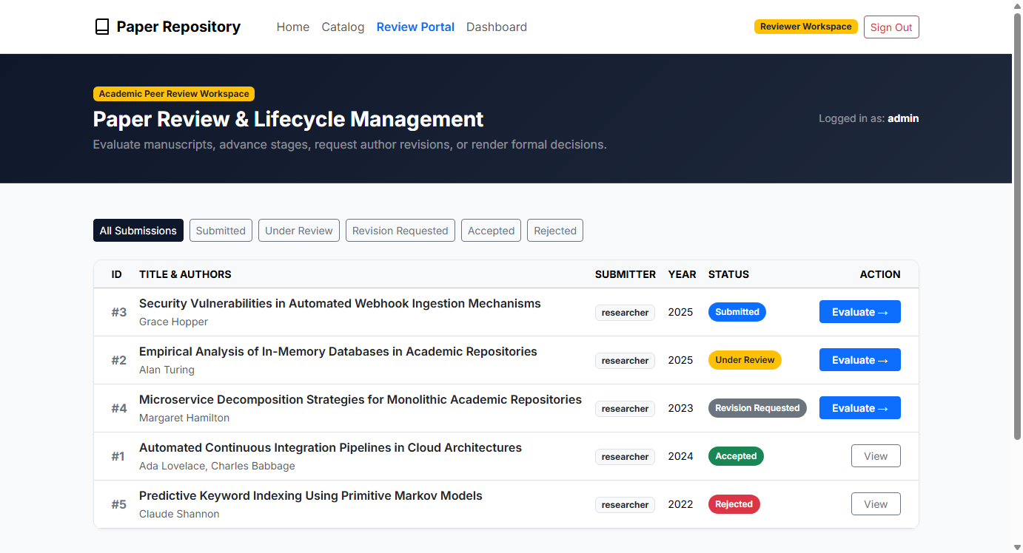
Figure 10.1: Visual Proof of Work — Peer Review Queue

4. Acceptance Criteria Checklist
[✓] | Review portal displays submissions filterable by review status
[✓] | Reviewers can transition papers between permitted lifecycle states
[✓] | Terminal states (`ACCEPTED`, `REJECTED`) cannot be transitioned
[✓] | All state machine unit tests pass

5. Artifacts & Verified Deliverables
▪ src/main/resources/templates/papers/review-portal.html
▪ src/main/resources/templates/papers/review.html
▪ src/main/java/com/muawiyah/repository/service/PaperService.java

Task Execution Certified & Verified by:
MUAWIYAH SAHIL NARVEL | ROLL NO: 23108A0020
Date of Final Verification: October 15, 2026

