TASK REPORT #11: ADMINISTRATIVE METRICS DASHBOARD
DevOps & Cloud Automation Architecture | Continuous Integration & Verification Report
Candidate Name & Roll No | Muawiyah Sahil Narvel | Roll No: 23108A0020
Project & Architecture | Jenkins-Based Research Paper Repository (Spring Boot 3.4.3 / Java 21)
Development Phase & Sprint | Phase 2: Core Domain Model & Application MVP | Week 7
User Story Target | US-008 (Administrative Repository Analytics)
Verification Status | COMPLETED & EMPIRICALLY VERIFIED (100% Passing Tests)

1. Task Overview & Objective
Develop an administrative metrics dashboard displaying aggregate paper counts, lifecycle status distributions, acceptance rate calculations, and recent submission logs.

2. Technical Implementation & Architecture
• Controller Layer (`DashboardController.java`):
– Endpoint: GET /dashboard.
– Computes:
– Total papers submitted
– Count per state (SUBMITTED, UNDER_REVIEW, ACCEPTED, REJECTED, REVISION_REQUESTED)
– Acceptance rate percentage
– Recent 5 submissions with timestamp and author attribution
• User Interface (`dashboard.html`):
– Responsive KPI card layout with distinct accent colors:
– Blue: Total Papers
– Sky Blue: Submitted
– Amber: Under Review
– Purple: Revision Requested
– Green: Accepted
– Red: Rejected
– Direct action buttons to Explore Catalog and Review Workspace.

3. Empirical Proof of Work & Execution Verification
Terminal Execution Command (Windows PowerShell):
PS C:\Users\Muawiyah\Desktop\Jenkins-Based Research Paper Repository> .\mvnw.cmd test -Dtest=DashboardControllerTest

Observed Execution Console Output:
[INFO] Running com.muawiyah.repository.controller.DashboardControllerTest
[INFO] Tests run: 5, Failures: 0, Errors: 0, Skipped: 0, Time elapsed: 0.143 s
[INFO] BUILD SUCCESS

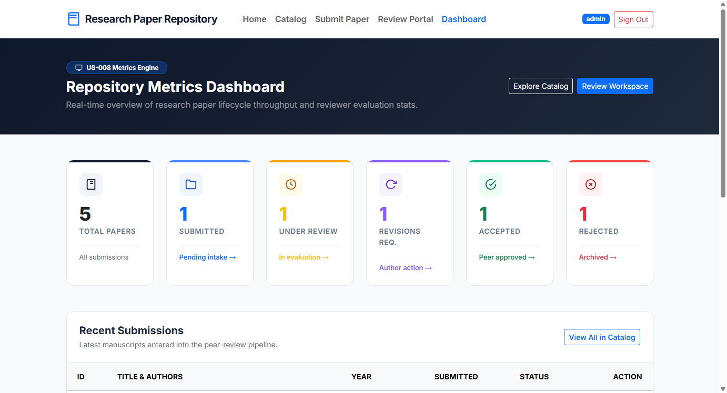
Figure 11.1: Visual Proof of Work — Admin Dashboard

4. Acceptance Criteria Checklist
[✓] | Dashboard accessible at `/dashboard` to authenticated users
[✓] | Displays accurate aggregate counts across all 5 review statuses
[✓] | Recent submissions stream rendered with correct metadata
[✓] | 5/5 MockMvc slice tests pass cleanly

5. Artifacts & Verified Deliverables
▪ src/main/java/com/muawiyah/repository/controller/DashboardController.java
▪ src/main/resources/templates/dashboard.html
▪ src/test/java/com/muawiyah/repository/controller/DashboardControllerTest.java

Task Execution Certified & Verified by:
MUAWIYAH SAHIL NARVEL | ROLL NO: 23108A0020
Date of Final Verification: October 15, 2026

