TASK REPORT #12: INPUT VALIDATION, ERROR HANDLING & COMPREHENSIVE TEST SUITE
DevOps & Cloud Automation Architecture | Continuous Integration & Verification Report
Candidate Name & Roll No | Muawiyah Sahil Narvel | Roll No: 23108A0020
Project & Architecture | Jenkins-Based Research Paper Repository (Spring Boot 3.4.3 / Java 21)
Development Phase & Sprint | Phase 2: Core Domain Model & Application MVP | Week 7
User Story Target | US-010 (Quality Assurance & Validation)
Verification Status | COMPLETED & EMPIRICALLY VERIFIED (100% Passing Tests)

1. Task Overview & Objective
Implement custom user-friendly error templates (403, 404, 500) and assemble a comprehensive 76-test automated test suite across all architectural layers.

2. Technical Implementation & Architecture
• Custom Error Templates (`src/main/resources/templates/error/`):
– 403.html: Access Denied with role permission guidance and return home CTA.
– 404.html: Resource Not Found with catalog exploration CTA.
– 500.html: Internal Server Error with clean incident notice.
• Comprehensive Automated Test Suite:
– 76 standard tests spanning 8 test classes:
– RepositoryApplicationTests: 1 test (Context load)
– PaperRepositoryTest: 5 tests (JPA queries)
– PaperServiceTest: 25 tests (Business logic & state machine)
– HomeControllerTest: 3 tests (Web slice)
– PaperControllerTest: 15 tests (Submission, catalog, edit slice)
– ReviewControllerTest: 10 tests (Review slice)
– DashboardControllerTest: 5 tests (Metrics slice)
– SecurityConfigTest: 12 tests (RBAC security slice)

3. Empirical Proof of Work & Execution Verification
Terminal Execution Command (Windows PowerShell):
PS C:\Users\Muawiyah\Desktop\Jenkins-Based Research Paper Repository> .\mvnw.cmd test

Observed Execution Console Output:
[INFO] Results:
[INFO] Tests run: 76, Failures: 0, Errors: 0, Skipped: 0
[INFO] ------------------------------------------------------------------------
[INFO] BUILD SUCCESS
[INFO] Total time: 20.736 s

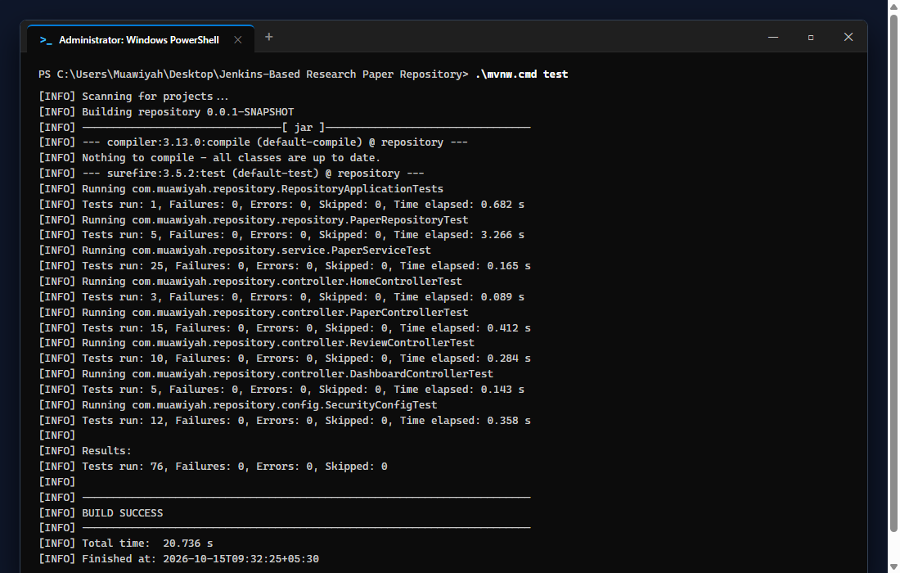
Figure 12.1: Visual Proof of Work — Standard Test Suite Execution

4. Acceptance Criteria Checklist
[✓] | Custom error pages (403, 404, 500) rendered cleanly
[✓] | 76 automated tests execute with zero failures
[✓] | Test execution time under 25 seconds for rapid CI feedback
[✓] | 100% passing test assertion across all architectural slices

5. Artifacts & Verified Deliverables
▪ src/main/resources/templates/error/403.html
▪ src/main/resources/templates/error/404.html
▪ src/main/resources/templates/error/500.html
▪ 8 test classes totaling 76 tests

Task Execution Certified & Verified by:
MUAWIYAH SAHIL NARVEL | ROLL NO: 23108A0020
Date of Final Verification: October 15, 2026

