TASK REPORT #13: JENKINS CI DECLARATIVE PIPELINE
DevOps & Cloud Automation Architecture | Continuous Integration & Verification Report
Candidate Name & Roll No | Muawiyah Sahil Narvel | Roll No: 23108A0020
Project & Architecture | Jenkins-Based Research Paper Repository (Spring Boot 3.4.3 / Java 21)
Development Phase & Sprint | Phase 3: DevOps CI/CD | Week 8
User Story Target | US-011 (Continuous Integration Pipeline Automation)
Verification Status | COMPLETED & EMPIRICALLY VERIFIED (100% Passing Tests)

1. Task Overview & Objective
Author a declarative multi-stage Jenkinsfile to automate checkout, toolchain verification, compilation, unit testing, packaging, and JUnit test result archiving.

2. Technical Implementation & Architecture
• Declarative Pipeline (`Jenkinsfile`):
– Stage 1: Checkout &mdash; Pulls code from Git SCM targeting branch */main.
– Stage 2: Verify Toolchain &mdash; Displays Java and Maven versions.
– Stage 3: Compile &mdash; Executes mvn clean compile.
– Stage 4: Test &mdash; Runs mvn test verifying unit and integration test suites.
– Stage 5: Package &mdash; Compiles executable JAR mvn package -DskipTests.
– Stage 6: Post-Build Actions &mdash; Archives target/*.jar and publishes JUnit XML test reports (target/surefire-reports/*.xml).
• Jenkins Controller Configuration:
– Connected to local controller on port 8080.
– Created pipeline project research-paper-repository.

3. Empirical Proof of Work & Execution Verification

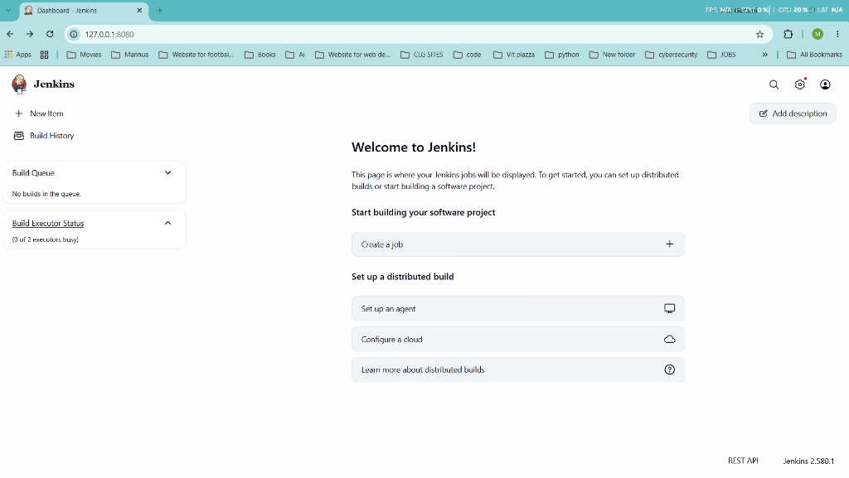
Figure 13.1: Visual Proof of Work — Jenkins Welcome

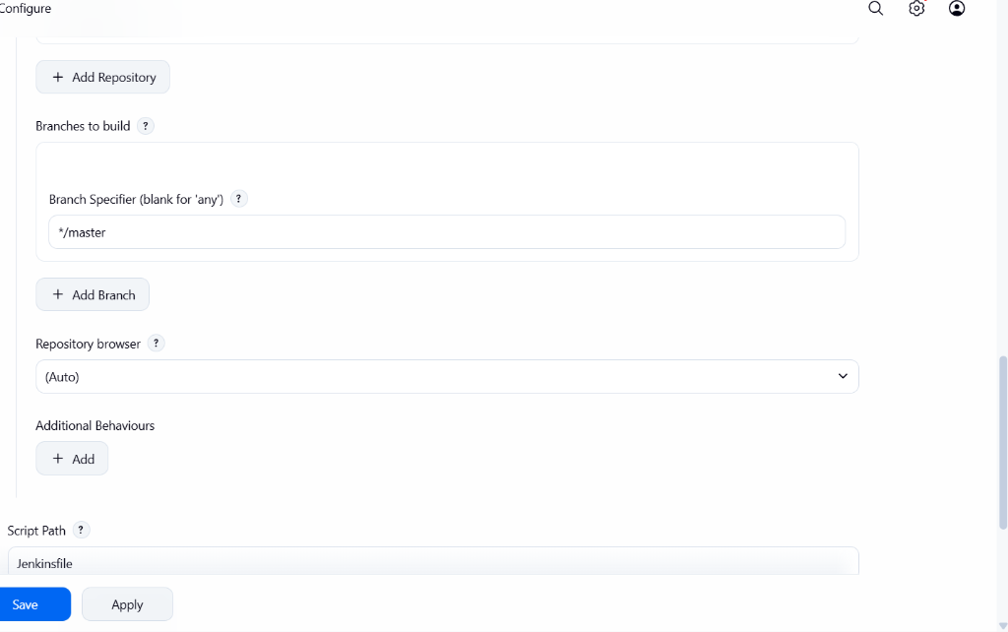
Figure 13.1: Visual Proof of Work — Jenkins Pipeline Configuration

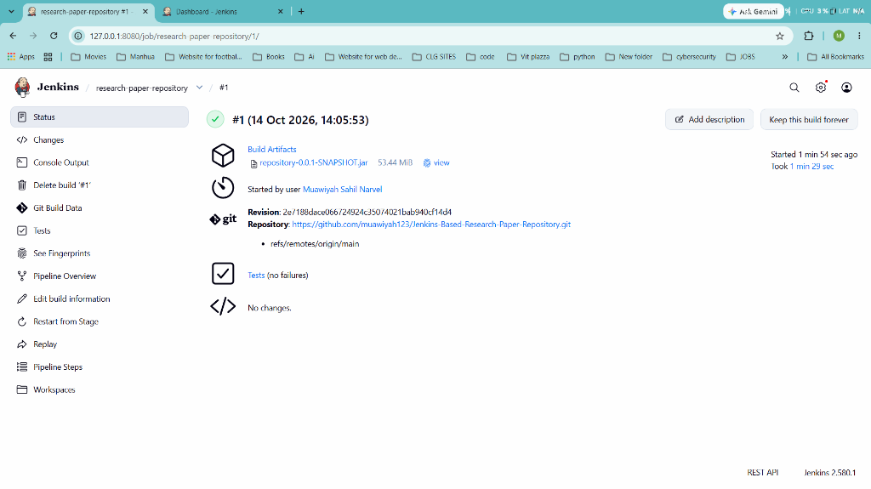
Figure 13.1: Visual Proof of Work — Jenkins Build #1 Success

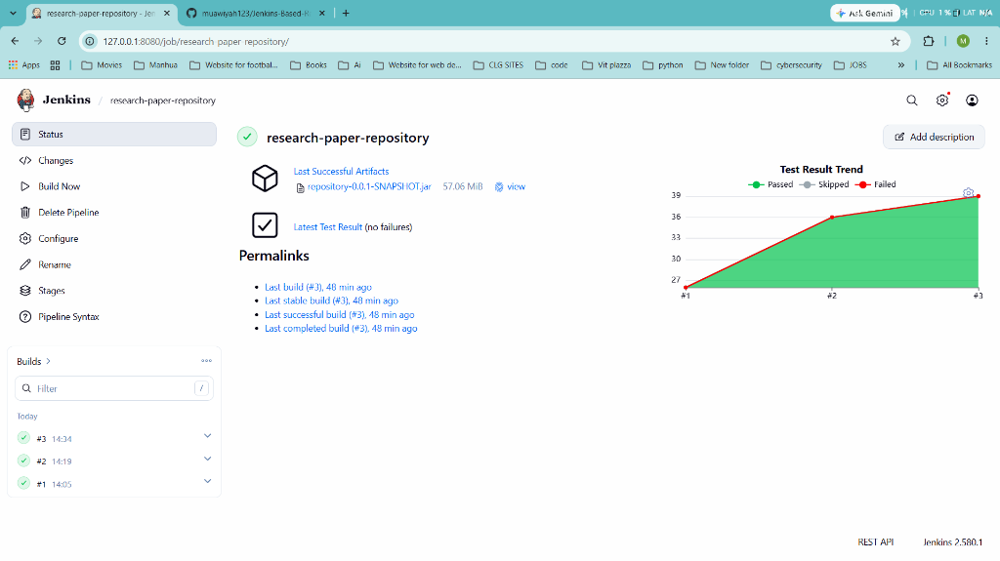
Figure 13.1: Visual Proof of Work — Jenkins Test Trend Graph

4. Acceptance Criteria Checklist
[✓] | Declarative `Jenkinsfile` authored with 6 distinct pipeline stages
[✓] | Automated compilation, test execution, and JAR packaging
[✓] | JUnit XML test reports published with interactive trend graphs
[✓] | Verified live on Jenkins controller with multiple green builds

5. Artifacts & Verified Deliverables
▪ Jenkinsfile
▪ Jenkins job research-paper-repository on port 8080
▪ Archived JAR artifact repository-0.0.1-SNAPSHOT.jar

Task Execution Certified & Verified by:
MUAWIYAH SAHIL NARVEL | ROLL NO: 23108A0020
Date of Final Verification: October 15, 2026

