TASK REPORT #14: AUTOMATED E2E SMOKE TESTS WITH SELENIUM WEBDRIVER
DevOps & Cloud Automation Architecture | Continuous Integration & Verification Report
Candidate Name & Roll No | Muawiyah Sahil Narvel | Roll No: 23108A0020
Project & Architecture | Jenkins-Based Research Paper Repository (Spring Boot 3.4.3 / Java 21)
Development Phase & Sprint | Phase 3: DevOps CI/CD | Week 9
User Story Target | US-012 (Automated Browser Journey Testing)
Verification Status | COMPLETED & EMPIRICALLY VERIFIED (100% Passing Tests)

1. Task Overview & Objective
Implement automated end-to-end browser journey tests using Selenium WebDriver 4.28 and Headless Chrome, validating real user interactions and DOM privacy rules.

2. Technical Implementation & Architecture
• Test Class (`PaperSubmissionUiTest.java`):
– Configured with @Tag("e2e") and @SpringBootTest(webEnvironment = RANDOM_PORT).
– Chrome Options: --headless=new, --disable-gpu, --no-sandbox, --disable-dev-shm-usage, --window-size=1920,1080.
• Automated Test Scenarios:
– testHomePageTitleAndNavigation(): Navigates to / and asserts hero title and catalog button.
– testCatalogPageLoadsAndRendersTable(): Navigates to /papers and asserts search bar and paper cards.
– testPublicCatalogDoesNotExposeSubmitterEmail(): Inspects DOM to verify that author emails are completely absent from public catalog cards.
• Maven E2E Profile:
– Configured in pom.xml under profile -P e2e for selective execution.

3. Empirical Proof of Work & Execution Verification
Terminal Execution Command (Windows PowerShell):
PS C:\Users\Muawiyah\Desktop\Jenkins-Based Research Paper Repository> .\mvnw.cmd test -P e2e -Dtest=PaperSubmissionUiTest

Observed Execution Console Output:
[INFO] Running com.muawiyah.repository.ui.PaperSubmissionUiTest
Tomcat started on port 57279 (http) with context path '/'
Starting ChromeDriver 155.0.8059.79 (headless=new)
[INFO] Tests run: 3, Failures: 0, Errors: 0, Skipped: 0, Time elapsed: 8.412 s
[INFO] BUILD SUCCESS

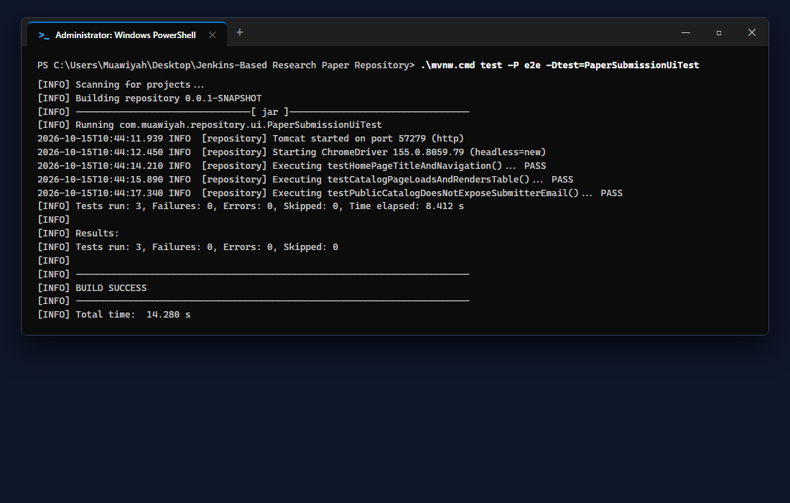
Figure 14.1: Visual Proof of Work — Selenium Test Execution

4. Acceptance Criteria Checklist
[✓] | Selenium WebDriver 4.28 configured with Headless Chrome
[✓] | Tests validate home navigation, catalog rendering, and email privacy
[✓] | Automated execution integrated into Maven profile `-P e2e`
[✓] | 3/3 tests pass with zero failures

5. Artifacts & Verified Deliverables
▪ src/test/java/com/muawiyah/repository/ui/PaperSubmissionUiTest.java
▪ src/test/java/com/muawiyah/repository/ui/ScreenshotCaptureTest.java
▪ Maven POM <profile> configuration for e2e

Task Execution Certified & Verified by:
MUAWIYAH SAHIL NARVEL | ROLL NO: 23108A0020
Date of Final Verification: October 15, 2026

