TASK REPORT #04: PUBLIC HOME & NAVIGATION SCAFFOLD
DevOps & Cloud Automation Architecture | Continuous Integration & Verification Report
Candidate Name & Roll No | Muawiyah Sahil Narvel | Roll No: 23108A0020
Project & Architecture | Jenkins-Based Research Paper Repository (Spring Boot 3.4.3 / Java 21)
Development Phase & Sprint | Phase 1: Foundation & Planning | Week 3
User Story Target | US-001 (Public Portal Landing)
Verification Status | COMPLETED & EMPIRICALLY VERIFIED (100% Passing Tests)

1. Task Overview & Objective
Design and build a responsive public home portal with glassmorphism hero styling, platform foundation metrics, accessible navigation, and candidate attribution banner.

2. Technical Implementation & Architecture
• Controller Layer (`HomeController.java`):
– Mapped GET / to render index.html.
– Injected system statistics and active profile metadata into the view model.
• Thymeleaf Template (`src/main/resources/templates/index.html`):
– Responsive Bootstrap 5 layout with custom typography (Inter via Google Fonts).
– Candidate Attribution Badge: Muawiyah Narvel (23108A0020).
– System Foundation Baseline Card: Java 21 LTS, Spring Boot 3.4.3, H2 Database, Apache Maven, JUnit 5.
– Direct CTA links to Browse Catalog (/papers) and H2 Database Console (/h2-console).
• Automated Unit Tests (`HomeControllerTest.java`):
– Validated HTTP 200 OK, view name "index", and candidate badge presence in DOM.

3. Empirical Proof of Work & Execution Verification
Terminal Execution Command (Windows PowerShell):
PS C:\Users\Muawiyah\Desktop\Jenkins-Based Research Paper Repository> .\mvnw.cmd test -Dtest=HomeControllerTest

Observed Execution Console Output:
[INFO] Running com.muawiyah.repository.controller.HomeControllerTest
[INFO] Tests run: 3, Failures: 0, Errors: 0, Skipped: 0, Time elapsed: 0.089 s
[INFO] BUILD SUCCESS

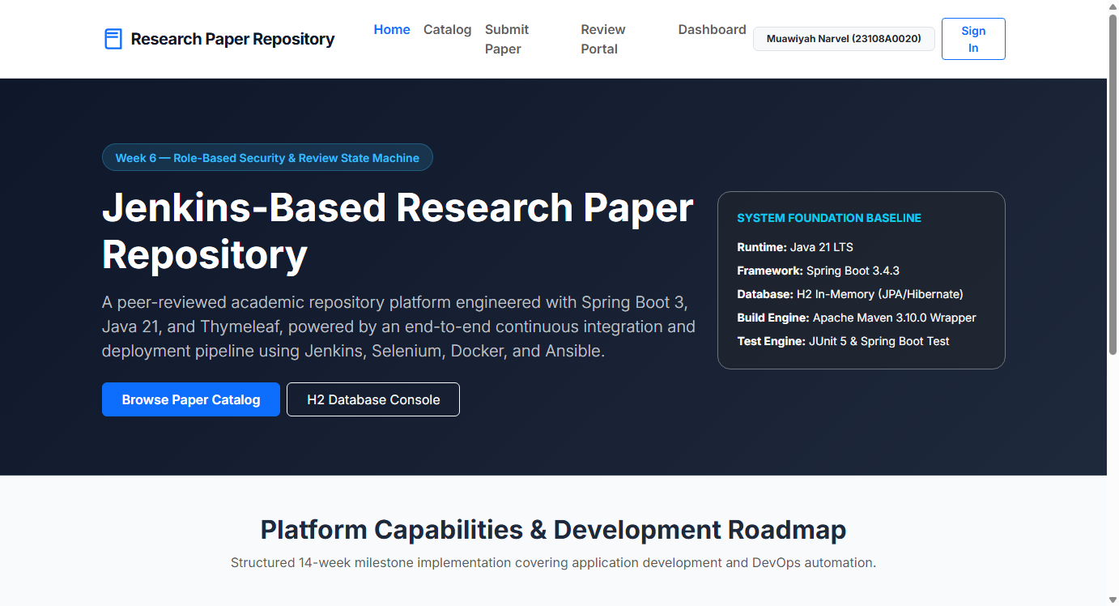
Figure 04.1: Visual Proof of Work — Public Home Portal

4. Acceptance Criteria Checklist
Public home page accessible at `GET /` without authentication
Hero banner displays platform specifications and candidate credentials
Navigation header links to Catalog, Submit, Review Portal, and Dashboard
MockMvc tests confirm view resolution and HTTP 200 response

5. Artifacts & Verified Deliverables
▪ src/main/java/com/muawiyah/repository/controller/HomeController.java
▪ src/main/resources/templates/index.html
▪ src/test/java/com/muawiyah/repository/controller/HomeControllerTest.java

