TASK REPORT #06: RESEARCH PAPER SUBMISSION WORKFLOW
DevOps & Cloud Automation Architecture | Continuous Integration & Verification Report
Candidate Name & Roll No | Muawiyah Sahil Narvel | Roll No: 23108A0020
Project & Architecture | Jenkins-Based Research Paper Repository (Spring Boot 3.4.3 / Java 21)
Development Phase & Sprint | Phase 2: Core Domain Model & Application MVP | Week 4
User Story Target | US-002 (Author Manuscript Submission)
Verification Status | COMPLETED & EMPIRICALLY VERIFIED (100% Passing Tests)

1. Task Overview & Objective
Build the secure paper submission form with server-side Jakarta Bean Validation, authenticated author username binding, and automatic initial status assignment.

2. Technical Implementation & Architecture
• Data Transfer Object (`PaperSubmissionDto.java` / `PaperSubmissionForm.java`):
– @NotBlank(message = "Title is required")
– @Size(min = 5, max = 255, message = "Title must be between 5 and 255 characters")
– @Min(value = 1900, message = "Year must be 1900 or later")
– @Max(value = 2100, message = "Year cannot exceed 2100")
– @Pattern(regexp = "^(https?://|doi:).*") (DOI or HTTP format validator)
• Controller Logic (`PaperController.java`):
– GET /papers/submit: Renders submit.html.
– POST /papers/submit: Validates form. Submitter username is bound server-side from Authentication.getName() to prevent author identity spoofing.
– Default status automatically initialized to SUBMITTED.
• User Interface (`submit.html`):
– Styled input cards, inline red field error alerts, and character counters.

3. Empirical Proof of Work & Execution Verification
Terminal Execution Command (Windows PowerShell):
PS C:\Users\Muawiyah\Desktop\Jenkins-Based Research Paper Repository> .\mvnw.cmd test -Dtest=PaperControllerTest

Observed Execution Console Output:
[INFO] Running com.muawiyah.repository.controller.PaperControllerTest
[INFO] Tests run: 15, Failures: 0, Errors: 0, Skipped: 0, Time elapsed: 0.412 s
[INFO] BUILD SUCCESS

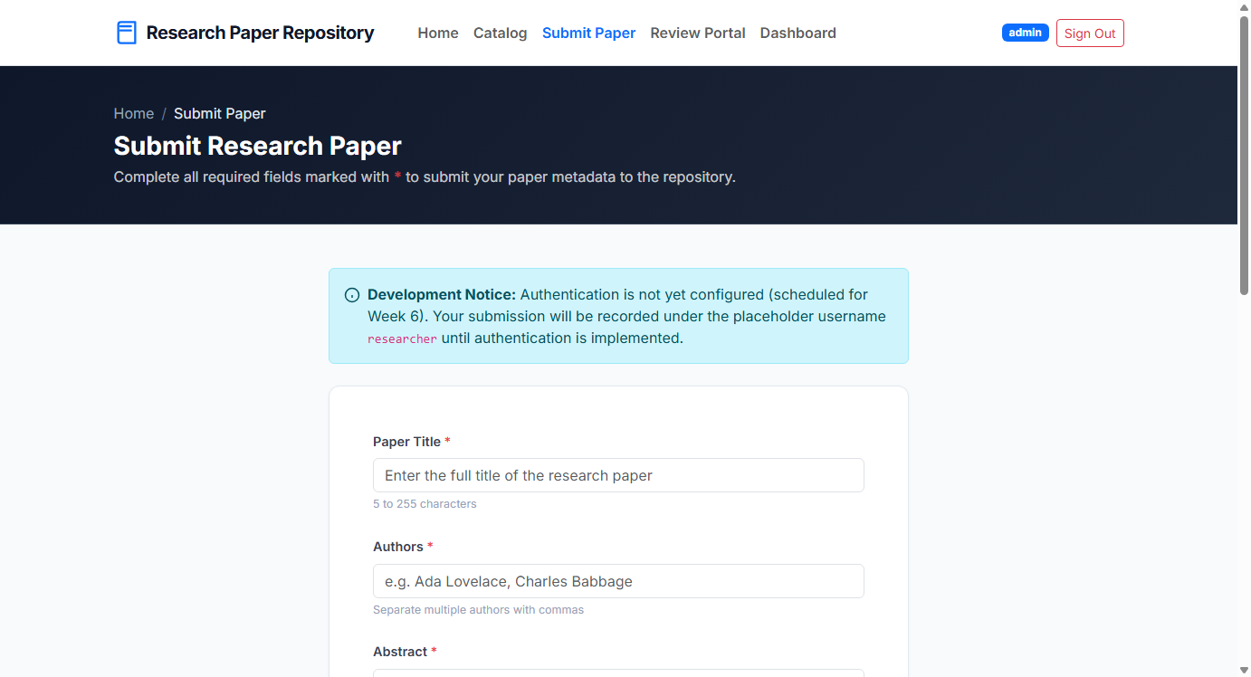
Figure 06.1: Visual Proof of Work — Paper Submission Form

4. Acceptance Criteria Checklist
Form enforces title, author, abstract, year, and DOI validation constraints
Submitter username derived securely from active authentication session
Initial status set to `SUBMITTED` with automated redirect to detail page
15/15 MockMvc controller tests passed with zero failures

5. Artifacts & Verified Deliverables
▪ src/main/java/com/muawiyah/repository/dto/PaperSubmissionForm.java
▪ src/main/java/com/muawiyah/repository/controller/PaperController.java
▪ src/main/resources/templates/papers/submit.html
▪ src/test/java/com/muawiyah/repository/controller/PaperControllerTest.java

