TASK REPORT #07: PUBLIC CATALOG & REAL-TIME KEYWORD SEARCH
DevOps & Cloud Automation Architecture | Continuous Integration & Verification Report
Candidate Name & Roll No | Muawiyah Sahil Narvel | Roll No: 23108A0020
Project & Architecture | Jenkins-Based Research Paper Repository (Spring Boot 3.4.3 / Java 21)
Development Phase & Sprint | Phase 2: Core Domain Model & Application MVP | Week 5
User Story Target | US-003 (Public Catalog), US-004 (Keyword Discovery)
Verification Status | COMPLETED & EMPIRICALLY VERIFIED (100% Passing Tests)

1. Task Overview & Objective
Construct the public paper catalog with real-time multi-field keyword search, pagination, and strict author email privacy protection.

2. Technical Implementation & Architecture
• Catalog Exploration Endpoints:
– GET /papers: Displays paginated list of papers with search filter.
– GET /papers/{id}: Displays full academic metadata card for individual paper.
• Search Logic (`PaperService.java`):
– Performs case-insensitive matching across title, authors, and keywords.
• Strict Privacy Enforcement Rule:
– **Privacy Policy:** The author's confidential email (submitterEmail) is **strictly omitted** from public catalog listings and public detail cards.
– Verified via both slice tests and headless Selenium DOM queries.

3. Empirical Proof of Work & Execution Verification

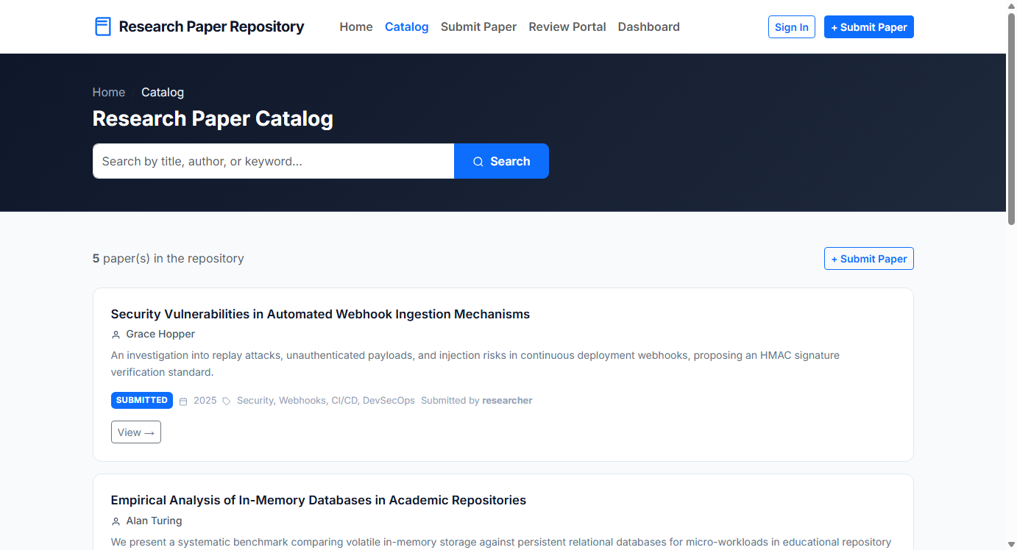
Figure 07.1: Visual Proof of Work — Public Catalog and Privacy

4. Acceptance Criteria Checklist
Catalog accessible to anonymous and authenticated users
Keyword search filters dynamically across title, author, and keywords
Author email addresses are completely excluded from public DOM rendering
Unit and integration tests pass verifying privacy rules

5. Artifacts & Verified Deliverables
▪ src/main/resources/templates/papers/catalog.html
▪ src/main/resources/templates/papers/detail.html
▪ src/main/java/com/muawiyah/repository/service/PaperService.java

