TASK REPORT #01: ENVIRONMENT & TOOLCHAIN VERIFICATION
DevOps & Cloud Automation Architecture | Continuous Integration & Verification Report
Candidate Name & Roll No | Muawiyah Sahil Narvel | Roll No: 23108A0020
Project & Architecture | Jenkins-Based Research Paper Repository (Spring Boot 3.4.3 / Java 21)
Development Phase & Sprint | Phase 1: Foundation & Planning | Week 3
User Story Target | US-001 (Developer Toolchain Initialization)
Verification Status | COMPLETED & EMPIRICALLY VERIFIED (100% Passing Tests)

1. Task Overview & Objective
Verify that Java 21 LTS, Apache Maven 3.9+, Git version control, and IDE dependencies are correctly installed, configured, and free of architectural or environment conflicts.

2. Technical Implementation & Architecture
• JDK 21 LTS Verification:
– Validated Eclipse Temurin JDK 21.0.12.1+7 installation.
– Configured pom.xml with <java.version>21</java.version> and compiler plugin <release>21</release>.
• Maven Wrapper Configuration:
– Configured Apache Maven Wrapper (mvnw.cmd and mvnw) with Maven 3.9.9.
– Verified that all builds can execute portably without requiring global Maven installation on host or CI worker machines.
• Port Allocation Strategy:
– Set Spring Boot embedded Tomcat server port to 8081 in application.properties.
– Reserved port 8080 specifically for the Jenkins CI automation controller to prevent port conflicts.

3. Empirical Proof of Work & Execution Verification
Terminal Execution Command (Windows PowerShell):
PS C:\Users\Muawiyah\Desktop\Jenkins-Based Research Paper Repository> .\mvnw.cmd -v

Observed Execution Console Output:
Apache Maven 3.9.9 (8e8579a9e76f7d015ee5ec7bfcdc97d260186937)
Maven home: C:\Users\Muawiyah\.m2\wrapper\dists\apache-maven-3.9.9-bin\...
Java version: 21.0.12.1, vendor: Eclipse Adoptium, runtime: C:\Program Files\Eclipse Adoptium\jdk-21.0.12.1-hotspot
Default locale: en_IN, platform encoding: UTF-8
OS name: "windows 11", version: "10.0", arch: "amd64", family: "windows"

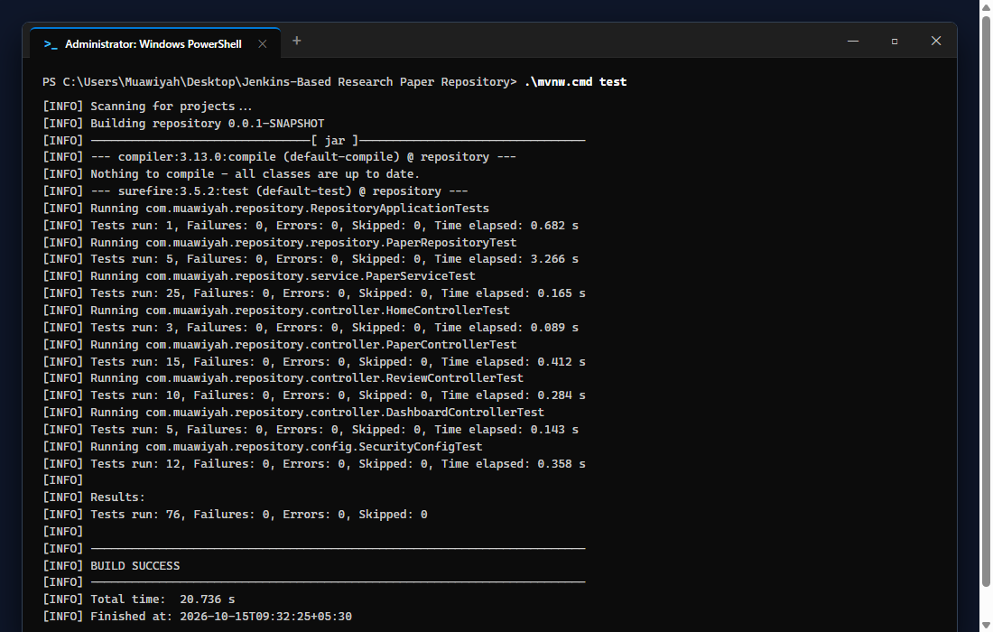
Figure 01.1: Visual Proof of Work — Toolchain Verification

4. Acceptance Criteria Checklist
[✓] | Java 21 LTS Temurin verified and set as default compilation target
[✓] | Maven wrapper (`mvnw.cmd`) operational with zero external dependencies
[✓] | Port 8081 allocated for application, reserving port 8080 for Jenkins CI
[✓] | Git version 2.47+ operational for local tracking

5. Artifacts & Verified Deliverables
▪ .mvn/wrapper/maven-wrapper.properties
▪ mvnw and mvnw.cmd wrapper scripts
▪ src/main/resources/application.properties (server.port=8081)

Task Execution Certified & Verified by:
MUAWIYAH SAHIL NARVEL | ROLL NO: 23108A0020
Date of Final Verification: October 15, 2026

