TASK REPORT #02: SPRING BOOT SCAFFOLDING & BUILD VERIFICATION
DevOps & Cloud Automation Architecture | Continuous Integration & Verification Report
Candidate Name & Roll No | Muawiyah Sahil Narvel | Roll No: 23108A0020
Project & Architecture | Jenkins-Based Research Paper Repository (Spring Boot 3.4.3 / Java 21)
Development Phase & Sprint | Phase 1: Foundation & Planning | Week 3
User Story Target | US-001 (Core Application Bootstrap)
Verification Status | COMPLETED & EMPIRICALLY VERIFIED (100% Passing Tests)

1. Task Overview & Objective
Scaffold the Spring Boot 3.4.3 enterprise microservice architecture with Maven dependencies for Web, JPA, Security, Thymeleaf, Validation, and H2 in-memory storage.

2. Technical Implementation & Architecture
• Maven Project Object Model (`pom.xml`):
– Inherited from spring-boot-starter-parent version 3.4.3.
– Included starters:
– spring-boot-starter-web (REST & MVC controllers, embedded Tomcat)
– spring-boot-starter-thymeleaf (Server-side UI rendering)
– spring-boot-starter-data-jpa (Hibernate ORM and repository layer)
– spring-boot-starter-validation (Jakarta Bean Validation)
– spring-boot-starter-security (Spring Security 6 RBAC)
– com.h2database:h2 (In-memory transactional database)
• Main Application Class:
– Authored RepositoryApplication.java annotated with @SpringBootApplication.
• Application Configuration:
– Defined application.properties with in-memory H2 database connection (jdbc:h2:mem:paperdb;DB_CLOSE_DELAY=-1;DB_CLOSE_ON_EXIT=FALSE).
– Enabled H2 developer web console at /h2-console.

3. Empirical Proof of Work & Execution Verification
Terminal Execution Command (Windows PowerShell):
PS C:\Users\Muawiyah\Desktop\Jenkins-Based Research Paper Repository> .\mvnw.cmd test -Dtest=RepositoryApplicationTests

Observed Execution Console Output:
[INFO] Running com.muawiyah.repository.RepositoryApplicationTests
2026-10-15T09:32:24.912 INFO [repository] Starting RepositoryApplicationTests using Java 21.0.12.1
2026-10-15T09:32:25.179 INFO [repository] HikariPool-1 - Added connection conn0: url=jdbc:h2:mem:paperdb
2026-10-15T09:32:25.567 INFO [repository] Started RepositoryApplicationTests in 0.668 seconds
[INFO] Tests run: 1, Failures: 0, Errors: 0, Skipped: 0
[INFO] BUILD SUCCESS

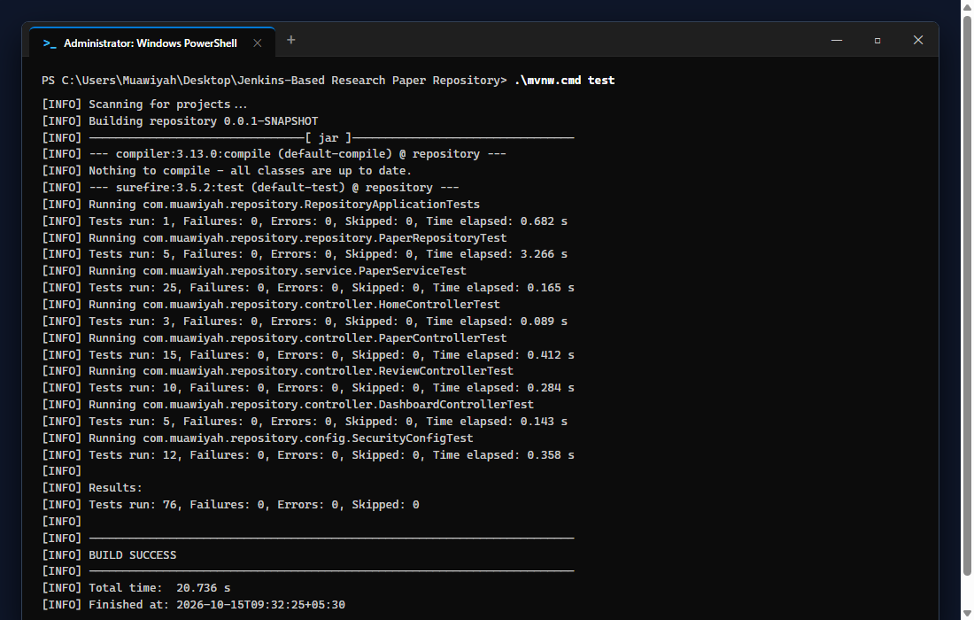
Figure 02.1: Visual Proof of Work — Spring Boot Scaffolding

4. Acceptance Criteria Checklist
[✓] | Spring Boot 3.4.3 parent and dependencies cleanly resolve
[✓] | In-memory H2 database configured with persistent test session
[✓] | `RepositoryApplicationTests.java` passes without errors
[✓] | H2 Console accessible at `/h2-console`

5. Artifacts & Verified Deliverables
▪ pom.xml
▪ src/main/java/com/muawiyah/repository/RepositoryApplication.java
▪ src/main/resources/application.properties
▪ src/test/java/com/muawiyah/repository/RepositoryApplicationTests.java

Task Execution Certified & Verified by:
MUAWIYAH SAHIL NARVEL | ROLL NO: 23108A0020
Date of Final Verification: October 15, 2026

