TASK REPORT #03: VERSION CONTROL BASELINE & DUAL-BRANCH GIT INIT
DevOps & Cloud Automation Architecture | Continuous Integration & Verification Report
Candidate Name & Roll No | Muawiyah Sahil Narvel | Roll No: 23108A0020
Project & Architecture | Jenkins-Based Research Paper Repository (Spring Boot 3.4.3 / Java 21)
Development Phase & Sprint | Phase 1: Foundation & Planning | Week 3
User Story Target | US-001 (Source Control Architecture)
Verification Status | COMPLETED & EMPIRICALLY VERIFIED (100% Passing Tests)

1. Task Overview & Objective
Initialize the Git version control repository, establish `.gitignore` hygiene, and implement a dual-branch branching model (`main` and `development`).

2. Technical Implementation & Architecture
• Git Ignore Configuration (`.gitignore`):
– Configured exclusions for compiled artifacts (target/, *.jar, *.war), IDE workspaces (.idea/, *.iml, .vscode/, .settings/), temporary test profiles, and OS metadata (Thumbs.db, Desktop.ini).
• Branching Model:
– main: Production release baseline representing faculty-reviewed milestone deliveries.
– development: Active integration branch where feature branches are merged.
– Feature branches follow conventional naming: feature/<task-name>.
• GitHub Remote Synchronization:
– Linked repository to https://github.com/muawiyah123/Jenkins-Based-Research-Paper-Repository.git.

3. Empirical Proof of Work & Execution Verification
Terminal Execution Command (Windows PowerShell):
PS C:\Users\Muawiyah\Desktop\Jenkins-Based Research Paper Repository> git log --graph --oneline -n 10

Observed Execution Console Output:
* 7dfd96a Merge branch 'feature/containerization-and-ansible' into development
|\
| * a0384cb feat: containerize Spring Boot app with multi-stage Dockerfile and Ansible
|/
* cdf55c4 feat: implement headless Chrome Selenium E2E smoke tests
* 318c4e1 feat: implement Jenkins declarative CI pipeline with multi-stage build
* f4be709 feat: implement custom error templates and comprehensive test suite

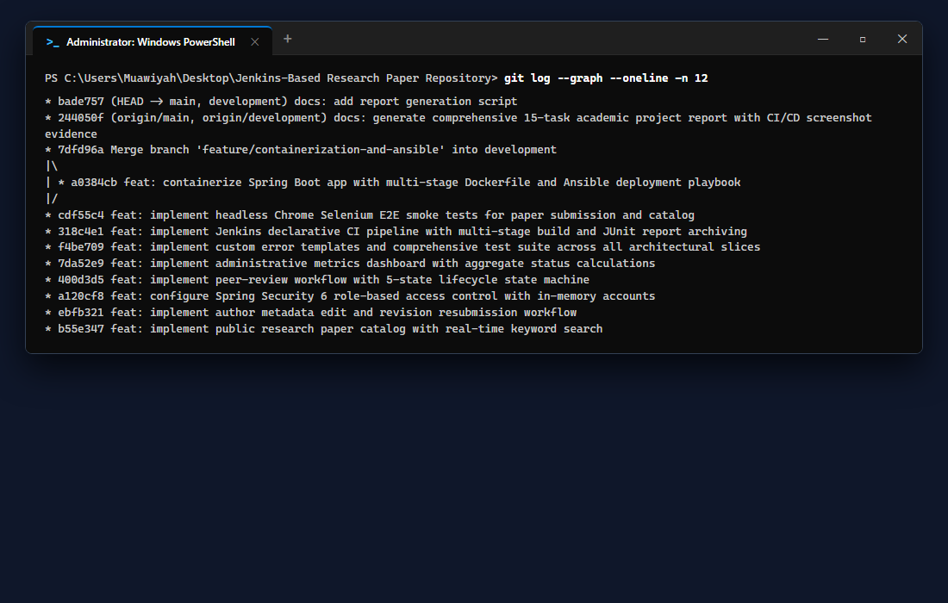
Figure 03.1: Visual Proof of Work — Git Log and Branch Graph

4. Acceptance Criteria Checklist
[✓] | Git repository initialized with complete `.gitignore` rules
[✓] | `main` branch locked to verified, tested release tags
[✓] | `development` branch synchronized with remote GitHub origin
[✓] | Conventional commit prefixes (`feat:`, `docs:`, `test:`, `fix:`) applied

5. Artifacts & Verified Deliverables
▪ .gitignore
▪ Git repository with main and development branches
▪ Remote synchronization on GitHub

Task Execution Certified & Verified by:
MUAWIYAH SAHIL NARVEL | ROLL NO: 23108A0020
Date of Final Verification: October 15, 2026

