Bahria University,

Karachi Campus



LAB EXPERIMENT NO.

**09**

LIST OF TASKS

|  |  |
| --- | --- |
| TASK NO | OBJECTIVE |
| 1 | **Use any of the following built-in-module: fs, os, or path** |
| 2 | **Create a module and export:**   * 1. **It as a value.**   2. **Its all functions**   3. **It as a single function** |
| 3 | **Npm install module**  **Use that module**. |
|  |  |
|  |  |

Submitted On:

**Task 01: Use any of the following built-in-module: fs, os, or path**

**Solution:**

const os=require("os")

console.log("OS module methods:\n");

console.log("os.arch: "+os.arch());

console.log("os.freemem:"+os.freemem()/1024/1024/1024);

console.log("os.totalmem: "+os.totalmem()/1024/1024/1024);

console.log("os.hostname: "+os.hostname());

console.log("os.platform: "+ os.platform());

console.log("os.release: "+os.release());

console.log("os.tmpdir: "+os.tmpdir());

console.log("os.type: "+os.type());

**Output:**

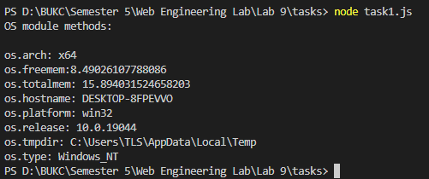

**Task 02: Create a module and export:**

* 1. **It as a value.**
  2. **It’s all functions**
  3. **It as a single function**

**Solution:**

**As a value, all function and single function**

**Module program:**const add=(a,b)=>{

    return a+b;

};

const sub=(a,b)=>{

    return a-b;

};

const name="M Muaz Shahzad"

module.exports.add1=add;

module.exports.sub1=sub;

module.exports={add,sub,name};

**Main program:**const a=require('./task2.js');

const {add,sub,name}=require('./task2.js');

console.log("As a single functions");

console.log(a.add(5,5));

console.log(a.sub(5,5));

console.log("\nAs a single value");

console.log(a.name);

console.log("\nAll function:\n");

console.log(add(5,5));

console.log(sub(5,5));

console.log(name);

**Output:**

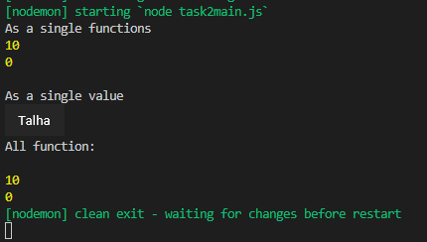

Muaz

**Task 03:**

* **Npm install module**
* **Use that module**.

**Solution:**

const path=require("path")

console.log(path.join(__dirname,".."));

**Output:**

