Table of Contents

Importing client & server in same workspace: 2

Running server: 3

Running Client: 4

# Importing client & server in same workspace:

* Unzip the “Bird_client_server_same_workspace.zip”.
* Following folder structure will be created,
  + Bird_client_server
    - BirdClient
    - BirdModel
    - BirdServer
* Now launch Eclipse IDE.
* Select “import” and select “Existing projects into workspace”.
* Select root directory up to “Bird_client_server”.
* Following three projects will be there to import,

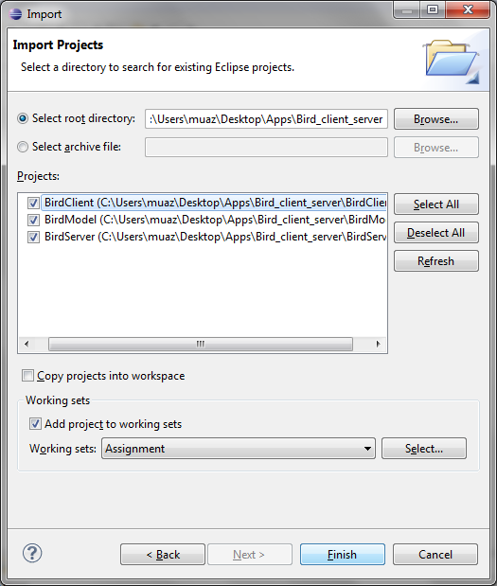

* Select all three projects and press finish.

## Running server:

* Create a run configuration for “Java Application” with name “ServerConfig”.
* Set project to “BirdServer”.
* Set main class to “bird.server.Server” as show below.

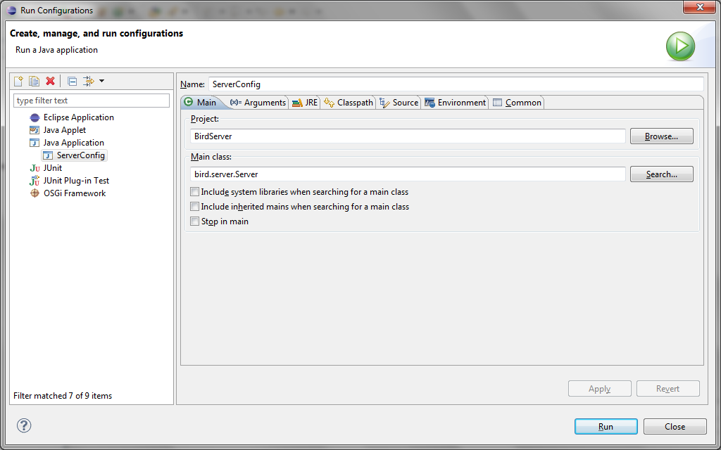

* For giving command line arguments, switch to “Arguments” tab and give argument as shown below,

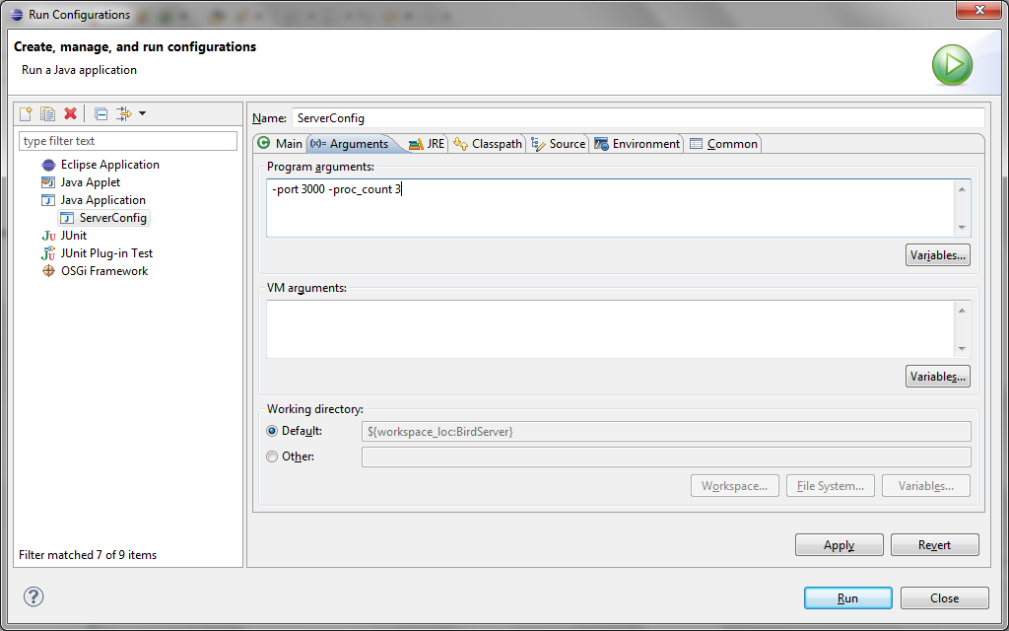

* Now press run to start server.
* Server will start with following console output,

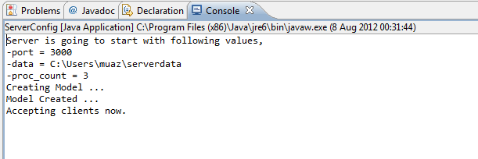

## Running Client:

* Create a run configuration for “Java Application” with name “ClientConfig”.
* Set project to “BirdClient”.
* Set main class to “bird.client.Client” as show below.

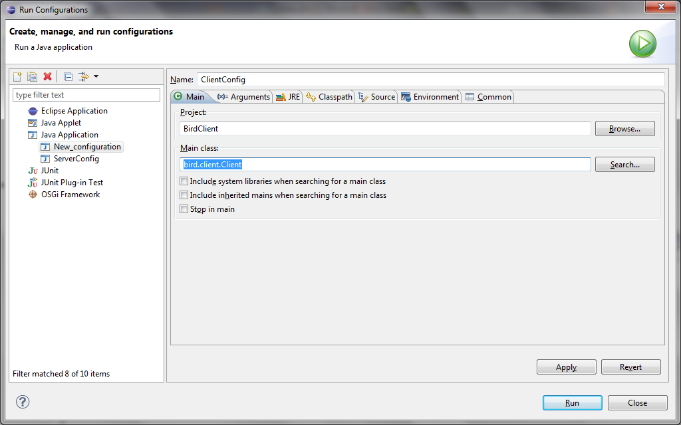

* For giving command line arguments, switch to “Arguments” tab and give argument as shown below,

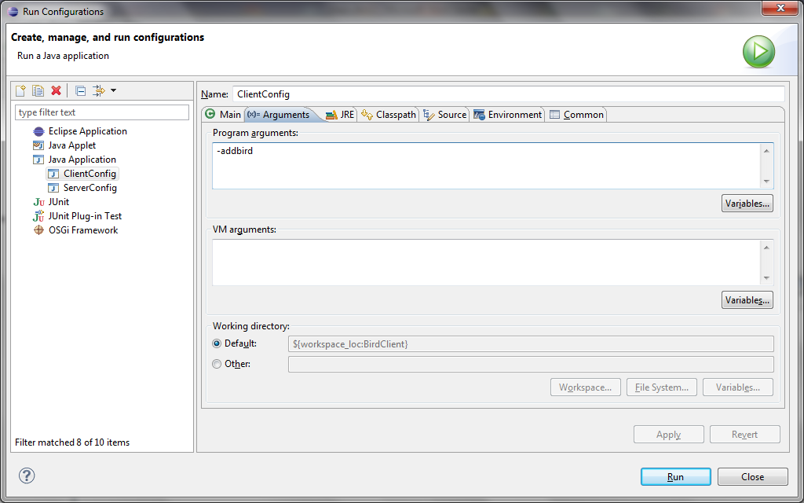

* Now press run to start client.