 **Manual Internet Programming Project**

**Theme:** Topic 4(Hotel Booking System)

**Team**: Group 4

Team Members:

1. Muhammad Fikri bin Hamidan (A18CS0138)

2. Muaz Bin Amir Nur Rashid (A18CS0114)

3. Muhammad Hafizul bin Shukran(A18CS0142)

4. Muhammad Burhanuddin Bin Ibrahim (A18CS0129)

5. Muhammad Danial Hakimi bin Mohd Habibullah(A18CS0133)

6. Muhammad Faiq bin Roslan (A18CS0134)

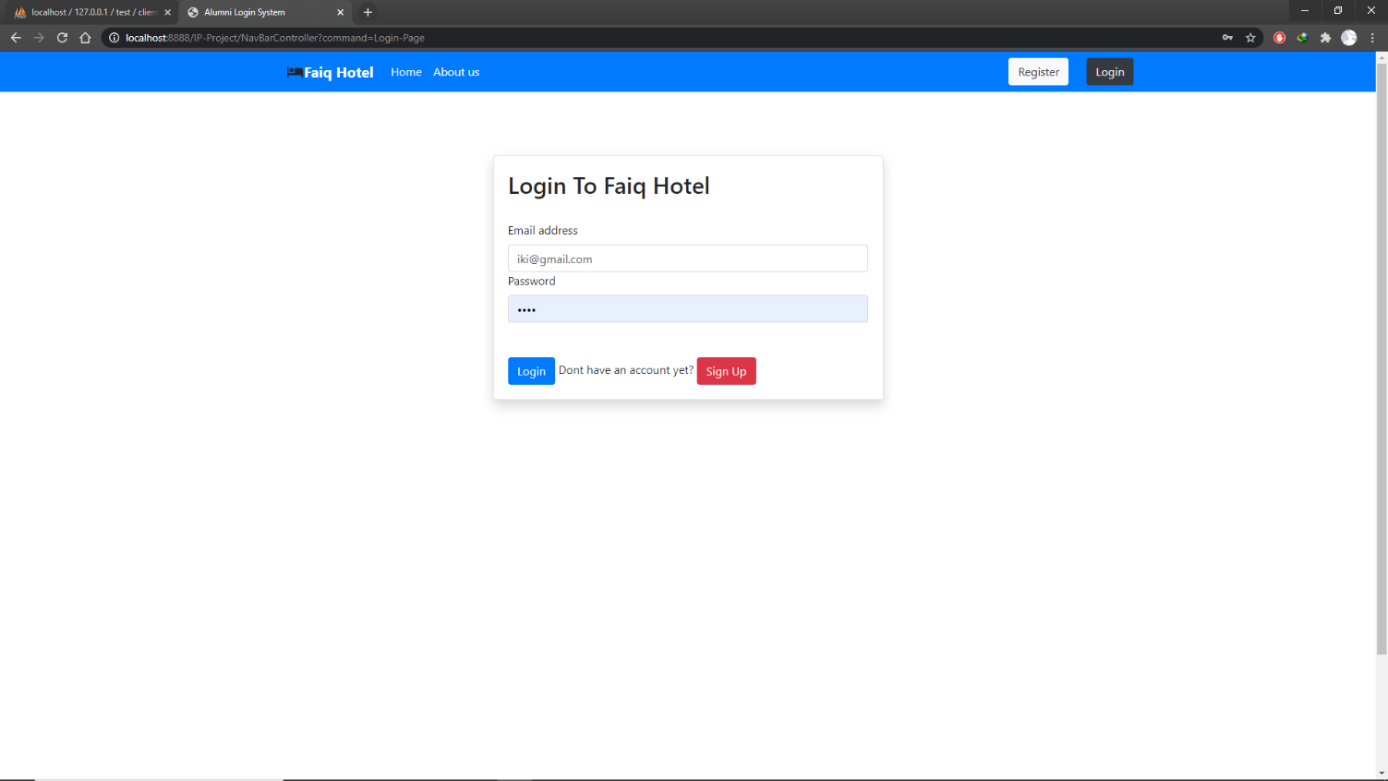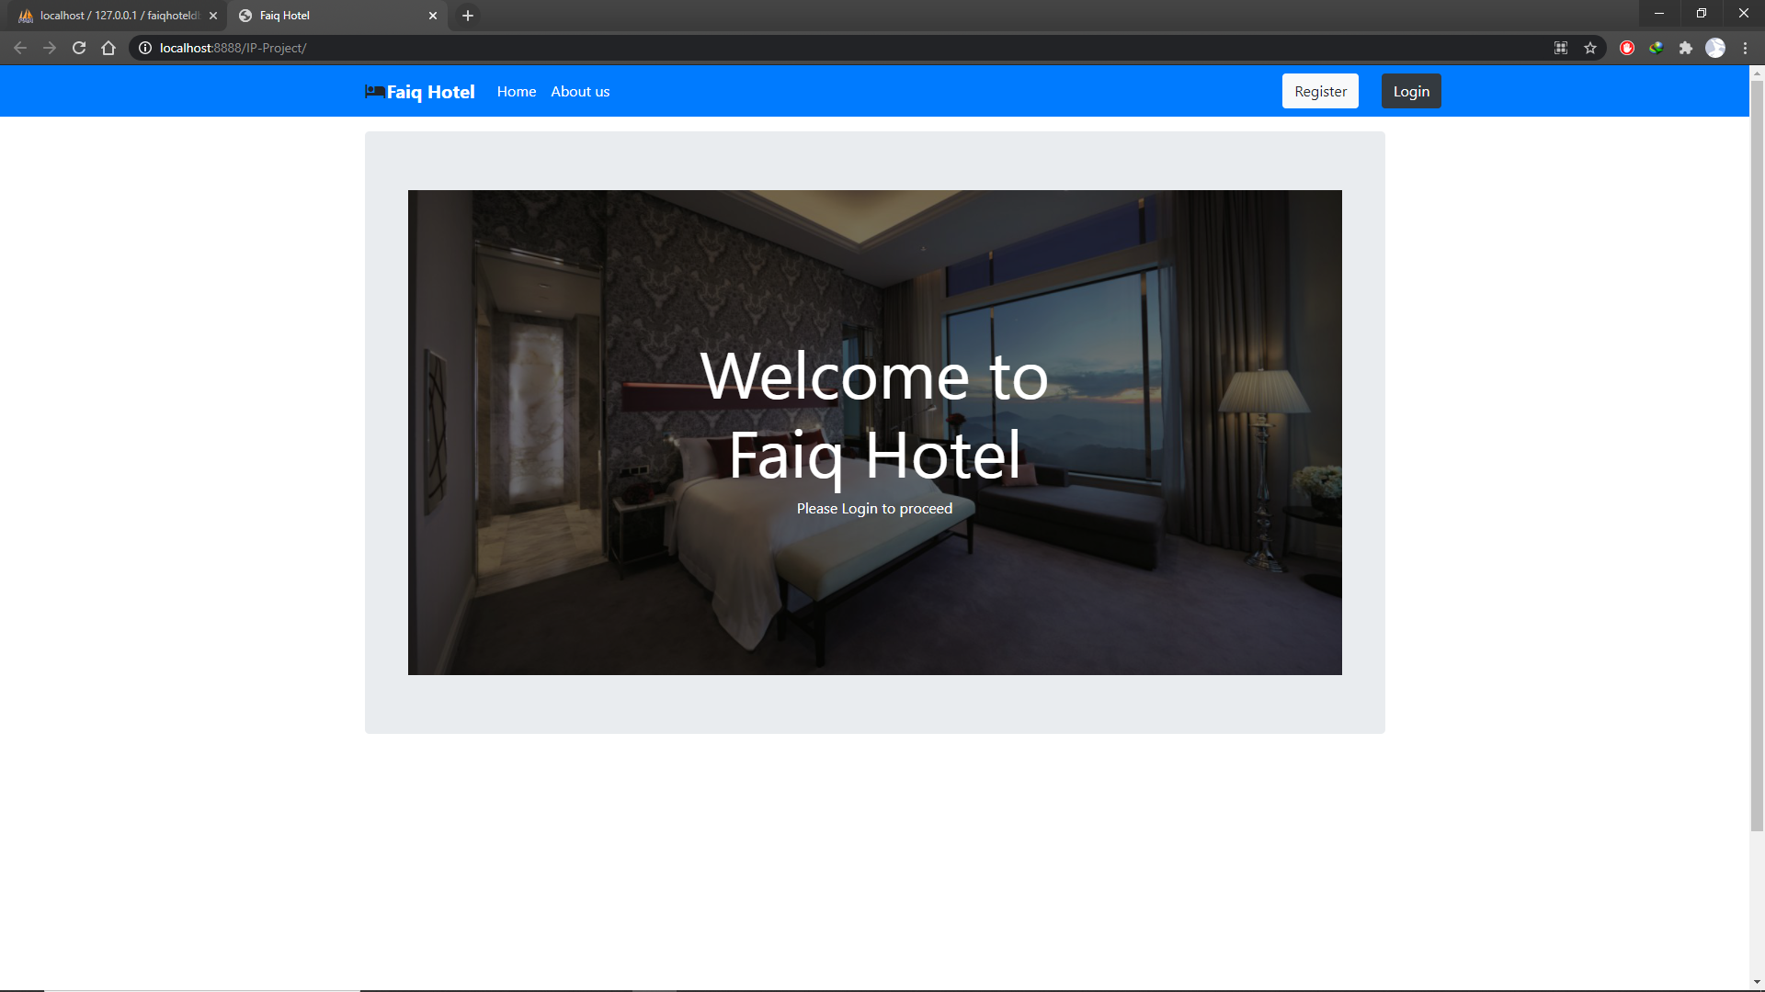

Register for new user

Admin

Email: [faiq@gmail.com](mailto:faiq@gmail.com)

Password: 1234

User

Email: [iki@gmail.com](mailto:iki@gmail.com)

Password: 1234

To login for existing user

To register for new user

**USER:**

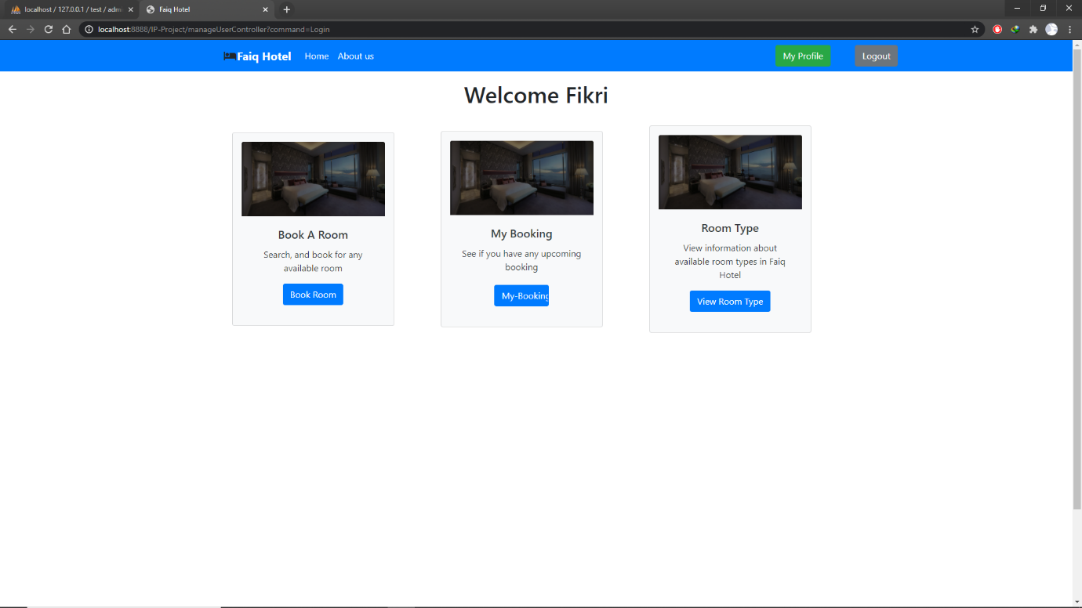

View available room type

Check booking status

To book a room

Logout

Go to my profile

Go to home page

**To book a room:**

-User need to input the number of people

-User need to input the check in and check out date

-User will choose which type of room they wanted **ADMIN:**

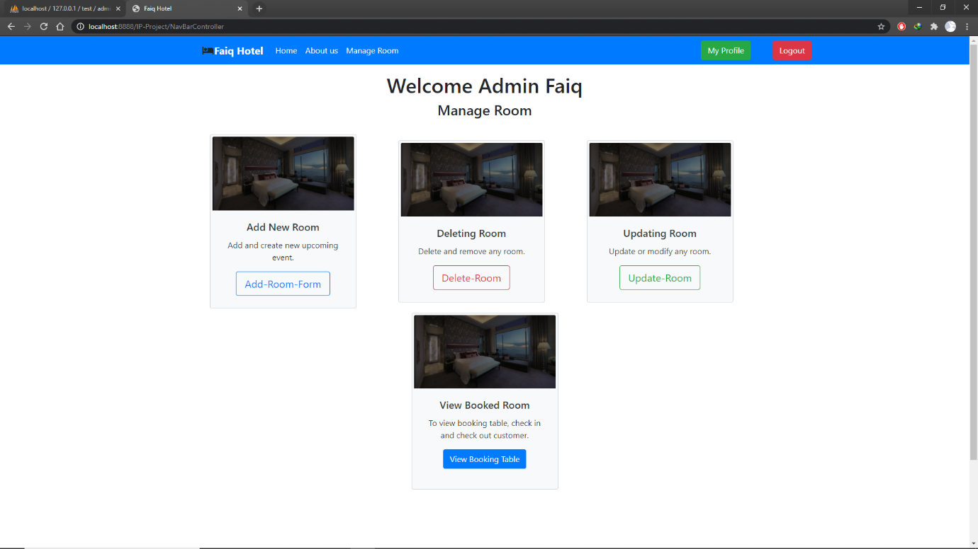

Delete a room

Add room

View booking

Update a room

Logout

Go to my profile

Go to home page

**To add a room:**

-Admin need to input the room number, room fee, room image and choose the room type

-Admin click add-room button

**To delete a room:**

-Admin need click the room that they want to delete

**To update a room:**

-Admin need to click the room that they want to update

-Admin need to input the room number, room fee, room image and choose the room type

-Admin click add-room button

**To view room booking:**

-Admin need click the room that the customer had check-in or check-out.