Tab 1
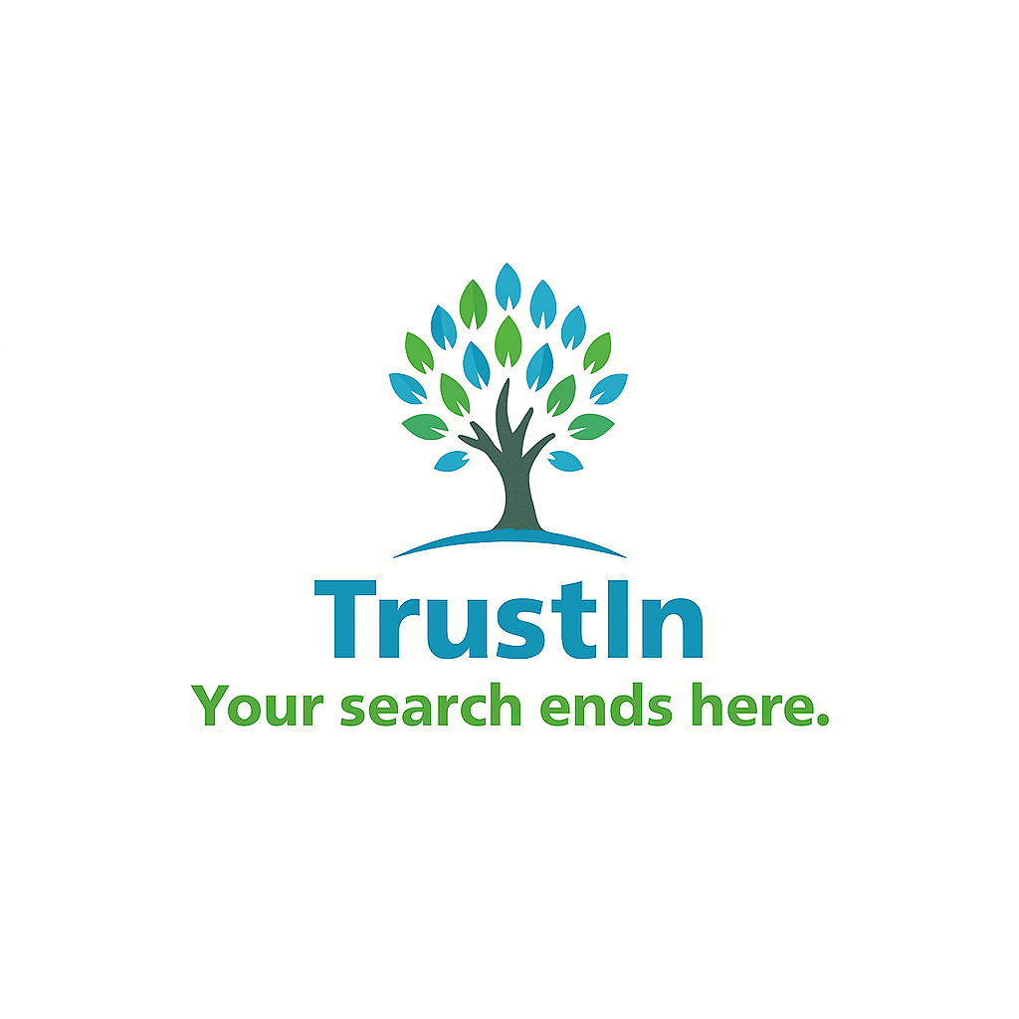
COMPANY LOGO

Tab 2
Website pages

- HOME
- PROCESS
- ABOUT US
- CONTACT US
- FAQs

Languages
- The main language should be in English but also available in Spanish, French and so on.

Color palette
- #5ac2a6
- #6abfd6

