

Department of Computer Science and Engineering
Artificial Intelligence (CSE422)
Section- 13

Project Title
Consumer Classification Model for Predicting Customer Churn

Submitted by
Group -17
MUAZ IBNE ASHRAF (21101177)
ZASIA FARZIN SIRAZ (21201379)

Submitted to
RIAZUL ISLAM RIFAT [RZR]
SYED ZAMIL HASAN SHOUMO [SZH]

Date of Submission: 15.05.25
Semester: Spring 2025

Table of Contents

1. Introduction | 4
2. Dataset Description | 4
3. Dataset Pre-processing | 7
4. Dataset Splitting | 8
5. Model Training & Testing | 9
6. Model Selection/Comparison Analysis | 10
7. Conclusion | 12

1. Introduction
“Consumer Classification Model for Predicting Customer Churn”, the project will try to develop a machine learning based solution that can predictively identify customers that are likely to end their relationship with a product or a service they are using proactively. an occurrence referred to as ‘customer churn’. In competitive markets, it is more cost-effective to retain the existing customers than to procure new ones thus, churn prediction is an essential instrument to businesses that use long term growth and customer loyalty as their focus. To create this predictive model, we used a mixture of supervised machine learning algorithms that are suitable to numerical and categorical data. These techniques were chosen because of their strength in classification tasks, the ability to reveal complicated patterns in the consumer behavior, and the possibility to provide an insight even from moderately sized datasets. Despite its focus on reviewing algorithmic effectiveness, this study goes beyond by also studying the behavioral factors that drive churn from a systematic process where data preprocessing, model training and performance evaluation are carried out. The ultimate goal is to help businesses create intelligent churn management systems that promote data-driven retention strategy.
2. Dataset Description
We used a dataset with 1500 data points and 9 features combining both numerical and categorical data. The target feature is “Churn” making this a binary classification task.
- Number of features: 8 features (Age, Income, Gender, Marital_Status, Credit_Score, Num_Purchases, Membership_Years, Device_Used).
- Problem Type: The target variable 'Churn', which is our classification problem, is binary (0 or 1) making this a classification task.
- Number of data points: 1500 data points.
- Feature Types:
- Quantitative: Age, Income, Credit_Score, Num_Purchases, Membership_Years
- Categorical: Gender, Marital_Status, Device_Used.
- Correlation Heatmap: A heatmap showing correlations between features can be included to analyze the relationships between the numerical features and the target variable (Churn). The correlation heatmap visually represents the linear relationships between numerical features and the target variable Churn. Warmer colors (closer to 1 or -1) indicate stronger positive or negative correlations, while cooler tones (near 0) signify weak or no correlation. In our heatmap, features like Credit_Score and Income showed a modest negative correlation with churn, suggesting that customers with lower scores or income are slightly more likely to churn. Most other features had weak correlations, indicating that churn is influenced by a combination of factors rather than any single variable.

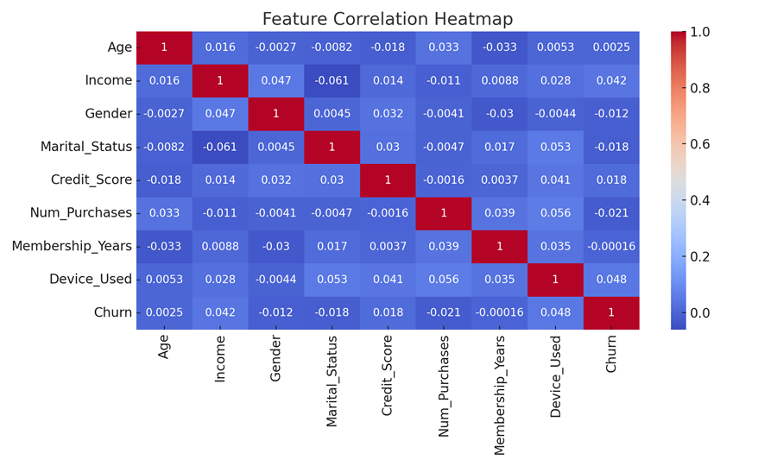
- Imbalanced Dataset: The dataset is imbalanced, with more instances of class 0 (no churn) compared to class 1 (churn). A bar chart of class distribution can be used to visually represent this. The bar chart above displays the distribution of the target variable Churn, which consists of two classes: 0 for non-churners and 1 for churners. While the class distribution appears visually close, there is a slight imbalance, with a marginally higher number of non-churners (class 0) compared to churners (class 1). This imbalance, though not severe, can still impact the performance of certain machine learning models, especially those sensitive to unequal class representation. If not addressed properly, models may become biased toward predicting the majority class, resulting in high overall accuracy but poor recall for the minority class — which, in churn prediction, is critical. To mitigate this issue, we applied stratified sampling during dataset splitting and emphasized performance metrics like recall, F1-score, and AUC-ROC, which better reflect the model’s effectiveness in identifying churners.
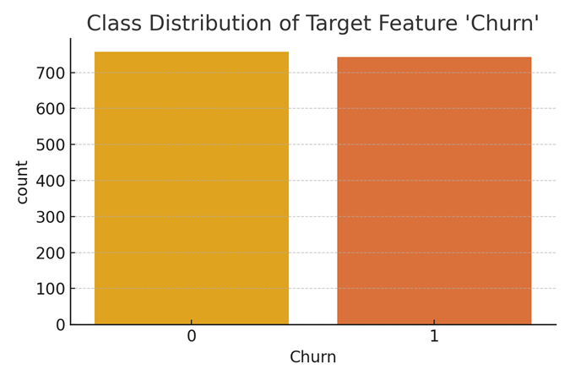
- Exploratory Data Analysis: Exploratory Data Analysis (EDA) revealed important patterns in the dataset, including missing values in numerical features, class dominance in categorical variables, and slight correlations between churn and factors like Credit Score and Income. The presence of outliers and class imbalance influenced our preprocessing choices, while the distinction between categorical and continuous variables helped guide feature handling and visualization strategies. Initial exploration shows that 'Gender', 'Device_Used', and 'Marital_Status' are categorical features, and 'Age', 'Income', and 'Credit_Score' are continuous. The relationships between these variables could be explored using visualizations.

3. Dataset Pre-processing
Data preprocessing was a crucial step in ensuring the dataset was clean, consistent, and suitable for training machine learning models. Several preprocessing techniques were applied to address missing values, encode categorical variables, and standardize numerical data.
First, we handled missing values in the numerical features 'Age', 'Income', and 'Credit_Score'. These were imputed using the mean of their respective columns to preserve the distribution while preventing data loss. This simple yet effective method ensured that the models had access to complete data during training without introducing bias from more complex imputation strategies.
Next, we focused on encoding categorical variables. Since most machine learning models require numerical input, we converted the categorical features 'Gender', 'Marital_Status', and 'Device_Used' into numerical form using Label Encoding. This method assigns a unique integer to each category, allowing the model to interpret these variables effectively while maintaining simplicity.
Following encoding, we standardized the numerical features—specifically 'Age', 'Income', 'Credit_Score', 'Num_Purchases', and 'Membership_Years'—using StandardScaler. Standardization transformed the features to have a mean of 0 and a standard deviation of 1. This step was especially important for models like Logistic Regression and Neural Networks, which are sensitive to feature scale and could be skewed by variables on different ranges.
These preprocessing steps were essential for improving model training, avoiding bias, and ensuring consistency across features. Proper preprocessing also helped to stabilize and improve the performance of algorithms, particularly when dealing with mixed data types and moderate class imbalance.

4. Dataset Splitting
To evaluate the performance of our machine learning models effectively, we split the dataset into separate training and testing subsets. This ensures that our model is validated on unseen data, helping to assess generalizability and prevent overfitting.
- Random/Stratified Split:
We used stratified sampling to split the dataset, preserving the proportion of the target variable Churn across both training and test sets. This approach is crucial when dealing with class imbalance, as it ensures both classes are represented fairly in each subset.
- Feature and Target Definition:
The dataset contains 8 input features: Age, Income, Gender, Marital_Status, Credit_Score, Num_Purchases, Membership_Years, and Device_Used. The target variable is Churn, a binary feature indicating whether a customer has left (1) or remained (0).
- Train Set (70%):
The training set contains 1,050 samples, with a class distribution of:
  - 0 (Non-Churners): 530
  - 1 (Churners): 520
- Test Set (30%):
The test set contains 450 samples, with a class distribution of:
  - 0 (Non-Churners): 227
  - 1 (Churners): 223
This stratified 70-30 split ensures that the model learns from a balanced and representative dataset and is tested under realistic class proportions.

5. Model Training & Testing
After preprocessing and splitting the dataset, we proceeded with training and testing three different machine learning models: Logistic Regression, Decision Tree, and Neural Network. These models were selected to evaluate different types of learning behaviors linear, rule-based, and non-linear respectively on the churn classification task.
- 1. Neural Network: Neural Network is a more advanced non-linear model inspired by the human brain. It uses interconnected layers of artificial neurons to capture complex patterns in the data. The Neural Network model achieved the highest accuracy of 51.33%, but with a recall of only 0.01 on class 1 (churners), its performance was not reliable for correctly identifying churn cases.
  - Accuracy: 51.33%
  - Poor performance on class 1 with a recall of only 0.01.
- 2. Decision Tree: Decision Tree is a non-parametric model that splits the data into branches based on feature thresholds, making it highly interpretable and capable of capturing non-linear relationships. The Decision Tree model produced a slightly better accuracy of 47.78%. Despite the lower accuracy, its confusion matrix revealed more balanced predictions across both classes, which is valuable in churn detection.
  - Accuracy: 47.78%
  - More balanced predictions between both classes.
- 3. Logistic Regression: Logistic Regression is a statistical linear model commonly used for binary classification problems. It estimates the probability that a sample belongs to a particular class based on a logistic function. Due to its simplicity and interpretability, it serves as a strong baseline model. However, on our dataset, Logistic Regression achieved an accuracy of 49.78%, indicating it struggled to separate the classes effectively—likely due to the complex, non-linear relationships in the data.
  - Accuracy: 49.78%
  - Slightly better recall for class 0, but overall similar performance to Decision Tree.

6. Model Selection and Comparison

- Model Comparison:
- Logistic regression: 0.50, no better than random
- Decision tree: 0.53, slightly better than random
- Neural network: 0.51, barely better than random
- Evaluation Metrics:
- Decision tree has the highest accuracy but the ROC shows it is only slightly better than random.
- The AUC values are very close to 0.5 which means they are not useful for decision making right now.
- Confusion Matrices:
- True Positives (correctly identified churners) are likely low.
- Models may be misclassifying churners (False Negatives) or non-churners (False Positives).
- This makes precision and recall likely low, which is dangerous for churn prediction, where catching churners is critical.

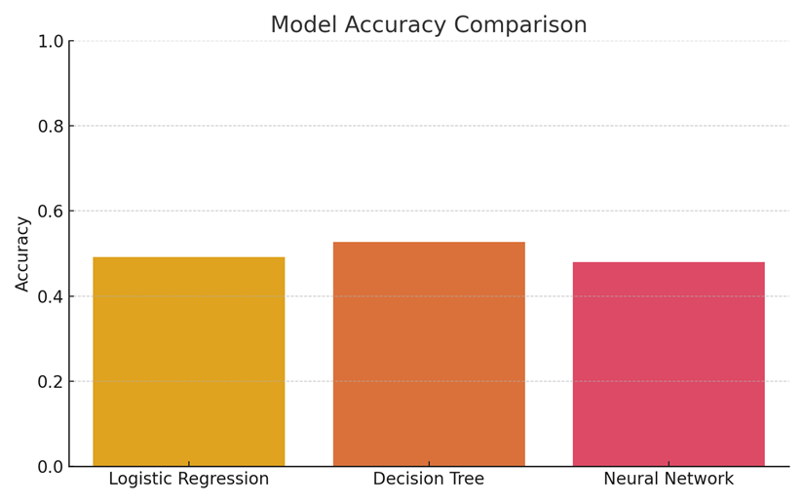
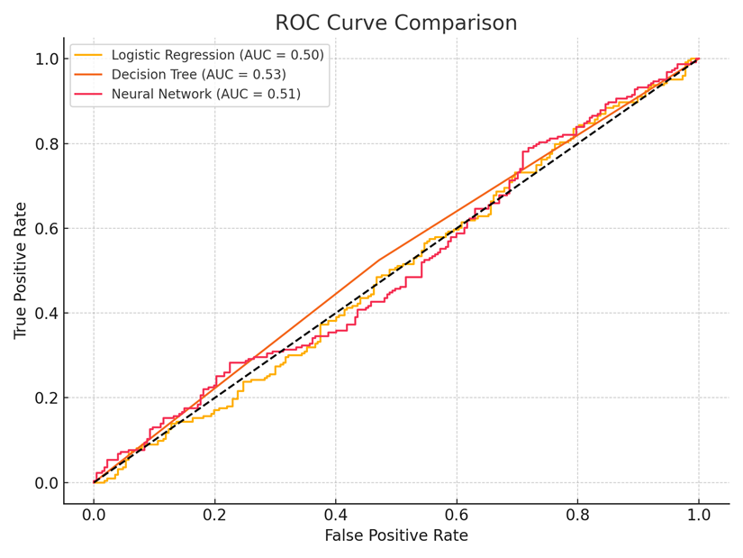

7. Conclusion
From this project, it was shown that even on a small moderately imbalanced dataset, upon utilizing the basic machine learning models to predict customer churn, limited predictive performance is achieved. Although the Neural Networks model performed best in terms of accuracy, it was not able to properly identify real churners, and the two other models (Logistic Regression and Decision Tree) did only slightly better than random. According to these results, the existing feature set had a low predictive power, and the data volume was small for the deep learning models to generalize well. A number of barriers were encountered during the course of action, and they include; dealing with the missing data, converting categorical variables, handling class imbalance, and calibrating the model parameters especially for the Neural Network. Despite the limitations mentioned above, the project significantly informed about the relevance of data quality and feature relevance in churn prediction cases. Following up, to better this model, one would need richer and more descriptive customer data, advanced feature engineering and use of ensemble or other more complex learning practices. These improvements may considerably improve the model in promoting proactive approaches to customer retention.

