1. How does our Architecture look like?
   1. Idea-1
      1. 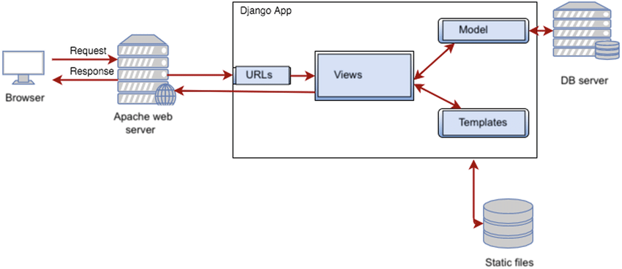
2. What database we need to use?
   1. PostgreSQL
3. Which cloud technologies we can use?
   1. GCP