**Muazzam Bin Aqeel  
CTS – 7  
Programming 3 – Tutorial**

**Plan:**

1. **Pointers**
2. **Classes and Objects**
3. **Inheritance**
4. **Polymorphism**

Now --- Past Exam – Question 1/2

1. **Overloading Operators**
2. **STL**

**Strategies:**

1. Rule Book
2. Resources
   1. Primary source:
      1. Prof. Script
      2. LearnCPP Website
      3. Udemy Course
3. Power of Chat GPT (For Practice purposes)
4. Cheat Sheet
   1. How to optimize your cheat sheet its maximum potential
      1. **Draft 1** – Find all the keywords from the script (Recommended – Split all the big topics in different notebooks on your IPAD/Paper Based Notebook)
      2. **Draft 2** – After looking over all the past exams, find the common questions asked by the Prof. And replace that with draft 1
      3. **Draft 3** – You will notice over the period of time, some concepts would get very easy to remember, because you would be using it in real life programming questions (So remove those extra Info.)
      4. **Final Draft –** Make sure to put all the past exam questions especially the theory on your cheat sheet.

**3 three W’s**

* What is the meaning of .....
* Why do we need .....
* What are the variations in the area of ..... (How can it be used in different cases)

**Plan:**

**Chapter 1 – Pointers**

1. What is the meaning of Pointers

Pointers simply represents a variable that stores another variable’s address (That's all)

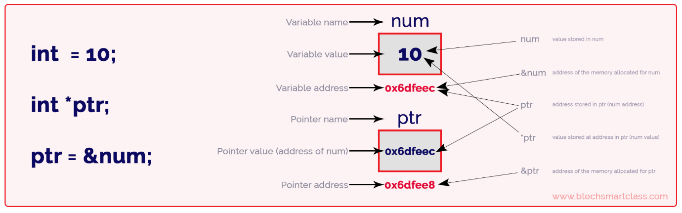

1. Why do we need Pointers  
     
   **Memory Management**:   
   Pointers give programmers direct access to memory.

**Dynamic Data Structures**:   
Pointers are essential for creating complex data structures like linked lists, trees, graphs, and more.

**Function Arguments and Return Types**:   
Pointers allow functions to modify the value of arguments passed to them, enabling the function to return multiple values.

**Efficiency and Performance:**   
Pointers can lead to more efficient programs.

1. What are the variations in the area of Pointers (How can be used in different cases)  
   **Power of Chat GPT (Learning Techniques) – Going beyond Scope**  
   Show me a simple example how ..... Are used in C++  
   Show me 10 different examples where .... are used in different ways  
   Show me a few limitations the concepts of .... bring along using Code examples in C++
2. Analysis in Depth