BBB3033 CLASS PRACTICE PURPOSE

**QUESTION: PROPOSAL (60 MINUTES - 50 MARKS)**

**(Content 30 Marks + Language 20 Marks)**

Read the description and propose a relevant project. Answer the following questions. In today's competitive job market, students need practical guidance and support to maximize their career prospects.

As the President of the Students' Association of UMT, you are given the responsibility by the UMT Board to write a proposal for a **mentorship program** that connects students with industry professionals to enhance their career prospects.

**(WARNING: PLEASE PARAPHRASE THE SENTENCES. MARKS WILL BE DEDUCTED FOR PLAGIARISM). **

**Figure 1: Perception on Work Preparedness according to Employers and Students Source (adapted from):**

Talent Corp Malaysia. (2022, January 16). Employers stress need industry mentorship. Community College Daily. https://www.ccdaily.com/2022/employers-stress-need-industry-mentorship/ z

1

BBB3033 CLASS PRACTICE PURPOSE 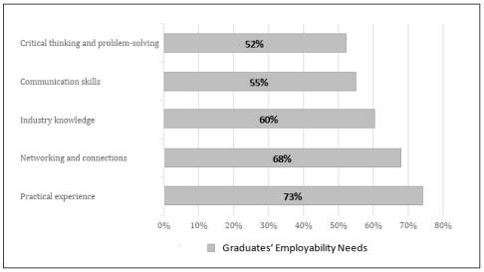

**Figure 2: Graduate Employability Blueprint**

**Source (adapted from)**:

Graduate Employability Blueprint. (2021). The importance of networking, mentorship, and real-world experience in improving graduates' employability. Ministry of Higher Education. https://www.mohe.gov.my/graduate-employability-blueprint

a) Write one paragraph that includes: **(10m)**

*● The main issue/problem in context (2m)*

*● TWO (2) pieces of evidence from the sources given to support the programme (4m) ● Statement of need for programme (2m)*

*● One sentence to propose (2m)*

The feeling of not prepared for work among employers and students. 1 in 3 employers feel that school has not adequately prepared them for work meanwhile 1 in 3 students feel that school is not adequately preparing them for work. Because of this we need a programme to prepare the student for work environments. Example of the programme that can be done to enhance their career prospects is mentorship programme that connects students with industry professionals to enhance their career prospects.

2

BBB3033 CLASS PRACTICE PURPOSE

_____________________________________________________________________________ _____________________________________________________________________________ _____________________________________________________________________________ _____________________________________________________________________________ _____________________________________________________________________________ _____________________________________________________________________________ _____________________________________________________________________________ _____________________________________________________________________________ _____________________________________________________________________________ _____________________________________________________________________________ _____________________________________________________________________________ _____________________________________________________________________________ _____________________________________________________________________________

b. Write **ONE goal** with **TWO measurable objectives (activities)** in the infinitive phrase for the proposed programme. **(7m)**

Goal (3m): Connects students with industry professional___________

Objectives (4m):

1. Organize the programme for 2 days to give students the opportunity to properly learn something
2. Invite 3 or more industry professionals to give a speech about the work environment.

c. Write a complete sentence on the **expected outcome** for the proposed programme. **(5m)** Expected outcome 1:

By the end of the programme student will understand the norms in the working environment based on the experience they get from the industry professionals._

3

BBB3033 CLASS PRACTICE PURPOSE

Expected outcome 2:

Participants feel more confident in their abilities and are motivated to pursue ambitious career goals.

d. Write a **SWOT analysis** in complete sentences for the proposed programme. **(8m)**

Strength :

The participants of this program can make connections with the speaker that been invited to the programme.

Weakness :

The program cost may be expensive because of the payment to the professionals

Opportunity :

Collaborating with industries, universities, or professional organizations can enhance credibility and reach.

Threat :

Budget constraints in companies or individuals may reduce willingness to invest in training